**✯ Trigonometriya ✯**

1.  radian necha gradusga teng?
2. , ,  sonlarni o`sish tartibida yozing?
3. Agar  bo`lsa,  qaysi chorakka tegishli?
4. Rasmdan  ning qiymatini toping?

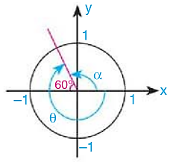

1.  ning radian o`lchovini toping?
2. Quyidagilardan qaysi birlari manfiy?

1)  2) 

3)  4) 

1. Rasmdan  ning qiymatini toping?

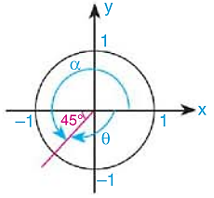

1.  radian necha gradusga teng?
2. , ,

,  sonlarini o`sish tartibida yozing?

1.  quyidagilarning qaysi biriga teng emas?

1)  2) 

3)  4) 

1. Rasmdan  ning qiymatini toping?

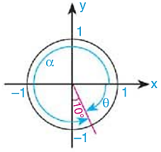

1. , ,  lar ishoralarining ketma-ketligini toping?
2.  ning qiymatini toping?
3. Rasmdan  ning qiymatini toping?

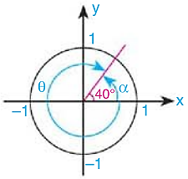

1.  ning qiymatini toping?