HARBIY TEST-2018
MATEMATIKA YECHIMLARI
1-QISM
1.Misol:
b₁=4 b₅=324 q⁴=b₅/b₁=81 $=>$ q=3
$b_{2}=b_{1}$ q=4$×3$=12 JAVOB: 12,36,108
$b_{3}=b_{2}×q=12×3=36$
$b_{4}=b_{3}×q=36×3=108$
2.Misol:
(1/2+3/2+5/2+……+15/2)+(2/3+4/3+…..16/3)=$\frac{\frac{1+15}{2}*8}{2}$+$\frac{\frac{2+16}{2}*8}{3}$=56
JAVOB:56
4.MISOL:
Sin(1º)+ Sin(2º)+ Sin(3º)+………+ Sin(358º)+ Sin(359º)=
= Sin(1º)+ Sin(359º)+ Sin(2º)+ Sin(358º)…..=
=2Sin(360º/2) Cos(-358º/2)+ 2Sin(360º/2) Cos(-358º/2)….=0
5.MISOL:
a₁=lg(a-b) a₂=lg$2\sqrt{\text{ab+}b^{2}} a_{3}=lg\left(a+b\right) 2log_{b}(a/5)= ?$ $\left\{\begin{aligned}\text{d=lg(2}\sqrt{\text{ab+}{\text{b}}^{\text{2}}}\text{)-lg(a-b)} \\ \text{d=lg(a+b)-lg(2}\sqrt{\text{ab+}{\text{b}}^{\text{2}}}\end{aligned}\right.$ lg2$\sqrt{ab+b^{2}}+lg2\sqrt{ab+b^{2}}=$lg(a+b)+lg(a-b)
Lg7(ab+b²)=lg(a²-b²) 4ab+4b²=a²-b² b4(a+b)=(a-b)(a+b) 5b=a
Log_{b}(a/5)=2log_{b}(5b/5)=2 JAVOB: 2

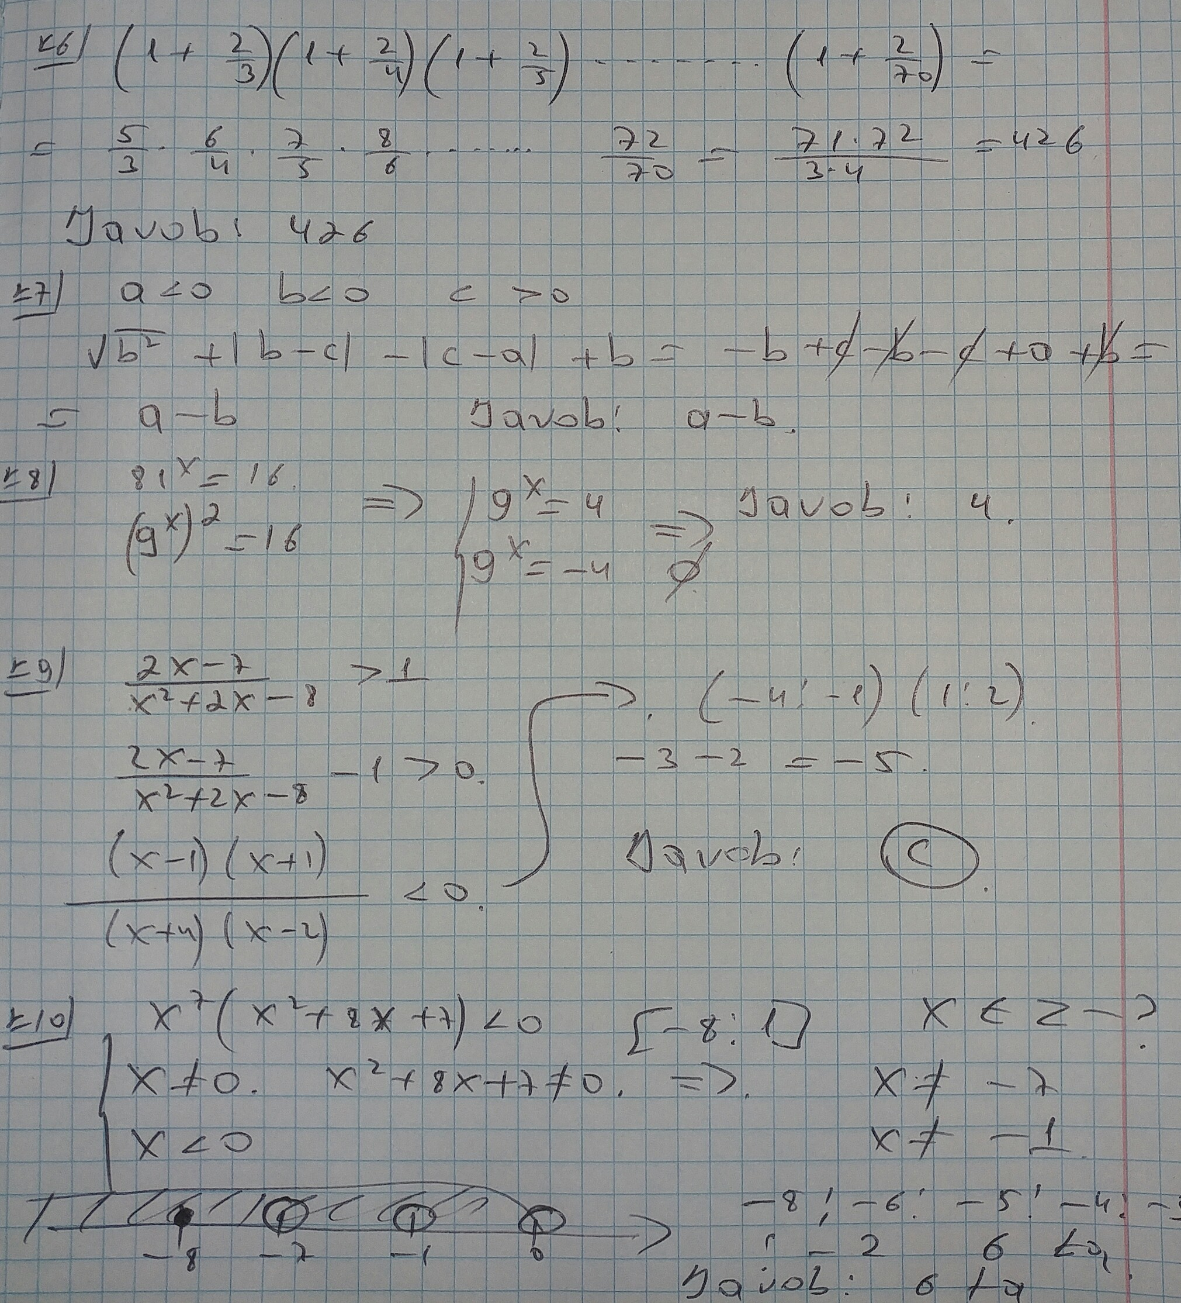

Misollar yechimi muallifi : @PulatovDilmurodHalimbayvich
Kompyuterga utgazgan shaxs : @GaybullayevKomron
Kanalimiz : @axborotnoma
Yordam guruhi : @axborotnomaguruhi

