**Test**

1. Hisoblang: 

Javob: ___________________________

1.  bo`lsa,  ni toping?

Javob: ___________________________

1. Hisoblang: 

Javob: ___________________________

1. Tengsizlikni yeching? 

Javob: ___________________________

1. Sayyohlar xaritada 21 sm ga teng bo`lgan masofani bosib o`tishlari kerak. Xaritaning mashtabi 1:3000000 va sayyohlar mashinasining o`rtacha tezligi 70 km/soat bo`lsa, ular bu masofani necha soatda bosib o`tadilar?

Javob: ___________________________

1. Tenglamani yeching?



Javob: ___________________________

1.  funksiyaning hosilasini toping.

Javob: ___________________________

1. Tenglamani yeching: 

Javob: ___________________________

1. Rasmda  funksiyaning grafigi tasvirlangan bo`lsa  ni toping?

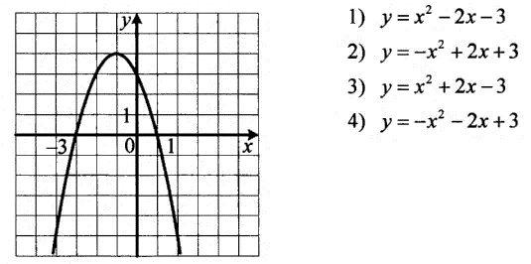

Javob: ___________________________

1.  sonni 5 ga bo`lgandagi qoldiqni toping?

Javob: ___________________________

1. Hisoblang:



Javob: ___________________________

1. Hisoblang:



Javob: ___________________________

1. Hisoblang:



Javob: ___________________________

1. Integralni hisoblang: 

Javob: ___________________________

1.  bo`lsa, 

Javob: ___________________________