TOPOGRAFIK SHARTLI BELGILAR BO’YICHA PISA TEST
1.Turar joyni shartli belgisini toping?
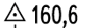
a) b) d) s)
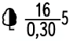
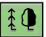
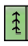
2. Igna bargli o’rmonni toping?
a) b) d) s)
3.Aloqa linyalarini toping?

a) b) d) s)



4.O’tga chidamsiz binolarni belgilang?
a) b) d) s)
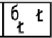
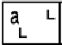
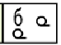
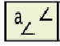
5.Shamol sindirgan daraxtni belgilang?
a) b) d) s)




6.Ko’lni shartli belgisini toping?
a) b) d) s)




7.Minora tipidagi inshootni belgilang?
a) b) d) s)
8.Tuproq yo’lni toping?
a) b) d) s)
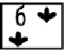
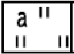
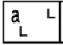
9.O’tloqlarni toping?
a) b) d) s)
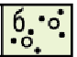


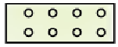
10.Mevazorni toping?
a) b) d) s)
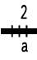
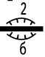
11.O’yilma yo’larni belgilang?
a) b) d) s)



12.Mashhur yodgorlikni toping?

a) b) d) s)
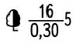
13.Elektr stansiyani belgilang?

a) b) d) s)
14.2000 dan 10.000 gacha aholi yashaydigan shaharni belgilang?
a) SHOSSE b) Qoraqishloq d) YANGIKENT s) FAYZIOBOD
15.Tor izli temiryo’lni belgilang?
a) b) d) s)

