2-sinf ingliz tili fanidan PISA test.
1.We like….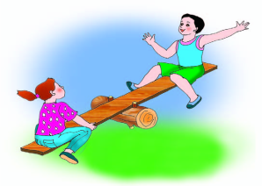a) playing hopscotch b)playing see-saw c)watching TV. d)play chess
2.Do you like..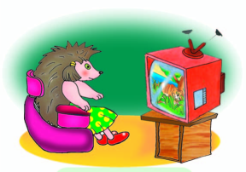a) playing tag b)playing chess)watchingTV d)play hopscotch
3.I don’t like…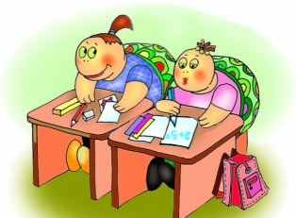a) doing sums b)playing chess c)playing games d)watching TV
4.It is a.. 
a) blue bag b) brown bag c) yellow bag d) black bag
5. What job is it? a)a doctor b)a fireman c)a housewife d) a director
6. 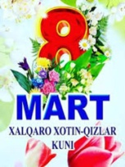What holiday is it? a) Navruz b)Women’s day c) New Year d)Teacher’s day
7.I have got … 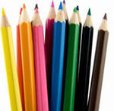 a) a book b) a pencil c) colour pencils d)a pen
8. Anvar has got a….pencil and a….pencil. 
a) red, blue b)yellow, green c) yellow, blue d)red,black
9.Can I have a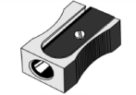please? a) eraser b) sharpener c) notebook d) pencil. 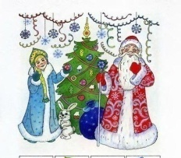
10.What holiday is it? a)Navruz b) New year c) Women’s day d)Teacher’s day

THE KEY

1 | 2 | 3 | 4 | 5 | 6 | 7 | 8 | 9 | 10 | 11 | 12 | 13 | 14 | 15 | 16 | 17 | 18 | 19 | 20
b | c | a | b | a | b | C | c | B | b | a | A | b | c | b | c | C | b | a | c

Tests for the 2nd forms
1-variant.
1.We like….a) playing tag b)playing see-saw c)watching TV.
2.Do you like..a) playing tag? b)playing see-saw? c) watchingTV?
3.I don’t like…a) doing sums b)watching TV c)playing games
4.It is a.. (3о4ыр сумка)
a) black bag b) brown bag c) yellow bag
5.Eleven,twelve,thirteen,…..fifteen a)fourteen b) sixteen c) eighteen
6. Eighteen… a) 8 b) 18 c) 6
7.I have got … a) a book b) a pencil c) colour pencils
8. Anvar has got a….pencil and a….pencil. (сары, к5к)
a) red,blue b)yellow,green c) yellow,blue
9.Can I have aplease? a) eraser b) sharpener c) notebook
10. Malika has got…. eraser a) a b) an c) and
11.This is …. white cat. a) a b) an c) and
12. I have breakfast.....a) in the morning b) in the afternoon c) in the evening.
13. I have lunch… a) in the morning b) in the afternoon c) in the evening.
14.I do my homework.. a) in the morning b) in the afternoon c) in the evening.
15. 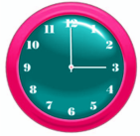 a) It’s two o’clock b) It’s three o’clock.c) It’s one o’clock.
16. 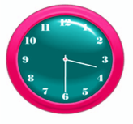a) It’s two thirty b) It’s one thirty c)It’s three thirty.
17. ?а3ытты жазы4. 7:00. a) It’s six o’clock. b) It’s four thirty c) It’s seven o’clock
18. ?а3ытты жазы4. 8:30 a) It’s six thirty b) It’s eight thirty c) It’s one thirty
19. I watch TV … a) at 9 o’clock b) at 3 o’clock c) at 12 o’clock
20. I have lunch….… a) at 9 o’clock b) at 3 o’clock c) at 12 o’clock

THE KEY

1 | 2 | 3 | 4 | 5 | 6 | 7 | 8 | 9 | 10 | 11 | 12 | 13 | 14 | 15 | 16 | 17 | 18 | 19 | 20
b | c | a | b | a | b | C | c | b | b | a | A | b | c | b | c | c | b | a | c

Tests for the 2nd forms
2-variant.
1.It is a…. (коричневая сумка) a) black bag b) brown bag c) yellow bag
2.I have got … a) a book b) a pencil c) colour pencils
3. Anvar has got a….pencil and a….pencil. (желтый,синий)
a) red,blue b)yellow,green c) yellow,blue
4. a) It’s two o’clock b) It’s three o’clock.c) It’s one o’clock.
5.This is …. white cat. a) a b) an c) and
6.Do you like..a) playing tag? b)playing see-saw? c) watchingTV?
7. Напишите время. 8:30 a) It’s six thirty b) It’s eight thirty c) It’s one thirty
8.Can I have aplease? a) eraser b) sharpener c) notebook
9. I have lunch….… a) at 9 o’clock b) at 3 o’clock c) at 12 o’clock
10.I do my homework… a) in the morning b) in the afternoon c) in the evening.
11. Malika has got…. eraser a) a b) an c) and
12. Напишите время. 7:00. a) It’s six o’clock. b) It’s four thirty c) It’s seven o’clock
13. a) It’s two thirty b) It’s one thirty c)It’s three thirty.
14.We like….a) playing tag b)playing see-saw c)watching TV.
15. I watch TV … a) at 9 o’clock b) at 3 o’clock c) at 12 o’clock
16.I don’t like…a) doing sums b)watching TV c)playing games
17.Eleven,twelve,thirteen,…..fifteen, a)fourteen b) sixteen c) eighteen
18.This is …. white cat. a) a b) an c) and
19. I have breakfast.....a) in the morning b) in the afternoon c) in the evening.
20. Eighteen… a) 8 b) 18 c) 6

THE KEY
1 | 2 | 3 | 4 | 5 | 6 | 7 | 8 | 9 | 10 | 11 | 12 | 13 | 14 | 15 | 16 | 17 | 18 | 19 | 20
b | c | c | b | a | c | B | b | c | c | b | C | c | b | a | a | a | a | a | b

Tests for the 2nd forms
2-variant.
1.It is a…. (3о4ыр сумка)
a) black bag b) brown bag c) yellow bag
2.I have got … a) a book b) a pencil c) colour pencils
3. Anvar has got a….pencil and a….pencil. (сары, к5к)
a) red,blue b)yellow,green c) yellow,blue
4. a) It’s two o’clock b) It’s three o’clock.c) It’s one o’clock.
5.This is …. white cat. a) a b) an c) and
6.Do you like..a) playing tag? b)playing see-saw? c) watchingTV?
7. ?а3ытты жазы4. 8:30 a) It’s six thirty b) It’s eight thirty c) It’s one thirty
8.Can I have aplease? a) eraser b) sharpener c) notebook
9. I have lunch….… a) at 9 o’clock b) at 3 o’clock c) at 12 o’clock
10.I do my homework… a) in the morning b) in the afternoon c) in the evening.
11. Malika has got…. eraser a) a b) an c) and
12. 7а3ытты жазы4. 7:00. a) It’s six o’clock. b) It’s four thirty c) It’s seven o’clock
13. a) It’s two thirty b) It’s one thirty c)It’s three thirty.
14.We like….a) playing tag b)playing see-saw c)watching TV.
15. I watch TV … a) at 9 o’clock b) at 3 o’clock c) at 12 o’clock
16.I don’t like…a) doing sums b)watching TV c)playing games
17.Eleven,twelve,thirteen,…..fifteen, a)fourteen b) sixteen c) eighteen
18.This is …. white cat. a) a b) an c) and
19. I have breakfast.....a) in the morning b) in the afternoon c) in the evening.
20. Eighteen… a) 8 b) 18 c) 6

THE KEY
1 | 2 | 3 | 4 | 5 | 6 | 7 | 8 | 9 | 10 | 11 | 12 | 13 | 14 | 15 | 16 | 17 | 18 | 19 | 20
b | c | c | b | a | c | B | b | c | c | b | C | c | b | a | a | a | a | a | b

Tests for the 2nd forms
1.What’s this? 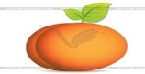
a) apple b) apricot c) peach
2.I’ve got ….pens. 
a) 3 b) 2 c) 1
3. A, B, …D. Find the letter.
a) E b) F c) C
4. Find a small letter.
a) a b) A c) E
5. Find the capital letter. a) a b)A c) b
6. Zumrad has got…..apples 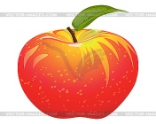
a) 3 b) 2 c) 1
7. A, B, C, D,…F. Find the letter.
a) E b) G c) C
8.The first day of the week.
a) Tuesday b) Monday c) Sunday
9. What’s this ? 
a) jam b) ball c) ice cream
10. I like….. 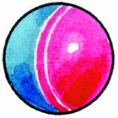 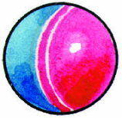
a) planes b) balls c) dolls
11.Translate into English “сумка”
a) ball b)doll c) bag
12.Find small letter “ L”.
a) l b) e c) f
13.I like blue…….. 
a)balls b)balloons c)apples
14. This is a pen. That’s a… 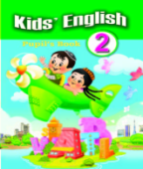
a)copy book b)book c) pen
15. What ‘s this ? 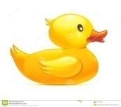
a) a green car b) a red apple c) a yellow duck
16.Translate into Russian “a red apple”
a) розовый мяч b) красное яблоко с) синий шар
17. I collect …..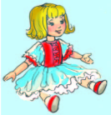
a) cars b) balls c) dolls
18. eight plus five is……
a) 13 b) 14 c) 15
19. What’s this ? 
a) balloon b) jam c) apricot
20. H,J,Q,W,R,U,Y write small letters. (киши 81риплерин жазы4)
a) h,j,q,w,r,u,y b)b,c,g,r,h,s,m c)y,s,a,v,o,h,l

1 | 2 | 3 | 4 | 5 | 6 | 7 | 8 | 9 | 10 | 11 | 12 | 13 | 14 | 15 | 16 | 17 | 18 | 19 | 20
c | b | C | a | b | a | a | b | c | b | c | A | b | b | c | b | c | a | b | a
Tests for the 2nd forms
1.What’s this?
a) apple b) apricot c) peach
2.I’ve got ….pens.
a) 3 b) 2 c) 1
3. A, B, …D. Find the letter.
a) E b) F c) C
4. Find a small letter.
a) a b) A c) E
5. Find the capital letter. a) a b)A c) b
6. Zumrad has got…..apples
a) 3 b) 2 c) 1
7. A, B, C, D,…F. Find the letter.
a) E b) G c) C
8.The first day of the week.
a) Tuesday b) Monday c) Sunday
9. What’s this ?
a) jam b) ball c) ice cream
10. I like…..
a) planes b) balls c) dolls
11.Translate into English “сумка”
a) ball b)doll c) bag
12.Find small letter “ L”.
a) l b) e c) f
13.I like blue……..
a)balls b)balloons c)apples
14. This is a pen. That’s a…
a)copy book b)book c) pen
15. What ‘s this ?
a) a green car b) a red apple c) a yellow duck
16.Translate into karakalpak “a red apple”
a) сары алма b) 3ызыл алма с) к5к шар
17. I collect …..
a) cars b) balls c) dolls
18. eight plus five is……
a) 13 b) 14 c) 15
19. What’s this ?
a) balloon b) jam c) apricot
20. H,J,Q,W,R,U,Y write small letters. (киши 81риплерин жазы4)
a) h,j,q,w,r,u,y b)b,c,g,r,h,s,m c)y,s,a,v,o,h,l

1 | 2 | 3 | 4 | 5 | 6 | 7 | 8 | 9 | 10 | 11 | 12 | 13 | 14 | 15 | 16 | 17 | 18 | 19 | 20
c | b | C | a | b | a | a | b | c | b | c | A | b | b | c | b | c | a | b | a

