Buxoro viloyati
Kogon tumani
- IDUM
Ingliz tili o’qituvchisi
Obidova Shahodatning
ingliz tilidan 4-sinflar orasida
“Siz -xaridor ,biz-savdogar” mavzusida
o’tkazgan tadbir ssenariysi

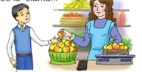

Kogon-2018

Bukhara district
Kagan region
SGSSS-№1
The English teacher
Obidova Shakhodat’s
party scenario and lesson plan for grade 4
on the theme “At the market”

Kagan-2018

Scenario on the theme “At the market”
Date:5.02.2018
Hour:1
Grade: 4 A,B

Syllabus for the party
№ | The procedure of party: | Time
1  2  3  4  5  6 | Introduction  Introducing the new theme  Practising  Consolidation  Giving homework  Marking | 3 min  7 min  20 min  10 min  3 min  2 min
The aims of the party:
Educational: to revise all materials and check pupils’ knowledge for the theme “at the market”
Developing:To develop their attention,memory,speech and communicative skills;
Socio-cultural:To raise awareness of learning about market;to give moral attitude and to teach politeness and to be friendly for nature.
Learning outcomes and competences:Pupils will be able to make dialogues and give questions
-to revise previous themes;
-to talk about fruits and vegetables and to ask how much are they.
Vocabulary and structure-Revision-soums a kilo,hundred,please,Can I help you?
Required equipments:Pupil’s book,The DVD,flashcards,classroom furniture pictures of textbooks for different subjects,basket,handouts,costumes.
Methods:Brainstorming,Hot seat,KLW,quizzes,lotteries,role-play
- Introduction
Beginners open the party:
Ruxsora:Good afternoon,dear teachers,welcome guests,pupils!
Akobir:Good afternoon our sun-teachers,our classmates!
R:Today we are going to make party for the theme “At the market”
A:Uzbek people like buying things,fruits,vegetables from the market .We think the market is where we can entertain us buying our favourite things.
R:We announce our party as opened.Now we have two groups :1-group-Vegetables 2-group-Fruit
The tasks of the party:
1)Introducing themselves-
2) Questionnaries
3)Making puzzles of groups-making diolugues
4)Plays of each group
5) Decorating the table-Going around the market

Each group introduces themselves with poems.
Vegetables:
Xurshid-the head of the group
Our group:Vegetables
Our motto:Eat us for your day,be healthy
-cabbage

Raimova:
Foziljon:tomato
Jasmina-cucumber
Jamolova Ruxshona-pumpkin
Abdurasul-eggplant
Jo’rabek-Beetroot
Ibodullayeva Mehrangiz-Potato
Akobir-carrot
Mirjon-Lotus
Ruxshona-onion
Fruits-the head of the group-Baxtiyor-cherry
Our group: Fruits

Our motto:We are sweet and fresh,dine us, be like us.
Abbos-apple
Shaxrinoz-grape
Gulmurodova-lemon
Nematov Dilshod-orange
Hasanov Yusuf-pomegranate
Musayeva Marjona-rasberry
Baqoyeva Madina-blackberry
Asad-banana
Ruxshona-strawberry
Asliddin-pineapple

Now the second task is questionnaires “Jolly Estafeta”
Each group members stand in a row and runs to take fruits answers and brings into basket.
Questions?
1.I am good at…..
2 Yesterday I….
3.Say a proverb….East or West….
4.How do you get to Samarkand?
5.Our school is…… police station. A) next to b)opposite c)behind d) in front of
6.I want to be a…….My friend…….
7.My grandparents…… sales assistants.
8.Maktabda qolmoq-
9.Say a proverb No pains,……
10.What shops do you know?......
11.They are beans.They ……….(yangiga o’xshaydi.)
12.Dubulg’a-
13.Make past simple tense-I am a teacher-I……. a teacher
14.My friends and I……. ill yesterday.
15.I can play…….(piono)
16.969 say English
17.878 say English
18.After Monday is……
19.Before Tuesday is……
20.Men bir chashka choy xohlayman.
21.Yordamlashib yuboraymi?
22.Mana oling.
23.Bir kosa palov
24.Bir stakan qulupnay sharbati.
After this the points are counted.Marks are announced.
3.Play”Faster the fastest”-Objective: to develop their memory.

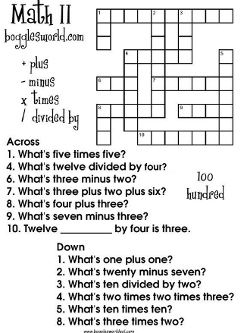

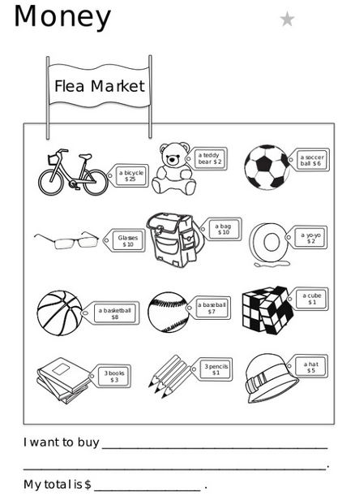
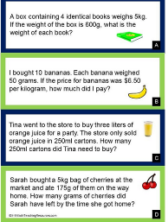

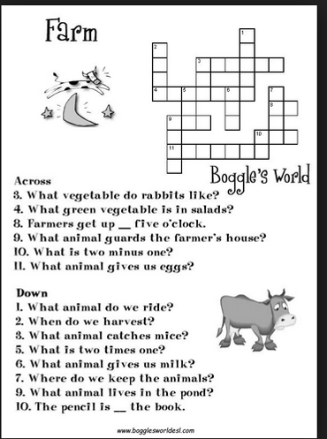

The next task will be plays from each group:
Objective:to raise awareness of fruits and veggies;
Fruits:”Cry banana”
Cook:Now my veggies and fruits are you ready? (chops all fruits and makes salad)
Cherry:So, I am ready,I am unhappy.
Strawberry: So, I am ready,I am unhappy.

Plum: So, I am ready,I am unhappy.

Pineapple: So, I am ready,I am unhappy.

Banana:No,no,no
(falls down from the window)
Banana:in Hawaii-How nice! How are you my dear friends?(leering its eyes and drinks juice)

Vegetables –“Turnip”

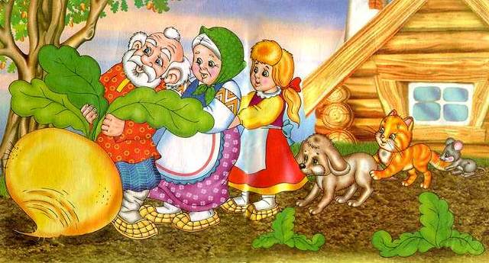
Действующие лица
Репка - Turnip Мышка – Mouse
Дедушка - Grandpa Петушок – Cock
Бабушка - Granny Солнышко – Sun
Внучка – Grand-daughter Дождик – Rain
Пес - Dog Ветерок – Wind
Кошка – Cat
Сцена 1.

Cock: Cock-a – doodle – do! Good morning!
Cock: Good morning, dear Doggy!
Dog: Good morning, my dear Cockerel!
Cock: Good morning, my honey Kitten!
Cat No, no! I want sleeping!

Mouse : Pi-pi-pi!
Cat : Ha! Ha! Ha!
Cat Little Mouse, little Mouse, come to my house!
Mouse: Little Cat, Little Cat, l cannot do that, you want to eat me!
Cat : Yes, l want to eat you!
Mouse : Help! Help
Dog: bow-wow! bow-wow!
Mew-Mew! Пес лает: bow-wow!
Cat Sorry!

Grandpa: Good morning, Doggy!
Granny: Good morning, my little Kitten!
Grand-daughter: Good morning, to you!
All the animals: Good morning!
Grandpa: let ‘s plant a turnip!
Grand-daughter: it will be the biggest turnip!
Granny: ОК!
Can you plant your turnip,
Just the way it should be planted?
Can you plant your turnip,
Just the way do it at home?
Sun: J am Sun! J am Sun!
I’ II warm the grain, and the grain will grow!

Rain: I am Rain! I am Rain!
I’ II water the grain, and the grain will grow!
Wind: I am Wind, I am Wind!
I am blowing warmly and coolly, and the grain will grow!

Grow, turnip, big!
Grow, turnip, sweet!
Grow, turnip, tasty!
Turnip
I’m Turnip! I’m Turnip!
I’m growing on the plot!
I’II soon be bigger – the biggest.
I’m happy!
Сцена 6.
Grandpa: What a turnip!
Wonderful! Beautiful!
What a big turnip!
Grandpa: Granny! Granny! Help me!
Together (вместе): One! Two! Three! Раз! Два! Три!
Granny: Granny after grandpa!
Grandpa: Grandpa after turnip!
Together (вместе): Pull and pull!
We Cannot pull it out!
Granny: Grand – daughter! Grand – daughter!
Help!
Together: One! Two! Three!
Grand – daughter: Grand – daughter after Granny!
Granny: Granny after Grandpa!
Grandpa: Grandpa after turnip!
Together: Pull and pull!
We Cannot pull it out!
Grand – daughter: Doggy! Doggy! Help!
Dog: Bow –wow! Bow – wow!
Together: One! Two! Three!
Dog: Doggy after Grand-daughter!
Grand-daughter: Grand – daughter after Granny!
Granny: Granny after Grandpa!
Grandpa: Grandpa after turnip!
Together: Pull and pull!
We Cannot pull it out!
Dog: Dear Cat! Dear Cat! Help!
Cat: Mew –mew!
Together: One! Two! Three!
Cat: Kitten after doggy!
Dog: Doggy after Grand-daughter!
Grand-daughter: Grand – daughter after Granny!
Granny: Granny after Grandpa!
Grandpa: Grandpa after turnip!
Together: Pull and pull!
We Cannot pull it out!
Cat: Little Mouse! Little Mouse! Help!

Mouse: Pi! Pi! Pi!
(хватается за кошку)
Together: One! Two! Three!
Mouse: Mouse after Kitten!
Cat: Kitten after doggy!
Dog: Doggy after Grand-daughter!
Grad-daughter: Grand – daughter after Granny!
Granny: Granny after Grandpa!
Grandpa: Grandpa after turnip!
Together: Pull and pull!
Cock: (Он все время бегал по сцене и волновался):
Cock-a – doodle-do!
They pulled the turnip out!
Сцена 7.
Turnip: Hi! I am Turnip!
I am round!
I am tasty!
I am sweet!
I am happy!
And what about you?
(Входят Солнышко, Дождик, Ветерок)
Together: What a beautiful turnip!
(начинают петь песню)
I am happy!
He is happy!
She is happy too!
You are happy!
They are happy!
We are happy too!
After these plays their marks will be announced.The winner group will be awarded.
Certificates will be given.Comments will be said.
Akabir:Now it is the end of our party.Now we eill listen comments.
The End!

