**Pisa test ona tili 2-sinf**

**1. Yumaloq, semiz, yog‘i yo‘q,terisi qalin, tuki yo‘q.Topishmoqning javobini toping**



a) b) c) d) 

**2.Qaysi javobda ketma-ket kelgan bir xil undoshli so’z ifodalangan?**

a) b)  c)  d) 

**3. Tilla sandiq ochildi,ichidan zar sochildi.Topishjmoqning javobini toping.**

a) b)  c) d)

**4…………… otasi G‘iyosiddin Kichkina badiiy adabiyotni sevardi. Ularning uyida she’rxonlik kechalari bo‘lib turardi.**

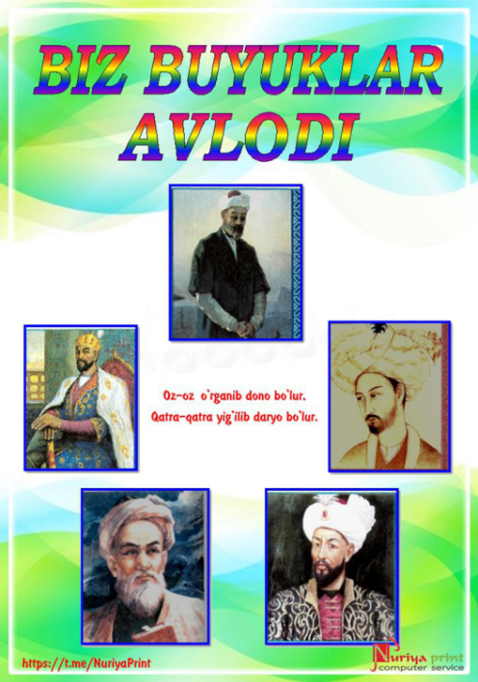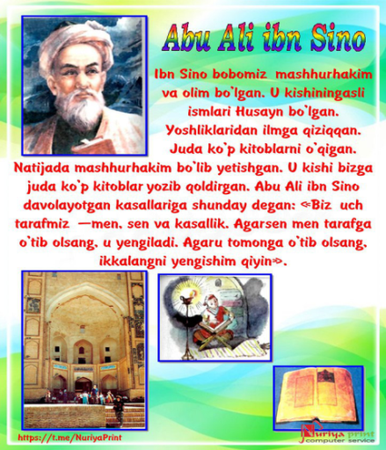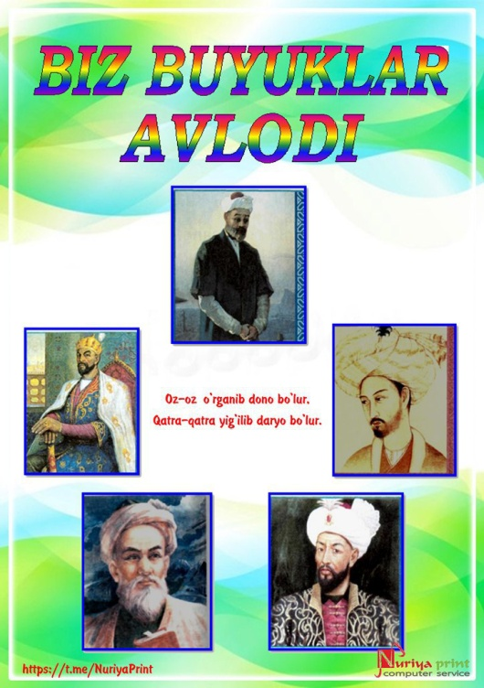a) 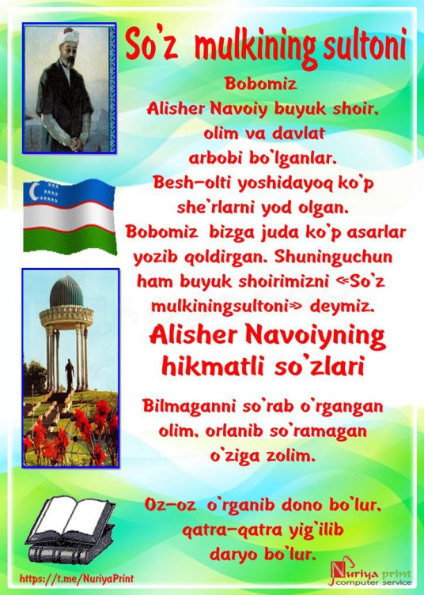 b) c) d)

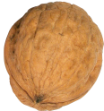**5. Shokirjonlarning bog‘ida bir tup ……….. o‘sadi.Nuqtalar o’rnini to’ldiring.**

a) b) c) d)

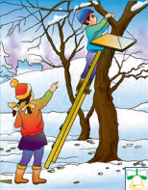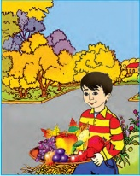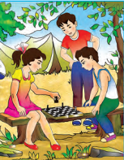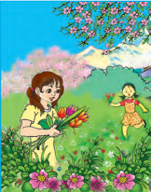**6.Kuzdan keyin qaysi fasl boshlanadi?**

a) b) c) d)

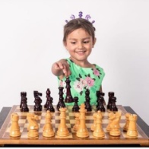**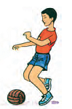7.Sportning futbol turi tasvirlangan rasmni toping**

a) b)  c) d)

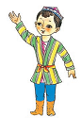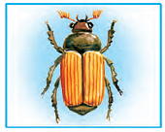**8.Kim so’rog’iga javob bo’lgan so’zni toping**

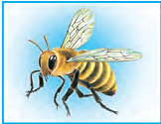a) b) c) d)

**9.Rasmda tasvirlangan narsalarning umumiy nomi nima?**

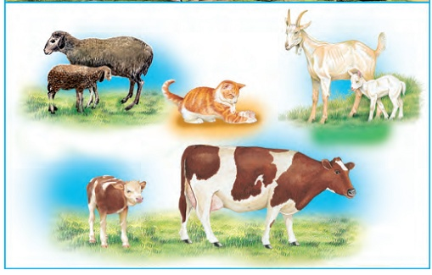

a) hayvonlar b) uy hayvoni c) yovvoyi hayvon d) parraanda

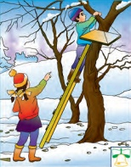**10.Qishdan keyin qaysi fasl boshlanadi?**

a) b) c) d)

**11.Sportning suzish turi tasvirlangan rasmni toping**

a) b)  c) d)

**12.Kim kasallarni davolaydi?**

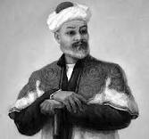j0291984j0240719a) j0301252 b) c) d)

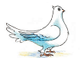**13. Akvariumda mayda … suzyapti.Nuqtalar o’rnini to’ldiring**

a) b) c) d)

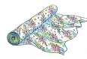**14.Birikma tuzing:………….uzmoq**

a) b) c) d)

**15.Yoqimli qo’shiq eshitildi.Ushbu gapga mos berilgan chizmani toping.**

a) 

b)

c)

d) 

**16.Qish keldi.Ushbu gapga mos chizmani toping**

a)

b)

c)

d) 

**17. chizmaga mos birikmani toping**

a) aqlli bola b) qor oppoq c)Zamira yugurdi d) shirin choy

**18.Harf birikmali so’z berilgan javobni toping**

a) b) c) d) 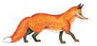

**19.Qaysi so’zda — 5 ta tovush, 5 ta harf bor?**

a) b) c) d)

**20.Qaysi hasharot eng kam umr ko’radi?**

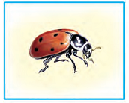a) b) c) d)

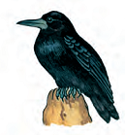**21.Qaysi qush bahor elchisi?**

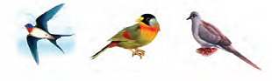a) b) c)  d)

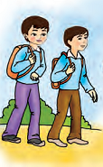**22.Kimlar?so’rog’iga javob bo’lgan so’zni toping**

a) b)  c) d)

**23.Qaysi boshqotirmadan shaxsni bildirgan so’z hosil bo’ladi?**

a) b) c) d)

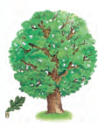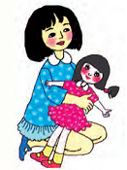**24.Nima qilyaptilar?so’rog’iga javob bo’lgan so’zni toping**

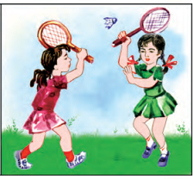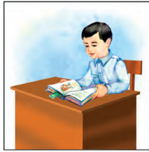a) b) c) d)

**25. Maqol berilgan qatorni toping**

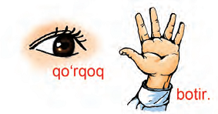a) b)



c) d)

**Test kaliti**

|  |  |  |  |  |  |  |  |  |  |  |  |  |  |  |  |  |  |  |  |  |  |  |  |  |
| --- | --- | --- | --- | --- | --- | --- | --- | --- | --- | --- | --- | --- | --- | --- | --- | --- | --- | --- | --- | --- | --- | --- | --- | --- |
| 1 | 2 | 3 | 4 | 5 | 6 | 7 | 8 | 9 | 10 | 11 | 12 | 13 | 14 | 15 | 16 | 17 | 18 | 19 | 20 | 21 | 22 | 23 | 24 | 25 |
| c | b | a | a | d | d | a | d | b | a | b | b | a | c | b | b | b | c | c | c | a | a | b | c | a |

**Buxoro viloyati Romitan tumani 1-umumta’lim maktabi boshlang’ich sinflar bo’yicha director o’rinbosari Surayyo Murodova**

**Telefon:99-702-73-71**

**Sayt:btr2014.zn.uz**