Maxsus yo’l
bilan
yechiladigan
masalalar.

Maxsus yo’l bilan yechiladigan masalalar
1.(96-6-19) f(1) – barcha koeffitsiyentlar yig’indisi. f(1)= (1-1)${}^{2}$ (1+1)${}^{2}$ +3∙11=2 (E)
2(98-11-68) (x) toq darajalaridagi koeffitsiyentlar yig’indisi $\frac{f(1)−f(−1)}{2}$ bo’ladi. f(1)=(1${}^{3}$-1+1)${}^{3}$
f(-1)=((-1)${}^{2}$ +1+1)-1=0;
(f(1)-f(-1))/2=(2-0)/2=1 (A)
3(98-4-11) $\frac{x(x+1)(x+2)}{3}$ juft son bo’ladi.
4(99-5-12) 5a-10a${}^{−4}$∙1b${}^{−4}$+5b${}^{8}$=5a-10a${}^{4}$∙b${}^{4}$+5b${}^{8}$+10a${}^{4}$∙1b${}^{4}$+10a${}^{−4}$∙1b${}^{−4}$-20+20 = =5(a-2 a${}^{4}$∙1b${}^{4}$+b${}^{8}$) +
+10(a${}^{4}$b${}^{4}$+10a${}^{−4}$b${}^{−4}$)+20=5(a${}^{4}$-b${}^{4}$)² + +10(a${}^{2}$b${}^{2}$-a${}^{−2}$b${}^{−2}$)${}^{2}$+20; a=b=1 bo’lganda
(a${}^{4}$-b${}^{4}$)${}^{2}$ eng kichik qiymat 0 ga, xuddi shunday (a${}^{2}$∙b${}^{2}$-a${}^{−2}$∙b${}^{−2}$)${}^{2}$ eng kichik qiymat 0 ga erishadi. 5∙0+10∙0+20=20 (B)
5(99-8-22) 2x${}^{2}$-2x+2y${}^{2}$+8y+9=x${}^{2}$-2x+ +1+2y${}^{2}$+8y+8=(x-1)${}^{2}$ +2(y+2)${}^{2}$ ifoda eng kichik qiymatga erishishi uchun x=1, y=-2 bo’lishi kerak. (1-1) ${\begin{aligned}2\end{aligned}}^{}$+2(2-2)${\begin{aligned}2\end{aligned}}^{}$=0 (A)
6(00-1-17) 2x${}^{2}$+2xy+2y${}^{2}$+2x-2y+3=x${}^{2}$+2xy + +y${}^{2}$+x${}^{2}$+2x+1+y${}^{2}$-2y+1+1=(x+y)${}^{2}$+(x+1)${}^{2}$ + +(y-1)${\begin{aligned}2\end{aligned}}^{}$+1ifoda eng kichik qiymatga erishishi uchun x=-y, x=-1 y=1 bo’lishi kerak, demak
xy=-1 (E)
7(00-3-19) $\frac{x(x+1)(x+2)}{3}$ (D)
8(97-7-36) to’g’ri tortburchakning bir tomoni
x bo’lsa ikkinchi tomoni peremetri 30 bo’lgani uchun (15-x) S=x(15-x)=15x-x${}^{2}$=7,5${}^{2}$-(7,5-x)${}^{2}$
shartga asosan x butun son, demak, x=7.
S=7(15-7)=56©
9(97-9-56) S=4∙5=20 (B)
10(98-7-27)$\frac{x^{4}+1}{x^{2}+x\sqrt{2}+1}$= $\frac{(x^{2}+1)^{2}−2x^{2}}{x^{2}+x\sqrt{2}+1}$=
=$\frac{(x^{2}+1)^{2}−(\sqrt{2}x)^{2}}{x^{2}+x\sqrt{2}+1}$= =$\frac{(x^{2}+1−\sqrt{2}x)(x^{2}+1+\sqrt{2}x)}{x^{2}+x\sqrt{2}+1}$=
=x${}^{2}$-$x\sqrt{2}+1$(E)
11(98-12-56)$\frac{x^{2}−x+1}{x^{4}+x^{2}+1}=\frac{x^{2}−x+1}{(x^{2}+1)^{2}−x^{2}}=$
=$\frac{x^{2}−x+1}{(x^{2}+1+x)(x^{2}+1−x)}=\frac{1}{x^{2}+x+1}$ (A)
12(98-12-26) maxrajni irratsionallikdan qutqaramiz $\frac{1}{\sqrt{1}+\sqrt{2}}+\frac{1}{\sqrt{2}+\sqrt{3}}+\text{.}\text{.}\text{.}+\frac{1}{\sqrt{\text{1599}}+\sqrt{\text{1600}}}$=
$\begin{aligned}=\frac{\sqrt{1}−\sqrt{2}}{(\sqrt{1}+\sqrt{2)}(\sqrt{1}−\sqrt{2)}}+\frac{\sqrt{2}−\sqrt{3}}{(\sqrt{2}+\sqrt{3)(}\sqrt{2}−\sqrt{3}}+\text{.}\text{.}\text{.} \\ +\frac{\sqrt{\text{1599}}−\sqrt{\text{1600}}}{(\sqrt{\text{1599}}+\sqrt{\text{1600})}(\sqrt{\text{1599}}−\sqrt{\text{1600}})}=\end{aligned}$=-$\sqrt{1}$+$\sqrt{2}−\sqrt{2}+\sqrt{3}−\text{.}\text{.}\text{.}−\sqrt{\text{1599}}+\sqrt{\text{1600}}$=
=-1+40=39 (C)
13(99-9-22) maxrajni irratsionallikdan qutqaramiz $\frac{1}{\sqrt{2}+1}+\frac{1}{\sqrt{3}+\sqrt{2}}+\text{.}\text{.}\text{.}+\frac{1}{\sqrt{9}+\sqrt{8}}$=
$$\begin{aligned}=\frac{\sqrt{2}−1}{(\sqrt{2}+1(\sqrt{2}−1)}+\frac{\sqrt{3}−\sqrt{2}}{(\sqrt{3}+\sqrt{2)(}\sqrt{3}−\sqrt{2})}+\text{.}\text{.}\text{.} \\ +\frac{\sqrt{9}−\sqrt{8}}{(\sqrt{9}+\sqrt{8})(\sqrt{9}−\sqrt{8})}=\end{aligned}$$
=$\sqrt{2}$-$1+\sqrt{3}−\sqrt{2}+\text{.}\text{.}\text{.}+\sqrt{9}−\sqrt{8}$=3-1=2 (A)
14(00-2-23) maxrajni irratsionallikdan qutqaramiz $\frac{1}{\sqrt{1}+\sqrt{3}}+\frac{1}{\sqrt{3}+\sqrt{5}}+\text{.}\text{.}\text{.}+\frac{1}{\sqrt{\text{79}}+\sqrt{\text{81}}}$=
$$\begin{aligned}=\frac{\sqrt{1}−\sqrt{3}}{(\sqrt{1}+\sqrt{3)}(\sqrt{1}−\sqrt{3})}+\frac{\sqrt{3}−\sqrt{5}}{(\sqrt{3}+\sqrt{5)(}\sqrt{3}−\sqrt{5}}+\text{.}\text{.}\text{.} \\ +\frac{\sqrt{\text{79}}−\sqrt{\text{81}}}{(\sqrt{\text{79}}+\sqrt{\text{81})}(\sqrt{\text{79}}−\sqrt{\text{81}})}=\end{aligned}$$
=$\frac{1}{2}$∙(-$\sqrt{1}$+$\sqrt{3}−\sqrt{3}+\sqrt{5}−\text{.}\text{.}\text{.}−\sqrt{\text{79}}+\sqrt{\text{81}}$)=
=$\frac{−1+9}{2}$=4 (C)
15(00-10-54)$\sqrt{2^{3}\sqrt{5\sqrt{2^{2}\sqrt{5^{3}\text{.}\text{.}\text{.}}}}}=x$ bo’lsin, x$0$ 2${}^{3}$$\sqrt{5\sqrt{2^{2}\sqrt{5^{3}\text{.}\text{.}\text{.}}}}$=x${}^{2}$
2${}^{6}⋅5^{3}$$\sqrt{2^{3}\sqrt{5\sqrt{2^{2}\sqrt{5^{3}\text{.}\text{.}\text{.}}}}}=x$${}^{4}$ (2${}^{2}⋅3)^{2}$x=x${}^{4}$ x(x${}^{3}−{\text{20}}^{3})$=0
(x-20)(x${}^{2}+\text{20}x+\text{400})$=0 yagona haqiqiy ildiz x=20 (E)
16(97-1-12) x${}^{3}+2x^{2}−9x−\text{18}=0$;
$x^{2}$(x+2)-9(x+2)=0; (x+2)($x^{2}$-9)=0 ;
(x+2)(x-3)(x+3)=0 $x_{1}=−2,$ $x_{2}=3,$ $x_{3}=−3,$ $x_{1}+x_{2}+x_{3}$=-2+3+(-3)=-2 (B)
17(97-5-15) x+$\frac{1}{y+\frac{1}{z}}$=$\frac{\text{10}}{7}$; $\frac{\text{10}}{7}$==1+$\frac{1}{2+\frac{1}{3}}$
x+ $\frac{1}{y+\frac{1}{z}}$= 1+$\frac{1}{2+\frac{1}{3}}$; x=1; y=2; z=3 (A)
18(97-5-18) $\left[x^{2}\right]$ =9
9 $x^{2}$ <10
$\begin{aligned}\left\{x^{2}−\text{10}<0 | \right.\end{aligned}$;$\begin{aligned}\left\{x^{2}−\text{10}<0 | \right.\end{aligned}$;$\begin{aligned}\left\{−\sqrt{\text{10}}<x<\sqrt{\text{10}} | \right.\end{aligned}$; x$∈(−\sqrt{\text{10}};−3]∪[3;\sqrt{\text{10}})$
19(97-6-12) x${}^{3}−3x^{2}−4x+\text{12}=0$;
$x^{2}$(x-3)-4(x-3)=0; (x-3)($x^{2}$-4)=0;
(x-3)(x-2)(x+2)=0; $x_{1}=3 ; x_{2}=2 ; x_{3}=−2$
$x_{1}x_{2}x_{3}$=3∙2∙(-2)=-12(D)
20(99-3-12) 4x${}^{2}$-3kx+36=0; kvadrat tenglama ikki manfiy ildizga ega bo’lishi uchun
$\begin{aligned}\left\{D>0 | \right.\left\{x_{1}+x_{2}<0 | \right.\end{aligned}$ bo’lishi kerak
x${}^{2}$ -$\frac{3k}{4}x$+9=0;
$\begin{aligned}\left\{D=9n^{2}−4⋅4⋅\text{36}>0 | \right.\left\{x_{1}+x_{2}=−p=\frac{3n}{4}<0 | \right.\end{aligned}$;
$\begin{aligned}\left\{3n<0 | \right.\end{aligned}$; $\begin{aligned}\left\{n<0 | \right.\end{aligned}$
n$∈\left(−∞;−8\right)$ yoki n<-8 (B)
21(99-9-6) x${}^{2}$+(t-2)x+0,25=0; kvadrat tenglama ikki manfiy ildizga ega bo’lishi uchun
$\begin{aligned}\left\{D>0 | \right.\left\{x_{1}+x_{2}<0 | \right.\end{aligned}$ bo’lishi kerak
$\begin{aligned}\left\{D=(t−2)^{2}−4⋅0,\text{25}>0 | \right.\left\{x_{1}+x_{2}=−p=−(t−2)<0 | \right.\end{aligned}$;
$\begin{aligned}\left\{(t−3)(t−1)<0 | \right.\end{aligned}$; t>3 (E)
22(00-8-4) 5n${}^{3}$-5n=5n(n${}^{2}$-1)=5n(n-1)(n+1); n(n-1)(n+1) uchta ketma-ket kelgan son bo’lgani uchun 6 bo’linadi. 5n(n-1)(n+1)=5∙6k=30 (A)
23(97-915)
x+$\frac{1}{y+\frac{1}{z}}$=$\frac{\text{17}}{\text{15}}$; $\frac{\text{17}}{\text{15}}$=1+$\frac{1}{7+\frac{1}{2}}$
x+ $\frac{1}{y+\frac{1}{z}}$=1+$\frac{1}{7+\frac{1}{2}}$; y=7 (D)
24(97-9-18) 36 x${}^{2}$<37
$\begin{aligned}\left\{x^{2}<\text{37} | \right.\end{aligned}$; $\begin{aligned}\left\{(x−\sqrt{\text{37})}(x+\sqrt{\text{37})}<0 | \right.\end{aligned}$ ;
$x∈(−\sqrt{\text{37}};−6)]∪[6:\sqrt{\text{37}})$
25(97-9-85) $\begin{aligned}\left\{x^{3}−3x^{2}y=y^{3}+\text{20} | \right.\end{aligned}$ $\begin{aligned}\left\{x^{3}−3x^{2}y−y^{3}=\text{20} | \right.\end{aligned}$ tenglamalarni qo’shamiz
x${}^{3}−3x^{2}y+3{\text{xy}}^{2}−y^{3}=\text{27}$
(x-y)${}^{3}$ =3${}^{3}$; x-y=3; $\frac{x−y}{3}=1$©
26(97-5-35) $−\frac{π}{2}≤\text{arcsin}a≤\frac{π}{2}$
arcsin(sin10)=arcsin(sin(3$π$-10)=3$π$-10 ©
27(97-5-32) $\begin{aligned}\left\{{\text{sin}}^{\text{1995}}x≤{\text{sin}}^{2}x | \right.\end{aligned}$
sin${}^{\text{1995}}$x+${\text{cos}}^{\text{1995}}x≤1$ bu tengsizlikning tengligi, faqat $\begin{aligned}\left\{\text{sin}x=1 | \right.\end{aligned}$ va $\begin{aligned}\left\{\text{sin}x=0 | \right.\end{aligned}$ da bajariladi. 1)$\begin{aligned}\left\{\text{sin}x=1 | \right.\end{aligned}$ $\begin{aligned}\left\{x=\frac{π}{2}+2πk | \right.\end{aligned}$
$x=\frac{π}{2}+2πk$ har ikki tenglikni qanoatlantiradi .
2)$\begin{aligned}\left\{\text{sin}x=0 | \right.\end{aligned}$ $\begin{aligned}\left\{x=πk | \right.\end{aligned}$ 2$π$k har ikki tenglamani qanoatlantiradi
x=2$π$k; x=$π$/2+2$π$k (A)
28 (97-9-32) x=2$π$n; x=$π$/2+2$π$n (A)
(27-masalaga qaralsin.)
29(97-12-10) (a-$\left|b\right|)^{2}+(a−2)^{2}=0$ bundan
$$\begin{aligned}\left\{a−\left|b\right|=0 | \right.\end{aligned}$$
- 2a-3b=2∙2-3∙2= -2
- 2a-3b=2∙2-3∙(-2)=10 (D)
30(98-3-60) sin ${}^{2}$x-0.5 sin2x-2cos ${}^{2}$x0
1) cos${}^{2}$x=0 bo’lsin, u holda
$\begin{aligned}\left\{\text{cos}x=0 | \right.\end{aligned}$ bundan x=$\frac{π}{2}+πk$
2) cos${}^{2}$x>0 (x$\frac{π}{2}+πk$)
bo’lsa tengsizlikning har ikki tomonini cos${}^{2}$x ga bo’lib quyidagini hosil qilamiz
tg ${}^{2}$x-tgx-2 0 tgx=t
t ${}^{2}$-t-2 0 ; (t+1)(t-2) 0 yoki t-1, t2
tgx2 ; arctg2+$π$kx<$\frac{π}{2}+π$k
tgx-1; -$\frac{π}{2}+π$k<x-$\frac{π}{4}$+$π$k
1-holda x=$\frac{π}{2}+π$k bo’lgani uchun tengsizlikning umumiy yechimi
a) arctg2+$π$kx$\frac{π}{2}+π$k bo’ladi bundan
k=0 bo’lsa, arctg2x$\frac{π}{2}$
k=1 bo’lsa, $π$+arctgx3$\frac{π}{2}$
b)- $\frac{π}{2}$+$π$kx-$\frac{π}{4}$+$π$k bundan
k=1 bolsa, $\frac{π}{2}$x3$\frac{π}{4}$
k=2 bo’lsa 3$\frac{π}{2}$x7$\frac{π}{4}$ Sunday qilib tengsizlikning $\left[0;2π\right]$ oraliqdagi yechimlari
x$∈$$\left[\text{arctg}2;\frac{3π}{4}\right]∪\left[π+\text{arctg}2;\frac{7π}{4}\right]$ (A)
31(98-6-21) agar tenglamalar umumiy ildizga ega bo’lsa, a va x quyidagi sistemani qanoatlantiradi. $\begin{aligned}\left\{x^{2}+\text{ax}−2=0 | \right.\end{aligned}$ tenglamalarni hadma-had ayirsak
x${}^{2}$-x${}^{3}$+ax-ax${}^{2}$=0; -x${}^{2}$(x-1)-ax(x-1)=0;
(x-1)(x(x+a)=0 bundan $x_{1}=1;x_{2}=0;x_{3}=−a$
x=1 bo’lsa a=1; x=0 bo’lsa va x=-a bo’lsa a$∈∅$ demak a=1 (A)
32(98-10-45) x${}^{2}$-2x-8=0 tenglamaning ildizlari qarama-qarshi ishorali. (D)
33(98-11-61) x${}^{2}$+y${}^{2}$+(y-1) ${}^{2}$=2xy;
x${}^{2}$-2xy+y${}^{2}$+(y-1) ${}^{2}$=0; (x-y) ${}^{2}$+(y-1) ${}^{2}$=0
bundan y=1, x=y=1; x+y=1+1=2 (D)
34(98-12-18)$\frac{a^{3}}{a^{2}−1}=\frac{\text{27}}{8}$; 8a${}^{3}$=27a${}^{2}$-27;
8a${}^{3}$-27a${}^{2}$+27=0; 8a${}^{3}$-24a${}^{2}$-3a${}^{2}$+27=0;
8a${}^{2}$(a-3)-3(a-3)(a+3)=0; (a-3)(8a${}^{2}$-3a-9)=0;
a=3; 8a${}^{2}$-3a-9=0 tenglamaning natural ildizi yo’q; a=1 (A)
35(98-12-80) x${}^{2}$+y${}^{2}$+2(2x-3y)+$\left|z−\text{xy}\right|$=0;
x${}^{2}$+y${}^{2}$+4x-6y+9+$\left|z−\text{xy}\right|$=0;
(x+2) ${}^{2}$+(y-3) ${}^{2}$+$\left|z−\text{xy}\right|$=0 bundan x=-2; y=3; z=xy=-2∙3=-6; x+y+z=-2+3-6=-5©
36(98-12-96) x(2+5x)=x${}^{8}−4x^{4}+4$
x${}^{8}−4x^{4}+4$=($x^{4}$-2) ${}^{2}$0 shuning uchun
x(2+5x) 0 bo’lishi kerak. 5x${}^{2}$+2>0 bundan x0 yoki tenglamaning manfiy ildizi yo’q (A)
37(99-10-6) x=1; x${}^{3}$-px${}^{2}$-qx+4=0
1${}^{3}$-p∙1${}^{2}$-q∙1+4=0 bundan p+q=5; -p-q=-5
1-p-q+4=1-5+4=0 (B)
38(99-5-10) $\begin{aligned}\left\{m^{2}+2n^{2}−2\text{nk}=\text{25} | \right.\end{aligned}$
tengliklarni hadma-had ayirib quyidagini hosil qilamiz.
m${}^{2}$+n${}^{2}$-2mn-2nk+k${}^{2}$=0;
m${}^{2}$-2mn+n${}^{2}$+n${}^{2}$-2nk+k${}^{2}$=0;
(m-n) ${}^{2}$+(n-k) ${}^{2}$=0; bundan m=n, n=k yoki m=n=k m,n,k$∈$N m${}^{2}$+2m${}^{2}$-2m${}^{2}$=25
m${}^{2}$=25; m=5; n=5; k=5 ; $\frac{(5+5)^{2}}{2⋅5}$=10 (D)
39(99-6-42) $\begin{aligned}\left\{x^{3}+y^{3}=\text{10} | \right.\end{aligned}$
x${}^{3}$+3x${}^{2}$y+3xy${}^{2}$+y${}^{3}$=27
(x+y)${}^{3}$=27 ; x+y=3 (A)
40(99-8-13) (x+1)( y-2)=2; 2=1∙2=2∙1=
=-1∙(-2)=-2∙(-1)
1) (x+1)(y-2)=1∙2 $\begin{aligned}\left\{x+1=1 | \right.\end{aligned}$ x=0; y=4
2) (x+1)(y-2)=2∙1 $\begin{aligned}\left\{x+1=2 | \right.\end{aligned}$ x=-1; y=3
3) (x+1)(y-2)=-2∙(-1) $\begin{aligned}\left\{x+1=−2 | \right.\end{aligned}$ x=-3; y=-2
4) (x+1)(y-2)=-1∙(-2) $\begin{aligned}\left\{x+1=−1 | \right.\end{aligned}$ x=-2; y=0
4 ta (A)
41(99-2-15) x${}^{4}$=3x${}^{2}$-2x ; x${}^{4}$-3x${}^{2}$+2x=0;
x(x${}^{3}$-3x+2)= 0; x${}_{1}$=0; x${}^{3}$-x-2x+2=0;
x(x-1)(x+1)-2(x-1)=0; (x-1)(x${}^{2}$+x-2)=0;
x${}_{2}$=1; x${}^{2}$+x-2=0; x${}_{3}$=-2; x${}_{4}$=1
eng katta ildiz 1, eng kichik ildiz -2, ularning yig’indisi -1 (D)
42(99-4-22) (x+2) ${}^{2}$=-$\frac{3}{x}$; x0
x(x+2)${}^{2}$=-3 tenglama butun ildizlarga ega bo’lsa u 3 ning butun bo’luvchilari bo’ladi ya’ni
$±1,±2,±3$. Bular orasidan -3 tenglamani qanoatlantiradi. 1 ta ©
43(99-5-43) A${}^{2}$+B${}^{2}$+C${}^{2}$=AB+BC+AC 2A${}^{2}$+2B${}^{2}$+2C${}^{2}$=2AB+2BC+2AC
A ${}^{2}$-2AB+B ${}^{2}$+B ${}^{2}$-2BC+B ${}^{2}$+A ${}^{2}$-AC+C ${}^{2}$ =0
(A-B) ${}^{2}$+(B-C) ${}^{2}$+(A-C) ${}^{2}$=0; A=B=C
(A+B)/C+(B+C)/A=2A/A+2A/A=2+2=4 (E)
44(99-5-33) 8(x${}^{4}$+y${}^{4}$)-4(x${}^{2}$+y${}^{2}$)+1=0 tenglikning ikki tomonini 2 ga ko’paytirib
16$x$${}^{4}$+16$y$${}^{4}$-8$x$${}^{2}$-8$y$${}^{2}$+2=0 ;
6$x$${}^{4}$-8$x$${}^{2}$+1+16$y$${}^{4}$-8$y$${}^{2}$+1=0;
(4x${}^{2}$-1)${}^{2}$+(4y${}^{2}$-1) ${}^{2}$=0 yoki 4x${}^{2}$-1=0,
$\left|x\right|=\frac{1}{2}$; 4y${}^{2}$-1=0. $\left|y\right|=\left|\frac{1}{2}\right|$
$\left|x\right|+\left|y\right|=\frac{1}{2}+\frac{1}{2}=1$ (A)
45 (99-8-28) x${}^{2}$+ ${\left(\frac{x}{x−1}\right)}^{2}$=8;
x${}^{2}$+2x∙$\frac{x}{x−1}$+${\left(\frac{x}{x−1}\right)}^{2}$-2x∙$\frac{x}{x−1}$-8=0;
${\left(x+\frac{x}{x−1}\right)}^{2}$-$\frac{x^{2}}{x−1}$-8=0 ; $\frac{x^{2}}{x−1}$=t bo’lsin
t${}^{2}$-2t-8=0 ; $t_{1}=4;$$t_{2}=−2$; $\frac{x^{2}}{x−1}$=4 va$\frac{x^{2}}{x−1}$=-2
4>-2 javob:4 (A)
46(99-9-8) $\begin{aligned}\left\{n−m=(a−2)^{2} | \right.\left\{p−n=(b−3)^{2} | \right.\end{aligned}$ tengliklarni hadma-had qo’shib (a-2) ${}^{2}$+(b-3) ${}^{2}$+(c-4) ${}^{2}$=0 ni hosil qilamiz. Bundan a=2, b=3, c=4
a+b+c=2+3+4=9
47(99-10-8) $\begin{aligned}\left\{m−n=(2x+y)^{2} | \right.\end{aligned}$ tengliklarni qo’shib (2x+y) ${}^{2}$+(4x-y+12) ${}^{2}$=0 ni hosil qilamiz yoki $\begin{aligned}\left\{2x+y=0 | \right.\end{aligned}$ bundan x=-2; y=4 xy=-2∙4=8
48(99-10-18) x${}^{2}$-4x+y${}^{2}$-6y+13=0
(x-2)${}^{2}$+(y-3)${}^{2}$=0 bundan x=2; y=3
1 ta ©
49(00-2-7) 4a${}^{2}$+9b${}^{2}$+16c${}^{2}$-4a-6b-8c+3=0
4a${}^{2}$-4a+1+9b${}^{2}$-6b+1+16c${}^{2}$-8c+1=0
(2a-1) ${}^{2}$+(3b-1) ${}^{2}$+(4c-1) ${}^{2}$=0
a=$\frac{1}{2}$; b=$\frac{1}{3}$; c$=\frac{1}{4}$; abc=$\frac{1}{\frac{1}{2}⋅\frac{1}{3}⋅\frac{1}{4}}$=24 (D)
50(00-4-36)$\begin{aligned}\left\{\frac{\text{ab}}{a+b}=1 | \right.\left\{\frac{\text{ac}}{a+c}=2 | \right.\end{aligned}$ ; $\begin{aligned}\left\{\frac{a+b}{\text{ab}}=1 | \right.\left\{\frac{a+c}{\text{ac}}=\frac{1}{2} | \right.\end{aligned}$;
$\begin{aligned}\left\{\frac{1}{a}+\frac{1}{b}=1 | \right.\left\{\frac{1}{c}+\frac{1}{a}=\frac{1}{2} | \right.\end{aligned}$; tengliklarni qo’shib
2($\frac{1}{a}+\frac{1}{b}+\frac{1}{c})=\frac{\text{11}}{\text{12}}$ ni hosil qilamiz,
$\frac{1}{a}+\frac{1}{b}+\frac{1}{c}=\frac{\text{11}}{\text{24}}$; $\frac{1}{a}+\frac{1}{b}=1$ bo’lgani uchun
1+$\frac{1}{c}=\frac{\text{11}}{\text{12}}$; c=-12, xuddi shunday b=$\frac{\text{12}}{5};a=\frac{\text{12}}{7}$; $\frac{\text{ab}}{c}=\frac{\frac{\text{12}}{5}⋅\frac{\text{12}}{7}}{−\text{12}}$=-$\frac{\text{12}}{\text{35}}$ (D)
51(00-6-14) $\begin{aligned}\left\{y=x^{2}+7x+\text{11} | \right.\end{aligned}$ tenglamalarni qo’shib 2y=x${}^{2}$+y${}^{2}$+10x+26 ;
x${}^{2}$+10x+25+y${}^{2}$-2y+1=0; (x+5)${}^{2}$+(y-1)${}^{2}$=0
bundan x=-5; y=1; 1ta (D)
52(00-7-10) $\begin{aligned}\left\{a^{2}+3\text{ab}+b^{2}=\text{44} | \right.\end{aligned}$ikkinchi teng-lamani 2 ga ko’paytirib 2a ${}^{2}$+2ab+2b ${}^{2}$=56 ni hosil qilamiz va undan birinchi tenflamani ayiramiz. a${}^{2}$-ab+b${}^{2}$=12©
53(97-11-12) x${}^{3}$+5x${}^{2}$-4x-20=0
x${}^{2}$(x+5)-4x(x+5) ; (x+5)(x${}^{2}$-4)=0;
(x+5)(x-2)(x+2)=0 bundan
$x_{1}=−5; x_{2}=2; x_{3}$=-2; $x_{1}x_{2}x_{3}=−\text{20}$ (D)
54(00-8-12) x${}^{3}$+3x${}^{2}$-4x-12=0;
x${}^{2}$(x+3)-4(x+3)=0; (x+3)(x${}^{2}$-4)=0;
(x+3)(x-2)(x+2)=0 bundan x${}_{1}$=-3; x${}_{2}$=2; x${}_{3}$=-2; x${}_{1}$+x${}_{2}$+x${}_{3}$=-3+2+(-2)=-3 (A)
55(00-9-11) a(a-b)+b(b-c)+c(c-a)=a${}^{2}$-ab+b${}^{2}$-bc+c${}^{2}$-+ac=0 hosil bo’lgan tenglikning har 2 tomonini 2 ga ko’paytiramiz 2a${}^{2}$-2ab+2b${}^{2}$+2b c+ 2 c${}^{2}$-2ac=a ${}^{2}$-
-2ab+b${}^{2}$+b${}^{2}$-2bc+c${}^{2}$+a${}^{2}$-2ab+b${}^{2}$=(a-b)${}^{2}$+(b-c)${}^{2}$+ +(a-c) ${}^{2}$=0, bundan a=b; b=c; a=c yoki a=b=c
$\frac{a^{3}+b^{3}+c^{3}}{a(b+c)+b(a+c)+c(a+b)}=\frac{3a^{3}}{\text{12}a^{2}}=\frac{1}{4}$ (A)
56(00-9-39) 9(x${}^{4}$+y${}^{4}$)-6(x${}^{2}$+y${}^{2}$)+2=0;
9x${}^{4}$-6x${}^{2}$+1+9x${}^{4}$-6y${}^{2}$+1=(3x${}^{2}$-1)${}^{2}$++(3y${}^{2}$-1)=0 bundan x${}^{2}$=$\frac{1}{3}$; y${}^{2}$=$\frac{1}{3}$; x${}^{2}$+y${}^{2}$=$\frac{2}{3}$ ©
57(00-10-49) x(x+a)(x+b)(x+a+b)+4m${}^{2}$=
=x(x+a+b)(x+a)(x+b)+4m${}^{2}$=(x${}^{2}$+ax+bx)∙((x${}^{2}$ +ax+ bx)+ab)=(x${}^{2}$+ax+bx)${}^{2}$+ ab∙∙(x${}^{2}$+ax+bx)+4m${}^{2}$= =(x${}^{2}$+ax+bx) ${}^{2}$+2∙$\frac{\text{ab}}{2}$∙(x${}^{2}$+ax+bx)+4m${}^{2}$ bu ifoda to’la kvadrat bo’lishi uchun 4m${}^{2}$= ($\frac{\text{ab}}{2}$)${}^{2}$ bo’lishi kerak yoki 2m=$±$$\frac{\text{ab}}{2}$; m=$±\frac{\text{ab}}{4}$ (B)
58(00-10-68) ax${}^{2}$+2(a+3)x+a+2=0; a$0$
x${}^{2}$+$\frac{2(a+3)}{a}+\frac{a+2}{a}$=0
tenglama ildizlari nomanfiy bo’lishi uchun
$\begin{aligned}\left\{x_{1}x_{2}≥0 | \right.\left\{x_{1}+x_{2}≥0 | \right.\end{aligned}$$⇒$$\begin{aligned}\left\{x_{1}x_{2}=\frac{a+2}{a}≥0 | \right.\left\{x_{1}+x_{2}=−\frac{2(a+3)}{a}≥0 | \right.\end{aligned}$$⇒$
$⇒$$\begin{aligned}\left\{a(a+2)≥0 | \right.\left\{a(a+3)≤0 | \right.\end{aligned}$ bundan a$∈\left[−\frac{9}{4};−2\right]$ (A)
59(00-10-68) a${}_{1}$=0; a${}_{2}$=1 a${}_{3}$=1; a${}^{4}$=0; $a_{5}=−1$; $a_{6}=−1$; a${}_{7}$=0 demak har oltim martaga takrorlanadi.
885=147∙6+3; $a_{\text{885}}=a_{3}=1$(A)
60(00-10-80) ($\left|x_{1}\right|−1$)${}^{2}$+($\left|x_{2}\right|−2$)${}^{2}$+…($(\left|x_{n}\right|−n)$${}^{2}$+…=0
$\left|x_{1}\right|=1,$ $x_{1}=±1$; $\left|x_{2}\right|=2$, x${}_{2}$=$±2$… $\left|x_{n}\right|$=$±n$…
1,2,3..n.. va -1,-2,-3…-n.. 2 ta
61(98-5-13) y=$\sqrt{{\text{kx}}^{2}+2x−1}$
kx${}^{2}$+2x-1=(x+1)(x-$\frac{1}{3}$)<0; 3x${}^{2}$+2x-1<0; k=3 ©
62(00-3-230) p=a${}^{2}$+b${}^{2}$+c${}^{2}$, q=ab+bc+ac
tengliklarni 2 ga ko’paytirib 2p=2a${}^{2}$+2b${}^{2}$+2c${}^{2}$ va 2q=2ab+2bc+2ac ni hosil qilamiz.
2p-2q=2a${}^{2}$+2b${}^{2}$+2c${}^{2}$-2ab-2bc-2ac=
=(a-b) ${}^{2}$+(b-c) ${}^{2}$+(a-c) ${}^{2}$$0$; 2p-2q$0$,
p$q$ (E)
63(00-10-53) 16xyzt100 ravshanki
$\frac{x}{y}+\frac{z}{t}$ eng kichik bo’lishi uchun x=16, t=100 bo’lishi kerak. $\frac{\text{16}}{y}+\frac{z}{\text{100}}≥2\sqrt{\frac{\text{16}}{y}⋅\frac{z}{\text{100}}}$=2∙$\frac{4}{\text{10}}\sqrt{\frac{z}{y}}$; yz, demak y=z; 2∙$\frac{4}{\text{10}}\sqrt{\frac{y}{y}}=2⋅\frac{4}{\text{10}}=0,8$
64(96-10-15) y=2sinx+cosx=$\sqrt{5}\left(\frac{2}{\sqrt{5}}\text{sin}x+\frac{1}{\sqrt{5}}\text{cos}x\right)$
${\left(\frac{2}{\sqrt{5}}\right)}^{2}+{\left(\frac{1}{\sqrt{5}}\right)}^{2}=1$ shuning uchun
$\frac{2}{\sqrt{5}}=\text{sin}x;$ $\frac{1}{\sqrt{5}}=\text{cos}x$ bo’lsin, u holda
y=$\sqrt{5}$(cos$ϕ$sinx+sin$ϕ$cosx)= $\sqrt{5}$sin(x+$ϕ$) bundan, y${}_{\text{max}}$=$\sqrt{5}$((B)
65(97-12-43) $f^{'}(x)$0 tengsizlik doim o’rinli bo’lsa, funksiya o’zining aniqlanish sohasida kamayuvchi bo’ladi. $f^{'}(x)$=k-cosx0 yoki cosxk bu tengsizlik doim o’rinli bo’lishi uchun k-1 bo’lishi kerak (A)
66(98-4-18) tg${}^{\text{100}}$x+ctg${}^{\text{100}}$x2$\sqrt{{\text{tg}}^{\text{100}}x⋅{\text{ctg}}^{\text{100}}x}$=
=2 ©
67(98-4-18) x${}^{2}$+z${}^{2}$+x+z+$\frac{1}{2}$=0
(x+$\frac{1}{2}$)${}^{2}$+(z+$\frac{1}{2}$)${}^{2}$=0 bundan x=-$\frac{1}{2}$; z=-$\frac{1}{2}$
xz=-$\frac{1}{2}$∙(-$\frac{1}{2}$)=0,25 (A)
68(98-6-15) y=sin${}^{2}$x+cosx=1-cos${}^{2}$x+cosx=
=-(cosx-$\frac{1}{2}$)${}^{2}$+$\frac{5}{4}$ bu funksiya o’zining eng katta qiymatiga cosx=$\frac{1}{2}$ bo’lganda erishadi.
Shatga asosan 0x$π$, demak x=$\frac{π}{3}$ (B
69(98-11-64) arccosa=$π$, arcsina=-$\frac{π}{2}$ bo’lgan-da ifoda eng katta qiymatga erishadi.
arccosa-4arcsina=$π$-4∙(-$\frac{π}{2}$)=3$π$ ©
70(98-12-77) $\frac{\text{10}}{x^{2}+8x+\text{41}}+\text{cos}5y=\frac{\text{10}}{(x+4)^{2}+\text{25}}+\text{cos}5y$
ifoda eng katta qiymatga erishishi uchun x=-4 va cos5y=1 bo’lishi kerak $\frac{\text{10}}{\text{25}}+1=1,4$©
71(98-12-52) $\begin{aligned}\left\{\text{sin}x≥0 | \right.\end{aligned}$; $\begin{aligned}\left\{2πk≤x≤π+2πk | \right.\end{aligned}$
k=0 bo’lsa $\begin{aligned}\left\{0≤x≤π | \right.\end{aligned}$ bu tengsizliklar sistemasini qanoatlatiruvchi butun sonlar 0,1,2,3
k=-1 bo’lsa $\begin{aligned}\left\{−2π≤x≤π | \right.\end{aligned}$ bu tengsizliklar sistemasini qanoatlatiruvchi butun son -4
5 ta ©
72(99-5-30) ifoda eng katta qiymatga erishishi uchun cos2$α=1\text{,cos}3β=−1\text{,cos}4γ=−1$ bo’lishi kerak. $\frac{8\text{cos}2α−5\text{cos}3β}{7+2\text{cos}4γ}$=
=$\frac{8⋅1−5(−1)}{7+2(−1)}=\frac{\text{13}}{5}=2,6$ (E)
73(99-5-26) 4arcsinx+arccosx= $π$
3arcsinx+arcsinx+arccosx= $π$
3arcsinx+ $\frac{π}{2}$= $π$; arcsinx=$\frac{π}{6}$; x=$\frac{1}{2}$
3x${}^{2}$=3∙$(\frac{1}{2})$${}^{2}$=0,75 (D)
74(99-5-27) 5sin2x+8cosx=13
5(sin2x-1)+8(cosx-1)=0 bundan
sin2x=1 va cosx=1 bo’lishi kerak.
sin2x=1 dan 2x= $\frac{π}{2}$+2 $π$k; x=$\frac{π}{4}$+ $π$k
cosx=1 dan x=2$π$k har ikki tenglikni qanoat-lantiruvchi x ning qiymatlari mavjud emas. x$∈∅$ (A)
75(99-5-59) sin${}^{4}$x+cos${}^{4}$x2sin${}^{2}$x cos${}^{2}$x=
=$\frac{{\text{sin}}^{2}2x}{2}$; sin${}^{4}$x+cos${}^{4}$x=asinx cosx tenglama yechimga ega bo’lishi uchun
asinx cosx$\frac{{\text{sin}}^{2}2x}{2}$ tengsizlik doim o’rinli bo’lishi kerak. a∙sinx cosx=$\frac{a\text{sin}2x}{2}$ $\frac{{\text{sin}}^{2}2x}{2}$
asin2x - sin ${}^{2}$2x 0; sin2x(a-sin2x) 0
1)agar sin2x 0 bo’lsa a-sin2x 0 bo’lishi kerak yoki a 1
2)agar sin2x 0 bo’lsa a-sin2x 0 bolishi
kerak, yoki a -1 shuday qilib a$∈(−∞;−1]∪[1;∞)$ (A)
76(99-5-31) sin$\left(\frac{π\sqrt{5}}{\text{20}}x\right)$=21-4$\sqrt{5}$x+x ${}^{2}$
-1sin$\left(\frac{π\sqrt{5}}{\text{20}}x\right)$1 bo’lgani uchun tenglikning o’n tomoni ham shu oraliqda bo’lishi kerak.
-121-4$\sqrt{5}$x+x${}^{2}$1; 21-4$\sqrt{5}$x+x ${}^{2}$=
=1+ ($\sqrt{\text{20}}$-x)${}^{2}$ bu ifodaning eng kichik qiymati 1 shuning uchun x= $\sqrt{\text{20}}$;
sin$\left(\frac{π\sqrt{5}}{\text{20}}\sqrt{\text{20}}\right)=\text{sin}\frac{π}{2}=1$; x=$\sqrt{\text{20}}$ bo’lganda tenglikning har ikki tomoni 1 ga teng va
-3$π$$\sqrt{\text{20}}$3$π$; 1 ta (B)
77(99-5-57) $\sqrt{2−\text{tgx}−\text{ctgx}}+\sqrt[4]{\text{sin}y−1}+\sqrt[6]{\text{cos}2z−1}=0$
bularning barchasi juft ildiz bo’lgani uchun
$\begin{aligned}\left\{2−\text{tgx}−\text{ctgx}=0 | \right.\left\{\text{sin}y−1=0 | \right.\end{aligned}$ bo’lishi kerak.
Shartga asosan -$\frac{π}{2}$x$\frac{π}{2}$; -$\frac{π}{2}$y$\frac{π}{2}$;
-$\frac{π}{2}$z$\frac{π}{2}$ ekanligidan x=$\frac{π}{4}$; y=$\frac{π}{2}$; z=0
$$\frac{3y}{2x+\text{57}}=\frac{3⋅\frac{π}{2}}{2⋅\frac{π}{4}+5⋅0}=\frac{3⋅\frac{π}{2}}{\frac{π}{2}}=3$$
78(99-5-57) y=$2^{\text{cos}x}\sqrt{x^{3}{\text{sin}}^{2}\frac{πx}{3}e^{−\text{sin}x}}$
x${}^{3}$sin${}^{2}$$\frac{πx}{3}$e${}^{−x}$0; e${}^{−x}$ doim musbat son.
x${}^{3}$sin${}^{2}$$\frac{πx}{3}$0; bundan sin${}^{2}$$\frac{πx}{3}$=0 yoki x${}^{3}$0
bolishi kerak. 1) $\frac{πx}{3}$=$π$k; x=3k sartga saosan
-10x10; -103k10; -3$\frac{1}{3}≤k≤3\frac{1}{3}$ bundan k=-3,-2,-1,0,1,2,3 yoki x=-9,-6,-3,0,3,6,9
x${}^{3}$0; x0 bundan x=0,1,2,3,4,5,6,7,8,9,10
0,3,6,9 bir marta hisoblaymiz. 14 ta (E)
79(99-4-52) $\text{cos}\frac{π}{7}⋅\text{cos}\frac{3π}{7}⋅\text{cos}\frac{5π}{7}=$

=$\text{cos}\frac{π}{7}⋅\text{cos}(π−\frac{π}{7})⋅\text{cos}(π−\frac{π}{7})$=

=$\frac{2\text{sin}\frac{2π}{7}⋅\text{cos}\frac{2π}{7}⋅\text{cos}\frac{4π}{7}}{4\text{sin}\frac{π}{7}}$=
=$\frac{2\text{sin}\frac{4π}{7}⋅\text{cos}\frac{4π}{7}}{8\text{sin}\frac{π}{7}}$=$\frac{\text{sin}\frac{8π}{7}}{8\text{sin}\frac{π}{7}}$=
=$\frac{\text{sin}(π+\frac{π}{7})}{8\text{sin}\frac{π}{7}}$=-$\frac{\text{sin}\frac{π}{7}}{\text{sin}\frac{π}{7}}$=-$\frac{1}{8}$(E)
80(99-5-54) 1+tg${}^{4}$x=cos${}^{2}$x
sin${}^{2}$2x+cos${}^{2}$2x+tg${}^{4}$x=cos${}^{2}$2x
sin${}^{2}$2x+tg${}^{4}$x=0;
$\begin{aligned}\left\{\text{sin}2x=0 | \right.\left\{\text{tgx}=0 | \right.\end{aligned}$$⇒$$\begin{aligned}\left\{2\text{sin}x⋅\text{cos}x=0 | \right.\left\{\text{sin}x=0 | \right.\end{aligned}$; sinx=0;
x=$π$k; -2$π$k$π$k2$π$k; -2k2 bundan
k=-2,-1,0,1,2 5 ta
81(99-4-56) cos4∙cosx $\sqrt{\frac{\text{cos}x}{1+{\text{ctg}}^{2}x}}$
$π$<4<$\frac{3π}{2}$ shuning uchun cos4 manfiy son, sinx0, $\frac{\text{cos}x}{1+{\text{ctg}}^{2}x}$0; 1+ctg${}^{2}$x doim musbat son, shuning uchun cosx0 bo’lishi kerak. Ikkinchi tomondan cos4<0 bo’lgani uchun cosx0, demak cosx=0; x=$\frac{π}{2}+π$k, ©
82(99-5-21) sin${}^{6}$x+cos${}^{6}$x=(sin${}^{2}$x+ cos${}^{2}$x)∙
∙(sin${}^{4}$x-sin${}^{2}$x∙cos${}^{2}$x+cos${}^{4}$x)=sin${}^{4}$x-
-sin${}^{2}$x∙cos${}^{2}$x+cos${}^{4}$x=(sin${}^{2}$x+cos${}^{2}$x)${}^{2}$-
-3sin${}^{2}$x∙cos${}^{2}$x=1-$\frac{3{\text{sin}}^{2}2x}{4}$ bu ifoda eng kichik qiymatga erishishi uchun sin${}^{2}$2x=1 bo’lishi kerak.
1-$\frac{3⋅1}{4}$=0,25©
83(00-9-35) $\frac{5}{{\text{tg}}^{2}α+{\text{ctg}}^{2}α}+\frac{5\text{sin}2β−\text{cos}γ}{5+\text{cos}3t}$
ifoda eng katta qiymatga erishishi uchun maxrajlar eng kichik, suratlar esa eng katta bo’- lishi kerak. Buning uchun tg${}^{2}$$α+{\text{ctg}}^{2}α$=2
(chunki tg${}^{2}$$α$+ctg${}^{2}$$α$2$\sqrt{{\text{tg}}^{2}α{\text{ctg}}^{2}α}$=2),
sin$2β=1$; cos$γ=−1$; cos3t=-1 bo’lishi kerak.
$\frac{5}{2}+\frac{5⋅1−1(−1)}{5+(−1)}=4$(E)
84(99-10-28) (1+cos${}^{2}$2$α$)(1+tg${}^{2}$$α$)+4sin${}^{2}$$α$=
=(1+cos${}^{2}$2$α$)(1+$\frac{{\text{sin}}^{2}α}{{\text{cos}}^{1}α}$)+4sin${}^{2}$$α$=
=(1+cos${}^{2}$2$α$)$\left(\frac{{\text{sin}}^{2}α+{\text{cos}}^{2}α}{{\text{cos}}^{2}α}\right)$+4sin${}^{2}$$α$=
=$\frac{1+{\text{cos}}^{2}2α}{{\text{cos}}^{2}α}$+4sin${}^{2}$$α$==$\frac{1+{\text{cos}}^{2}2α+4{\text{sin}}^{2}α⋅{\text{cos}}^{2}α}{{\text{cos}}^{2}α}$=
=$\frac{1+{\text{cos}}^{2}2α+{\text{sin}}^{2}2α}{{\text{cos}}^{2}2α}$=$\frac{2}{{\text{cos}}^{2}α}$ bu ifoda eng kichik qiymatga erishishi uchun cos${}^{2}$$α$=1 bo’lishi kerak. 2/1=2 ©
85(00-1-30) 4($\sqrt{3}$cos$α$+sin$α$)=
=8($\frac{\sqrt{3}}{2}$cos$α$+$\frac{1}{2}$sin$α$)=8(sin$\frac{π}{3}$cos$α$+
+cos$\frac{π}{3}$sin$α$)=8sin($\frac{π}{3}$+$α$) eng katta qiymat 1 ©
86(00-3-57) y=6sin2x+8cos2x=10($\frac{6}{\text{10}}\text{sin}2x+\frac{8}{\text{10}}\text{cos}2x$)=
$(\frac{8}{\text{10}})^{2}+(\frac{6}{\text{10}})^{2}=1$demak $\frac{8}{\text{10}}=\text{cos}ϕ;$$\frac{6}{\text{10}}=\text{sin}ϕ$
10(cos$ϕ$sin2x+sin$ϕ$cos2x)=10sin(2x+$ϕ$)
-1sin(2x+$ϕ$)1; -1010sin(2x+$ϕ$)10 (A)
87(00-4-44) 0$β$$\frac{π}{4}$ bo’lsa 0tg$β$1 bo’ladi yoki 0$\left|\frac{a^{2}−5a+4}{a^{2}−4}\right|≤1$ bundan
-1$\left|\frac{a^{2}−5a+4}{a^{2}−4}\right|≤1$; $\begin{aligned}\left\{\frac{a^{2}−5a+4}{a^{2}−4}≤1 | \right.\end{aligned}$

tengsizliklar sistemasini yechib
a$∈\left[0;1,6\right]∪[2,5;∞)$ni topamiz ©
88(00-5-30) cos$\frac{2π}{7}+\text{cos}\frac{4π}{7}+\text{cos}\frac{6π}{7}$=
=$\frac{\text{cos}\frac{2π}{7}\text{sin}\frac{π}{7}+\text{cos}\frac{4π}{7}\text{sin}\frac{π}{7}+\text{cos}\frac{6π}{7}\text{sin}\frac{π}{7}}{\text{sin}\frac{π}{7}}$=
$$\frac{−\text{sin}\frac{π}{7}+\text{sin}\frac{3π}{7}−\text{sin}\frac{3π}{7}+\text{sin}\frac{5π}{7}−\text{sin}\frac{5π}{7}+\text{sin}π}{2\text{sin}\frac{π}{7}}$$
=-sin$\frac{π}{7}⋅\frac{1}{2\text{sin}\frac{π}{7}}$=-$\frac{1}{2}$ (A)
89(00-5-42) sin5x-3cos2x=4
(sin5x-1)-3(cos2x+1)=0; sin5x-10;
-3(cos2x-1) 0 shu sababli yuqoridagi tenglik bajarilishi uchun sin5x=1va cos2x=-1 bo’lishi kerak. Bundan x=$\frac{π}{\text{10}}+\frac{2πk}{5}$ va x=$\frac{π}{2}+2πk$
umumiy yechim x=$\frac{π}{2}+2πk$ (D)
90(00-5-43) y=sin$\left|x\right|$=$\begin{aligned}\left\{\text{sin}x | \right.\end{aligned}$ $\begin{aligned}\text{agar},x≥0 \\ \text{agar},x<0\end{aligned}$

bu funksiya $\left[−\frac{3π}{2};\frac{3π}{2}\right]$ oralig’ida davriy emas.
Funksiya davriy emas. ©
91(00-6-52) cos$\frac{π}{5}−\text{cos}\frac{2π}{5}$=cos36⁰-cos72⁰=
=-2sin($\frac{\text{36}°−\text{72}°}{2}$)sin($\frac{\text{36}\text{°+}\text{72}°}{2}$)=
=sin$\text{18}°$sin54⁰=2sin18⁰cos36=
=$\frac{2\text{cos}\text{18}°\text{sin}\text{18}°\text{cos}\text{72}°}{\text{cos}\text{18}°}$=$\frac{2\text{sin}\text{36}°\text{cos}\text{36}°}{2\text{cos}\text{18}°}$=
=$\frac{\text{sin}\text{72}°}{\text{cos}\text{18}°}=\frac{\text{cos}\text{18}°}{\text{cos}\text{18}°}=\frac{1}{2}$ (E)
92(00-6-55) сosx∙cos2x∙cos4x=1
$\begin{aligned}\left\{\left|\text{cos}x\right|≤1 | \right.\left\{\left|\text{cos}2x\right|≤1 | \right.\end{aligned}$ yoki $\left|\text{cos}x\right|⋅\left|\text{cos}2x\right|⋅\left|\text{cos}4x\right|≤1$
$\begin{aligned}\left\{\text{cos}x=1 | \right.\left\{\text{cos}2x=1 | \right.\end{aligned}$ $\begin{aligned}\left\{x=2πk | \right.\left\{x=πk | \right.\end{aligned}$ x=2$πk$umimiy yechim
qolgan hollarda ya’ni ko’paytuvchilardan biri birga ikkitasi -1 ga teng bo’lsa tenglamaning yechimi mavjud emas.
-$2π≤2πk≤2π$; -1$k≤1$, bundan
k=-1,0,1 uchta ©
93(00-9-37)-1$\text{cos}(\frac{\sqrt{3}π}{\text{12}}x)≤1$ shu sababli tenglamaninig o’ng tomoni ham yuqoridagi oraliqda bo’lishi kerak. 13+4$\sqrt{3}x+x^{2}$=
=1+($\sqrt{\text{12}}+x)^{2}$ bu ifodaning eng kichik qiymati x=-$\sqrt{\text{12}}$ bo’lganda 1 ga teng. Tenglamaning chap tomoning eng katta qiymati 1 ga x=-$\sqrt{\text{12}}$ bo’lganda erishmaydi.Shu sababli tenglama yechimga ega emas. (A)
94(00-9-46) $α∈(0;\frac{π}{2})$ $β,γ∈\left[0;π\right]$
2cos$γ+3\text{sin}2β+\frac{4}{{\text{tg}}^{2}α+{\text{ctg}}^{2}α}$ ifodaning eng katta qiymati 7 va o’zining eng qiymatiga.
$\text{cos}γ=1\text{,sin}2β=1,{\text{tg}}^{2}α+{\text{ctg}}^{2}α=2$ bo’lgandagina erishadi. Bundan $γ=0,β=\frac{π}{4},α=\frac{π}{4}$; $\frac{3⋅\frac{π}{4}−0}{5⋅0+\frac{π}{4}⋅6}=\frac{1}{2}$ (D)
95(00-10-52) cos24${}^{0}$-cos84${}^{0}$-cos12${}^{0}$+sin42${}^{0}$=
=(cos24${}^{0}$+cos48${}^{0}$)-(cos84${}^{0}$+cos12${}^{0}$)=
=2cos36${}^{0}$cos12${}^{0}$-2cos48${}^{0}$cos36${}^{0}$=
=2cos36${}^{0}$(cos12${}^{0}$-cos48${}^{0}$) = =4cos36${}^{0}$sin18${}^{0}$sin30${}^{0}$=
=$\frac{2\text{sin}\text{18}°\text{cos}\text{18}°\text{cos}\text{36}°}{\text{cos}\text{18}°}$=$\frac{2\text{sin}\text{36}°\text{cos}\text{36}°}{2\text{cos}\text{18}°}$=
=$\frac{\text{sin}\text{72}°}{2\text{cos}\text{18}°}$=$\frac{1}{2}$(A)
96(00-10-65) x${}^{2}$-4xarccos(x${}^{2}$-4x+5)<0
-1x${}^{2}$-4x+51; x${}^{2}$-4x+5=(x-2) ${}^{2}$+1 bu ifoda-ning eng kichik qiymati x=2 bo’lganda 1 ga teng, demak 2 tengsizlikning aniqlanish sohasiga tegishli yagona yechim.2 esa tengsizlikni qanoatlantirmaydi. Tengsizlik yechimga ega emas. (E)
97(96-7-35)tenglamani grafik usulda yechamiz.
y=e${}^{−x}$=${\left(\frac{1}{e}\right)}^{x}$; y=x-2
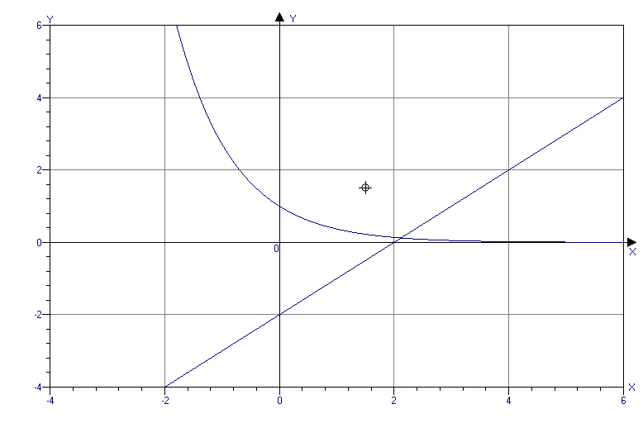

tenglama grafiklari bitta nuqtada kesishgan
1 ta (A)
98(98-4-22) $\left|\text{ln}(x+\text{15})\right|=$-(x+k) ${}^{2}$ tenglamaning chap tomoni musbat yoki 0, o’ng tomoni esa manfiy yoki 0. Shuning uchun tenglamaning har ikki tomoni 0 ga teng bo’lishi kerak.
$\left|\text{ln}(x+\text{15})\right|=$0, x=-14; -(x+k) ${}^{2}$=0,
k=-x=-(-14)=14
4 ; (B)
99(98-5-30) $(\frac{4}{5})^{x}=4$; y=$(\frac{4}{5})^{x}$ funksiya kamayuvchi va x=-1 bo’lsa y=1,25 boladi.
Shuning uchun x<-1 (A)
100(98-6-17) y=2${}^{x+\frac{1}{x}}$; x>0, bo’lsa x+$\frac{1}{x}≥2$ bo’ladi; x<0 bo’lsa x+$\frac{1}{x}≤−2$ bo’ladi. Bundan
0y$\frac{1}{4};y≥4$ y$∈(0;\frac{1}{4}]∪[4;∞)$ (E)
101(98-11-24) Tenglama ildizlari sonini funksiya grafiklarini chizish orqali topamiz.
$$y=|{\text{log}}_{2}x| ; y=−x+4$$
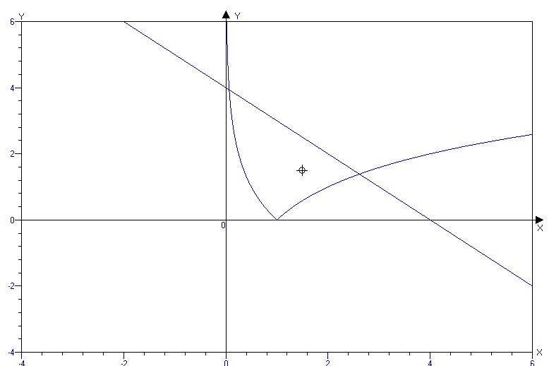

funksiya grafiklari ikki nuqtada kesishgan (D)
102((98-12-81) funksiya grafiklari OX o’qida kesishsa $f(x)=g(x)=0$ bo’ladi yoki
$\begin{aligned}\left\{−\left|x−7\right|=0 | \right.\end{aligned}$ bundan x=7; k=8 (E)
103(98-12-85)
(x-2-x${}^{2}$)(2x+$\frac{1}{e})$${}^{4}$log${}_{x^{2}+2x+2}\left(1−\frac{x^{2}}{π}\right)$0
(x${}^{2}$-x-2) (2x+$\frac{1}{e})$${}^{4}$log${}_{x^{2}+2x+2}\left(1−\frac{x^{2}}{π}\right)$0
x${}^{2}$-x-2 doim musbat; (2x+$\frac{1}{e})$${}^{4}$ musbat yoki
x=-$\frac{1}{е}$ da 0 va yechim; x${}^{2}$+2x+2 =(x+1) ${}^{2}$+1 bundan x$−1$va doim birdan katta.
01-$\frac{х^{2}}{π}$1; 0$\frac{х^{2}}{π}$1; 0x${}^{2}$$π$ bundan
-$\sqrt{π}≤x≤\sqrt{π}$ bu oraliqda cheksiz ko’p manfiy yechim bor(A)
104(99-5-20) 7${}^{2x}−2∗7^{x}\text{cos}\frac{z}{2}+1=0$
7${}^{2x}+2∗7^{x}\text{cos}\frac{z}{2}+{\text{cos}}^{2}\frac{z}{2}+{\text{sin}}^{2}\frac{z}{2}=0$

(7${}^{x}−\text{cos}\frac{z}{2})^{2}+{\text{sin}}^{2}\frac{z}{2}=0$; bundan sin$\frac{z}{2}$=0 va 7${}^{x}−\text{cos}\frac{z}{2}=0$; bu yerda z=2$πk$ va 7${}^{x}=\text{cos}\frac{z}{2}$;
z=2$πk$ bo’lgani uchun cos$\frac{z}{2}$ ning qiymati 1 va -1 bo’ladi. $7^{x}$ musbat son,demak, cos$\frac{z}{2}$ ham 1 ga teng bo’lishi kerak. Bundan x=0 degan xulosa chiqadi. (2$πk$+3)${}^{0}$=1 (D)
105(99-7-31) ${\left(\frac{2}{3}\right)}^{х}=2$; y=${\left(\frac{2}{3}\right)}^{x}$ funksiya kamayuvchi funksiya. ${\left(\frac{2}{3}\right)}^{−1}<2<{\left(\frac{2}{3}\right)}^{−2}$ , demak, -2<x<-1 (D)
106(99-5-22) $9−{\text{log}}_{3}x=2^{x}$; 3 tenglamani qanoatlantiradi, demak, x=3 tenglamaning ildizi. y=9-log${}_{3}x$=9+${\text{log}}_{\frac{1}{3}}x$ funksiya o’zining aniqlanish sohasida kamayuvchi, y=2${}^{x}$ funksi-ya esa o’suvchi. Bundan tenglama yagona ildizga ega ekanligi kelib chiqadi. (B)
107(99-5-41) y=log${}_{3}(x^{2}−8x+7)$
$3^{y}=x^{2}−8x+7$; $3^{y}$=(x-1)(x-7) shartga asosan x–butun son bo’lgani uchun (x-1)(x-7) ko’paytma ham butun son bo’ladi. Bundan esa $3^{y}$ ham bubtu son ekanligi kelib chiqadi ya’ni y>0. U holda x-1=$3^{n}$; x-7=3${}^{m}$ bu tengliklarni ayirib. $3^{n}$-3${}^{m}$=6; bu yerdan n=2; m=1
$3^{y}$=$3^{n}$∙3${}^{m}$=3${}^{2}∗3^{1}$=$3^{3}$; y=3
$3^{3}$=x${}^{2}$-8x+7; x${}^{2}$-8x-20=0 bundan $x_{1}=\text{10};x_{2}=−2$ (10;3) (-2;3) 2 ta ©
108(99-5-51) 7${}^{x^{2}+\left|x\right|}={\left(\frac{1}{5}\right)}^{x^{4}}$
y=7${}^{x^{2}+\left|x\right|}$ osuvchi funksiya va eng kichik qiymati x=0 da y=1
y=${\left(\frac{1}{5}\right)}^{x^{4}}$ kamayuvchi funksiya va eng katta qiymati x=0 da y=1, demak yagona yechim x=0 1 ta (B)
109(99-4-51) cos(x${}^{2}$+1)∙log${}_{4}$(3-2x-x${}^{2}$)1
cos(x${}^{2}$+1) 1; log${}_{4}$(4-(1+x) ${}^{2}$) 1 ravshanki yuqoridagi tengsizlik bajarilishi uchun.
cos(x${}^{2}$+1)=1; log${}_{4}$(3-2x-x${}^{2}$)=1; x=-1 har ikki tengsizlikni qanoatlantiruvchi yagona yechim. (D)
110(00-3-37) tenglamani grafik usulda yechamiz.
y=log${}_{2}(2+x)$; $y=\frac{x^{2}}{2}$
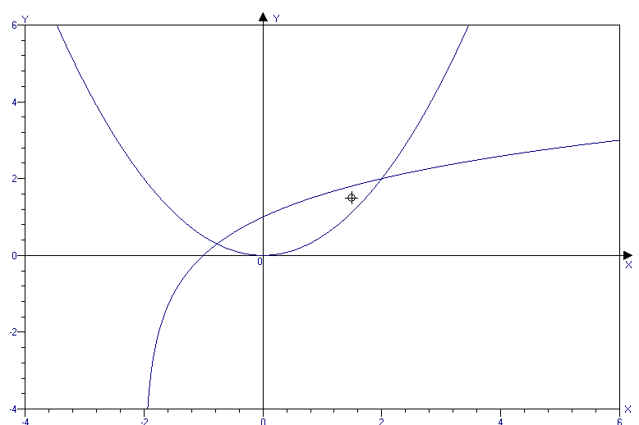
Funksiya grafiklari ikki nuqtada kesishgan
2 ta (A)
111(00-5-45) y=x+$\left|х\right|$
- x>0 bo’lsa y=x+x=2x $y^{'}={\left(2x\right)}^{′}=2$
- x=0 da mavjud emas
- x<0 da y=x-x=0 $y^{'}=0$ (D)
112(00-9-24) ${\text{log}}_{3}x$+${\text{log}}_{x}3=2\text{cos}(6{πx}^{2})$
x>o; x$1$; ${\text{log}}_{3}x$=t bo’lsin, ${\text{log}}_{x}3=\frac{1}{t}$ bo’ladi. ${\text{log}}_{3}x$+ ${\text{log}}_{x}3=\frac{1}{t}$+t
agar t>0 bo’lsa, t+2 bo’ladi;
agar t<0 bo’lsa t+$\frac{1}{t}$-2 bo’ladi.
-22cos$6{πx}^{2}$2 bundan esa
${\text{log}}_{3}x$+log${}_{х}3$=2 va ${\text{log}}_{3}x$+log${}_{х}3$=-2 degan xulosa chiqadi. Bu tenglamalarni yechib x=3 va x=$\frac{1}{3}$ yechimlarni topamiz. Faqat x=3 tenglamaning ildizi bo’ladi. 1 ta (B)
113(00-9-30) tenglama ildizlari sonini funksiya grafiklarinin chizish orqali topamiz.
y=3${}^{−x}={\left(\frac{1}{3}\right)}^{x}$; y=4+x-x${}^{2}$
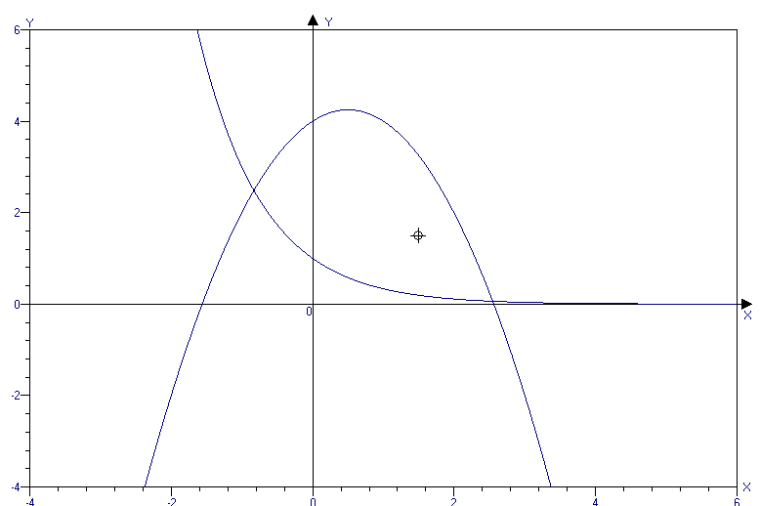
funksiya grafiklari ikki nuqtada kesishgan.
2 ta ©
114(00-10-20) tenglama ildizlari sonini funksiya grafiklarinin chizish orqali topamiz.
y=$\left|{\text{log}}_{5}x\right|;$ y=-x+5
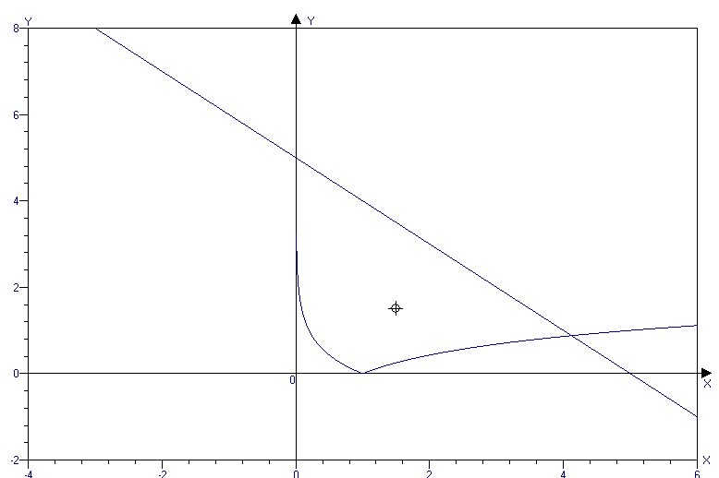
funksiya grafiklari ikki nuqtada kesishgan.
2 ta (D)
115(98-6-16) $f(x+3)=−\frac{1}{f(x+1)}$; x=1 bo’lsa $f(4)=−\frac{1}{f(2)}$; x=-1 bo’lsa
$f(2)=\frac{1}{f(0)}$ bu tengliklarni bo’lib yuborsak $\frac{f(4)}{f(0)}=1$ ekanligi kelib chiqadi.(A)
116(98-11-65) $(x−2)f(x−2)+f(2x)+f(x+2)=x+6$
x=2 bo’lsa $(2−2)f(2−2)+f(2⋅2)+f(2+2)=2+6$
$2f(4)=8;f(4)=4$ (D)
117(99-1-14) $\left|a\right|≠\left|b\right|$shu sababli x=-1 bo’lishi mumkin.$f\left(\frac{a(−1)−b}{b(−1)−a}\right)=f(1)=(−1)^{\text{50}}+(−1)^{\text{49}}+\text{.}\text{.}\text{.}+1$=
=1-1+1-1+…+1=1 (A)
118(99-5-58) $f(x)=x^{2};ϕ(x)=2x−1$
$$ϕ(f(x))=2x^{2}−1;f(ϕ(x))=(2x−1)^{2}$$
shartga asosan $f(ϕ(x))=ϕ(f(x)$
2x${}^{2}$-1=(2x-1) ${}^{2}$; 2x${}^{2}$-1=4x${}^{2}$-4x+1
2x${}^{2}$-4x+2=0; x${}^{2}$-2x+1=0; x=1 1ta (B)
119 (00-10-61)

120(01-2-31) cos${}^{2}$(x+1)∙lg(9-2x-x${}^{2}$)1
x=-1 (B) 109-misolga qaralsin.
121(01-2-67) $\sqrt{3x^{2}+6x+7}+\sqrt{5x^{2}+\text{10}x+\text{14}}=4−2x−x^{2}$$\sqrt{3(x+1)^{2}+4}+\sqrt{5(x+1)^{2}+9}=5−(x+1)^{2}$
tenglamaning chap tomoni o’suvchi va eng kichik qiymati 5 ga x=-1 bo’lganda erishadi.
Tenglamaning ong tomoni esa kamayuvchi va o’ziing eng katta qiymati 5 ga x=-1 bo’lganda erishadi. Yagona yechim -1 (B)
122(01-4-1) tenglama ildizlari qaysi oraliqqa tegishlilginifunksiya grafiklarini chizish orqali topamiz; y=sinx; y=x${}^{2}$-x+0,75
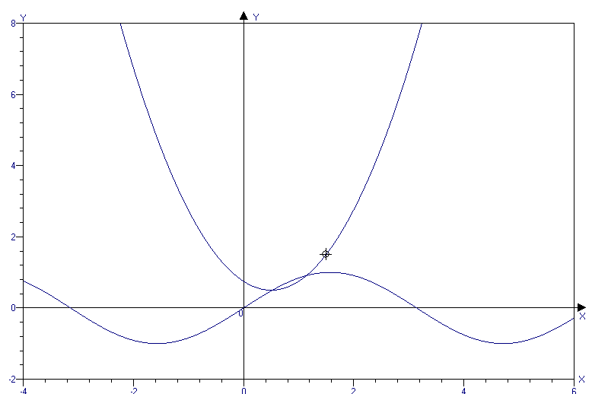
funksiya grafiklari $\left[0;π\right]$ oraliqda kesishgan.
(A)
123(01-8-34) 3-4x-4x${}^{2}$=$2^{4x^{2}+4x+3}$
4-(1+2x) ${}^{2}$=$2^{(2x+1)^{2}+2}$
tenglamaning chap tomoni kamayuvchi va eng katta qiymati 4 ga x=-$\frac{1}{2}$ bo’lganda erishadi.
Tenglikning chap tomoni esa o’suvci va eng katta qiymati 4 ga x=-$\frac{1}{2}$bo’lganda erishadi.
Shuning uchun x=-$\frac{1}{2}$ yagona ildiz (B)
124(01-8-55) tg${}^{4}x−{\text{cos}}^{2}2x=\text{cos}\frac{π}{7}\text{cos}\frac{2π}{7}\text{cos}\frac{4π}{7}$
cos$\frac{π}{7}\text{cos}\frac{2π}{7}\text{cos}\frac{4π}{7}=−\frac{1}{8}$(79-misolga qaralsin)
tg${}^{4}x−{\text{cos}}^{2}2x=−\frac{1}{8}−\frac{7}{8}$; ${\text{tg}}^{4}x−{\text{cos}}^{2}2x=−1$
tg${}^{4}$x+1-cos${}^{2}$2x=0; tg ${}^{4}$x + sin${}^{2}$2x=0
bundan tgx=0; sinx=0; cosx$0$.
tgx=0 bo’lsa x=$π$k
sin2x=2sinxcosx=0 bo’lsa x= $π$k (cosx$0$)
umimiy yechim $π$k (B)
125(01-9-43) tenglama ildizlari sonini funksiya grafiklarinin chizish orqali topamiz
y=x${}^{2}$-6x+8; y=log${}_{2}$(x+1)
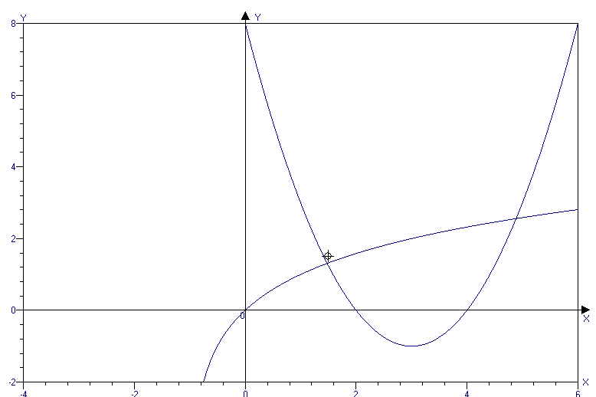
funksiya grafiklari ikki nuqtada kesishgan.
2 ta (A)
126(01-10-38) $\frac{3\text{sin}α+2}{5+\text{cos}β}+\frac{7}{{\text{tg}}^{2}α+{\text{ctg}}^{2}α}$ bu ifoda eng katta qiymatga erishishi uchun
$\text{sin}α=1\text{;cos}α=−1;{\text{tg}}^{2}α+{\text{ctg}}^{2}α=2$ bo’lishi kerak (83-misolga qaralsin)
$\frac{3⋅1+2}{5+(−1)}+\frac{7}{2}=4,\text{75}$(B)
127 (01-10-52) 2$\left|x−3\right|+x−1+2\text{sin}\left(\frac{πx}{2}\right)=0$
2$\left|x−3\right|+x−1=−2\text{sin}\left(\frac{πx}{2}\right)$; -2$−\text{sin}\left(\frac{πx}{2}\right)≤2$.
Shuning uchun tenglamaning chap tomoni ham yuqoridagi oraliqda bo’lishi kerak.
$−2≤2\left|x−3\right|+x−1≤2$;
1) $\begin{aligned}\left\{x≥3 | \right.\end{aligned}$ $\begin{aligned}\left\{x≥3 | \right.\end{aligned}$ tengsizliklar sistemasini qanoatlantiruvchi
yagona son x=3 va uni tengllamaga etib qo’ysak
tenglamani qanoatlantiradi.
2)$\begin{aligned}\left\{x<3 | \right.\end{aligned}$ $\begin{aligned}\left\{x<3 | \right.\end{aligned}$ bu tengsizliklar sistemasini qanoatlantiruvchi son mavjud emas. Shunday qilib x=3 yagona yechim (B)
128(01-12-10) tenglama ildizlari sonini funksiya grafiklarinin chizish orqali topamiz
y=$2^{x}+0,5;y=\left|\text{sin}x\right|$
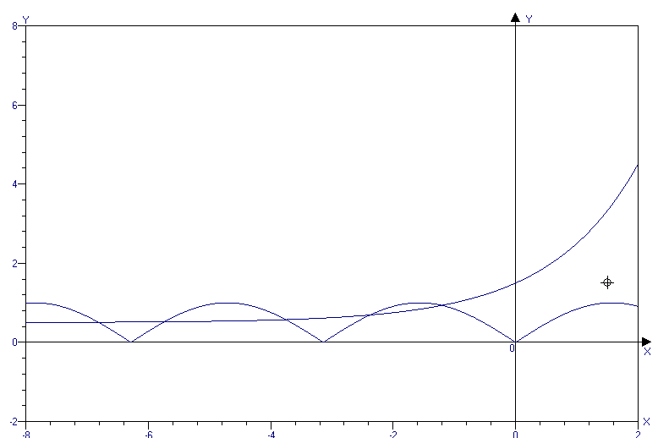
cheksiz ko’p (E)
129(01-12-22) cos${}^{2}$$\frac{x}{2}−{\text{sin}}^{2}\left(\frac{\sqrt{3}x}{2}\right)=1$
cos${}^{2}\frac{x}{2}−{\text{sin}}^{2}\left(\frac{\sqrt{3}x}{2}\right)={\text{cos}}^{2}\frac{x}{2}+{\text{sin}}^{2}\frac{x}{2}$
sin${}^{2}$$\frac{x}{2}+\text{sin}\left(\frac{\sqrt{3}x}{2}\right)=0$, bu yerdan
$\begin{aligned}\left\{\text{sin}\frac{x}{2}=0 | \right.\end{aligned}$ $\begin{aligned}\left\{x=4πk | \right.\end{aligned}$ k=0 bo’lgandagina har ikki tenglikda x=0 bo’ladi. Yagona yechim x=0 (A)
130(01-12-44) tenglama ildizlari sonini funksiya grafiklarinin chizish orqali topamiz

y=$−\frac{1}{\left|x\right|}$; y=x${}^{2}$-4
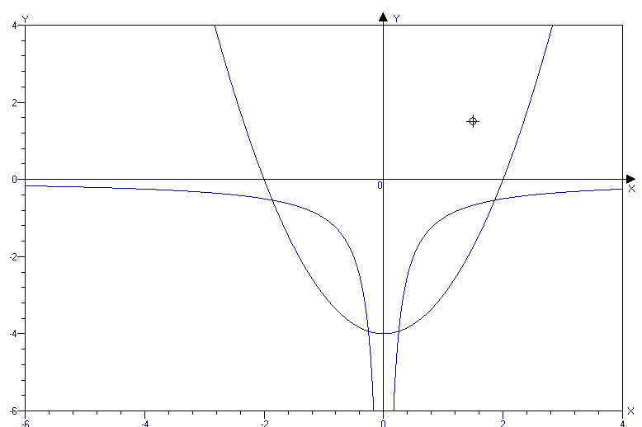
funksiya grafiklari to’rtta nuqtada kesishgan.
4 ta (D)
131 (02-1-6) 2cos$\frac{x}{\text{20}}=2^{x}+2^{−x}$
-2$\text{cos}\frac{x}{\text{20}}≤2$; $2^{x}+2^{−x}≥2$ bundan ko’rinib turibdiki, $\begin{aligned}\left\{2\text{cos}\frac{x}{\text{20}}=2 | \right.\end{aligned}$ bolgandagina tenglama yechimga ega bo’ladi. Shuning uchun x=0 yagona yechim.
132 (02-1-7) 2$\sqrt{\frac{9}{\text{81}}}=2∗\frac{1}{3}=\frac{2}{3}$ (63-misolga qaralsin) (A)
133(01-1-12) arcsin$\frac{x}{2}+2\text{arccos}x=π$
arcsin$\frac{x}{2}=π−2\text{arccos}x$ tenglamaning har ikki tomonini sinuslaymiz.
sin(arcsin$\frac{x}{2}$)=sin($π$-2arccox); $\frac{x}{2}$=sin(2arccosx)
$$\begin{aligned}\left\{\frac{x}{2}=2x\sqrt{1−x^{2}} | \right.\left\{−1≤\frac{x}{2}≤1 | \right.\end{aligned}$$
x=4x$\sqrt{1−x^{2}}$; x(4$\sqrt{1−x^{2}−1=0}$; $x_{1}=0$
$\sqrt{1−x^{2}}=0;$ bundan $x_{2}=\frac{\sqrt{\text{15}}}{4};x_{3}=−\frac{\sqrt{\text{15}}}{4}$
tekshirish
1) x=0, arcsin0+2arccos0=0+$π$=$π$;
x=0 tenglamani qanoatlantiradi
2) x$=\frac{\sqrt{\text{15}}}{4}$; arcsin$\frac{\sqrt{\text{15}}}{8}+2\text{arccos}\frac{\sqrt{\text{15}}}{4}<π$
3) x=-$\frac{\sqrt{\text{15}}}{4};$ u holda
arcsin(-$\frac{\sqrt{\text{15}}}{8}$)+2arccos$(−\frac{\sqrt{\text{15}}}{4})$>$π$
x=0 yagona yechim (A)
134(02-1-15) 2$\sqrt{\frac{\text{25}}{\text{64}}}=2∗\frac{5}{8}=1,\text{25}$ (A)
(63-misolga qaralsin)
135(02-1-22)tenglamalar umumiy ildizga ega bo’lsa, u ildiz $\begin{aligned}\left\{x^{2}+\text{mx}+8=0 | \right.\end{aligned}$ sistemani qnoatlantiradi.
$\begin{aligned}\left\{x^{2}+\text{mx}+8=0 | \right.\end{aligned}$ ; $\begin{aligned}\left\{x^{3}=8 | \right.\end{aligned}$ ; $\begin{aligned}\left\{x=2 | \right.\end{aligned}$ (A)
136(02-1-43) $x≠0;y≠0$; x-y=xy;
$\frac{x−y}{\text{xy}}=1$; $\frac{1}{y}−\frac{1}{x}=1$; $\frac{1}{x}−\frac{1}{y}=−1$ (D)
137(02-1-57) tenglama ildizlari sonini funksiya grafiklarinin chizish orqali topamiz
y=$\left|x^{3}\right|$; y=-x${}^{2}$+x+1
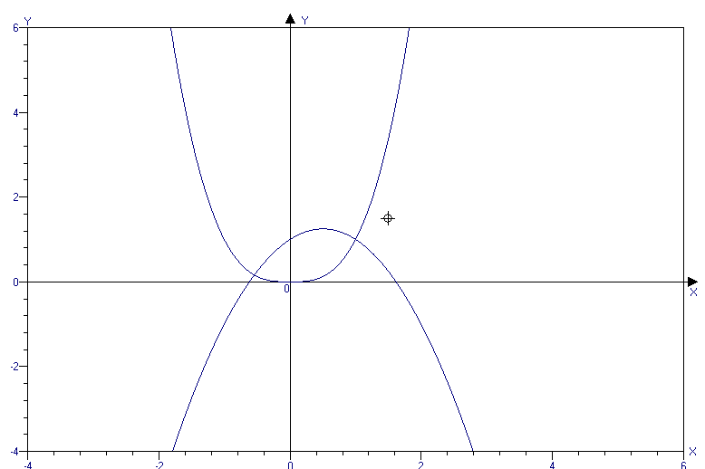
funksiya grafiklari ikki nuqtada kesishgan.
2 ta(B)
138(02-2-15) 2$\sqrt{\frac{7}{\text{112}}}=2⋅\sqrt{\frac{1}{\text{16}}}=0,5$ (A)
139(02-2-58) 5${}^{x}+7^{x}={\text{12}}^{x}$;${\left(\frac{5}{\text{12}}\right)}^{x}+{\left(\frac{7}{\text{12}}\right)}^{x}=1$;
${\left(\sqrt{\frac{5}{\text{12}}}\right)}^{2x}+{\left(\sqrt{\frac{7}{\text{12}}}\right)}^{2x}=1$; ${\left(\sqrt{\frac{5}{\text{12}}}\right)}^{2}+{\left(\sqrt{\frac{7}{\text{12}}}\right)}^{2}=1$ ekanligidan va ularning -1;1 orasida ekanligdan. sin$α=\sqrt{\frac{5}{\text{12}}}$ ; cos$α=\sqrt{\frac{7}{\text{12}}}$bo’lsin, u holda 2x=2 bo’ladi yoki
x=1 (A)
140(02-2-62) $2\sqrt{\frac{\text{16}}{\text{121}}}=\frac{8}{\text{11}}$ (A)
141(02-3-2) 125 ${}^{6}⋅{\text{15}}^{4}⋅{\text{2048}}^{2}$= =$(5^{3})^{6}∗(3∗5)^{4}∗(2^{\text{11}})^{2}$=
=5${}^{\text{18}}⋅3^{4}⋅5^{4}⋅2^{\text{22}}={\text{10}}^{\text{22}}⋅3^{4}$
lg(${\text{10}}^{\text{22}}⋅3^{4})=\text{lg}{\text{10}}^{\text{22}}+\text{lg}3^{4}=\text{10}+\text{lg}\text{81}$
1<lg81<2; 23<10+lg81<24
23+1=24 xonali son (A)
142(02-3-23) 2$\sqrt{\frac{8}{\text{200}}}=2⋅\sqrt{\frac{1}{\text{25}}}=2⋅\frac{1}{5}=0,4$(A)
143(02-3-27) a${}_{n}=−3n^{2}+\text{18}n+1$=-3(n${}^{2}$-6n+9)+28=-3(n-3) ${}^{2}$+28; n=3 (A)
144(02-3-55) 2$\sqrt{\frac{5}{\text{320}}}=2\sqrt{\frac{1}{\text{64}}}=2⋅\frac{1}{8}=0,\text{25}$ (A)
145(02-3-78) cos${}^{2}$x+6sinx=4a${}^{2}$-2;
1-sin${}^{2}$x+6sinx=4a${}^{2}$-2; sin${}^{2}$x-6sinx=3-4a${}^{2}$;
sin${}^{2}$x-2∙3∙sinx+9-9=3-4a${}^{2}$; (sinx-3)${}^{2}$=12-4a${}^{2}$;
-1$\text{sin}x≤1$ bo’lganligi sababli
4$(\text{sin}x−3)^{2}≤\text{16}$ tenglamaning o’ng tomoni ham shu oraliqda bo’lishi kerak. 4$\text{12}−4a^{2}≤\text{16}$
-8$−4a^{2}≤4$; $2≥a^{2}≥−1$ bundan
-$\sqrt{2}≤a≤\sqrt{2}$ (A)
146(02-4-44) tengsizlikning aniqlanish sohasini olamiz. $\begin{aligned}\left\{1+x≥0 | \right.\end{aligned}$ $\begin{aligned}\left\{x≥−1 | \right.\end{aligned}$ tengsizliklar sistemasini qanoatlantiruvchi yagona son -1. x=-1 berilgan tengsizlikni qanoatlantiradi.
1 ta (B)
147(02-6-4) xy${}^{2}$-xy-y${}^{2}$+y=xy(y-1)-y(y-1)=
=(y-1)(xy-y)=(y-1)y(x-1)=1∙2∙47; y, y-1 ketma-kelgan natural sonlar. Shu sababli y-1=1, y=2,
x-1=47, x=48 (48;2) (A)
148(02-6-14) x${}^{2}$-y${}^{2}$=53; (x-y)(x+y)=53
x,y$∈$N, demak, x+y>x-y
(x-y)(x+y)=1∙53 bundan
$\begin{aligned}\left\{x−y=1 | \right.\end{aligned}$ $\begin{aligned}\left\{x=\text{27} | \right.\end{aligned}$ (27;26) 1 ta (B)
149(02-639) $\frac{2\text{sin}α−1}{5−2\text{sin}β}+\frac{{\text{tg}}^{2}γ+{\text{ctg}}^{2}λ}{2}$ ifoda eng kichik qiymatga erishishi uchun sin$α$=-1, sin$β$=1, tg${}^{2}γ+{\text{ctg}}^{2}γ=2$ bo’lishi kerak.
$\frac{2⋅(−1)−1}{5−2⋅1}+\frac{2}{2}$=0
150(02-7-21) $2^{x}+2^{\frac{2−x−y}{2}}+2^{y}=$2${}^{x}+\frac{2}{2^{x}⋅2^{y}}+2^{y}$=
=${\left(2^{\frac{x}{2}}−2^{\frac{y}{2}}\right)}^{2}+$2∙2${}^{\frac{x}{2}}⋅2^{\frac{y}{2}}+\frac{2}{2^{\frac{x}{2}}⋅2^{\frac{y}{2}}}$=
=${\left(2^{\frac{x}{2}}−2^{\frac{y}{2}}\right)}^{2}+$2${\left(2^{\frac{x}{4}}⋅2^{\frac{y}{4}}−\frac{1}{2^{\frac{x}{4}}⋅2^{\frac{y}{4}}}\right)}^{2}+4$ ifodaning x=y=0 bo’lganda eng kichik qiymati
4 ga erishadi. (A)
151(02-8-4) x${}^{\text{2001}}$+3x${}^{\text{2000}}$+3x+13=
=x${}^{\text{2000}}$(x+3)+3(x+3) +4 bu ifodani (x+3) ga bo’lsak 4 qoldiq qoladi. (A)
152(02-8-5) x${}^{6}$+x${}^{4}$-3x${}^{2}$+5=x${}^{6}$-3x${}^{2}$+x${}^{4}$-3+2=
=x${}^{2}$ (x${}^{4}$-3)+ (x${}^{4}$-3)+8= =x${}^{2}$$(x^{2}−\sqrt{3})(x^{2}+\sqrt{3})$+ $(x^{2}−\sqrt{3})(x^{2}+\sqrt{3})$ + +8 bu ifodani (x${}^{2}$-$\sqrt{3})$ ga bo’lsak 8 qoldiq qoladi.(A)
153(02-9-8) 16a${}^{2}$+9b${}^{2}$+4c${}^{2}$+3=8a+6b+4c;
16a${}^{2}$-8a+1+9b${}^{2}$-6b+1+4c${}^{2}$-4c+1=0;
(4a-1) ${}^{2}$+(3b-1) ${}^{2}$+(2c-1) ${}^{2}$=0 bundan
a=$\frac{1}{4};b=\frac{1}{3};c=\frac{1}{2}$; $\frac{1}{a+b+c}=\frac{1}{\frac{1}{4}+\frac{1}{3}+\frac{1}{2}}$=
=$\frac{\text{12}}{\text{13}}$ (B)
154(02-9-16) a+b+c=12; ab+bc+ac=-15
a${}^{2}$+b${}^{2}$+c${}^{2}$=(a+b+c) ${}^{2}$-2(ab+bc+ac) =
=12${}^{2}$-2(-15)=174 (D)
155(02-9-17) 2a${}^{2}$-2ab+b${}^{2}$-2a+2=a${}^{2}$-2ab+b${}^{2}$+
+a${}^{2}$-2a+1+1=(a-b) ${}^{2}$+(a-1) ${}^{2}$+1 ifodaning eng kichik qiymati 1 ga teng. (B)
156(02-11-22) x${}^{3}$-3x${}^{2}$-2x+6=0;
x${}^{2}$(x-3)-2(x-3)=0; (x-3)(x${}^{2}$-2)=0;
(x-3)(x-$\sqrt{2}$)(x+$\sqrt{2}$)=0; x${}_{1}$=3; x${}_{2}$=$\sqrt{2}$;
x${}_{3}$=-$\sqrt{2}$; x${}_{1}$ x${}_{2}$ x${}_{3}$=3∙ $\sqrt{2}$∙(- $\sqrt{2}$)=-6 (B)
157(02-11-24) x${}^{3}$-7x-6=0; x${}^{3}$-x-6x-6=0
x(x${}^{2}$-1)-6(x+1)=0; x(x-1)(x+1)-6(x+1)=0;
(x+1)( x${}^{2}$-x-6)=0; (x+1)(x-3)(x+2)=0
x${}_{1}$=-1; x${}_{2}$=3; x${}_{3}$=-2
$\sqrt[3]{x_{1}x_{2}x_{3}}=\sqrt[3]{−1⋅3⋅(−2)}=\sqrt[3]{6}$ (B)
158(02-12-22) 1∙2∙3∙…∙20 qatnashgan 2 lar
2, 4=2∙2, 6, 8=2∙2∙2, 10, 12=2∙2∙3, 14,
16=2∙2∙2∙2, 18, 20=2∙2∙5 jami 18 ta (B)
159(03-1-23) $\left|x^{2}+3x+2\right|=\left|x^{2}+2x+5\right|+\left|x−3\right|$
$$\left|(x^{2}+2x+2)+(x+3)\right|≤\left|x^{2}+2x+5\right|+\left|x−3\right| ;$$
bu tenglik bajarilishi uchun $x−3≥0 ; x≥3$ bo’loshi kerak. ©
160(03-1-36) $\frac{5^{x^{2}}−5}{3\text{sin}x+4\text{cos}x−2π}≥0$
3sinx+4cosx=5$(\frac{3}{5}\text{sin}x+\frac{4}{5}\text{cos}x)=$
=5(cos$ϕ$sinx+sin$ϕ$cosx)=5sin(x+$ϕ$)
-5$\text{sin}(x+ϕ)≤5<2π$ yoki
3sinx+4cosx-2$π$<0; 5${}^{x^{2}}$-5$0$
5${}^{x^{2}}$5; x${}^{2}$-10; -1x1
161(03-1-38) tenglama ildizlari sonini funksiya grafiklarinin chizish orqali topamiz
y=$\frac{3}{x}$; y=x${}^{2}$-6x+7
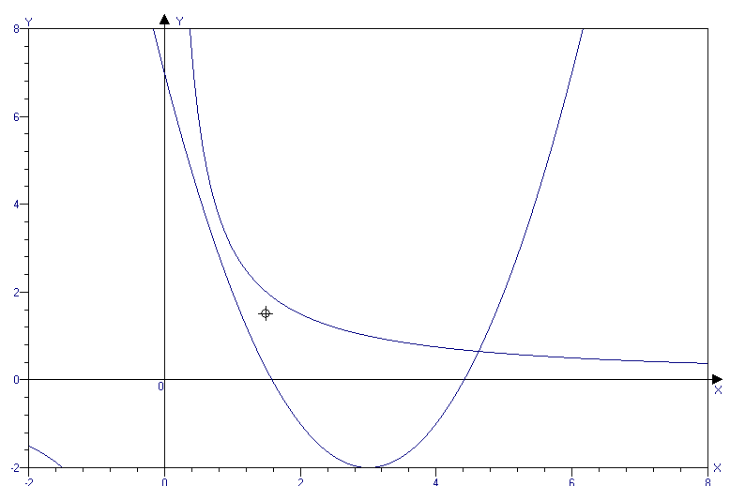
funksiya grafiklari bitta nuqtada kesishgan.
1 ta (B)
162(03-2-2) m${}^{2}$+n${}^{2}$=1; p${}^{2}$+q${}^{2}$=1; mp+nq=0
1)p=0 bo’lsa q=$±1$, n=0 bo’ladi bundan mn+pq=0
2) p$0$ bo’lsa, m=$−\frac{\text{nq}}{p}$ boladi; ${\left(−\frac{\text{nq}}{p}\right)}^{2}$+n${}^{2}$=1;
$\frac{n^{2}q^{2}+n^{2}p^{2}}{p^{2}}$=$\frac{n^{2}(q^{2}+p^{2})}{p^{2}}=\frac{n^{2}}{p^{2}}=$1; n${}^{2}=p^{2}$
n=$±p$; m=-$−\frac{\text{nq}}{p}$=$\frac{±\text{pq}}{p}=∓q$
mn+pq=$±p$$\left(∓q\right)$+pq=0 haikki holda ham ifodaning qiymati 0 gat eng. (B)
163(03-2-59) tenglama ildizlari sonini funksiya grafiklarinin chizish orqali topamiz
y=sinx; y=${\text{log}}_{2}x$
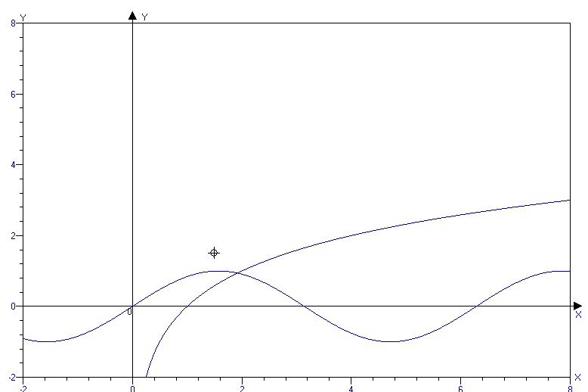
funksiya grafiklari bitta nuqtada kesishgan.
1 ta (B)

164(03-2-1) x${}^{4}$+a=x${}^{2}$+a${}^{2}$; x${}^{4}$-x${}^{2}$-(a${}^{2}$-a)=0
x${}^{2}$=t; t${}^{2}$-t-(a${}^{2}$-a)=0 bu kvadrat tenglama bir ildizi 0 ga teng bo’lsagina berilgan bikvadrat tenglamaning 3 ta turli haqiqiy ildizlarga ega bo’ladi. t=0 bo’lsa x=0 bo’ladi.
0${}^{4}$+a=0${}^{2}$+a${}^{2}$; a${}^{2}$-a=0; a${}_{1}$=0; a${}_{2}$=1©
165(03-5-9) m,n,k$∈$N
m${}^{2}$∙k=2${}^{2}$∙5; m=2,k=5;
m∙n${}^{2}$=18; 2∙n${}^{2}$=18, n=3 (A)
166(03-12-56) x${}^{2}$7${}^{x}$+1>7${}^{x}$+x
7${}^{x}$(x${}^{2}$-1)-(x-1)>0; 7${}^{x}$(x-1)(x+1)-(x-1)>0
(x-1)(x∙7${}^{x}$+7${}^{x}$-1)>0
1)x>1 bo’lsa har ikki ko’paytuvchi musbat bo’ladi yoki bu oraliq tengsizlikning yechimi bo’ladi.
2) 0<x<1 bo’lsa birinchi ko’paytuvchi manfiy, ikkinchi ko’paytuvchi musbat(bu oraliqda x∙7${}^{x}$>0; 7${}^{x}$-1>0) yoki bu oraliq tengsizlikning yechimi bo’lmaydi.
3)x<0 bo’lsa har ikki ko’paytuvchi manfiy bo’ladi (bu oraliqda x∙7${}^{x}$<0; 7${}^{x}$-1<0) bu oraliq tengsizlikning yechimi bo’ladi. Shunday qilib
x$∈\left(−∞;0\right)∪\left(1;∞\right)$(D)

