San yil
Sinf: 9-sinf
Fan: Algebra
Mavzu: 7-8-sinf algebra kursini takrorlash
Maqsad: a) ta’limiy: O’quvchilardan o’tilgan mavzular, tushunchalar,ta’riflarni so’rash orqali bilim, malaka va ko’nikma hosil qilish;
b) tarbiyaviy: Oquvchilarni shu mavzu asosida Milliy istiqlol ruhida va o’zaro hurmat ruhida tarbiyalash, ajdodlarimiz ijodi bilan tanishtirish;
c) rivojlantiruvchi: o’quvchilar bilimini rivojlantirish, ko’nikma va malakasini o’stirish, dunyoqarashi va fikrlash qobiliyatini riviojlantirish.
Dars turi: Aralash dars
Dars uslubi : Klaster va BBB , aqliy hujum usullaridan foydalangan holda, venn diagrammasi, Sherigingni top o’yini, mustaqil ish.
Darsning xronologik jadvali
t/r | Dars etaplari | vaqti | Usuli
1 | Tashhkiliy qism | 2- minut
2 | Uyga vazifani so’rash | 3-minut | Guruh sardorlari yordamida
3 | O’tgan mavzuni takrorlash | 5- minut | BBB usuli yordamida
4 | Yangi mavzu bayoni | 20-minut | Guruhlarga bo’lish orqali
5 | Dasrni mustahkamlash | 13- minut | Aqliy hujum usulidan
5 | Uyga vazifa va xulosalash | 2-minut
Darsning borishi
- Tashkiliy ishlar (2-minut) O’quvchilar sinf xonasiga kirib joylashadilar . davomat aniqlanib , darsga tayyorgarlik tekshiriladi ,o’quvchilar guruhlarga bo’lib olinadi.
1-guruh: Xorazmiy
MURAKKAB
SON
NATURAL
SON
BUTUN
SON
RAQAMLAR
YI’G’NDISI
10 GA
TENG
IKKI
XONALI
SON
JUFT SON
28
2-guruh: Beruniy

- Uyga vazifani so’rash (3-minut) Uyga vazifa so’raladi va teksiriladi .
- O’tgan mavzuni so’rash .(5-minut)
a) 7-8-sinf algebrada o’tilgan mavzular yuzasidan “aqliy hujum ” o’tkaziladi . Bunda o’quvchilar barchasi ishtiroki ta’minlanadi . Bunda 1-o’quvchi bobga doir bir termin aytadi . 2-o’quvchi 1-o’quvchi aytgan terminni aytib yana o’zi ham termin aytadi. 3- o’quvchi o’zidan oldinga terminlarni aytib o’zi ham termin aytadi . jarayon shu tarzda davom etadi
b) Hisoblang:
Yangi mavzu bayoni: (20-minut)
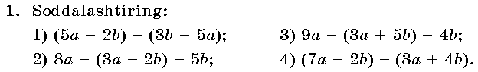
Javoblari: 1)10a-5b; 2)5a-3b; 3)6a-9b; 4)4a-6b.
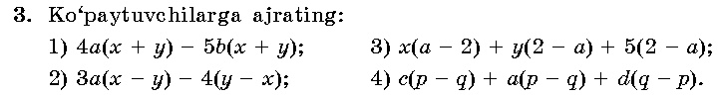
Javoblari: 1)(x+y)(4a-5b); 2)(x-y)(3a+4); 3)(a-2)(x-y-5); 4)(p-q)(c+a-d).
TESTLAR:
1. Hisoblang:
A) B) C) D)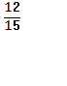
2.Soddalashtiring: 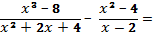
A)4 B)-2x C)-4 D)2x
3.Hisoblang: 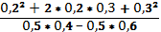=
A)-2,5 B)0,25 C)2,5 D)-5,2
4. Bir ishni 10 kishi 8 kunda bajara oladi. 2 kundan so’ng, uchinchi kuni ularga yordam berish uchun bir necha kishi kelib qo’shildi va qolgan ish 4 kunda bajarildi.Nechta ishchi kelib qo’shilgan?
A) 3ta B)4ta C)5ta D)6ta
5. Hisoblang: 4,21(31)+3,31(21)
A)7 B)7,52 C)7,(51) D)7,51(9)
KALIT: 1-C; 2-C; 3-A; 4-C; 5-A.
DARSNI MUSTAHKAMLASH
Tenglamalar sistemasini yeching: { 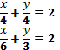
A)(-4;4) B)(4;4) C)(-4;4) D)(4;-4)
Baholash:
Uyga vazifa: 6-7 – misollarni yechib kelish.

Sana: yil
Sinf: 9-sinf
Fan: Algebra
Mavzu: 8-sinf algebra kursini takrorlash
Maqsad: a) ta’limiy: O’quvchilardan o’tilgan mavzular, tushunchalar,ta’riflarni so’rash orqali bilim, malaka va ko’nikma hosil qilish;
b) tarbiyaviy: Oquvchilarni shu mavzu asosida Milliy istiqlol ruhida va o’zaro hurmat ruhida tarbiyalash, ajdodlarimiz ijodi bilan tanishtirish;
c) rivojlantiruvchi: o’quvchilar bilimini rivojlantirish, ko’nikma va malakasini o’stirish, dunyoqarashi va fikrlash qobiliyatini riviojlantirish.
Dars turi: Aralash dars
Dars uslubi : Klaster , aqliy hujum usullari,sherigingni top o’yini, mustaqil ish. Darsning xronologik jadvali
t/r | Dars etaplari | vaqti | Usuli
1 | Tashhkiliy qism | 2- minut
2 | Uyga vazifani so’rash | 3-minut | Guruh sardorlari yordamida
3 | O’tgan mavzuni takrorlash | 5- minut | BBB usuli yordamida
4 | Yangi mavzu bayoni | 20-minut | Guruhlarga bo’lish orqali
5 | Dasrni mustahkamlash | 13- minut | Aqliy hujum usulidan
5 | Uyga vazifa va xulosalash | 2-minut
Darsning borishi:
- Tashkiliy ishlar (2-minut) O’quvchilar sinf xonasiga kirib joylashadilar . davomat aniqlanib , darsga tayyorgarlik tekshiriladi ,o’quvchilar guruhlarga bo’lib olinadi.
- Uyga vazifani so’rash (3-minut) Oldingi dars mavzusi va uyga vazifa so’raladi va teksiriladi .
- O’tgan mavzuni so’rash .(5-minut)
8-sinf algebrada o’tilgan mavzular yuzasidan “aqliy hujum ” o’tkaziladi . Bunda o’quvchilar barchasi ishtiroki ta’minlanadi . Bunda 1-o’quvchi bobga doir bir termin aytadi . 2-o’quvchi 1-o’quvchi aytgan terminni aytib yana o’zi ham termin aytadi. 3- o’quvchi o’zidan oldinga terminlarni aytib o’zi ham termin aytadi . jarayon shu tarzda davom etadi
Yangi mavzu bayoni: (20-minut)
1.Tenglamalar sistemasini yeching: { 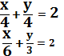
A)(-4;4) B)(4;4) C)(-4;4) D)(4;-4)
2.Hisoblang:
3.Hisoblang: 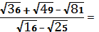
A)-4 B)4 C)-5 D)5
4.Tenglamani yeching: 6- 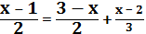
5.Tenglamalar sistemasini yeching: {
A)(-4;4) B)(4;4) C)(-4;4) D)(4;-4)
6. Taqqoslang: 10²⁰ va 20¹⁰
A) > B)< C)≥ D)≤
DARSNI MUSTAHKAMLASH
7.Tengsizliklar sistemasini yeching:
8.Tengsizlikni yeching: I3x-1I4
A)[-1; ] B)[-1;5] C)(1;] D)(-1;)
9.Sonlarni taqqoslang: va 5
Baholash:
Uyga vazifa: 12-13misollar.

Sana: yil
Sinf: 9-sinf
Fan: Algebra
Mavzu: 8-sinf algebra kursini takrorlash
Maqsad: a) ta’limiy: O’quvchilardan o’tilgan mavzular, tushunchalar, ta’riflarni so’rash orqali bilim, malaka va ko’nikma hosil qilish;
b) tarbiyaviy: O’quvchilarni shu mavzu asosida Milliy istiqlol ruhida va o’zaro hurmat ruhida tarbiyalash, ajdodlarimiz ijodi bilan tanishtirish;
c) rivojlantiruvchi: O’quvchilar bilimini rivojlantirish, ko’nikma va malakasini o’stirish, dunyoqarashi va fikrlash qobiliyatini riviojlantirish.
Dars turi: Aralash dars
Dars uslubi : Klaster , aqliy hujum usuli, mustaqil ish
Dars jihozi: tarqatmalar, darslik
- Tashkiliy qism.
Salomlashish. Navbatchi axborotini tinglash. O’quvchilar davomatini olish.
- O’tilgan mavzuni takrorlash.
Uyga vazifani so’rash.
“Klaster” usuli:
Bir o’quvchi doskada matematik
terminlarni yozadi:
kvadrat ildiz, tenglama, teorema,…
Mustaqil ish:
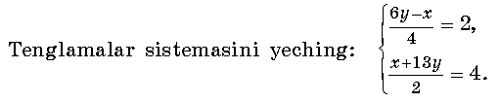
Yechish: 6y-x=8 x=6* -8= -8= -2 .
x+13y=8
19y=16; y= 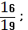 J: (-2 ; )
- Yangi mavzuning bayoni.
Yechish: 1) (x+3)²= (x-3)² 3) (x+6)²=(x+10)²
x²+6x+9= x²-6x+9 x²+12x+36= x²+20x+100
12x=0; x=0. -8x=64; x= -8.
2) (1-x)²= (x+2)² 4) (x+5)²= (x-7)²
1-2x+x²= x²+4x+4 x²+10x+25= x²-14x+49
-6x=3; x= -0,5. 24x=24; x=1.
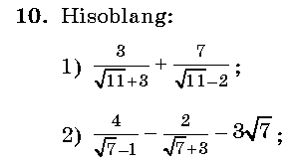
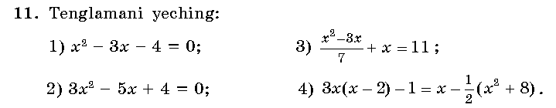
Yechish: 1) x₁=4; x₂=-1. 2) x₁= ; x₂=1. 3) x₁=7; x₂= -11.
- Mustahkamlash.
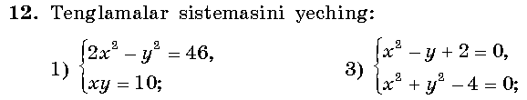
Yechish: 1) ______________________________________________________________________________________________________________________________________________________________________________________________________________________________________________________________________________________________________________________________________________________________________________________________________________________________________________________________________________

- Baholash. O’quvchilar bilimini baholash.
- Uyga vazifa. №12(2,4) ; №13- misollar.

Sana:
Sinf: 9-sinf
Fan: Algebra
Mavzu: y= ax²+bx+c funksiya
Maqsad: a) ta’limiy: O’quvchilarga kvadrat funksiya, uning ta’rifini o’rgatish orqali bilim, malaka va ko’nikma hosil qilish;
b) tarbiyaviy: Oquvchilarni shu mavzu asosida Milliy istiqlol ruhida va o’zaro hurmat ruhida tarbiyalash, ajdodlarimiz ijodi bilan tanishtirish;
c) rivojlantiruvchi: o’quvchilar bilimini rivojlantirish, ko’nikma va malakasini o’stirish, dunyoqarashi va fikrlash qobiliyatini riviojlantirish.
Dars turi: Yangi bilim berish.
Dars uslubi : Savol- javob
Jihozlar: Chizg’ich, tarqatmalar, rangli shakllar.
- Tashkiliy qism.
Salomlashish. Navbatchi o’quvchining o’quvchilar davomati, ob-havo, o’quvchilarning darsga tayyorligi to’g’risidagi axborotini tinglash.

- O’tilgan mavzuni so’rash
Uyga vazifalarni tekshirish.
Mustaqil ish:
1. 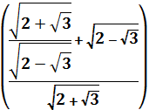² ni hisoblang.
A)16; B)18; C)14; D)12;
2. 1998 ²⁰⁰²+ 1997 ²⁰⁰¹ yig’indining oxirgi raqamini toping.
A)1; B)5; C)3; D)7

III. Yangi mavzuning bayoni
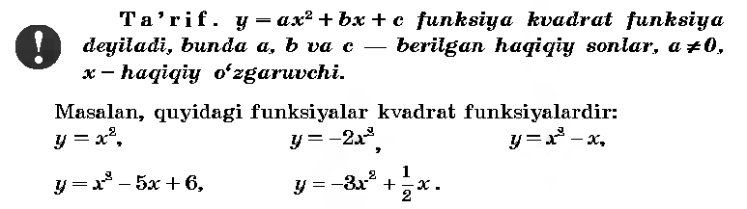
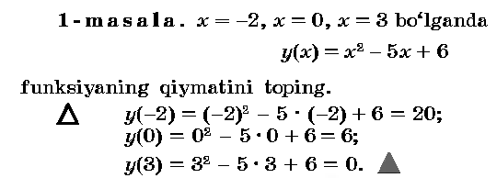

X | -3 | -2 | -1 | 0 | 1 | 2 | 3
Y= x²-2x+3 | 18 | 11 | 6 | 3 | 2 | 3 | 6

IV.Mustahkamlash.24-26 –misollar.
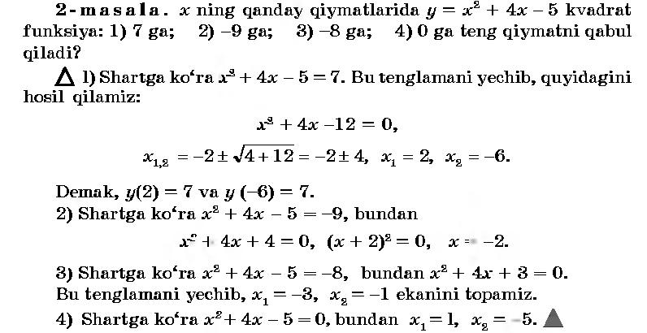
V.Baholash.
Darsda faol qatnashgan o’quvchilarni baholash.
VI.Uyga vazifa. 6-7 –misollar.
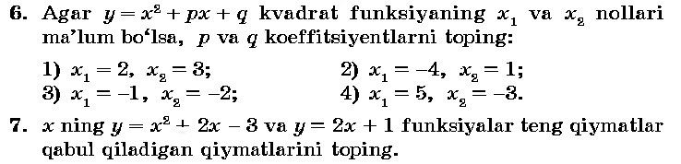

Sana:
Sinf: 9-sinf
Fan: Algebra
Mavzu: y= x² funksiya
Maqsad: a) ta’limiy: O’quvchilarga y= x² funksiya, uning grafigi va
xossalarini o’rgatish orqali bilim, malaka va ko’nikma hosil qilish;
b) tarbiyaviy: Oquvchilarni shu mavzu asosida o’zaro hurmat ruhida
tarbiyalash, ajdodlarimiz ijodi bilan tanishtirish;
c) rivojlantiruvchi: o’quvchilar bilimini rivojlantirish, dunyoqarashi
va fikrlash qobiliyatini riviojlantirish.
Dars turi: Yangi bilim berish.
Dars uslubi : Savol- javob
Jihozlar: Chizg’ich, tarqatmalar, rangli shakllar.
- Tashkiliy qism.
Salomlashish. Navbatchi o’quvchining o’quvchilar davomati, ob-havo, o’quvchilarning darsga tayyorligi to’g’risidagi axborotini tinglash.
- O’tilgan mavzuni so’rash
Uyga vazifalarni tekshirish.
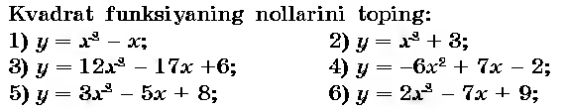______________________________________________________________________________________________________________________________________________________________________________________________________________________________________________________________________________________________________________________________________________________________
III. Yangi mavzuning bayoni
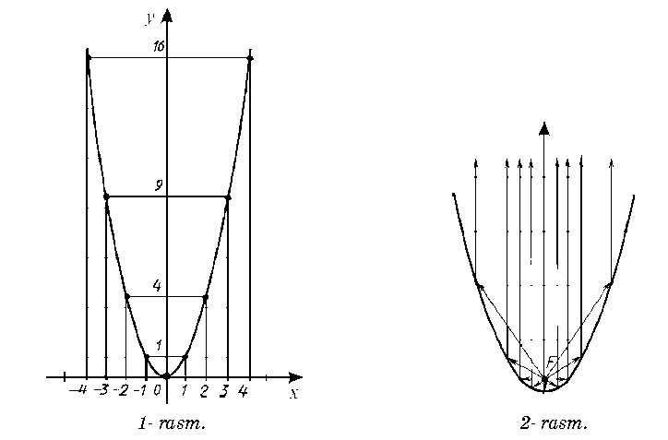
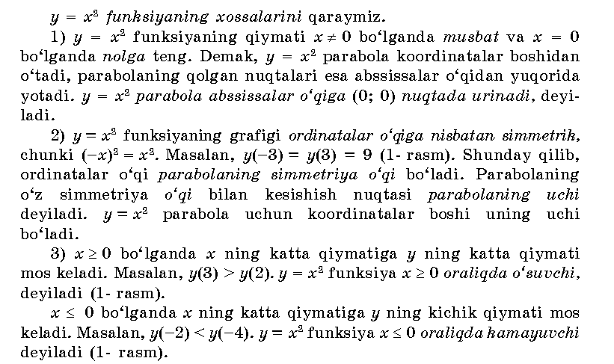
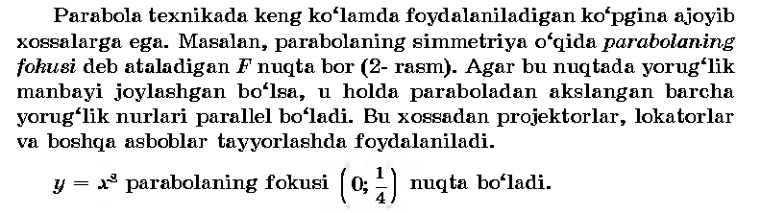
IV.Mustahkamlash.
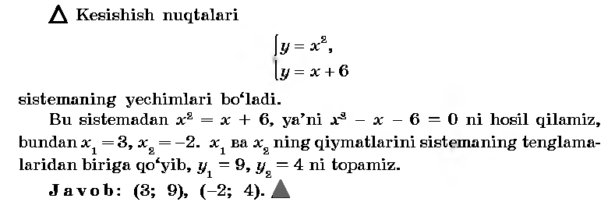
V.Baholash.
Darsda faol qatnashgan o’quvchilarni baholash.
VI.Uyga vazifa. 14-16 –misollar.

Sana: 12.09. 2014
Sinf: 9-sinf
Fan: Algebra
Mavzu: y= ax² funksiya
Maqsad: a) ta’limiy: O’quvchilarga y= ax² funksiya, uning grafigi va
xossalarini o’rgatish orqali bilim, malaka va ko’nikma hosil qilish;
b) tarbiyaviy: Oquvchilarni shu mavzu asosida o’zaro hurmat ruhida
tarbiyalash, ajdodlarimiz ijodi bilan tanishtirish;
c) rivojlantiruvchi: o’quvchilar bilimini rivojlantirish, dunyoqarashi
va fikrlash qobiliyatini riviojlantirish.
Dars turi: Yangi bilim berish.
Dars uslubi : Savol- javob
Jihozlar: Chizg’ich, tarqatmalar, rangli shakllar.
- Tashkiliy qism.
Salomlashish. Navbatchi o’quvchining o’quvchilar davomati, ob-havo, o’quvchilarning darsga tayyorligi to’g’risidagi axborotini tinglash.
- O’tilgan mavzuni so’rash
Uyga vazifalarni tekshirish.
Savol: - Parabola nima?
- Yangi mavzuning bayoni
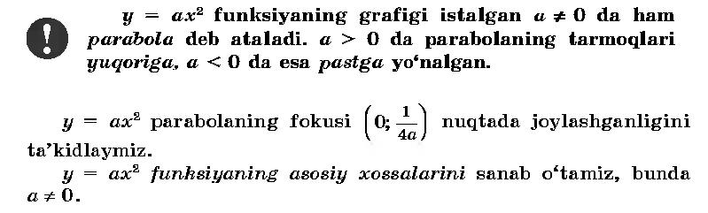
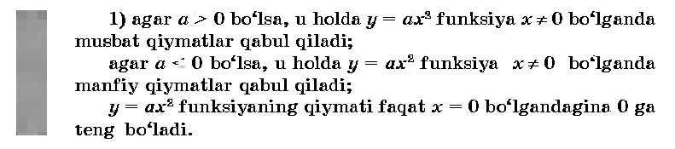
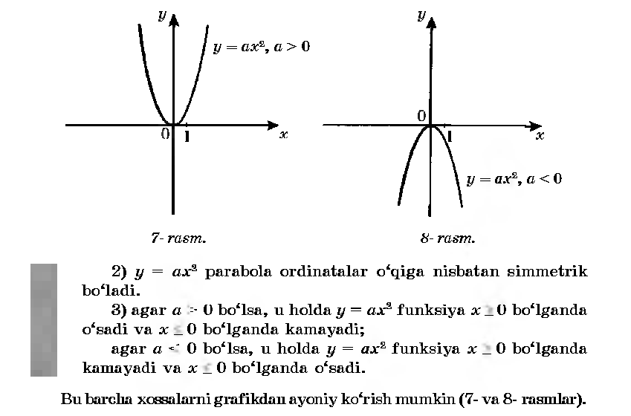
IV.Mustahkamlash.
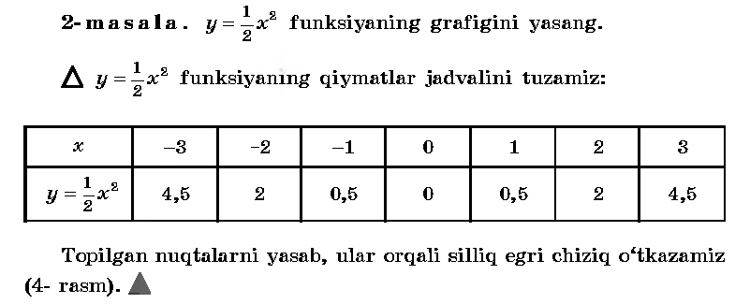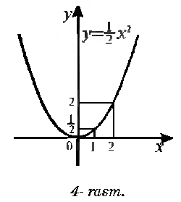
V.Baholash.
Darsda faol qatnashgan o’quvchilarni baholash.
VI.Uyga vazifa. 20-21 –misollarni yechish.

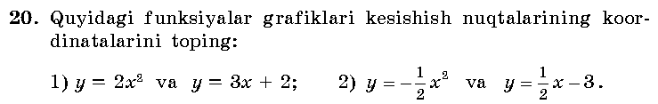
Sana:
Sinf: 9-sinf
Fan: Algebra
Mavzu: Misollar yechish.
Maqsad: a) ta’limiy: O’quvchilarga y= ax² funksiya, uning grafigi va
xossalarini o’rgatish orqali bilim, malaka va ko’nikma hosil qilish;
b) tarbiyaviy: Oquvchilarni shu mavzu asosida o’zaro hurmat ruhida
tarbiyalash, ajdodlarimiz ijodi bilan tanishtirish;
c) rivojlantiruvchi: o’quvchilar bilimini rivojlantirish, dunyoqarashi
va fikrlash qobiliyatini riviojlantirish.
Dars turi: Aralash dars.
Dars uslubi : Savol- javob
Jihozlar: Chizg’ich, tarqatmalar, rangli shakllar.
- Tashkiliy qism.
Salomlashish. Navbatchi o’quvchining o’quvchilar davomati, ob-havo, o’quvchilarning darsga tayyorligi to’g’risidagi axborotini tinglash.
- O’tilgan mavzuni so’rash
Uyga vazifalarni tekshirish.
Mustaqil ish:
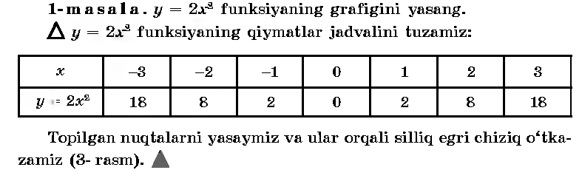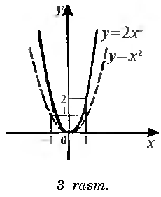

- Yangi mavzuning bayoni
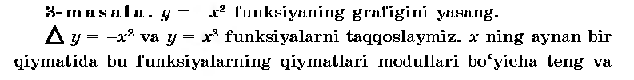
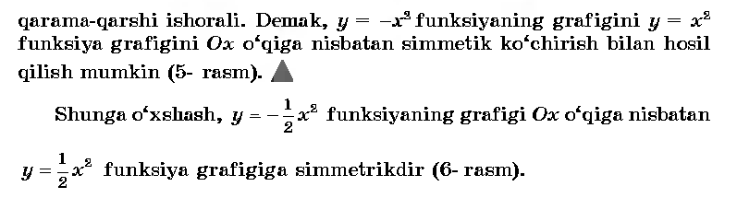
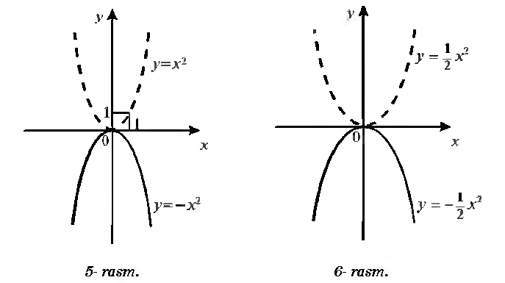
IV.Mustahkamlash.
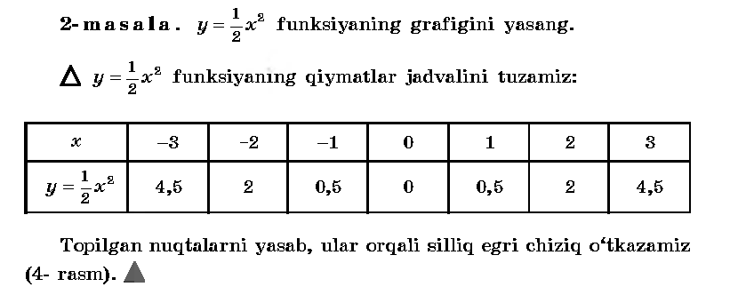
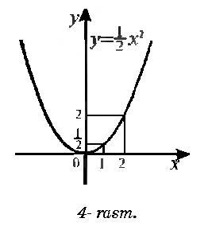
V.Baholash.
Darsda faol qatnashgan o’quvchilarni baholash.
VI.Uyga vazifa. 23 –misol.
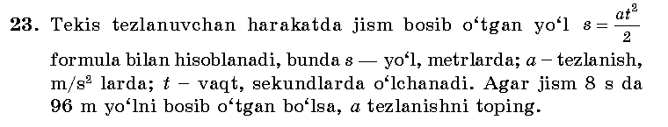

Sana:
Sinf: 9-sinf
Fan: Algebra
Mavzu: y= ax²+bx+c funksiya
Maqsad: a) ta’limiy: O’quvchilarga kvadrat funksiya xossalari va uning grafigini o’rgatish orqali bilim, malaka va ko’nikma hosil qilish;
b) tarbiyaviy: Oquvchilarni shu mavzu asosida Milliy istiqlol ruhida va o’zaro hurmat ruhida tarbiyalash, ajdodlarimiz ijodi bilan tanishtirish;
c) rivojlantiruvchi: o’quvchilar bilimini rivojlantirish, ko’nikma va malakasini o’stirish, dunyoqarashi va fikrlash qobiliyatini riviojlantirish.
Dars turi: Yangi bilim berish.
Dars uslubi : Savol- javob
Jihozlar: Chizg’ich, tarqatmalar, rangli shakllar.
- Tashkiliy qism.
Salomlashish. Navbatchi o’quvchining o’quvchilar davomati, ob-havo, o’quvchilarning darsga tayyorligi to’g’risidagi axborotini tinglash.

- O’tilgan mavzuni so’rash
Uyga vazifalarni tekshirish.
Mustaqil ish:
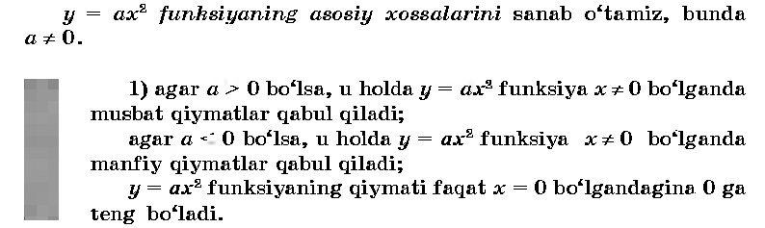
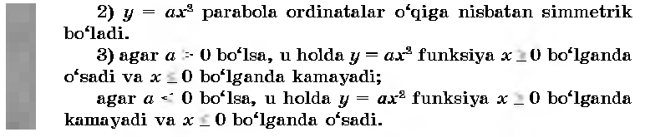
III. Yangi mavzuning bayoni
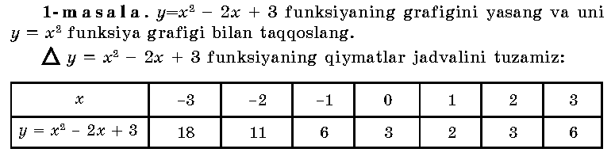
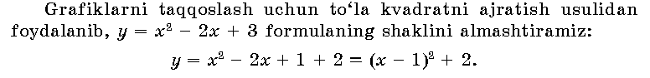
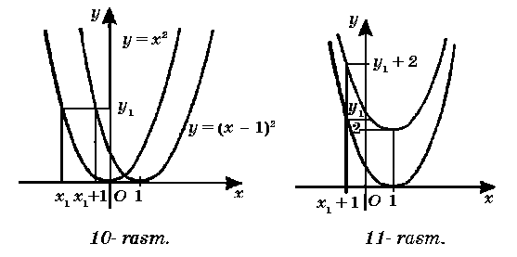
IV.Mustahkamlash.
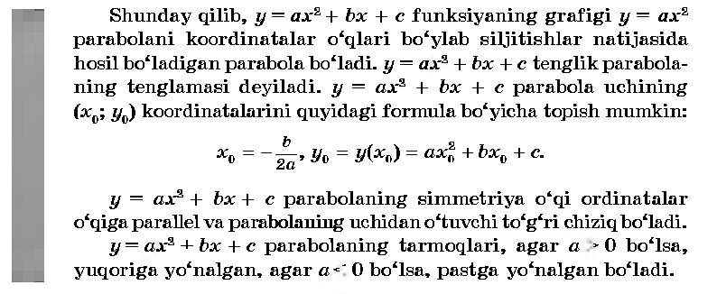
V.Baholash.
Darsda faol qatnashgan o’quvchilarni baholash.
VI.Uyga vazifa. 6-7 –misollar.

Sana:
Sinf: 9-sinf
Fan: Algebra
Mavzu: Misollar yechish.
Maqsad: a) ta’limiy: O’quvchilarga kvadrat funksiya xossalari va uning grafigini o’rgatish orqali bilim, malaka va ko’nikma hosil qilish;
b) tarbiyaviy: Oquvchilarni shu mavzu asosida Milliy istiqlol ruhida va o’zaro hurmat ruhida tarbiyalash, ajdodlarimiz ijodi bilan tanishtirish;
c) rivojlantiruvchi: o’quvchilar bilimini rivojlantirish, ko’nikma va malakasini o’stirish, dunyoqarashi va fikrlash qobiliyatini riviojlantirish.
Dars turi: Aralash dars.
Dars uslubi : Savol- javob
Jihozlar: Chizg’ich, tarqatmalar, darslik.
- Tashkiliy qism.
Salomlashish. Navbatchi o’quvchining o’quvchilar davomati, ob-havo, o’quvchilarning darsga tayyorligi to’g’risidagi axborotini tinglash.

- O’tilgan mavzuni so’rash
Uyga vazifalarni tekshirish.
Mustaqil ish: y=(x-1)² va y=(x-1)² +2 funksiyalarning grafigini yasang.
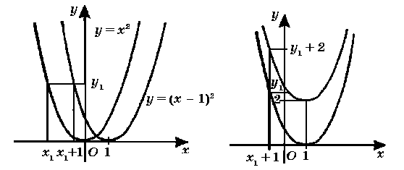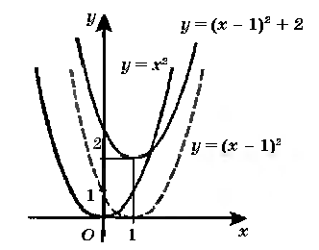
III. Yangi mavzuning bayoni
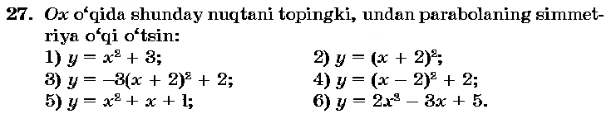
Yechish: 1) x₀=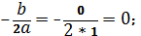 2) x₀=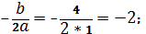
3) x₀=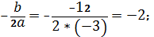 4) x₀=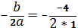 =2.
Yechish: x₀=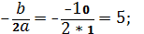 J: (5;10) va (5;0) nuqtalardan o’tadi.
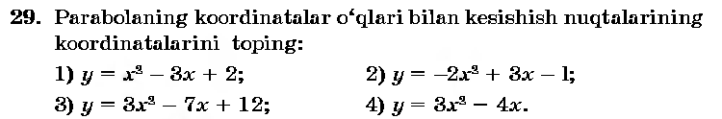
Yechish: 1) x²-3x+2=0; x₁=1; x₂=2; OX o’qi bilan (1;0) va (2;0) nuqtalarda; OY o’qi bilan (0;2) nuqtalarda kesishadi.
2) -2x²+3x-1=0; x₁=1; x₂=0,5; OX o’qi bilan (1;0) va (0,5;0) nuqtalarda; OY o’qi bilan (0;-1) nuqtalarda kesishadi.
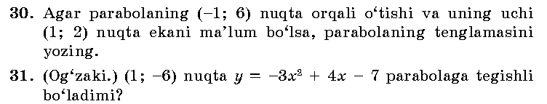____________________________________________________________________________________________________________________________________________________________________________________________________________________________________________________________________________________
IV.Mustahkamlash.
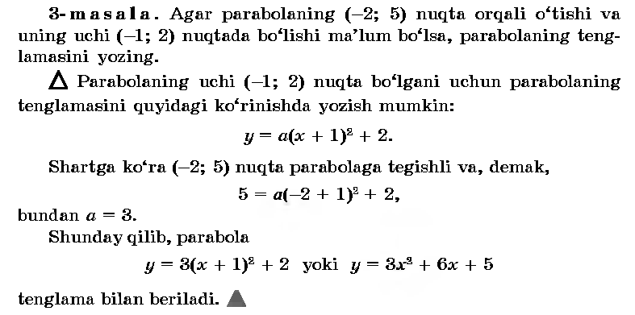
V.Baholash.
Darsda faol qatnashgan o’quvchilarni baholash.
VI.Uyga vazifa. 34 –misol.
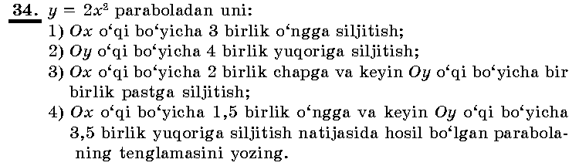

Sana:
Sinf: 9-sinf
Fan: Algebra
Mavzu: Kvadrat funksiya grafigini yasash.
Maqsad: a) ta’limiy: O’quvchilarga kvadrat funksiya, uning grafigiini chizishni o’rgatish orqali bilim, malaka va ko’nikma hosil qilish;
b) tarbiyaviy: Oquvchilarni shu mavzu asosida Milliy istiqlol ruhida va o’zaro hurmat ruhida tarbiyalash, ajdodlarimiz ijodi bilan tanishtirish;
c) rivojlantiruvchi: o’quvchilar bilimini rivojlantirish, ko’nikma va malakasini o’stirish, dunyoqarashi va fikrlash qobiliyatini riviojlantirish.
Dars turi: Aralash dars
Dars uslubi : Savol- javob
Darsning borishi
- Tashkiliy qism.
Salomlashish. Navbatchi o’quvchining o’quvchilar davomati, ob-havo, o’quvchilarning darsga tayyorligi to’g’risidagi axborotini tinglash.

- O’tilgan mavzuni so’rash
Uyga vazifalarni tekshirish.
Mustaqil ish:
- Y=x²+ 3x-4 funksiyaning grafigini yasash

X | -1 | 0 | 1 | 2 | -4
Y | -6 | -4 | 0 | 6 | 0

- Y=-(x²- 5x+4) funksiyaning grafigini yasash
x | Y
0 | -4
1 | 0
2 | 2
4 | 0
-1 | -10
- Yangi mavzuning bayoni
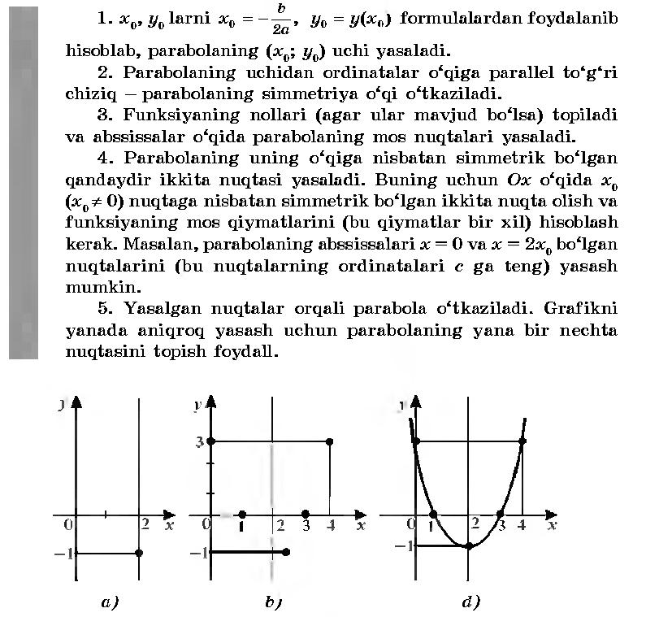
IV.Mustahkamlash.
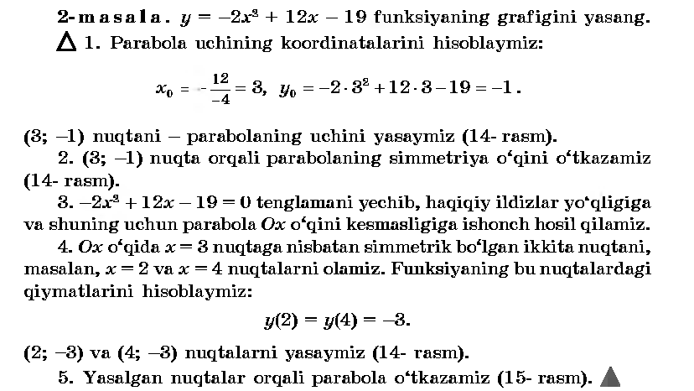
V.Baholash
VI.Uyga vazifa. 38 –misol

Sana
Sinf: 9-sinf
Fan: Algebra
Mavzu: Misollar yechish. №39- 44
Maqsad: a) ta’limiy: O’quvchilarga kvadrat funksiya, uning grafigini chizishni o’rgatish orqali bilim, malaka va ko’nikma hosil qilish;
b) tarbiyaviy: Oquvchilarni shu mavzu asosida milliy istiqlol ruhida va o’zaro hurmat ruhida tarbiyalash;
c) rivojlantiruvchi: o’quvchilar bilimini rivojlantirish, ko’nikma va malakasini o’stirish, dunyoqarashi va fikrlash qobiliyatini riviojlantirish.
Dars turi: Aralash dars
Dars uslubi : Savol- javob
Darsning borishi
- Tashkiliy qism.
Salomlashish. Navbatchi o’quvchining o’quvchilar davomati, ob-havo, o’quvchilarning darsga tayyorligi to’g’risidagi axborotini tinglash.
- O’tilgan mavzuni so’rash
Uyga vazifalarni tekshirish.
Mustaqil ish:
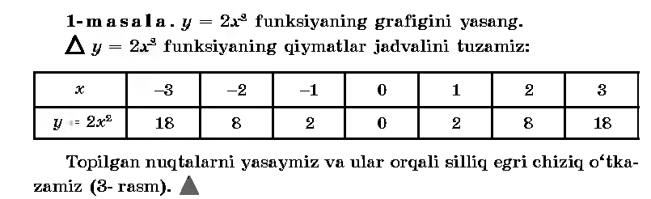
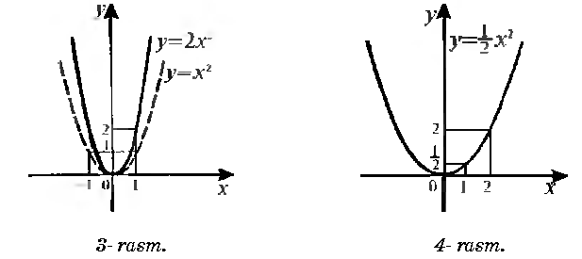
- Yangi mavzuning bayoni
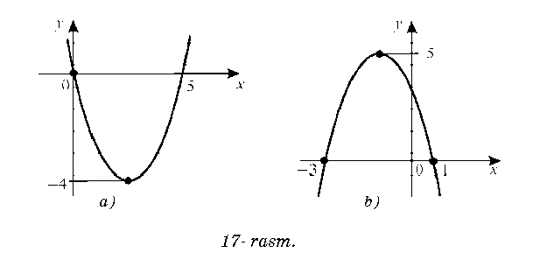
Yechimi: 15=7+8 (7*8=56)
15=1+14 (1*14=14); 15=3+12 (3*13=39);
15=2+13 (2*13=26); 15=4+11 (4*11=44);
Javob: 15=7+8.
Yechimi: 1+9=10 (1³+9³=1+729=730);
2+8=10 (2³+8³=8+512=520);
3+7=10 (3³+7³=27+313=360);….. 5+5=10 (5³+5³=125+125=250)
Javob: 5 soni.
IV.Mustahkamlash. 44 –misol
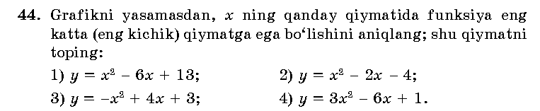__________________________________________________________________________________________________________________________________________________________________________________________________________________________________________________________________________________________________________________________________________________________________________________________________________________________
V.Baholash
VI.Uyga vazifa. 37, 45 –misollar.

Sana:
Sinf: 9-sinf
Fan: Algebra
Mavzu: Misollar yechish. №47- 50
Maqsad: a) ta’limiy: O’quvchilarga kvadrat funksiya, uning grafigini chizishni o’rgatish orqali bilim, malaka va ko’nikma hosil qilish;
b) tarbiyaviy: Oquvchilarni shu mavzu asosida milliy istiqlol ruhida va o’zaro hurmat ruhida tarbiyalash;
c) rivojlantiruvchi: o’quvchilar bilimini rivojlantirish, ko’nikma va malakasini o’stirish, dunyoqarashi va fikrlash qobiliyatini riviojlantirish.
Dars turi: Aralash dars
Dars uslubi : Savol- javob
Darsning borishi
- Tashkiliy qism.
Salomlashish. Navbatchi o’quvchining o’quvchilar davomati, ob-havo, o’quvchilarning darsga tayyorligi to’g’risidagi axborotini tinglash.

- O’tilgan mavzuni so’rash
Uyga vazifalarni tekshirish.
Mustaqil ish:
1.Y=2x²+x-4 funksiyaning grafigini yasash
Parabola uchini topib olamiz: x₀=- =- ;
Y₀=2*(-)+ (-)- 4= -4,75 demak, (-0,25 ; -4,75)

x | Y
-1 | -3
0 | -4
1 | -1
2 | 6
-2 | 2

2.Y=-x²- 2x+3 funksiyaning grafigini yasash
Parabola uchining koordinatalarini topamiz:
x₀=- =- 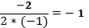;
Y₀=-(-1)²- 2*(-1)+3=-1+2+3=4
Parabola uchi (-1;4) nuqtada bo’ladi.
x | Y
0 | 3
1 | 0
2 | -5
-3 | 0
-1 | 4

III. Yangi mavzuning bayoni
47 -misol.
X=-2, x=0, x=3 bo’lganda y(x)= x²-5x+6 funksiyaning qiymatini toping.
Yechish: y(-2)=(-2)²-5(-2)+6=20
Y(0)=0²-5(0)+6=6
48-masala.
X ning qanday qiymatlarida y= x²+4x-5 kvadrat funksiya 7ga, -9ga, 0ga teng qiymatni qabul qiladi?
Yechish: Shartga ko’ra x²+4x-5=7. Bu tenglamani yechib, x₁=2 va x₂=-6 ni hosil qilamiz.
Demak, y(2)=7 va y(-6)=7.
49-masala.
Y= x²-3x funksiyaning nollarini toping.
Yechish: x²-3x=0 tenglamani yechib, x₁=0 va x₂=3 ekanini topamiz.
IV.Mustahkamlash. 50 –misol
50- misol. y= x²-7x+10 funksiyaning grafigini yasang.
Parabola uchining koordinatalarini topamiz:
X₀=- 3,5 Y₀=(3,5)²-7*3,5+10=12,25-24,5+10=-2,25
Uchi (3,5; -2,25)nuqtada bo’ladi
V.Baholash
VI.Uyga vazifa. 52- 53 –misol

Sana:
Sinf: 9-sinf
Fan: Algebra
Mavzu: Nazorat ishi
Maqsad: a) ta’limiy: O’quvchilarning kvadrat funksiya, uning grafigini yasashga doir bilimlarini tekshirish;
b) tarbiyaviy: Oquvchilarni shu mavzu asosida milliy istiqlol ruhida va o’zaro hurmat ruhida tarbiyalash;
c) rivojlantiruvchi: o’quvchilar bilimini rivojlantirish, ko’nikma va malakasini o’stirish, fikrlash qobiliyatini riviojlantirish.
Dars turi: O’quvchilar bilimini tekshirish
Dars uslubi : Yozma ish
Tashkiliy qism.
Salomlashish. Navbatchining o’quvchilar davomati, ob-havo, o’quvchilarning darsga tayyorligi to’g’risidagi axborotini tinglash.
Darsning borishi:
I variant
- Y= - funksiyaning grafigini yasang.
- Y=x²-4x-5 funksiyaning grafigini yasang. Grafikdan y=0, y<0, y>0 bo’ladigan oraliqlarni , funksiya kamayish va o’sish oraliqlarini toping.
- Y=x²+x-12 funksiyaning grafigini koordinata o’qlari bilan kesishgan nuqtalarining koordinatalarini toping.
- Ko’paytuvchilarga ajrating: x²-5x+4
- Tenglamani yeching:

II variant
- Y= funksiyaning grafigini yasang.
- Y=- x²+2x+8 funksiyaning grafigini yasang. Grafikdan y=0, y<0, y>0 bo’ladigan oraliqlarni , funksiya kamayish va o’sish oraliqlarini toping.
- Y=x²+7x+10 funksiyaning grafigini koordinata o’qlari bilan kesishgan nuqtalarining koordinatalarini toping.
- Ko’paytuvchilarga ajrating: x²-8x+15
- Tenglamani yeching:

UYGA VAZIFA. Takrorlash

Sana:
Sinf: 9-sinf
Fan: Algebra
Mavzu: Masalalar yechish.
Maqsad: a) ta’limiy: O’quvchilarga kvadrat funksiya, uning grafigini chizishni o’rgatish orqali bilim, malaka va ko’nikma hosil qilish;
b) tarbiyaviy: Oquvchilarni shu mavzu asosida milliy istiqlol ruhida va o’zaro hurmat ruhida tarbiyalash;
c) rivojlantiruvchi: o’quvchilar bilimini rivojlantirish, ko’nikma va malakasini o’stirish, dunyoqarashi va fikrlash qobiliyatini riviojlantirish.
Dars turi: Aralash dars
Dars uslubi : Savol- javob
- Tashkiliy qism.
Salomlashish. Navbatchi o’quvchining o’quvchilar davomati, ob-havo, o’quvchilarning darsga tayyorligi to’g’risidagi axborotini tinglash.
- O’tilgan mavzuni so’rash
Uyga vazifalarni tekshirish.
Mustaqil ish:
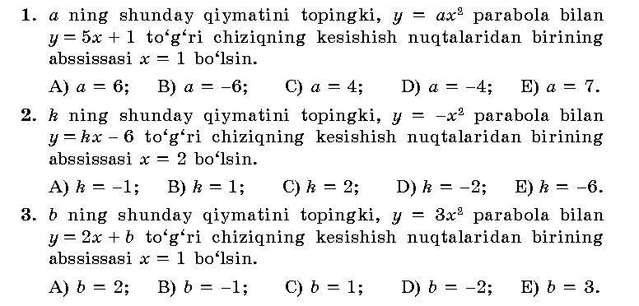
Kalit:
- Yangi mavzuning bayoni
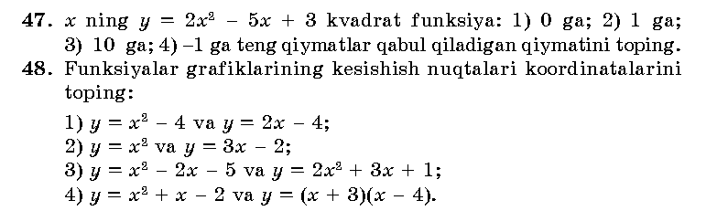____________________________________________________________________________________________________________________________________________________________________________________________________________________________________________________________________________________________________________________________________________________________________________________________________________________________________________________________________________________________________________________________________________________________________________
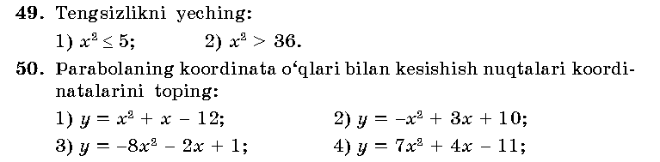___________________________________________________________________________________________________________________________________________________________________________________________________________________________________________________________________________________________________________________________________________________________
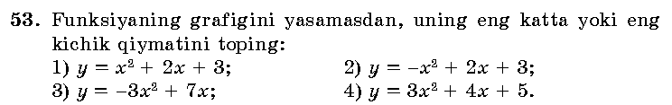_____________________________________________________________________________________________________________________________________________________________________________________________________________________________________________________________________________________________________________________________________________________________
IV.Mustahkamlash.
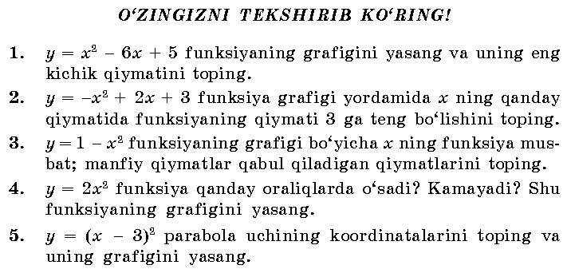
V.Baholash
VI.Uyga vazifa. 57-58 –misol

Sana:
Sinf: 9-sinf
Fan: Algebra
Mavzu: Kvadrat tengsizlik va uning yechimi
Maqsad: a) ta’limiy: O’quvchilarga kvadrat tengsizlik va uning yechimini o’rgatish orqali bilim, malaka va ko’nikma hosil qilish;
b) tarbiyaviy: Oquvchilarni shu mavzu asosida o’zaro hurmat ruhida tarbiyalash;
c) rivojlantiruvchi: o’quvchilar bilimini rivojlantirish, ko’nikma va malakasini o’stirish, dunyoqarashi va fikrlash qobiliyatini riviojlantirish.
Dars turi: Aralash dars
Dars uslubi : Savol- javob
- Tashkiliy qism.
Salomlashish. Navbatchi o’quvchining o’quvchilar davomati, ob-havo, o’quvchilarning darsga tayyorligi to’g’risidagi axborotini tinglash.

- O’tilgan mavzuni so’rash
Uyga vazifalarni tekshirish.
Mustaqil ish:
Y=-x²- 2x+3 funksiyaning grafigini yasash
Parabola uchining koordinatalarini topamiz:
x₀=- =- 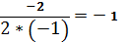;
Y₀=-(-1)²- 2*(-1)+3=-1+2+3=4
Parabola uchi (-1;4) nuqtada bo’ladi.
x | Y
0 | 3
1 | 0
2 | -5
-3 | 0
-1 | 4

III. Yangi mavzuning bayoni
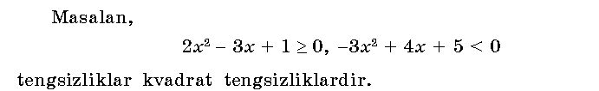
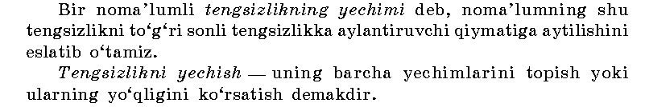
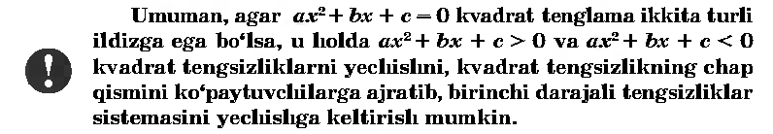

IV.Mustahkamlash. 60-62 –misollar
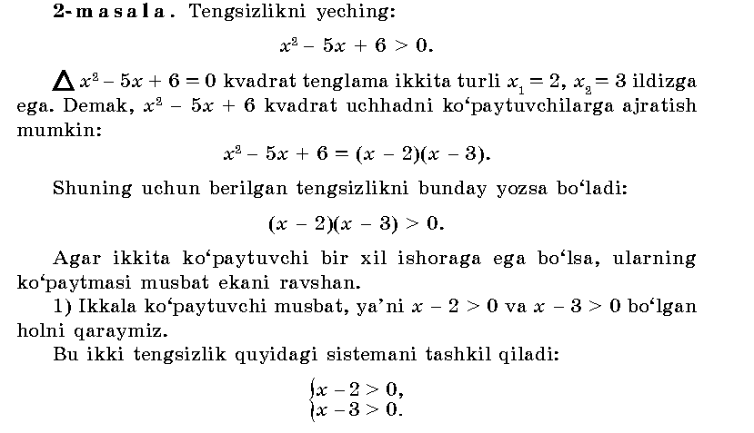
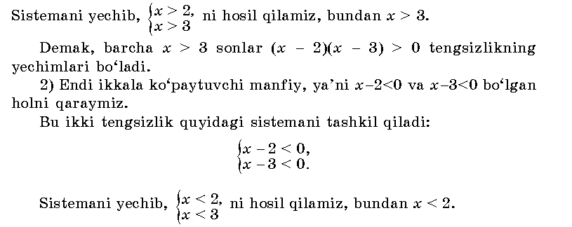
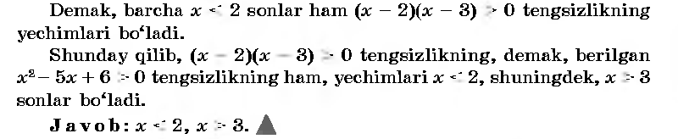
V.Baholash
VI.Uyga vazifa. 63 –misol

Sana:
Sinf: 9-sinf
Fan: Algebra
Mavzu: Misollar yechish №64-67
Maqsad: a) ta’limiy: O’quvchilarga kvadrat tengsizlik va uning yechimini o’rgatish orqali bilim, malaka va ko’nikma hosil qilish;
b) tarbiyaviy: Oquvchilarni shu mavzu asosida o’zaro hurmat ruhida tarbiyalash;
c) rivojlantiruvchi: o’quvchilar bilimini rivojlantirish, ko’nikma va malakasini o’stirish, dunyoqarashi va fikrlash qobiliyatini riviojlantirish.
Dars turi: Aralash dars
Dars uslubi : Savol- javob
- I. Tashkiliy qism.
Salomlashish. Navbatchi o’quvchining o’quvchilar davomati, ob-havo, o’quvchilarning darsga tayyorligi to’g’risidagi axborotini tinglash.
- II. O’tilgan mavzuni so’rash
Uyga vazifalarni tekshirish.
Quyidagi tengsizliklardan qaysi biri kvadrat tengsizlik ekanini ko’rsating:
1) 4)4x-5<0
2)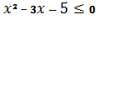 5)
3)3x+4>0 6)x⁴-16>0
Aqliy hujum:
- Qanday tengsizlik kvadrat tengsizlik deyiladi?
- Tengsizlikning yechimi deb nimaga aytiladi?
- Tengsizlikni yechish nima?
- Y=3 parabola qaysi choraklarda joylashgan?
- Y= - parabola uchining koordinatalarini toping.
III. Yangi mavzuning bayoni. 64-67-misollar
№64. Tengsizlikni yeching:
1) (x-2)(x+4)>0
x-2>0 x>2
x+4>0 x>-4 bundan: x>2
x-2<0 x<2
x+4<0 x<-4 bundan: x<-4
javob: x<-4 va x>2
2)(x-3)(x+5)<0
x-3<0 x<3
x+5>0 x>-5 bundan: -5<x<3
x-3>0 x>3
x+5<0 x<-5 bundan: x€ᴓ
javob: -5<x<3
3)(x-11)(x-3)<0
x-11<0 x<11
x-3>0 x>3 bundan: 3<x<11
x-11>0 x>11
x-3<0 x<3 bundan: x€ᴓ
66- misol. Quyidagi tengsizliklardan qaysilari kvadrat tengsizlik ekanini ko’rsating:
1)x²-4>0 3)x²-3x-5<0 5)3x+4 ≤ 0
2)4x-5>0 4)x²-1≥ 0 6)x⁴-16<0
67- misol. Quyidagi tengsizliklarni kvadrat tengsizlikka keltiring:
1)x²<3x+4 x²-3x-4<0
2)3x²<x²-5x+6 2x²+5x-6<0
IV.Mustahkamlash.
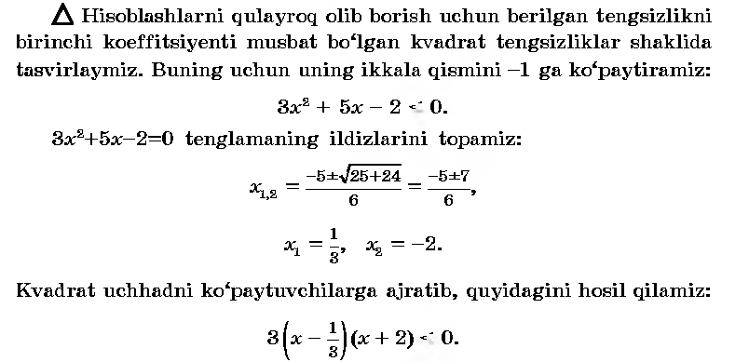
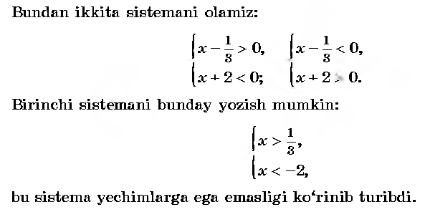
V.Baholash
VI.Uyga vazifa. 68 –misol

Sana:
Sinf: 9-sinf
Fan: Algebra
Mavzu: Kvadrat tengsizlikni kvadrat funksiyaning grafigi orqali yechish
Maqsad: a) ta’limiy: O’quvchilarga kvadrat tengsizlikni kvadrat funksiyaning grafigi orqali yechishni o’rgatish orqali bilim, malaka va ko’nikma hosil qilish;
b) tarbiyaviy: Oquvchilarni shu mavzu asosida o’zaro hurmat ruhida tarbiyalash;
c) rivojlantiruvchi: o’quvchilar bilimini rivojlantirish, ko’nikma va malakasini o’stirish, dunyoqarashi va fikrlash qobiliyatini riviojlantirish.
Dars turi: Yangi bilim berish
Dars uslubi : Savol- javob
Darsning borishi
- Tashkiliy qism.
Salomlashish. Navbatchi o’quvchining o’quvchilar davomati, ob-havo, o’quvchilarning darsga tayyorligi to’g’risidagi axborotini tinglash.
- O’tilgan mavzuni so’rash
Uyga vazifalarni tekshirish.
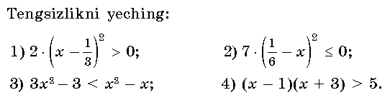
Yechilishi:
- x - =0 x= - karrali ildiz Javob: x < ; x >
- - x = 0 x= - karrali ildiz Javob: x=
- 2 + x-3 < 0 2 + x-3 = 0 D= 1+4*2*3=25
x₁=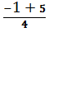 = 1; x₂ = 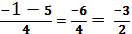 = -1,5
Javob: -1,5< x< 1
- x²+2x-3>5 x²+2x-8>0 x₁= - 4; x₂= 2
Javob: x<-4; x < 2
- Yangi mavzuning bayoni
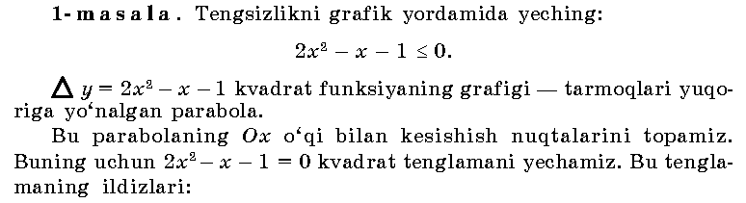
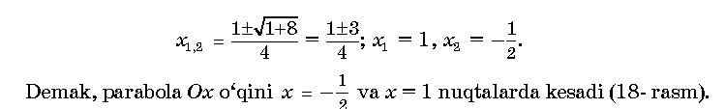
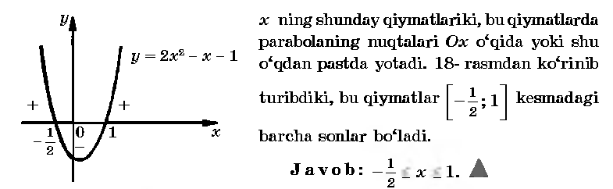
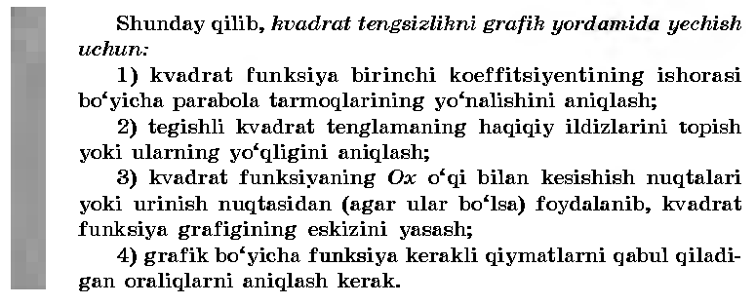
IV.Mustahkamlash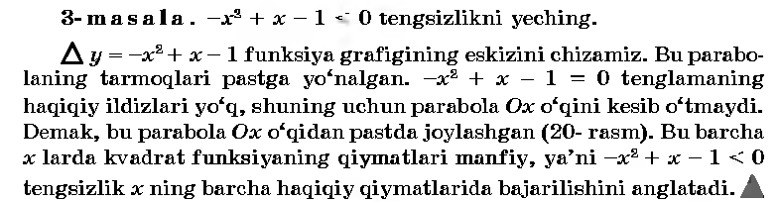
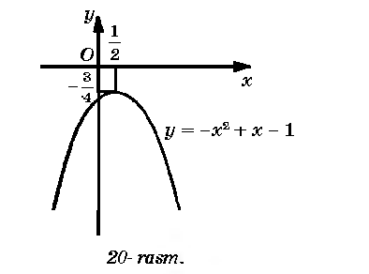
V.Baholash
VI.Uyga vazifa. 74-75 –misollar

Sana:
Sinf: 9-sinf
Fan: Algebra
Mavzu: Misollar yechish №76-79
Maqsad: a) ta’limiy: O’quvchilarga kvadrat tengsizlikni kvadrat funksiyaning grafigi yordamida yechishni o’rgatish orqali bilim, malaka va ko’nikma hosil qilish;
b) tarbiyaviy: Oquvchilarni shu mavzu asosida o’zaro hurmat ruhida tarbiyalash;
c) rivojlantiruvchi: o’quvchilar bilimini rivojlantirish, ko’nikma va malakasini o’stirish, dunyoqarashi va fikrlash qobiliyatini riviojlantirish.
Dars turi: Aralash dars
Dars uslubi : Savol- javob
- Tashkiliy qism.
Salomlashish. Navbatchi o’quvchining o’quvchilar davomati, ob-havo, o’quvchilarning darsga tayyorligi to’g’risidagi axborotini tinglash.
- O’tilgan mavzuni so’rash
Uyga vazifalarni tekshirish.
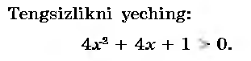
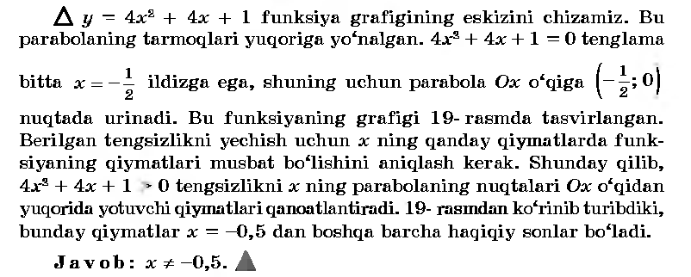
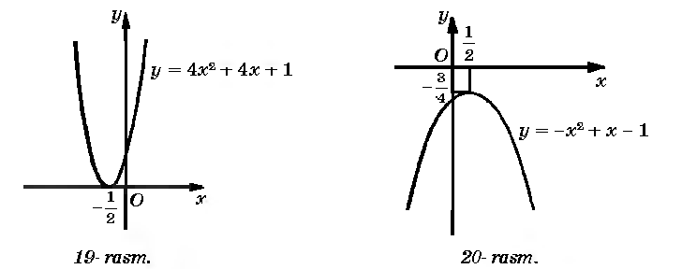
- Yagi mavzuning bayoni. №76-79-misollar
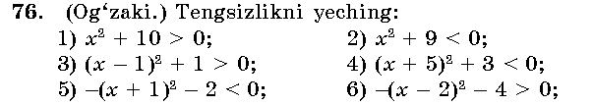
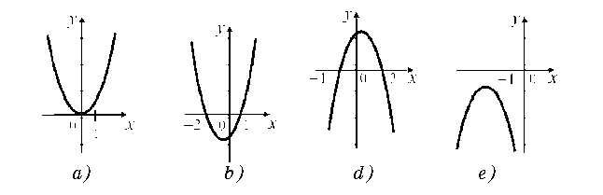
Javoblari: 1) x ning istalgan qiymatida tengsizlik to’g’ri;
2) x€ᴓ ; 3) x ning istalgan qiymati; 4) x€ᴓ;
5) x ning istalgan qiymati; 6) x€ᴓ; 7) x€ᴓ; 8) x ning istalgan qiymati;
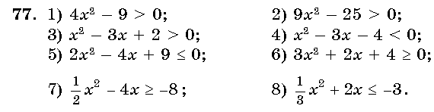
Yechilishi: 1)y= 4x²-9 parabolaning tarmoqlari yuqoriga yo’nalgan,
4x²-9=0; x₁=1,5 va x₂=-1,5
grafikdan foydalanib, x ning funksiya musbat
qiymatlar oladigan oraliqlarni aniqlaymiz.
Javob: x<-1,5 va x>1,5
IV.Mustahkamlash.
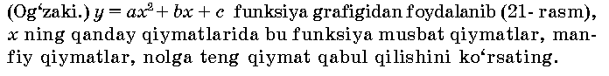
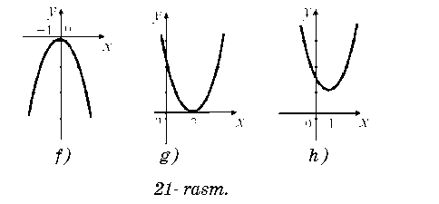
V.Baholash
VI.Uyga vazifa. 80- 81 –misollar

Sana:
Sinf: 9-sinf
Fan: Algebra
Mavzu: Intervallar usuli
Maqsad: a) ta’limiy: O’quvchilarga kvadrat tengsizlikni intervallar usuli orqali yechishni o’rgatish bilan bilim, malaka va ko’nikma hosil qilish;
b) tarbiyaviy: Oquvchilarni shu mavzu asosida o’zaro hurmat ruhida tarbiyalash;
c) rivojlantiruvchi: o’quvchilar bilimini rivojlantirish, ko’nikma va malakasini o’stirish, dunyoqarashi va fikrlash qobiliyatini riviojlantirish.
Dars turi: Aralash dars
Dars uslubi : Savol- javob
- Tashkiliy qism.
Salomlashish. Navbatchi o’quvchining o’quvchilar davomati, ob-havo, o’quvchilarning darsga tayyorligi to’g’risidagi axborotini tinglash.
- O’tilgan mavzuni so’rash
Uyga vazifalarni tekshirish.
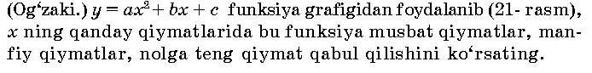
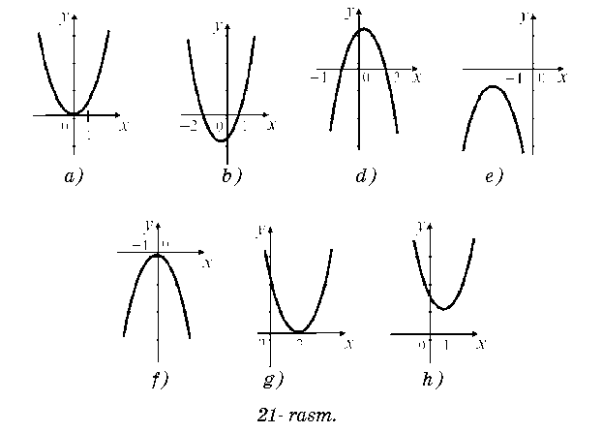
Javoblari: a)Funksiya x>0 da musbat, x<0 da manfiy va x=0 da nolga teng bo’ladi.
b)x<-2 va x>1da musbat, -2<x<1 da manfiy qiymatlar qabul qiladi.
- Yangi mavzuning bayoni.
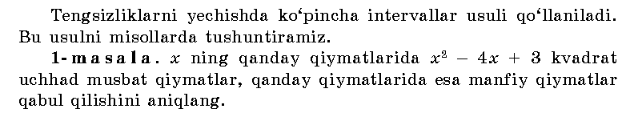
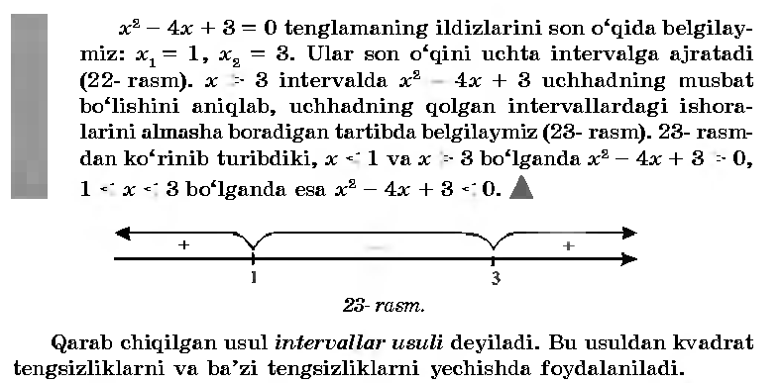
IV.Mustahkamlash.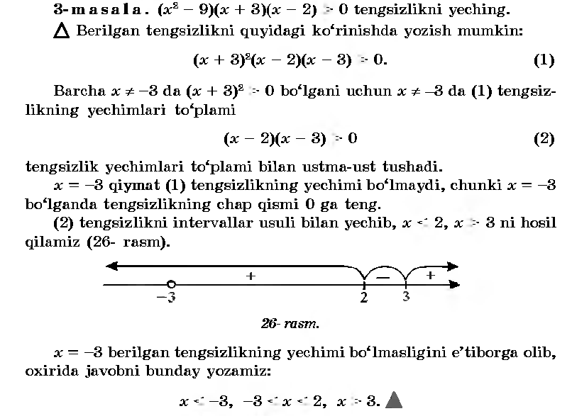
V.Baholash
VI.Uyga vazifa. 88- 89 –misollar
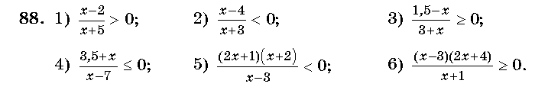

Sana
Sinf: 9-sinf
Fan: Algebra
Mavzu: Misollar yechish №90-93.
Maqsad: a) ta’limiy: O’quvchilarga kvadrat tengsizlikni intervallar usuli bilan yechishni puxta o’rgatish orqali bilim, malaka va ko’nikma hosil qilish;
b) tarbiyaviy: Oquvchilarni shu mavzu asosida o’zaro hurmat ruhida tarbiyalash;
c) rivojlantiruvchi: o’quvchilar bilimini rivojlantirish, ko’nikma va malakasini o’stirish, dunyoqarashi va fikrlash qobiliyatini riviojlantirish.
Dars turi: Aralash dars
Dars uslubi : Savol- javob
Darsning borishi
- Tashkiliy qism.
Salomlashish. Navbatchi o’quvchining o’quvchilar davomati, ob-havo, o’quvchilarning darsga tayyorligi to’g’risidagi axborotini tinglash.
- O’tilgan mavzuni so’rash
Uyga vazifalarni tekshirish.
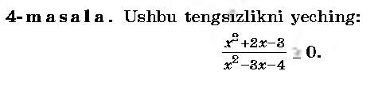
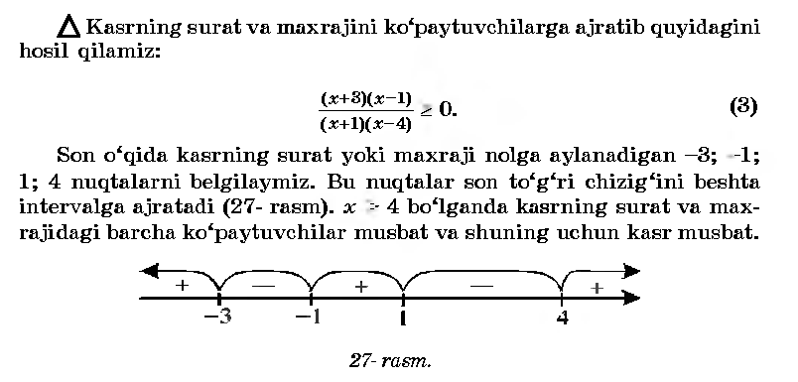
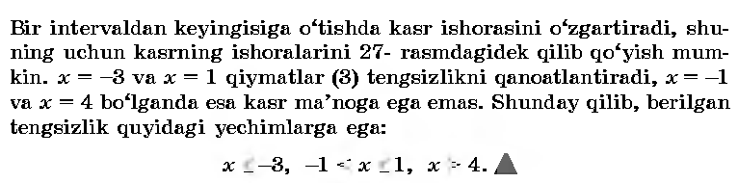
- Yangi mavzuning bayoni.
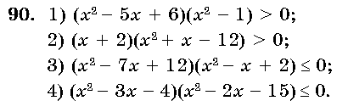
Javoblari: 1) x²-5x+6=0; x₁=2; x₂=3;
x²-1=0; x₃=1.
Javob: 1<x<2 va x>3
2) x+2=0 x₁=-2;
x²+x-12=0 x₂=-4; x₃=3.
Javob: -4<x<-2 va x>3
3) x²-7x+12=0 x₁=3; x₂=4
x²-x+2=0 x€R
javob: 3≤ x ≤ 4
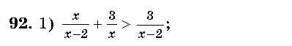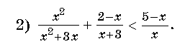
x²+3(x-2)>3x x²+x(2-x)<(5-x)(x+3)
x²+3x-6-3x>0 x²+2x- x²< 15+2x- x²
x²-6>0 J: x<; x>. x²-15<0 J: -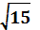< x <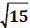 .
IV.Mustahkamlash.
(x²-7x-8)( x²-64)<0 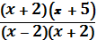 > 0
x²-7x-8=0 x₁=8; x₂= -1. (x+5)(x-2)>0
x²-64≠0 x≠ ±8 x₁= -5; x₂≠2
demak, x= -1 va x≠ -8

javob: -8< x < -1 javob: x<-5 va x>2

V. Baholash .
VI.Uyga vazifa. 94-95 –misollar.

Sana:
Sinf: 9-sinf
Fan: Algebra
Mavzu: Kvadrat tengsizlikka olib keladigan sodda masalalar.
Maqsad: a) ta’limiy: O’quvchilarga kvadrat tengsizlikka olib keladigan sodda masalalar yechishni puxta o’rgatish orqali bilim, malaka va ko’nikma hosil qilish;
b) tarbiyaviy: Oquvchilarni shu mavzu asosida o’zaro hurmat ruhida tarbiyalash;
c) rivojlantiruvchi: o’quvchilar bilimini rivojlantirish, ko’nikma va malakasini o’stirish, dunyoqarashi va fikrlash qobiliyatini riviojlantirish.
Dars turi: Aralash dars
Dars uslubi : Savol- javob
Darsning borishi
- Tashkiliy qism.
Salomlashish. Navbatchi o’quvchining o’quvchilar davomati, ob-havo, o’quvchilarning darsga tayyorligi to’g’risidagi axborotini tinglash.
- O’tilgan mavzuni so’rash
Uyga vazifalarni tekshirish.
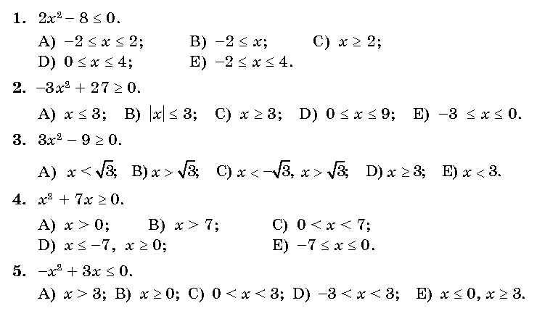
Kaliti: 1-A, 2-B, 3-C, 4-D, 5-E.
- Yangi mavzuning bayoni.
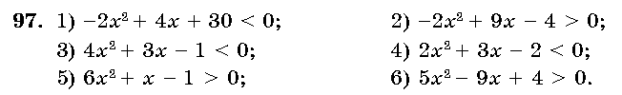
_________________________________________________________________________________________________________________________________________________________________________________________________________________________________________________________________________________________________________________________________________________________________________________________________________________________________________________________________________________________________________________________________________________________________________________________________________________________________________________________________________________________________________________________________________________________________________________________________________________________________________________________________________________________________________________________________________________________________________________________________________________________________________
IV.Mustahkamlash.
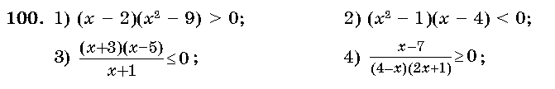
Yechilishi:
___________________________________________________________________________________________________________________________________________________________________________________________________________________________________________________________________________________________________________________________________________________________________________________________________________________________________________________________________________________________________________________________________________________________________________________________________________________________________________________________________________________________________________________________________________________
____________________________________________________________________________________________________________________________________________________________________________________________________________________________________________________________________
V. Baholash .
VI.Uyga vazifa. 101- 102 –misollar.

Sana:
Sinf: 9-sinf
Fan: Algebra
Mavzu: Misollar yechish №103- 106
Maqsad: a) ta’limiy: O’quvchilarga kvadrat tengsizlikka olib keladigan sodda masalalar yechishni puxta o’rgatish orqali bilim, malaka va ko’nikma hosil qilish;
b) tarbiyaviy: Oquvchilarni shu mavzu asosida o’zaro hurmat ruhida tarbiyalash;
c) rivojlantiruvchi: o’quvchilar bilimini rivojlantirish, ko’nikma va malakasini o’stirish, dunyoqarashi va fikrlash qobiliyatini riviojlantirish.
Dars turi: Aralash dars
Dars uslubi : Savol- javob
- Tashkiliy qism.
Salomlashish. Navbatchi o’quvchining o’quvchilar davomati, ob-havo, o’quvchilarning darsga tayyorligi to’g’risidagi axborotini tinglash.
- O’tilgan mavzuni so’rash
Uyga vazifalarni tekshirish.
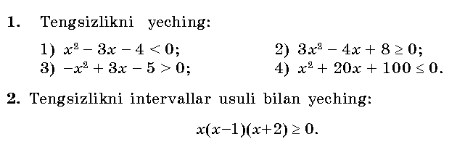
________________________________________________________________________________________________________________________________________________________________________________________________________________________________________________________________________________________________________________________________________________________________________________________________________________________________________________________________________________________________________________________________________________________________________________________________________________________________________________________________________________________________________________________________________________________________________________________________________________________________________________
- Yangi mavzuning bayoni.
_________________________________________________________________________________________________________________________________________________________________________________________________________________________________________________________________________________________________________________________________________________________________________________________________________________________________________________________________________________________________________________________________________________________________________________________________________________________________________________________________________________________________________________________________________________________________________
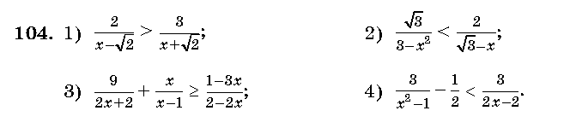 _____________________________________________________________________________________________________________________________________________________________________________________________________________________________________________________________________________________________________________________________________________________________________________________________________________________________________________________________________________________________________________________________________________________________________________________________________________________________________________________________________________________________________________________________________________________________________________________________________________________________________________
IV.Mustahkamlash.
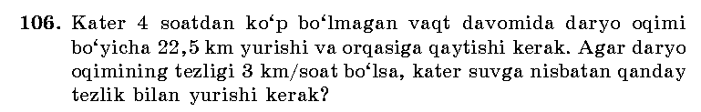
Yechilishi:
____________________________________________________________________________________________________________________________________________________________________________________________________________________________________________________________________________________________________________________________________________________________________________________________________________
V. Baholash .
VI.Uyga vazifa. 108 –misol .

Sana:
Sinf: 9-sinf
Fan: Algebra
Mavzu: Misollar yechish. 1-9-testlar.
Maqsad: a) ta’limiy: O’quvchilarga kvadrat tengsizlikka olib keladigan sodda masalalar yechishni puxta o’rgatish orqali bilim, malaka va ko’nikma hosil qilish;
b) tarbiyaviy: Oquvchilarni shu mavzu asosida o’zaro hurmat ruhida tarbiyalash;
c) rivojlantiruvchi: o’quvchilar bilimini rivojlantirish, ko’nikma va malakasini o’stirish, dunyoqarashi va fikrlash qobiliyatini riviojlantirish.
Dars turi: Aralash dars
Dars uslubi : Savol- javob
Darsning borishi
- Tashkiliy qism.
Salomlashish. Navbatchi o’quvchining o’quvchilar davomati, ob-havo, o’quvchilarning darsga tayyorligi to’g’risidagi axborotini tinglash.
- O’tilgan mavzuni so’rash
Uyga vazifalarni tekshirish.
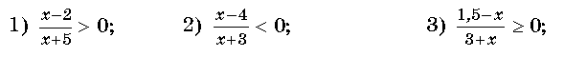
________________________________________________________________________________________________________________________________________________________________________________________________________________________________________________________________________________________________________________________________________________________________________________________________________________________________________________________________________________________________
_______________________________________________________________________________________________________________________________________________________________________________________________________________
- Yangi mavzuning bayoni.
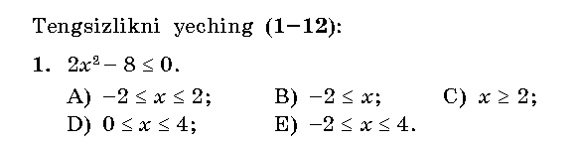
______________________________________________________________________________________________________________________________________________________________________________________________________________________________________________________________________________________________________________________________________________________________________________________________
________________________________________________________________________________
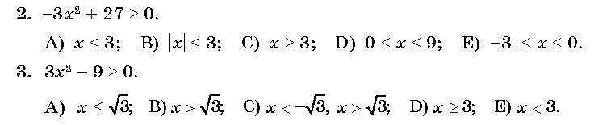
_______________________________________________________________________________________________________________________________________________________________________________________________________________________________________________________________________________________________________________________________________________________________________________________________________________________________________________________________________________________________________________________________________________________________________________________________________________________________________________________________
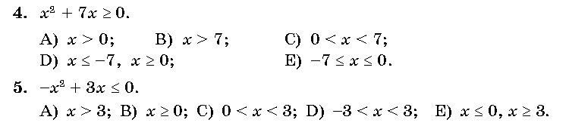 ________________________________________________________________________________________________________________________________________________________________________________________________________________________________________________________________________________________________________________________________________________________________________________________________________________________________________________________________________________________________________________________________________________________________________________________________________________________________________________________________
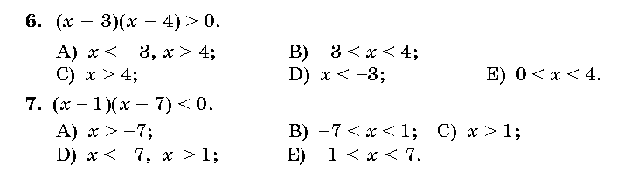 ______________________________________________________________________________________________________________________________________________________________________________________________________________________________________________________________________________________________________________________________________________________________________________________________________________________________________________________________________________
IV.Mustahkamlash
V. Baholash .
VI.Uyga vazifa. 10- 12-testlar.
Sana: _________________ Sinf: 9-sinf
Fan: Algebra
Mavzu: Nazorat ishi
Maqsad: a) ta’limiy: O’quvchilarning kvadrat tengsizlik va uning yechimini topishga doir bilimlarini tekshirish;
b) tarbiyaviy: Oquvchilarni shu mavzu asosida milliy istiqlol ruhida va o’zaro hurmat ruhida tarbiyalash;
c) rivojlantiruvchi: o’quvchilar bilimini rivojlantirish, ko’nikma va malakasini o’stirish, fikrlash qobiliyatini riviojlantirish.
Dars turi: O’quvchilar bilimini tekshirish
Dars uslubi : Yozma ish
Tashkiliy qism.
Salomlashish. Navbatchining o’quvchilar davomati, darsga tayyorligi to’g’risidagi axborotini tinglash.
Darsning borishi:
I variant
1.Tengsizlikni algebraik usulda yeching:
(6-2a)(5a-10)<0
2.Tengsizlikni kvadrat funksiyaning grafigi yordamida yeching:
-2+3x-x²>0
3.Kvadrat tengsizlikni intervallar usulida yeching:
3x²-5x+2≤ 0
4.Tengsizlikni yeching: 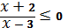
5.y=x²+3x-5 funksiyaning qiymatlar to’plamini toping.
II variant
1.Tengsizlikni algebraik usulda yeching:
(2-a)(2a-5)<0
2.Tengsizlikni kvadrat funksiyaning grafigi yordamida yeching:
4+3x-x²>0
3.Kvadrat tengsizlikni intervallar usulida yeching:
3x²-5x+2≥ 0
4.Tengsizlikni yeching: 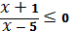
5.y=-x²+5x-2 funksiyaning qiymatlar to’plamini toping.
UYGA VAZIFA. Takrorlash

Sana:
Sinf: 9-sinf
Fan: Algebra
Mavzu: Butun ko’rsatkichli daraja va uning xossalari
Maqsad: a) ta’limiy: O’quvchilarga butun ko’rsatkichli daraja va uning xossalari ni o’rgatish orqali bilim, malaka va ko’nikma hosil qilish;
b) tarbiyaviy: Oquvchilarni shu mavzu asosida milliy istiqlol ruhida va o’zaro hurmat ruhida tarbiyalash;
c) rivojlantiruvchi: o’quvchilar bilimini rivojlantirish, ko’nikma va malakasini o’stirish, dunyoqarashi va fikrlash qobiliyatini riviojlantirish.
Dars turi: Yangi bilim berish
Dars uslubi : Savol- javob
Darsning borishi
- Tashkiliy qism.
Salomlashish. Navbatchi o’quvchining o’quvchilar davomati, ob-havo, o’quvchilarning darsga tayyorligi to’g’risidagi axborotini tinglash.

- O’tilgan mavzuni so’rash
Uyga vazifalarni tekshirish.
Mustaqil ish: Tengsizliklarni yeching:
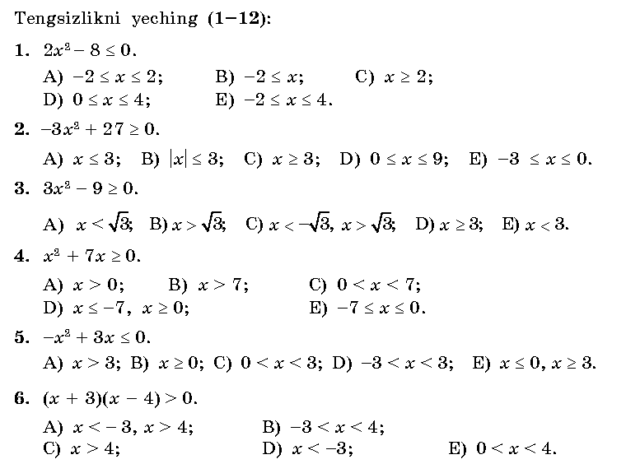_______________________________________________________________________________________________________________________________________________________________________________________________________________

- Yangi mavzuning bayoni
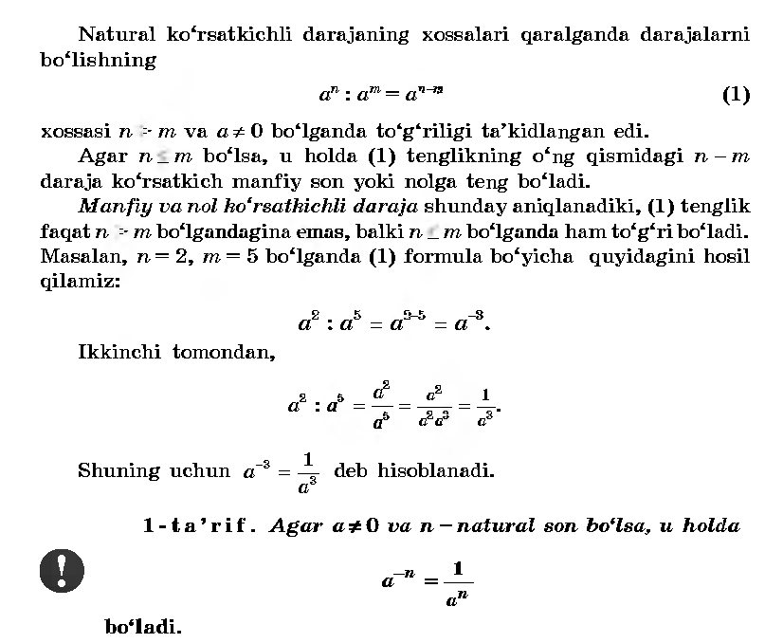
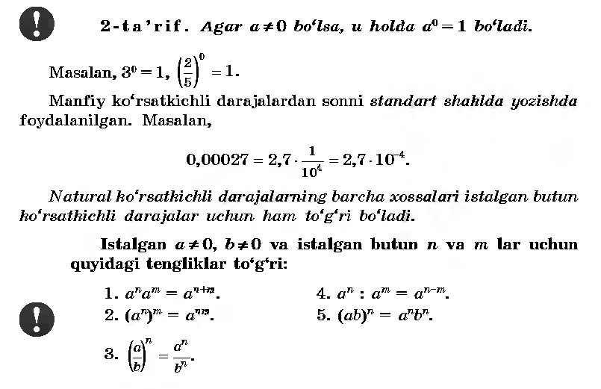
IV.Mustahkamlash.109-114 –misollar
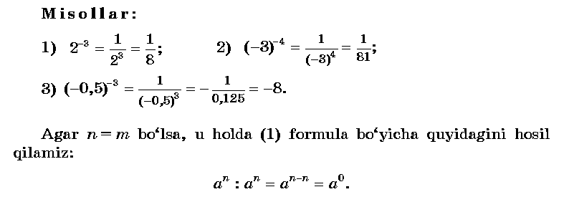
V.Baholash
VI.Uyga vazifa. 115-116 –misollar

Sana:
Sinf: 9-sinf
Fan: Algebra
Mavzu: Natural ko’rsatkichli darajaning arifmetik ildizi
Maqsad: a) ta’limiy: O’quvchilarga natural ko’rsatkichli darajaning arifmetik ildizi va uning xossalarini o’rgatish orqali bilim, malaka va ko’nikma hosil qilish;
b) tarbiyaviy: O’quvchilarni shu mavzu asosida o’zaro hurmat ruhida tarbiyalash;
c) rivojlantiruvchi: O’quvchilar bilimini rivojlantirish, ko’nikma va malakasini o’stirish, dunyoqarashi va fikrlash qobiliyatini riviojlantirish.
Dars turi: Yangi bilim berish
Dars uslubi : Savol- javob
Darsning borishi
- Tashkiliy qism.
Salomlashish. Navbatchi o’quvchining o’quvchilar davomati, ob-havo, o’quvchilarning darsga tayyorligi to’g’risidagi axborotini tinglash.
- O’tilgan mavzuni so’rash
Uyga vazifalarni tekshirish.
MUSTAQIL ISH:
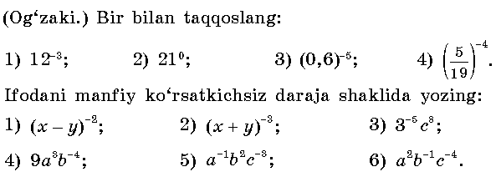
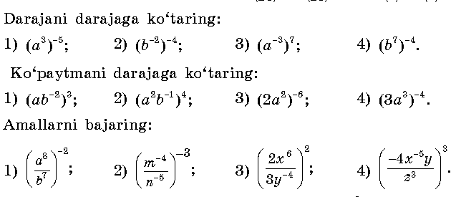__________________________________________________________________________________________________________________________________________________________________________________________________________________________________________________________________________________________________________________________________________________
- Yangi mavzuning bayoni
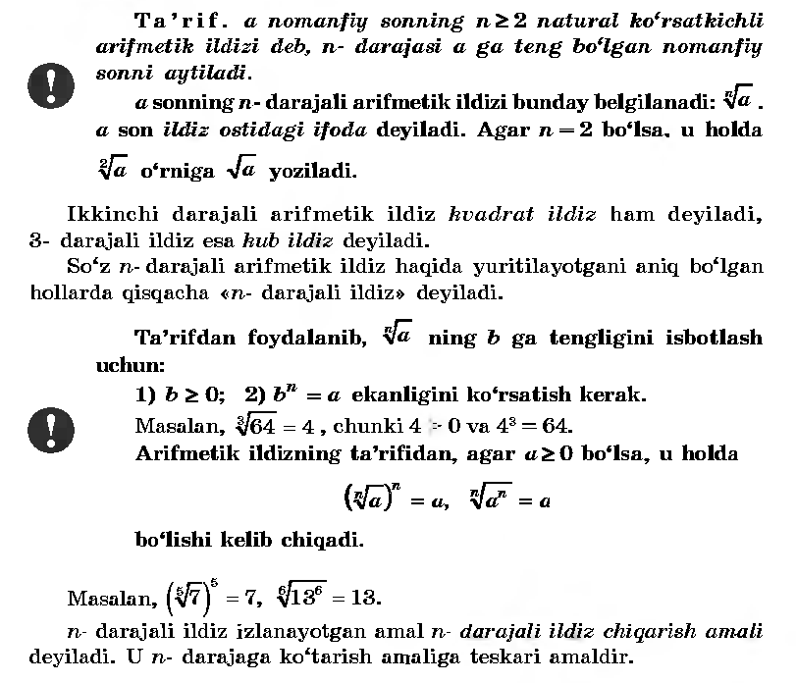
IV.Mustahkamlash.
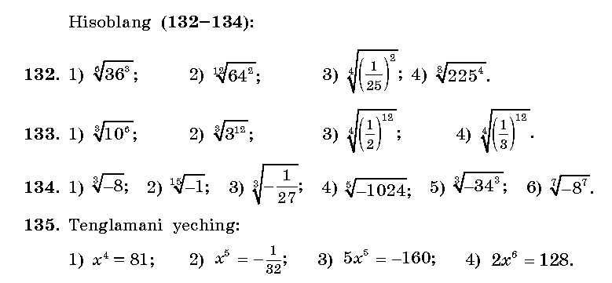
Yechish: _________________________________________________________________________________________________________________________________________________________________________________________________________________________________________________________________________________________________________________________________________________________________________________________________________________________________________________________________________________________
V.Baholash
VI. Uyga vazifa. 138- 139- misollar
Sana:
Sinf: 9-sinf
Fan: Algebra
Mavzu: Arifmetik ildizning xossalari
Maqsad: a) ta’limiy: O’quvchilarga arifmetik kvadrat ildiz va uning xossalarini o’rgatish orqali bilim, malaka va ko’nikma hosil qilish;
b) tarbiyaviy: Oquvchilarni shu mavzu asosida o’zaro hurmat ruhida tarbiyalash;
c) rivojlantiruvchi: o’quvchilar bilimini rivojlantirish, ko’nikma va malakasini o’stirish, dunyoqarashi va fikrlash qobiliyatini riviojlantirish.
Dars turi: Yangi bilim berish
Dars uslubi : Savol- javob
Darsning borishi
- Tashkiliy qism.
Salomlashish. Navbatchi o’quvchining o’quvchilar davomati, ob-havo, o’quvchilarning darsga tayyorligi to’g’risidagi axborotini tinglash.
- O’tilgan mavzuni so’rash
Uyga vazifalarni tekshirish.
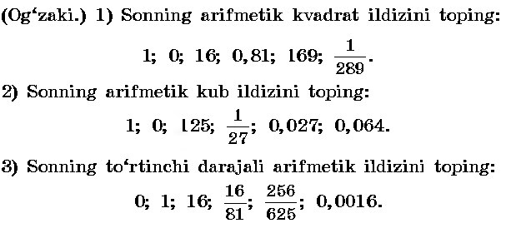
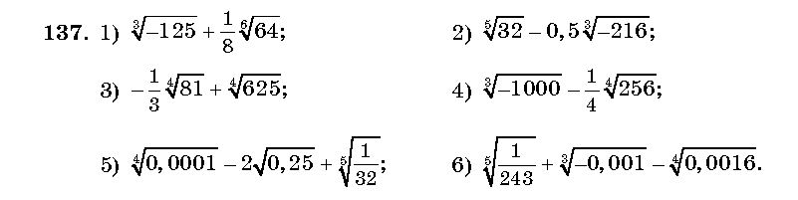________________________________________________________________________________________________________________________________________________________________________________________________________________________________________________________________________________
- Yangi mavzuning bayoni
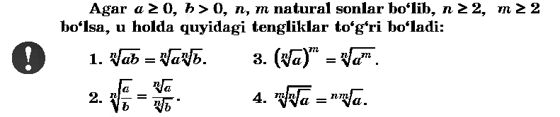
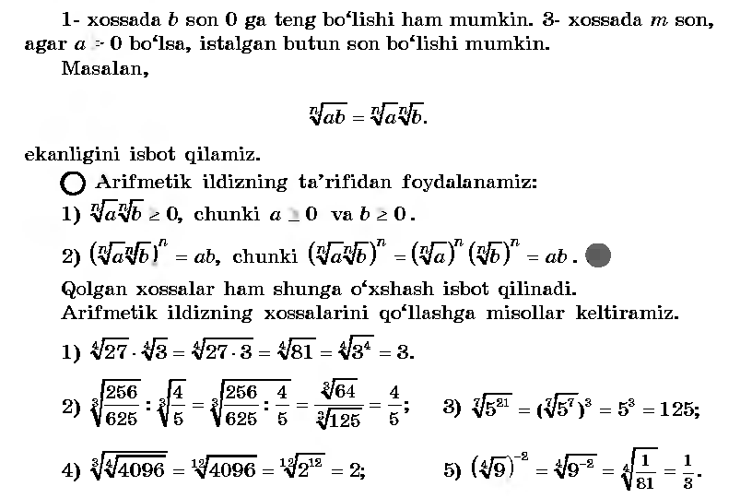
IV.Mustahkamlash. 141-145 –misollar
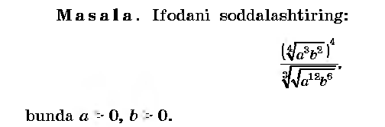
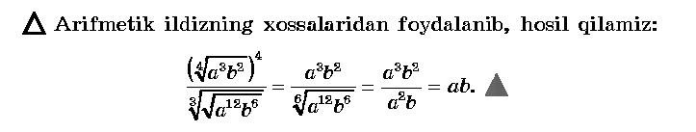
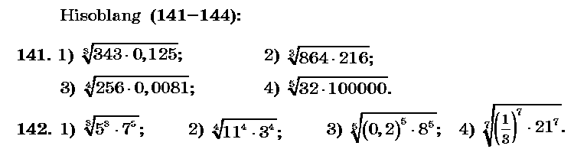________________________________________________________________________________________________________________________________________________________________________________________________________________________________________________________________________________
V.Baholash
VI.Uyga vazifa. 147- 149 –misollar
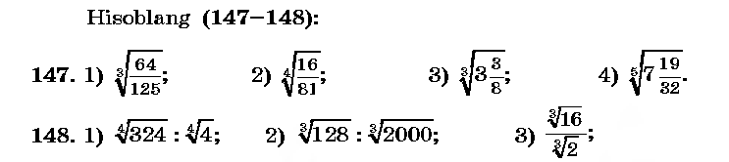
Sana:
Sinf: 9-sinf
Fan: Algebra
Mavzu: Misollar yechish №150-156.
Maqsad: a) ta’limiy: O’quvchilarga arifmetik kvadrat ildiz va uning xossalarini
o’rgatish orqali bilim, malaka va ko’nikma hosil qilish;
b) tarbiyaviy: Oquvchilarni shu mavzu asosida o’zaro hurmat ruhida
tarbiyalash;
c) rivojlantiruvchi: o’quvchilar bilimini rivojlantirish, ko’nikma va
malakasini o’stirish, dunyoqarashi va fikrlash qobiliyatini
riviojlantirish.
Dars turi: Aralash dars
Dars uslubi : Savol- javob
Darsning borishi
- Tashkiliy qism.
Salomlashish. Navbatchi o’quvchining o’quvchilar davomati, ob-havo, o’quvchilarning darsga tayyorligi to’g’risidagi axborotini tinglash.

- O’tilgan mavzuni so’rash
Uyga vazifalarni tekshirish.
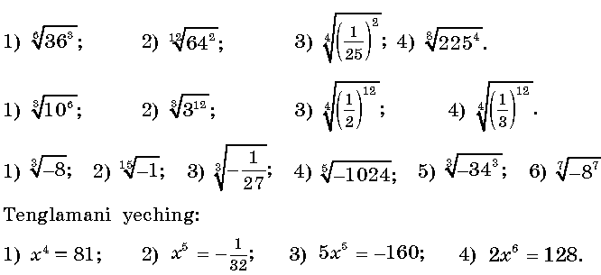______________________________________________________________________________________________________________________________________________________________________________________________________________________________________________________________________________________________________________________________________________________

- Yangi mavzuning bayoni. 150- 156-misollar
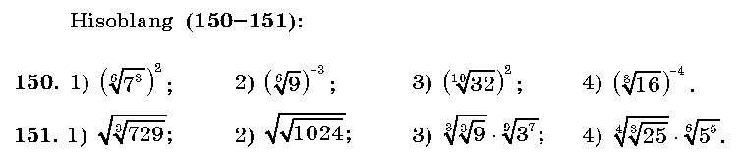_____________________________________________________________________________________________________________________________________________________________________________________________________________________________________________________________________________
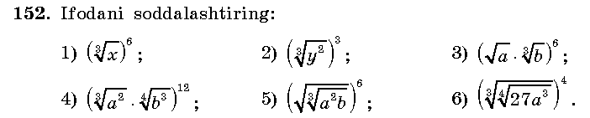__________________________________________________________________________________________________________________________________________________________________________________________________________
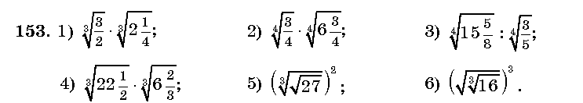_________________________________________________________________________________________________________________________________________________________________________________________________________
IV.Mustahkamlash.
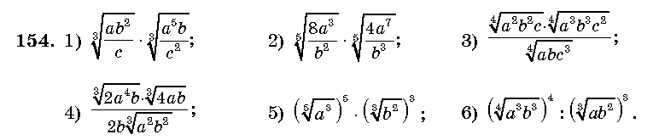_________________________________________________________________________________________________________________________________________________________________________________________________________________________________________________________________________________________________________________________________________________
V.Baholash
VI.Uyga vazifa. 157- 158 –misollar
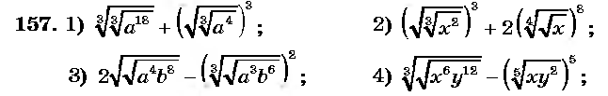_____________________________________________________________________________________________________________________________________

Sana:
Sinf: 9-sinf
Fan: Algebra
Mavzu: Ratsional ko’rsatkichli daraja
Maqsad: a) ta’limiy: O’quvchilarga ratsional ko’rsatkichli daraja va uning xossalarini o’rgatish orqali bilim, malaka va ko’nikma hosil qilish;
b) tarbiyaviy: O’quvchilarni shu mavzu asosida milliy istiqlol ruhida va o’zaro hurmat ruhida tarbiyalash;
c) rivojlantiruvchi: O’quvchilar bilimini rivojlantirish, ko’nikma va malakasini o’stirish, dunyoqarashi va fikrlash qobiliyatini rivojlantirish.
Dars turi: Yangi bilim berish.
Dars uslubi : Savol- javob
Darsning borishi
- Tashkiliy qism.
Salomlashish. Navbatchi o’quvchining o’quvchilar davomati, ob-havo, o’quvchilarning darsga tayyorligi to’g’risidagi axborotini tinglash.

- O’tilgan mavzuni so’rash
Uyga vazifalarni tekshirish.
Mustaqil ish: Soddalashtiring:
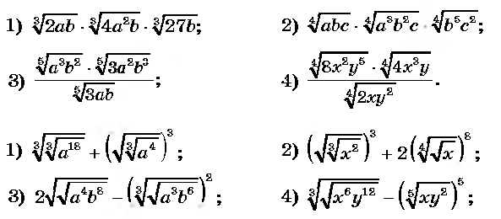____________________________________________________________________________________________________________________________________________________________________________________________________________________________________________________________________________________________________________________________________________________________________________________________________________________________________________________________________________________________
- Yangi mavzuning bayoni
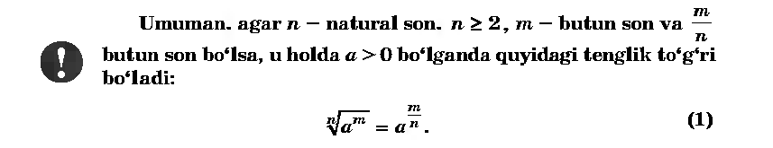
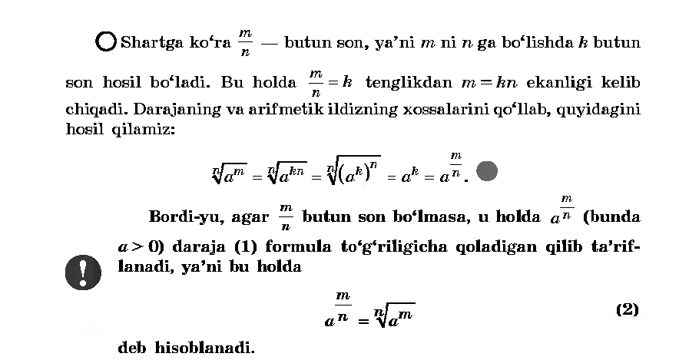
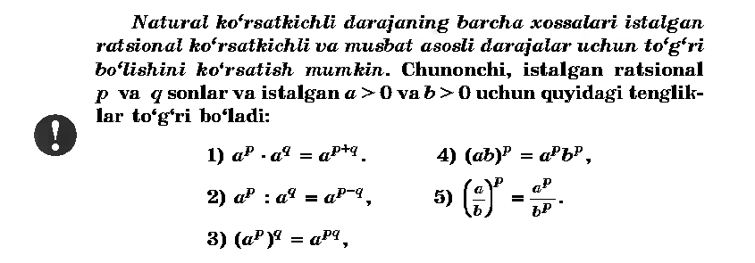
IV.Mustahkamlash.160-165 –misollar
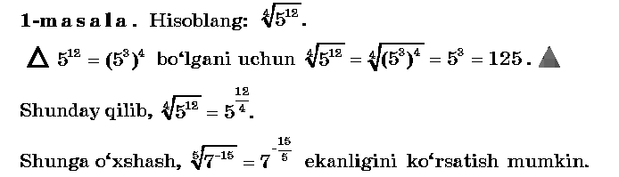
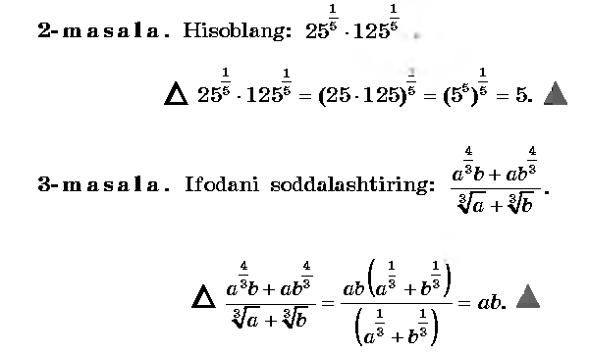
V.Baholash
VI.Uyga vazifa. 166-167 –misollar

Sana:
Sinf: 9-sinf
Fan: Algebra
Mavzu: Misollar yechish. №170- 173
Maqsad: a) ta’limiy: O’quvchilarga ratsional ko’rsatkichli daraja va uning xossalarini puxta o’rgatish orqali bilim, malaka va ko’nikma hosil qilish;
b) tarbiyaviy: O’quvchilarni shu mavzu asosida milliy istiqlol ruhida va o’zaro hurmat ruhida tarbiyalash;
c) rivojlantiruvchi: O’quvchilar bilimini rivojlantirish, ko’nikma va malakasini o’stirish, dunyoqarashi va fikrlash qobiliyatini riviojlantirish.
Dars turi: Aralash dars
Dars uslubi : Savol- javob
Darsning borishi
- Tashkiliy qism.
Salomlashish. Navbatchi o’quvchining o’quvchilar davomati, ob-havo, o’quvchilarning darsga tayyorligi to’g’risidagi axborotini tinglash.

- O’tilgan mavzuni so’rash
Uyga vazifalarni tekshirish.
Mustaqil ish: Tengsizliklarni yeching: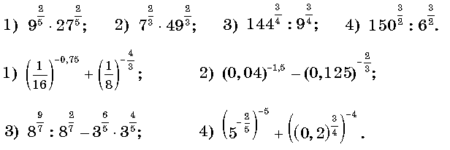
Yechimlari:
1)* ==9 ;
2) 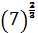 = 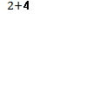 = 7²=49
3) 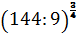 = = 2³= 8
- Yangi mavzuning bayoni
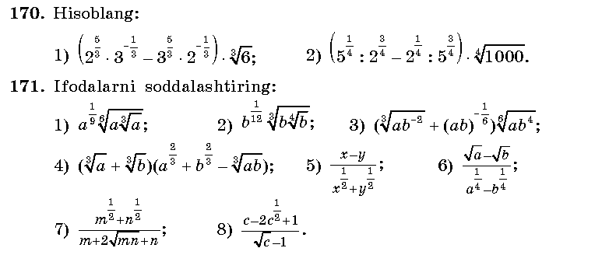
_________________________________________________________________________________________________________________________________________________________________________________________________________________________________________________________________________________________________________________________________________________________________________________________________________________________________________________________________________________________________
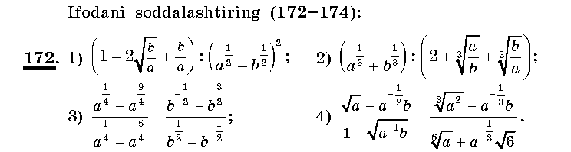_________________________________________________________________________________________________________________________________________________________________________________________________________________________________________________________________________________________________________________________________________________________________________________________________________________________________________________________________________________________________
IV.Mustahkamlash.
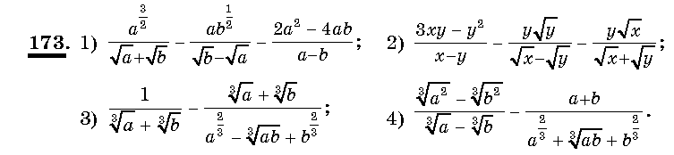___________________________________________________________________________________________________________________________________________________________________________________________________________________________________________________________________________________________________________________________________________________V.Baholash
VI.Uyga vazifa. 174–misol
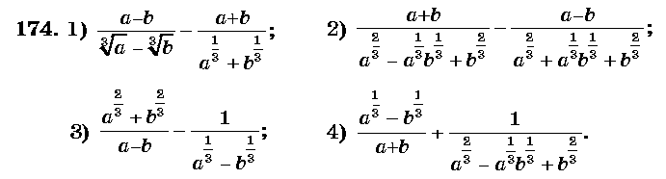

Sana:
Sinf: 9-sinf
Fan: Algebra
Mavzu: Irratsional daraja haqida tushuncha
Maqsad: a) ta’limiy: O’quvchilarga irratsional ko’rsatkichli daraja va uning xossalarini puxta o’rgatish orqali bilim, malaka va ko’nikma hosil qilish;
b) tarbiyaviy: O’quvchilarni shu mavzu asosida milliy istiqlol ruhida va o’zaro hurmat ruhida tarbiyalash;
c) rivojlantiruvchi: O’quvchilar bilimini rivojlantirish, ko’nikma va malakasini o’stirish, dunyoqarashi va fikrlash qobiliyatini riviojlantirish.
Dars turi: Yangi bilim berish
Dars uslubi : Savol- javob
Darsning borishi
- Tashkiliy qism.
Salomlashish. Navbatchi o’quvchining o’quvchilar davomati, ob-havo, o’quvchilarning darsga tayyorligi to’g’risidagi axborotini tinglash.

- O’tilgan mavzuni so’rash
Uyga vazifalarni tekshirish. Mustaqil ish:
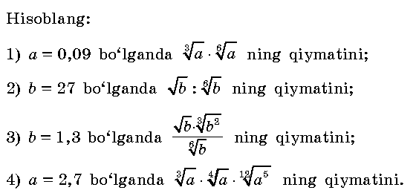
Yechimlari:
- *=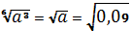 = 0,3
2)
3)
- Yangi mavzuning bayoni
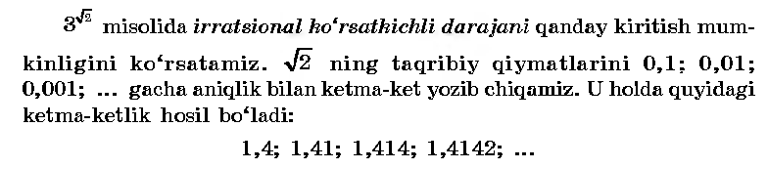
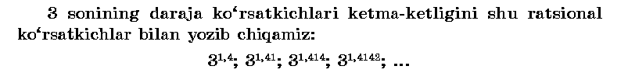

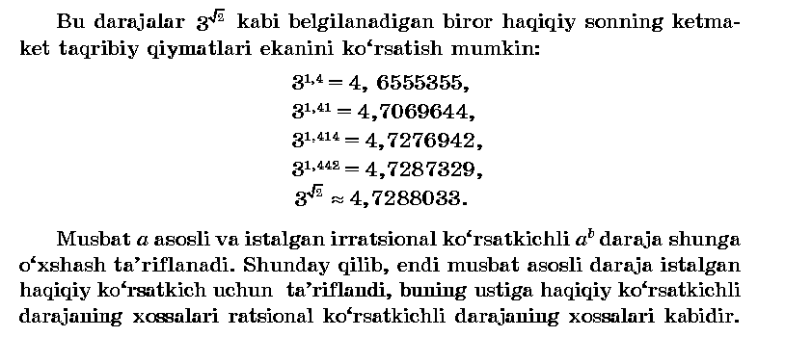
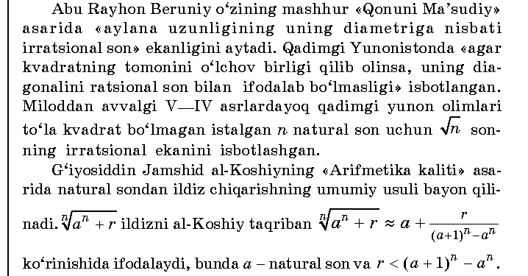
IV.Mustahkamlash.
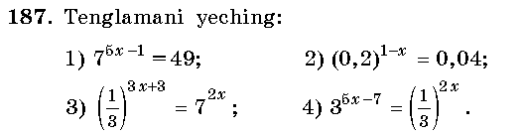
______________________________________________________________________________________________________________________________________________________________________________________________________________________________________________________________________________________________________________________________________________________________________________________________________________________________________________________________________________________________________
V.Baholash
VI.Uyga vazifa. 190 –misol

Sana
Sinf: 9-sinf
Fan: Algebra
Mavzu: Sonli tengsizliklarni darajaga ko’tarish
Maqsad: a) ta’limiy: O’quvchilarga sonli tengsizliklarni darajaga ko’tarishni puxta o’rgatish orqali bilim, malaka va ko’nikma hosil qilish;
b) tarbiyaviy: O’quvchilarni shu mavzu asosida milliy istiqlol ruhida va o’zaro hurmat ruhida tarbiyalash;
c) rivojlantiruvchi: O’quvchilar bilimini rivojlantirish, ko’nikma va malakasini o’stirish, dunyoqarashi va fikrlash qobiliyatini riviojlantirish.
Dars turi: Yangi bilim berish
Dars uslubi : Savol- javob
Darsning borishi
- Tashkiliy qism.
Salomlashish. Navbatchi o’quvchining o’quvchilar davomati, ob-havo, o’quvchilarning darsga tayyorligi to’g’risidagi axborotini tinglash.

- O’tilgan mavzuni so’rash
Uyga vazifalarni tekshirish. Mustaqil ish:
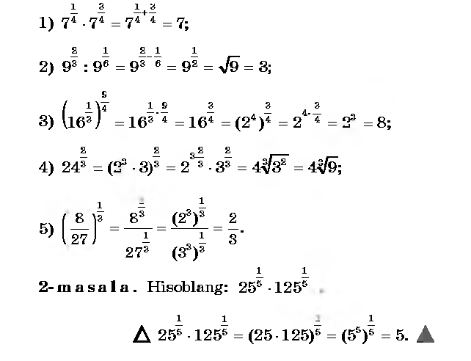
- Yangi mavzuning bayoni
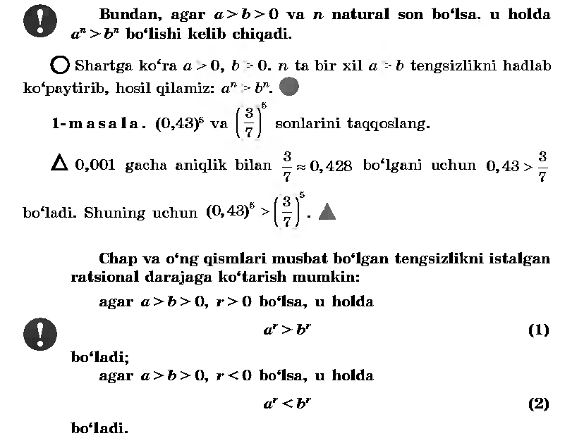
IV.Mustahkamlash.
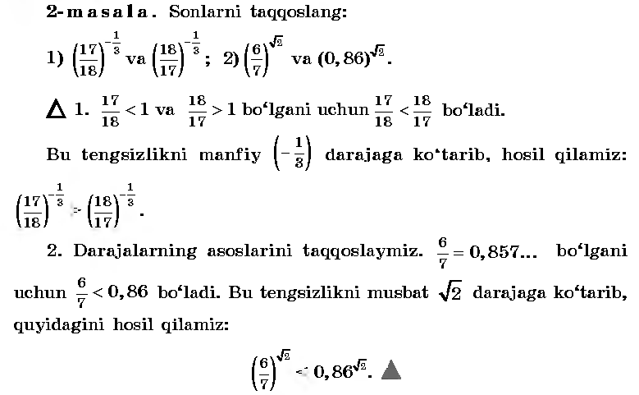
V.Baholash
VI.Uyga vazifa. 181-182 –misollar

Sana:
Sinf: 9-sinf
Fan: Algebra
Mavzu: Misollar yechish №183- 187.
Maqsad: a) ta’limiy: O’quvchilarga sonli tengsizliklarni darajaga ko’tarishni puxta o’rgatish orqali bilim, malaka va ko’nikma hosil qilish;
b) tarbiyaviy: O’quvchilarni shu mavzu asosida milliy istiqlol ruhida va o’zaro hurmat ruhida tarbiyalash;
c) rivojlantiruvchi: O’quvchilar bilimini rivojlantirish, ko’nikma va malakasini o’stirish, dunyoqarashi va fikrlash qobiliyatini riviojlantirish.
Dars turi: Aralash dars
Dars uslubi : Savol- javob
Dars jihozi: darslik, tarqatmalar, rangli kartochkalar.
Darsning borishi
- Tashkiliy qism.
Salomlashish. Navbatchi o’quvchining o’quvchilar davomati, ob-havo, o’quvchilarning darsga tayyorligi to’g’risidagi axborotini tinglash.

- O’tilgan mavzuni so’rash
Uyga vazifalarni tekshirish.
Mustaqil ish:
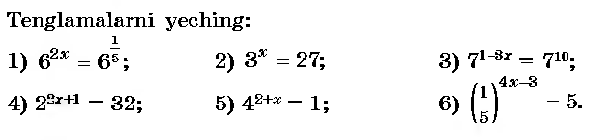
Yechilishi: 1) 2x=; x=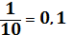. 2)x=3;
3)1-8x=10 ; 8x=-9; x=-. 4)3x+1=5 3x=4 x=;
5)2+x=0 x=- 2; 6)4x-3= -1 4x=2 x=0,5.

- Yangi mavzuning bayoni
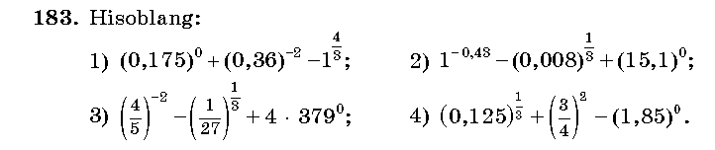
Yechilishi: 1)1+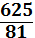 -1= = 7 ; 2)1-0,2+1= - 0,2;
3)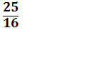 -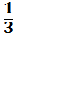 +4=+4= 4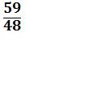; 4)0,5+ - 1= 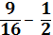 = .
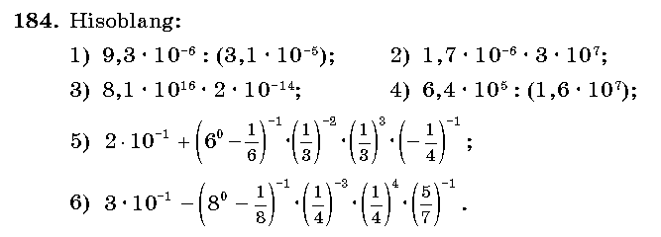
Yechilishi: 1)9,3: 3,1=3; 2) 1,7*3*10= 51;
- 8,1*10²*2= 1620; 4)6,4:(1,6*100)= 4:100= 0,04;
5)0,2+ 1,2*9* *(-4)= 0,2- 1,6= - 1,4;
6)0,3 - * 64** = 0,3- 0,4= -0,1.
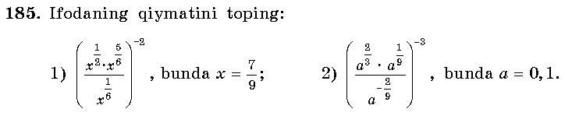
Yechish: 1) ( ) ⁻²= 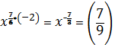
- ( 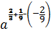) ⁻³= 10³=1000.
IV.Mustahkamlash.
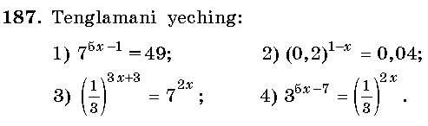
Yechilishi: 1)5x-1=2 5x=3 x=0,6.
2)1-x=2 -x=1 x= -1;
3)3x+3= -2x 3x+2x=-3 5x= -3 x= -0,6;
4)5x-7= -2x 5x+2x=7 7x=7 x=1.
V.Baholash
VI.Uyga vazifa. 188-189 –misollar.
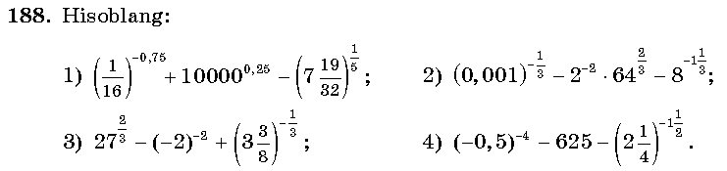

Sana:
Sinf: 9-sinf
Fan: Algebra
Mavzu: Nazorat ishi
Maqsad: a) ta’limiy: O’quvchilarning butun ko’rsatkichli, ratsional ko’rsatkichli darajalar va ularning xossalari, arifmetik kvadrat ildiz, sonly tengsizlikni darajaga ko’tarishga doir bilimlarini tekshirish;
b) tarbiyaviy: Oquvchilarni shu mavzu asosida milliy istiqlol ruhida va o’zaro hurmat ruhida tarbiyalash;
c) rivojlantiruvchi: o’quvchilar bilimini rivojlantirish, ko’nikma va malakasini o’stirish, fikrlash qobiliyatini riviojlantirish.
Dars turi: O’quvchilar bilimini tekshirish
Dars uslubi : Yozma ish
- Tashkiliy qism.
Salomlashish. Navbatchining o’quvchilar davomati, darsga tayyorligi to’g’risidagi axborotini tinglash.
Darsning borishi:
I variant
1.Hisoblang: 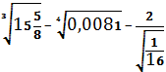
2. Hisoblang: 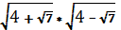
3.Ifodaning qiymatini toping: 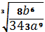; bunda a=2, b=1, a≠0.
4.Tengsizlikni yeching: >0
5.Tenglamani yeching: .
II variant
1.Hisoblang: 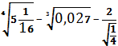
2. Hisoblang: 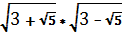
3.Ifodaning qiymatini toping: 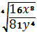; bunda x=1, y=2, y>0.
4.Tengsizlikni yeching: <0
5.Tenglamani yeching: .
Yechimlari:
I variant

1.Hisoblang: =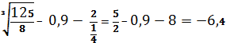
2. Hisoblang: =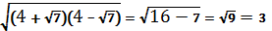 3
3.Ifodaning qiymatini toping: 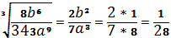; bunda a=2, b=1, a≠0.
4.Tengsizlikni yeching: >0
(9-x)(9+x)>0
9-x=0, 9+x=0
x₁=9; x₂=-9
javob: -9<x<9.
5.Tenglamani yeching: .
An.soha: x-1≠0, x+1≠0 bundan x≠1 va x≠ -1.
2(x+1)+ 3(x-1)=(x-1)(x+1)
2x+2+3x-3=x²-1
x²-5x=0 x(x-5)=0 x₁=0, x₂=5. Javob: 0 va 5.

II variant
1.Hisoblang: =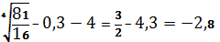
2. Hisoblang: =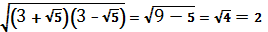
3.Ifodaning qiymatini toping: 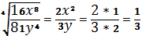; bunda x=1, y=2, y>0.
4. Tengsizlikni yeching: <0
(4-x)(4+x)<0
4-x=0; 4+x=0
x₁=4; x₂=-4
javob: x<-4, x>4.
5.Tenglamani yeching: .
An.soha: x-1≠0, x+1≠0 bundan x≠1 va x≠ -1.
2(x+1)+ 3(x-1)=(x-1)(x+1)
2x+2+3x-3=x²-1
x²-5x=0 x(x-5)=0 x₁=0, x₂=5. Javob: 0 va 5.

UYGA VAZIFA. Takrorlash

Sana:
Sinf: 9-sinf
Fan: Algebra
Mavzu: Funksiyaning aniqlanish sohasi
Maqsad: a) ta’limiy: O’quvchilarga funksiyaning aniqlanish sohasini topishni puxta o’rgatish orqali bilim, malaka va ko’nikma hosil qilish;
b) tarbiyaviy: O’quvchilarni shu mavzu asosida milliy istiqlol ruhida va o’zaro hurmat ruhida tarbiyalash;
c) rivojlantiruvchi: O’quvchilar bilimini rivojlantirish, ko’nikma va malakasini o’stirish, dunyoqarashi va fikrlash qobiliyatini riviojlantirish.
Dars turi: Yangi bilim berish
Dars uslubi : Savol- javob
Darsning borishi
- Tashkiliy qism.
Salomlashish. Navbatchi o’quvchining o’quvchilar davomati, ob-havo, o’quvchilarning darsga tayyorligi to’g’risidagi axborotini tinglash.

- O’tilgan mavzuni so’rash
Uyga vazifalarni tekshirish.
Mustaqil ish:
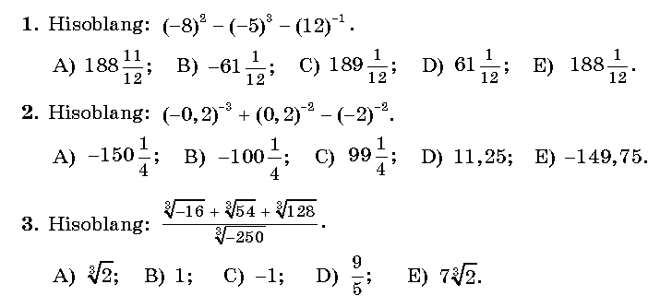
Javoblari: 1)64+125- = 189- = 188; A)
2)(- 5)³+ 5² – (- )² = -125+25 – 0,25= -100,25; B)
3) 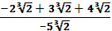 = = -1; C)
- Yangi mavzuning bayoni
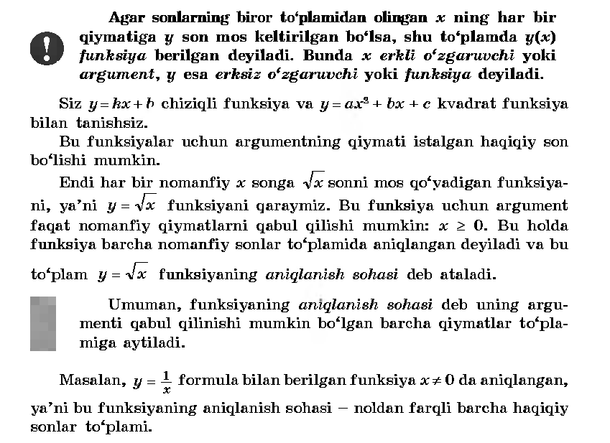
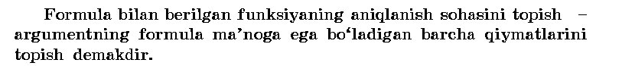
IV.Mustahkamlash.
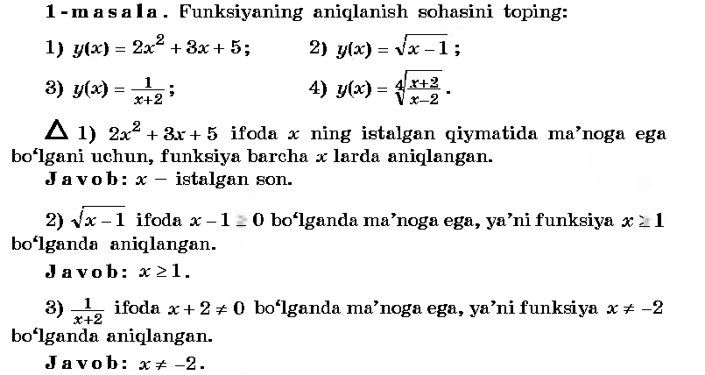
V.Baholash
VI.Uyga vazifa. 197-198 –misollar.

Sana:
Sinf: 9-sinf
Fan: Algebra
Mavzu: Funksiyaning o’sishi va kamayishi
Maqsad: a) ta’limiy: O’quvchilarga funksiyaning o’sishi va kamayish oraliqlarini topishni o’rgatish orqali bilim, malaka va ko’nikma hosil qilish;
b) tarbiyaviy: O’quvchilarni shu mavzu asosida milliy istiqlol ruhida va o’zaro hurmat ruhida tarbiyalash;
c) rivojlantiruvchi: O’quvchilar bilimini rivojlantirish, ko’nikma va malakasini o’stirish, dunyoqarashi va fikrlash qobiliyatini riviojlantirish.
Dars turi: Yangi bilim berish
Dars uslubi : Savol- javob
Darsning borishi
- Tashkiliy qism.
Salomlashish. Navbatchi o’quvchining o’quvchilar davomati, ob-havo, o’quvchilarning darsga tayyorligi to’g’risidagi axborotini tinglash.

- O’tilgan mavzuni so’rash
Uyga vazifalarni tekshirish.
Mustaqil ish:
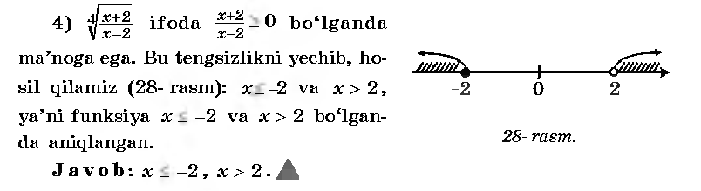
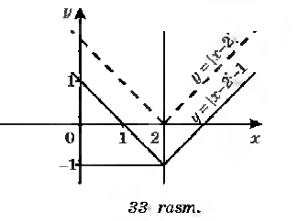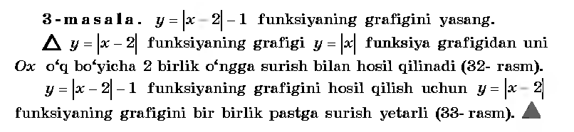
- Yangi mavzuning bayoni
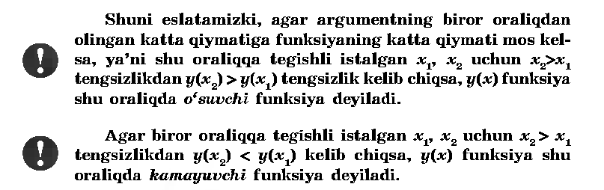
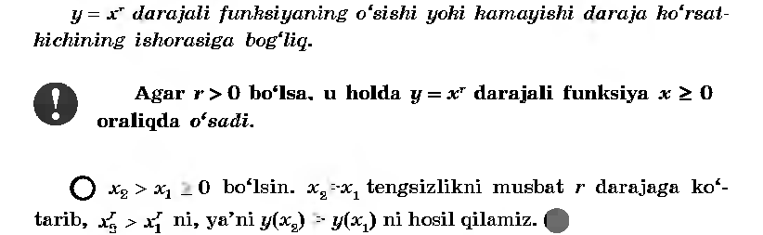
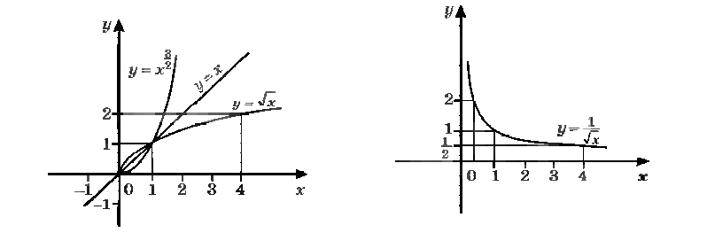
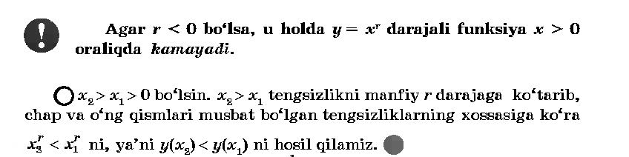
IV.Mustahkamlash.
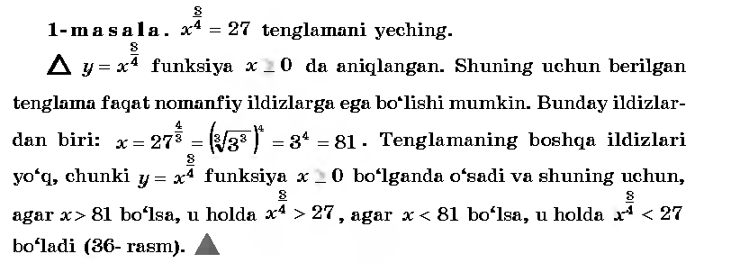
V.Baholash. VI.Uyga vazifa. 205-206 –misollar.

Sana: __.
Sinf: 9-sinf
Fan: Algebra
Mavzu: Funksiyaning juftligi va toqligi.
Maqsad: a) ta’limiy: O’quvchilarga funksiyaning juftligi va toqligini topishni o’rgatish orqali bilim, malaka va ko’nikma hosil qilish;
b) tarbiyaviy: O’quvchilarni shu mavzu asosida milliy istiqlol ruhida va o’zaro hurmat ruhida tarbiyalash;
c) rivojlantiruvchi: O’quvchilar bilimini rivojlantirish, ko’nikma va malakasini o’stirish, dunyoqarashi va fikrlash qobiliyatini riviojlantirish.
Dars turi: Yangi bilim berish
Dars uslubi : Savol- javob
Darsning borishi
- Tashkiliy qism.
Salomlashish. Navbatchi o’quvchining o’quvchilar davomati, ob-havo, o’quvchilarning darsga tayyorligi to’g’risidagi axborotini tinglash.

- O’tilgan mavzuni so’rash
Uyga vazifalarni tekshirish.
Mustaqil ish:
Yechilishi: 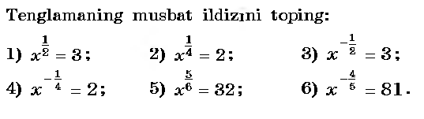
1)x=3² → x=9; 4) x=2⁻⁴ → x=
2) x=2⁴ → x=16; 5) x= → x=2⁶= 64;
3) x=3⁻² → x= ; 6) x= → x= 3⁻⁵= .
- Yangi mavzuning bayoni
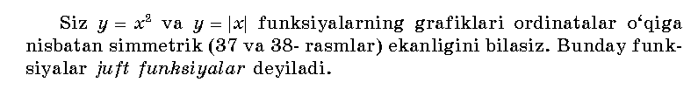
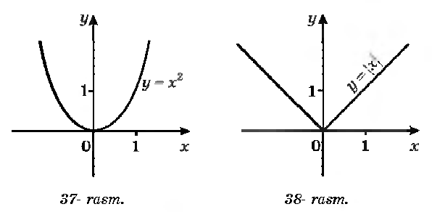
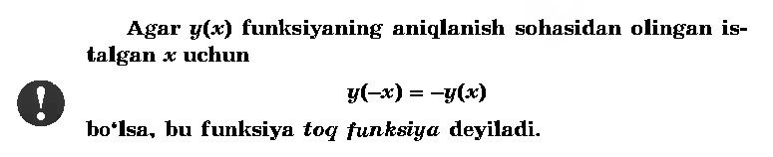
IV.Mustahkamlash.
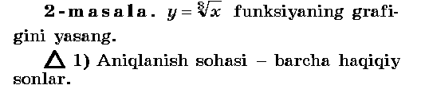
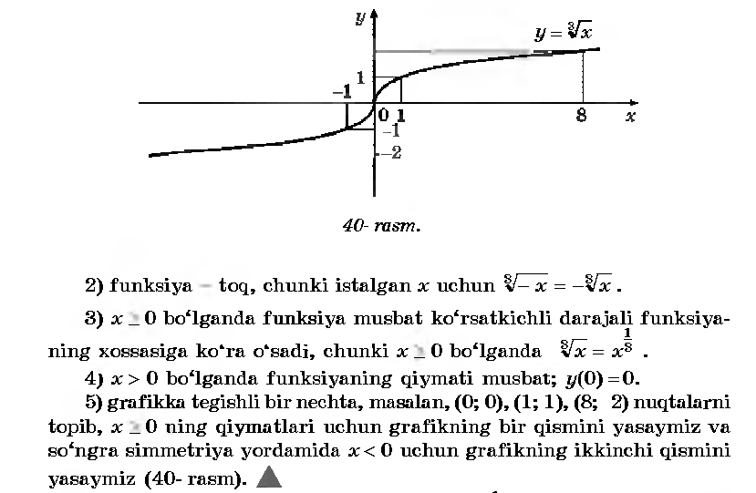
V.Baholash. VI.Uyga vazifa. 217-219 –misollar.

Sana:
Sinf: 9-sinf
Fan: Algebra
Mavzu: 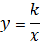 funksiya.
Maqsad: a) ta’limiy: O’quvchilarga funksiya va uning xossalarini o’rgatish orqali bilim, malaka va ko’nikma hosil qilish;
b) tarbiyaviy: O’quvchilarni shu mavzu asosida milliy g’oya ruhida va o’zaro hurmat ruhida tarbiyalash;
c) rivojlantiruvchi: O’quvchilar bilimini rivojlantirish, ko’nikma va malakasini o’stirish, dunyoqarashi va fikrlash qobiliyatini riviojlantirish.
Dars turi: Yangi bilim berish
Dars uslubi : Savol- javob
Darsning borishi
- Tashkiliy qism.
Salomlashish. Navbatchi o’quvchining o’quvchilar davomati, ob-havo, o’quvchilarning darsga tayyorligi to’g’risidagi axborotini tinglash.
- O’tilgan mavzuni so’rash
Uyga vazifalarni tekshirish.
Mustaqil ish: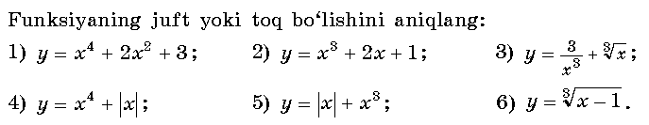
Javoblari: 1)y(-x)=(-x)⁴+2*(-x)²+3=x⁴+2x²+3 - juft f-ya;
2)y(-x)=(-x)³+2*(-x)+1=-x³-2x+1=-( x³+2x-1) – na juft, na toq f-ya;
3)y(-x)==-()- toq f-ya;
4)y(-x)=(-x)⁴+abs(-x)=x⁴+abs(x) – juft f-ya;
5)y(-x)=abs(-x)+(-x)³=abs(x)- x³= -(-abs(x)+x³) – na juft, na toq f-ya.
- Yangi mavzuning bayoni
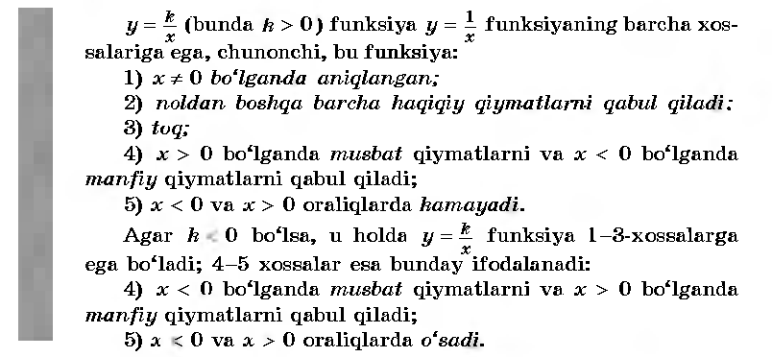
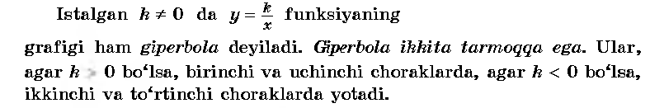
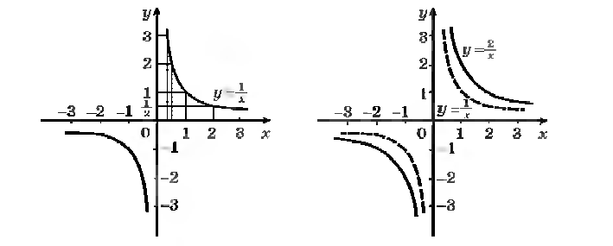
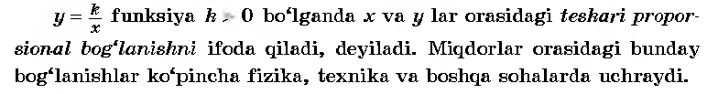
IV.Mustahkamlash.
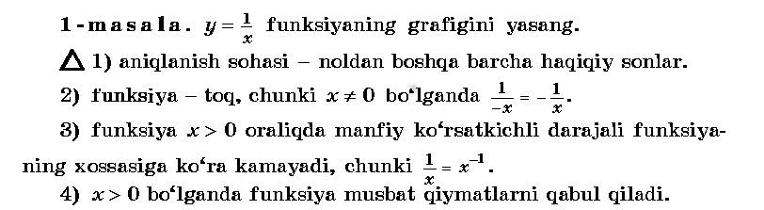
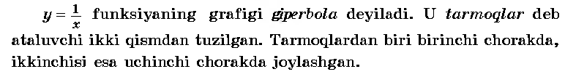
V.Baholash.
VI.Uyga vazifa. 222 –misol

Sana:
Sinf: 9-sinf
Fan: Algebra
Mavzu: .
Maqsad: a) ta’limiy: O’quvchilarga funksiya va uning xossalarini puxta o’rgatish orqali bilim, malaka va ko’nikma hosil qilish;
b) tarbiyaviy: O’quvchilarni shu mavzu asosida milliy g’oya ruhida va o’zaro hurmat ruhida tarbiyalash;
c) rivojlantiruvchi: O’quvchilar bilimini rivojlantirish, ko’nikma va malakasini o’stirish, dunyoqarashi va fikrlash qobiliyatini riviojlantirish.
Dars turi: Yangi bilim berish
Dars uslubi : Savol- javob
Darsning borishi
- Tashkiliy qism.
Salomlashish. Navbatchi o’quvchining o’quvchilar davomati, ob-havo, o’quvchilarning darsga tayyorligi to’g’risidagi axborotini tinglash.
- O’tilgan mavzuni so’rash
Uyga vazifalarni tekshirish.
Mustaqil ish:
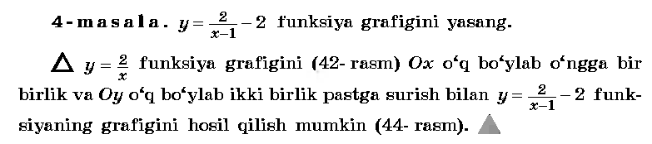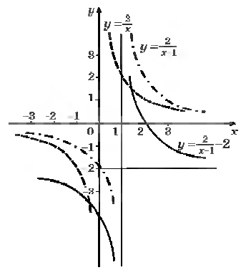
- Yangi mavzuning bayoni
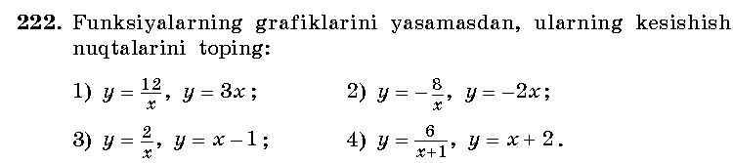________________________________________________________________________________________________________________________________________________________________________________________________________________________________________________________________________________________________________________________________________________________________________________________________________________________________________________________________________________________
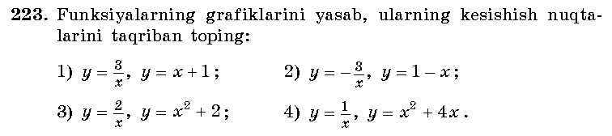

IV.Mustahkamlash.
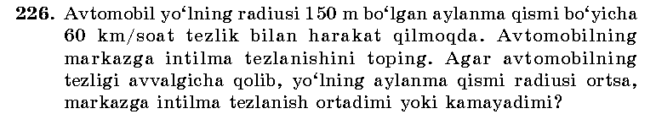
Yechish:______________________________________________________________________________________________________________________________________________________________________________________________________________________________________________________________
V.Baholash.
VI.Uyga vazifa. 227 –misol .

Sana:
Sinf: 9-sinf
Fan: Algebra
Mavzu: Daraja qatnashgan tenglama va tengsizliklar.
Maqsad: a) ta’limiy: O’quvchilarga daraja qatnashgan tenglama va tengsizliklarni yechishni o’rgatish orqali bilim, malaka va ko’nikma hosil qilish;
b) tarbiyaviy: O’quvchilarni shu mavzu asosida milliy g’oya ruhida va o’zaro hurmat ruhida tarbiyalash;
c) rivojlantiruvchi: O’quvchilar bilimini rivojlantirish, ko’nikma va malakasini o’stirish, dunyoqarashi va fikrlash qobiliyatini riviojlantirish.
Dars turi: Yangi bilim berish
Dars uslubi : Savol- javob
Darsning borishi
- Tashkiliy qism.
Salomlashish. Navbatchi o’quvchining o’quvchilar davomati, ob-havo, o’quvchilarning darsga tayyorligi to’g’risidagi axborotini tinglash.
- O’tilgan mavzuni so’rash
Uyga vazifalarni tekshirish.
Mustaqil ish:
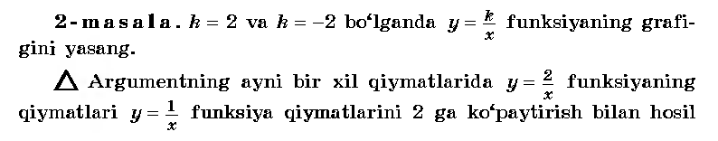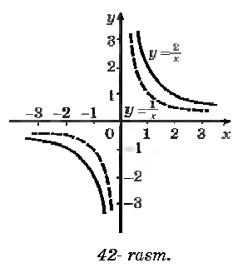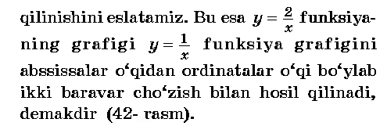

- Yangi mavzuning bayoni
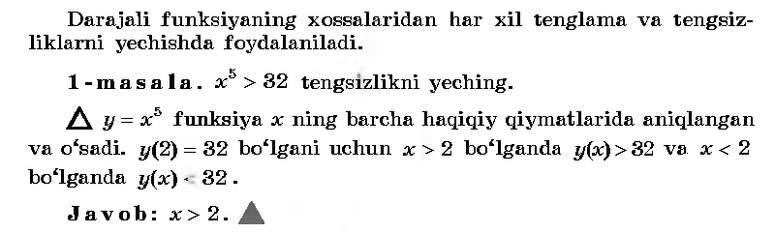
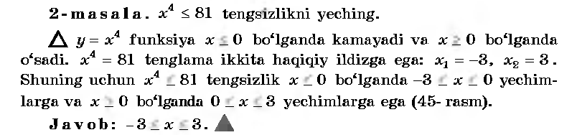
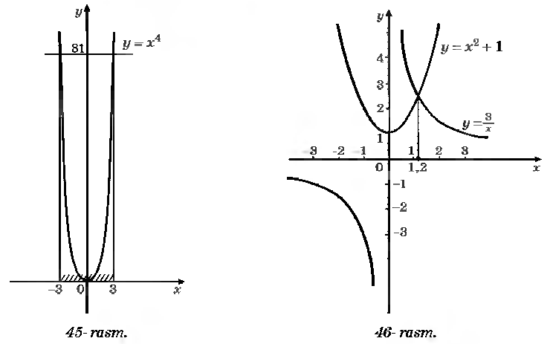
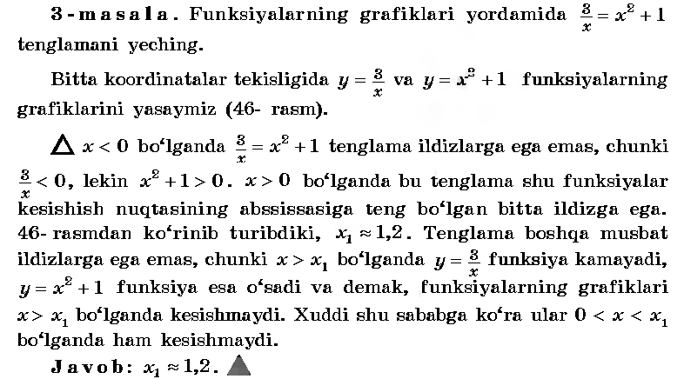
IV.Mustahkamlash.№232-233.
V.Baholash.
VI.Uyga vazifa. 234-236 –misollar .

Sana:
Sinf: 9-sinf
Fan: Algebra
Mavzu: Misollar yechish №237-243.
Maqsad: a) ta’limiy: O’quvchilarga daraja qatnashgan tenglama va tengsizliklarni yechishni o’rgatish orqali bilim, malaka va ko’nikma hosil qilish;
b) tarbiyaviy: O’quvchilarni shu mavzu asosida milliy g’oya ruhida va o’zaro hurmat ruhida tarbiyalash;
c) rivojlantiruvchi: O’quvchilar bilimini rivojlantirish, ko’nikma va malakasini o’stirish, dunyoqarashi va fikrlash qobiliyatini riviojlantirish.
Dars turi: Yangi bilim berish
Dars uslubi : Savol- javob
Darsning borishi
- Tashkiliy qism.
Salomlashish. Navbatchi o’quvchining o’quvchilar davomati, ob-havo, o’quvchilarning darsga tayyorligi to’g’risidagi axborotini tinglash.
- O’tilgan mavzuni so’rash
Uyga vazifalarni tekshirish.
Mustaqil ish: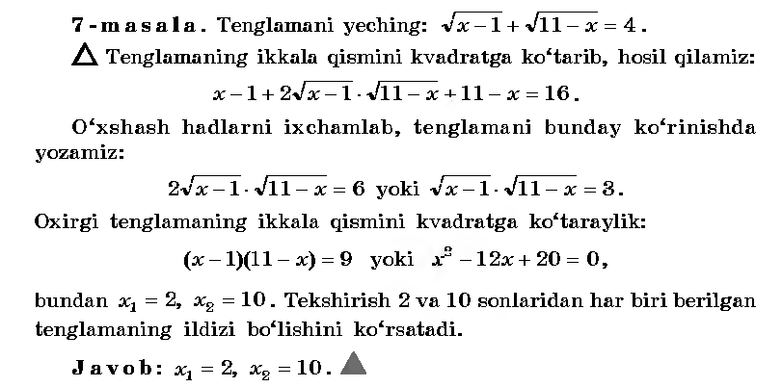
- Yangi mavzuning bayoni
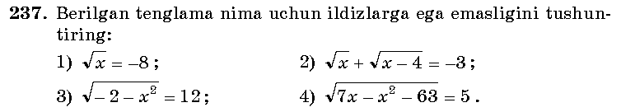
Yechilishi: 1)x≥0 shartni qanoatlantirmaydi.
2) An.soha: x≥0 va x≥4; 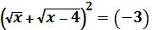²
x+2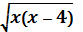+x-4=9; 2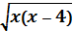=13+2x
x²-4x=42,25+13x+x²; 17x=-42,25; x=-2,48-chet ildiz ,chunki -2,48soni an.sohaga kirmaydi.
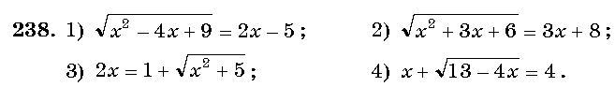
Yechilishi: 1)An.soha: x²-4x+9≥0; 2x-5≥0; x≥2,5.
x²-4x+9=4x²-20x+25
3x²-16x+16=0; D=(-8)²-3*16=64-48=16;
X_{1,2}=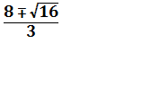 =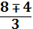; x₁= ; x₂ = 4.
X= -chet ildiz. Javob: x=4.
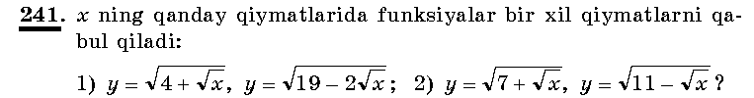
Yechilishi: 1)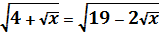;
4+ =19-2; 3=15; =5; x=25. J:25
IV.Mustahkamlash.№242-243.
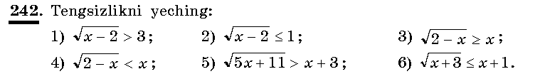
Yechish: 1)An.soha: x-2>0; x>2.
x-2>9; x>11. J:x>11
2) An.soha: x-2>0; x>2.
x-2≤1; x≤ 3; J:2<x≤ 3
V.Baholash. VI.Uyga vazifa. 249-250 –misollar .

Sana:
Sinf: 9-sinf
Fan: Algebra
Mavzu: Nazorat ishi
Maqsad: a) ta’limiy: O’quvchilarning funksiyani aniqlanish sohasi, uning o’sish va kamayish oraliqlari, juftligi, toqligi, y= funksiya xossalariga doir bilimlarini tekshirish;
b) tarbiyaviy: Oquvchilarni shu mavzu asosida milliy istiqlol ruhida va o’zaro hurmat ruhida tarbiyalash;
c) rivojlantiruvchi: o’quvchilar bilimini rivojlantirish, ko’nikma va malakasini o’stirish, fikrlash qobiliyatini riviojlantirish.
Dars turi: O’quvchilar bilimini tekshirish
Dars uslubi : Yozma ish
Tashkiliy qism.
Salomlashish. Navbatchining o’quvchilar davomati, darsga tayyorligi to’g’risidagi axborotini tinglash.
Darsning borishi:
I variant
1. y= funksiyaning aniqlanish sohasini toping.
2. y= va y= funksiyalarning grafiklarini yasamasdan, ularning kesishish nuqtalarining koordinatasini toping.
3. y= funksiyaning grafigini yasang va xossalarini ko’rsating.
4. Tenglamani yeching: =4-x
5. Tengsizlikni yeching: 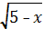 <4
II variant
1. y= funksiyaning aniqlanish sohasini toping.
2. y= va y=2x funksiyalarning grafiklarini yasamasdan, ularning kesishish nuqtalarining koordinatasini toping.
3. y= funksiyaning grafigini yasang va xossalarini ko’rsating.
4. Tenglamani yeching: =7-x
5. Tengsizlikni yeching: <5
Yechimlari:
I variant

- Aniqlanish soha: 12-4x-x² ≥ 0 tengsizlikning yechimlari bo’ladi.
12-4x-x²=0; x₁=-6; x₂=2.
Javob: -6≤ x ≤ 2
____________________________________________________________________________________________________________________________________________________________________________________________________________________________________________________________________________________________________________________________________________________________________________________________________________________________________________________________________________________________________________________________________________________________________________________________________________________________________________________________________________________________________________________________________________________________________________________________________________________________________________________________________________________________________________________________________________________________________________________________________________________________________________________________________________________________________________________________________________________________________________________________________________________________________________________________________________________________________________________________________________________________________________________________________________________________________________________________________________________________________________________________________________________________________________________________________________________________________________________________________________________________________________________________________________________________________________________________________________________________________________________________________________________________

UYGA VAZIFA. Takrorlash

Sana:
Sinf: 9-sinf
Fan: Algebra
Mavzu: Burchakning radian o’lchovi.
Maqsad: a) ta’limiy: O’quvchilarga burchakning radian o’lchovini topishni o’rgatish orqali bilim, malaka va ko’nikma hosil qilish;
b) tarbiyaviy: O’quvchilarni shu mavzu asosida milliy g’oya ruhida va o’zaro hurmat ruhida tarbiyalash;
c) rivojlantiruvchi: O’quvchilar bilimini rivojlantirish, ko’nikma va malakasini o’stirish, dunyoqarashi va fikrlash qobiliyatini riviojlantirish.
Dars turi: Yangi bilim berish
Dars uslubi : Savol- javob
Darsning borishi
- Tashkiliy qism.
Salomlashish. Navbatchi o’quvchining o’quvchilar davomati, ob-havo, o’quvchilarning darsga tayyorligi to’g’risidagi axborotini tinglash.
- O’tilgan mavzuni so’rash
Uyga vazifalarni tekshirish.
Mustaqil ish:
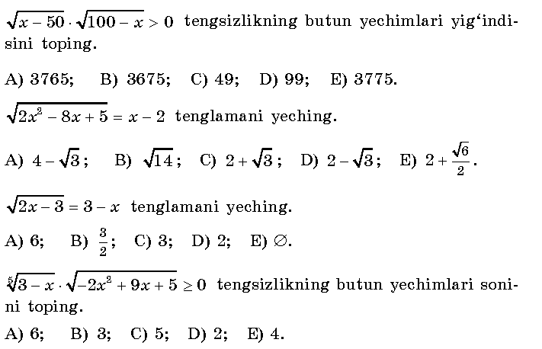
Test kaliti: 1-B; 2-C; 3-D; 4-E.
- Yangi mavzuning bayoni

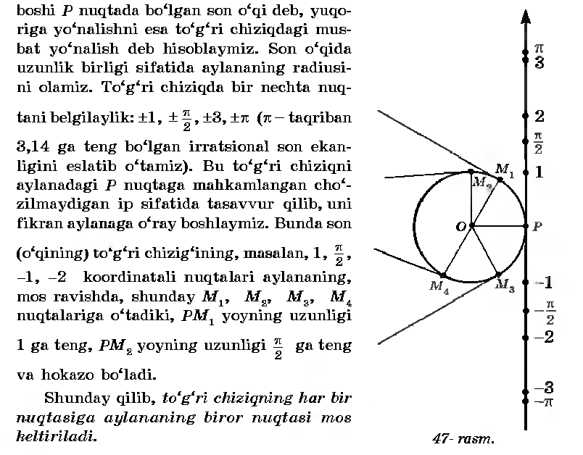
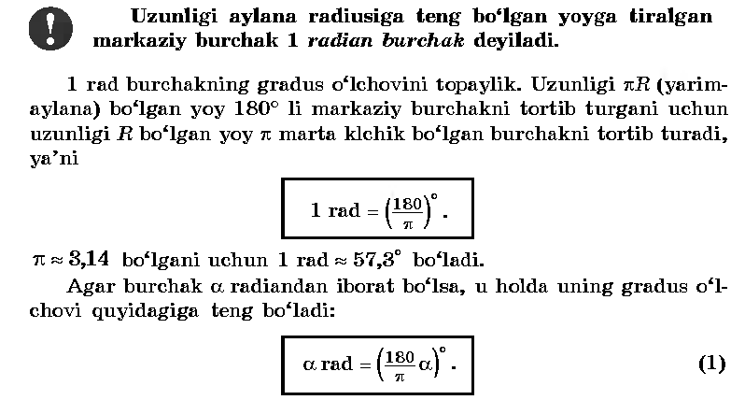
IV.Mustahkamlash.
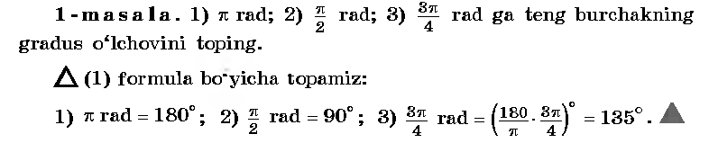
V.Baholash.
VI.Uyga vazifa. 261 –misol .

Sana:
Sinf: 9-sinf
Fan: Algebra
Mavzu: Misollar yechish №262-265.
Maqsad: a) ta’limiy: O’quvchilarga burchakning radian o’lchovini topishga doir misollar yechishni o’rgatish orqali bilim, malaka va ko’nikma hosil qilish;
b) tarbiyaviy: O’quvchilarni shu mavzu asosida milliy g’oya ruhida va o’zaro hurmat ruhida tarbiyalash;
c) rivojlantiruvchi: O’quvchilar bilimini rivojlantirish, ko’nikma va malakasini o’stirish, dunyoqarashi va fikrlash qobiliyatini riviojlantirish.
Dars turi: Yangi bilim berish
Dars uslubi : Savol- javob
Darsning borishi
- Tashkiliy qism.
Salomlashish. Navbatchi o’quvchining o’quvchilar davomati, ob-havo, o’quvchilarning darsga tayyorligi to’g’risidagi axborotini tinglash.
- O’tilgan mavzuni so’rash
Uyga vazifalarni tekshirish.
Mustaqil ish:
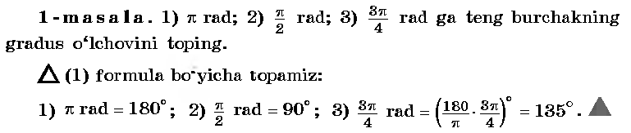
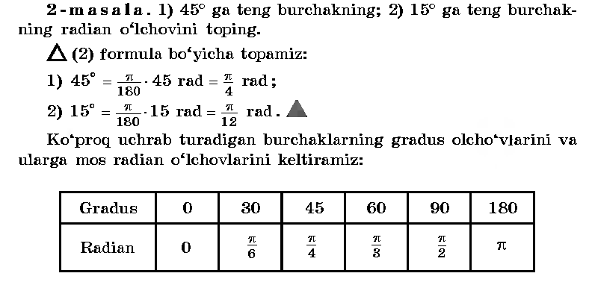
- Yangi mavzuning bayoni
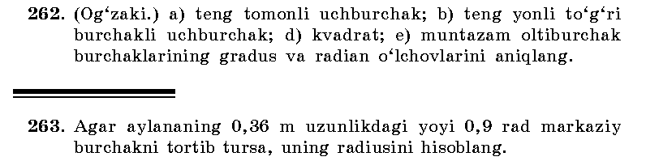
B-gan: Yechish:
l=0,36 R = 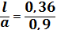 =0,4
α=0,9 rad Javob: R=0,4m
R=?
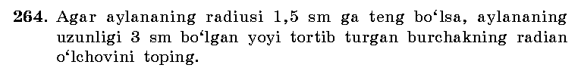
B-gan: Yechish:
R=1,5 sm l=αR
l=3sm α= 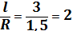
α=? Javob: 2 rad.
IV.Mustahkamlash.№242-243.
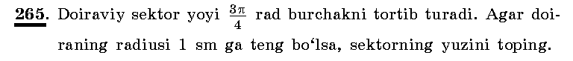
B-gan: Yechish:
α=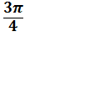 S== * =
R=1 sm Javob: sm²
S=?
V.Baholash.
VI.Uyga vazifa. 266 –misol .

Sana:
Sinf: 9-sinf
Fan: Algebra
Mavzu: Nuqtani koordinata boshi atrofida burish.
Maqsad: a) ta’limiy: O’quvchilarga burchakning radian o’lchovini toppish, nuqtani koordinata boshi atrofida burishni o’rgatish orqali bilim, malaka va ko’nikma hosil qilish;
b) tarbiyaviy: O’quvchilarni shu mavzu asosida milliy g’oya ruhida va o’zaro hurmat ruhida tarbiyalash;
c) rivojlantiruvchi: O’quvchilar bilimini rivojlantirish, ko’nikma va malakasini o’stirish, dunyoqarashi va fikrlash qobiliyatini riviojlantirish.
Dars turi: Yangi bilim berish
Dars uslubi : Savol- javob
Darsning borishi
- Tashkiliy qism.
Salomlashish. Navbatchi o’quvchining o’quvchilar davomati, ob-havo, o’quvchilarning darsga tayyorligi to’g’risidagi axborotini tinglash.
- O’tilgan mavzuni so’rash
Uyga vazifalarni tekshirish.
Mustaqil ish:
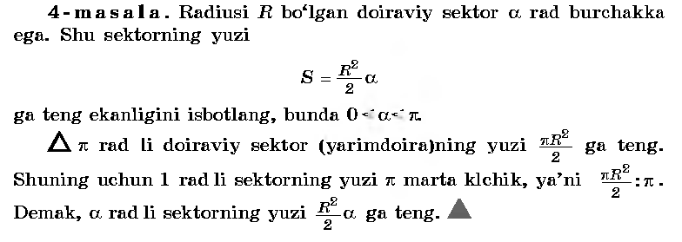
- Yangi mavzuning bayoni
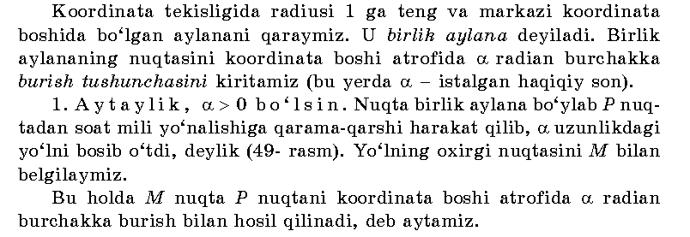
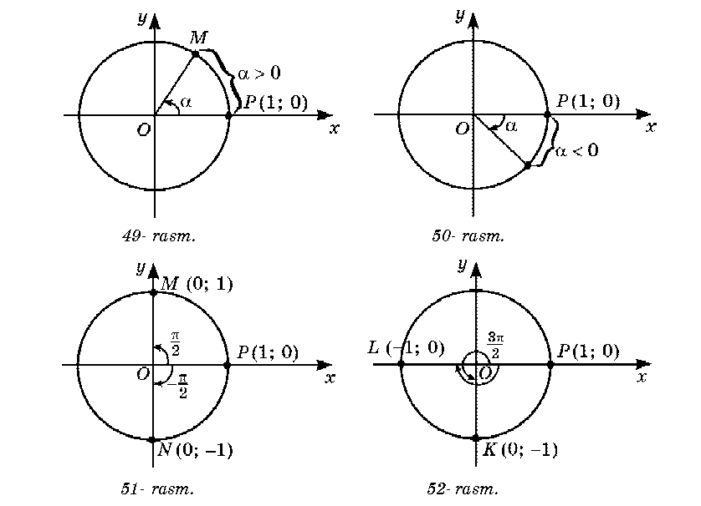
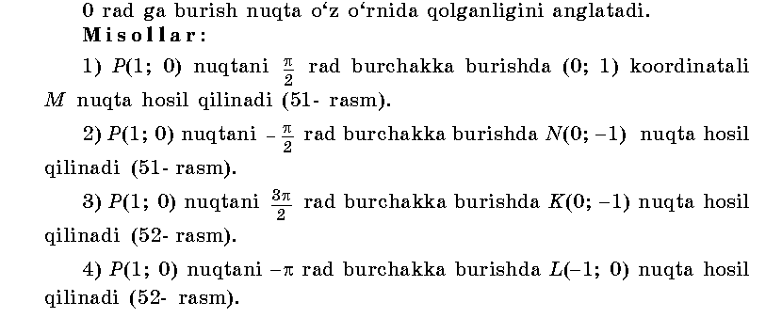
IV.Mustahkamlash.
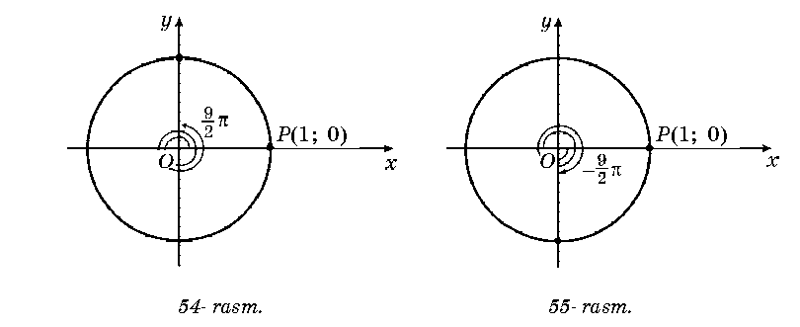
V.Baholash.
VI.Uyga vazifa. 271-272 –misollar .

Sana: _________
Sinf: 9-sinf
Fan: Algebra
Mavzu: Nazorat ishi
Maqsad: a) ta’limiy: O’quvchilarning trigonometriya elementlari, nuqtani koordinata boshi atrofida burish, o’tkir burchak sin, cos, tg va ctgsini topishga doir bilimlarini tekshirish;
b) tarbiyaviy: Oquvchilarni shu mavzu asosida milliy istiqlol ruhida va o’zaro hurmat ruhida tarbiyalash;
c) rivojlantiruvchi: o’quvchilar bilimini rivojlantirish, ko’nikma va malakasini o’stirish, fikrlash qobiliyatini riviojlantirish.
Dars turi: O’quvchilar bilimini tekshirish
Dars uslubi : Yozma ish
Tashkiliy qism.
Salomlashish. Navbatchining o’quvchilar davomati, darsga tayyorligi to’g’risidagi axborotini tinglash.
Darsning borishi:
I variant
1. (1;0)nuqtani - (k € Z)burchakka burishda hosil bo’lgan nuqtaning koordinatalarini toping.
2. (0;1), (0;-1) nuqtalarni hosil qilish uchun P(1;0)nuqtani burish kerak bo’lgan barcha burchaklarni toping.
3. Ifodaning qiymatini toping: sin 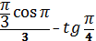.
4. Tenglamani yeching: =0
5. Birlik aylanada P(1;0)nuqtani burchakda tasvirlang.
II variant
1. (1;0)nuqtani (k € Z)burchakka burishda hosil bo’lgan nuqtaning koordinatalarini toping.
2. (-1;0), (1;0) nuqtalarni hosil qilish uchun P(1;0)nuqtani burish kerak bo’lgan barcha burchaklarni toping.
3. Ifodaning qiymatini toping: ( 2tg):cos.
4. Tenglamani yeching: =0
5. Birlik aylanada P(1;0)nuqtani burchakda tasvirlang.
Yechimlari:
I variant
________________________________________________________________________________________________________________________________________________________________________________________________________________________________________________________________________________________________________________________________________________________________________________________________________________________________________________________________________________________________________________________________________________________________________________________________________________________________________________________________________________________________________________________________________________________________________________________________________________________________________________________________________________________________________________________________________________________________________________________________________________________________________________________________________________________________________________________________________________________________________________________________________________________________________________________________________________________________________________________________________________________________________________________________________________________________________________________________________________________________________________________________________________________________________________________________________________________________________________________________________________________________________________________________________________

UYGA VAZIFA. Takrorlash

Sana: Sinf: 9-sinf
Fan: Algebra
Mavzu: Misollar yechish №273-275.
Maqsad: a) ta’limiy: O’quvchilarga burchakning radian o’lchovini topish, nuqtani koordinata boshi atrofida burishni o’rgatish orqali bilim, malaka va ko’nikma hosil qilish;
b) tar biyaviy: O’quvchilarni shu mavzu asosida milliy g’oya ruhida va o’zaro hurmat ruhida tarbiyalash;
c) rivojlantiruvchi: O’quvchilar bilimini rivojlantirish, ko’nikma va malakasini o’stirish, dunyoqarashi va fikrlash qobiliyatini riviojlantirish.
Dars turi: Aralash dars
Dars uslubi : Savol- javob
Darsning borishi
- Tashkiliy qism.
Salomlashish. Navbatchi o’quvchining o’quvchilar davomati, ob-havo, o’quvchilarning darsga tayyorligi to’g’risidagi axborotini tinglash.
- O’tilgan mavzuni so’rash
Uyga vazifalarni tekshirish.
Mustaqil ish:
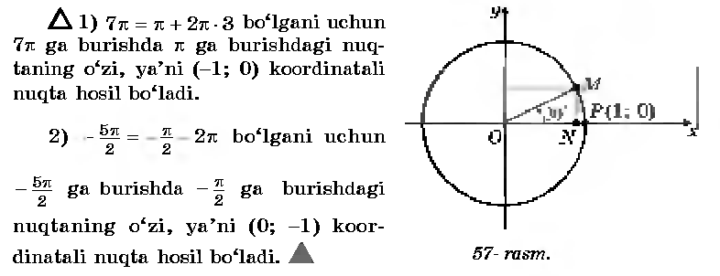
- Yangi mavzuning bayoni
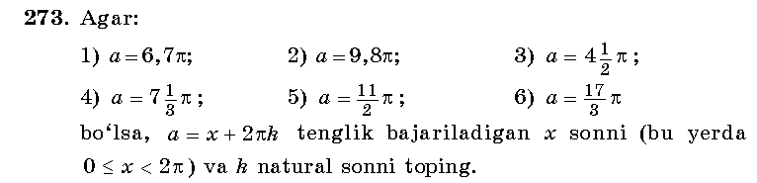
Yechish: 1)a=6,7𝛑 ; a=x+2𝛑k; 0 ≤ x< 2𝛑 k-natural son
a=0,7𝛑+6𝛑 bundan x=0,7𝛑 va k=3.
2) a=9,8𝛑 ; a=x+2𝛑k; 0 ≤ x< 2𝛑 k-natural son
a=1,8𝛑+8𝛑 ,bundan x=1,8𝛑 va k=4.
3)a=4,5𝛑 ; a=x+2𝛑k; 0 ≤ x< 2𝛑 k-natural son
a=0,5𝛑+4𝛑 bundan x=0,5𝛑 va k=2.
4) a=7 𝛑 ; a=x+2𝛑k; 0 ≤ x< 2𝛑 k-natural son
a=1 𝛑+6𝛑 bundan x=1 𝛑 va k=3.
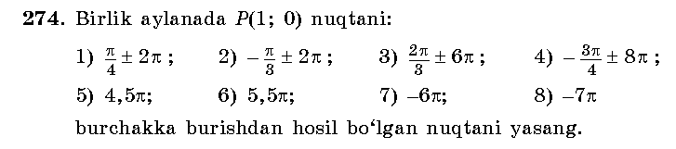
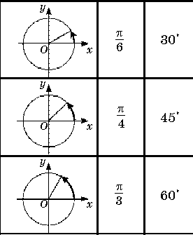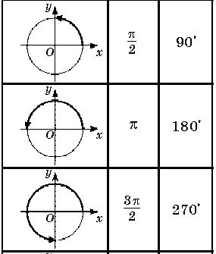
IV.Mustahkamlash.
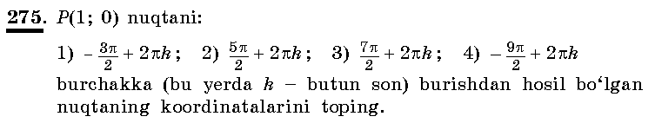
Yechish: 1)P(0;1), 2)P(0;-1), 3)P(0;1), 4)P(0;-1)
V.Baholash.
VI.Uyga vazifa. 276 –misol .

Sana:
Sinf: 9-sinf
Fan: Algebra
Mavzu: Burchakning sinusi, kosinusi, tangensi va kotangensi ta’riflari.
Maqsad: a) ta’limiy: O’quvchilarga ixtiyoriy burchakning sinus, kosinus, tangens va kotangensi ta’riflarini o’rgatish orqali bilim, malaka va ko’nikma hosil qilish;
b) tarbiyaviy: O’quvchilarni shu mavzu asosida milliy g’oya ruhida va o’zaro hurmat ruhida tarbiyalash;
c) rivojlantiruvchi: O’quvchilar bilimini rivojlantirish, ko’nikma va malakasini o’stirish, dunyoqarashi va fikrlash qobiliyatini riviojlantirish.
Dars turi: Yangi bilim berish
Dars uslubi : Savol- javob
Darsning borishi
- Tashkiliy qism.
Salomlashish. Navbatchi o’quvchining o’quvchilar davomati, ob-havo, o’quvchilarning darsga tayyorligi to’g’risidagi axborotini tinglash.
- O’tilgan mavzuni so’rash
Uyga vazifalarni tekshirish.
Mustaqil ish:
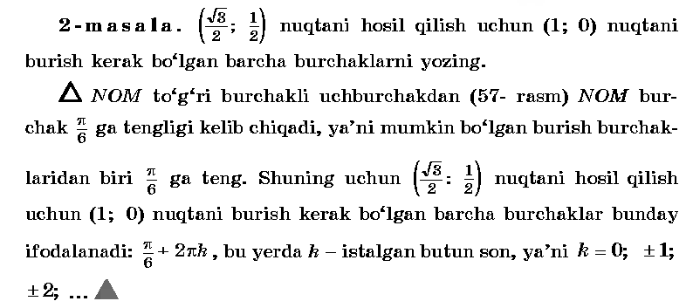
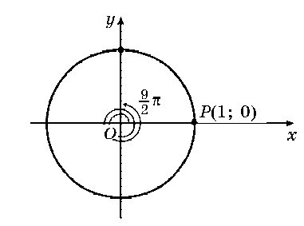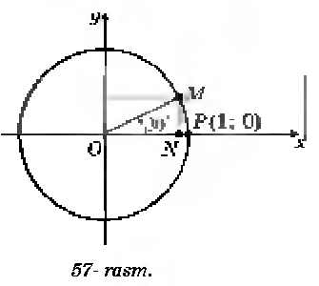
- Yangi mavzuning bayoni
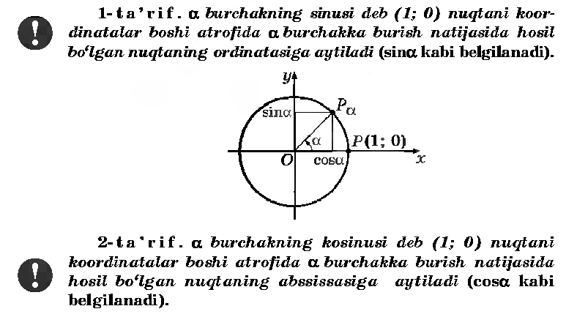
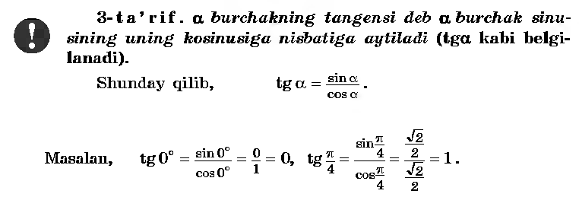
IV.Mustahkamlash.
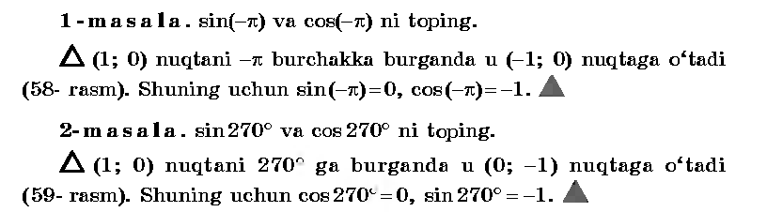
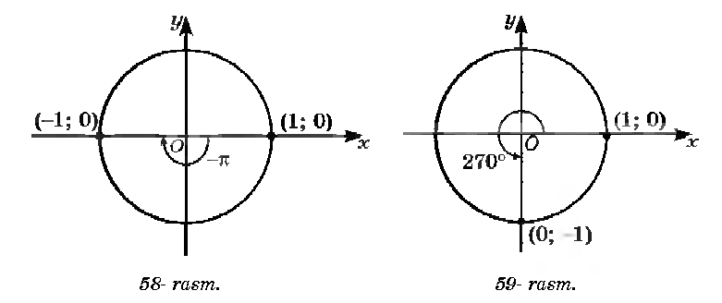
V.Baholash. VI.Uyga vazifa. 281-282 –misollar .

Sana
Sinf: 9-sinf
Fan: Algebra
Mavzu: Misollar yechish №283-285.
Maqsad: a) ta’limiy: O’quvchilarga burchakning radian o’lchovini topish, burchakning sinusi, kosinusi va tangensini hisoblashni o’rgatish orqali bilim, malaka va ko’nikma hosil qilish;
b) tarbiyaviy: O’quvchilarni shu mavzu asosida milliy g’oya ruhida va o’zaro hurmat ruhida tarbiyalash;
c) rivojlantiruvchi: O’quvchilar bilimini rivojlantirish, ko’nikma va malakasini o’stirish, dunyoqarashi va fikrlash qobiliyatini riviojlantirish.
Dars turi: Aralash dars
Dars uslubi : Savol- javob
- Tashkiliy qism.
Salomlashish. Navbatchi o’quvchining o’quvchilar davomati, ob-havo, o’quvchilarning darsga tayyorligi to’g’risidagi axborotini tinglash.
- O’tilgan mavzuni so’rash
Uyga vazifalarni tekshirish.
Mustaqil ish: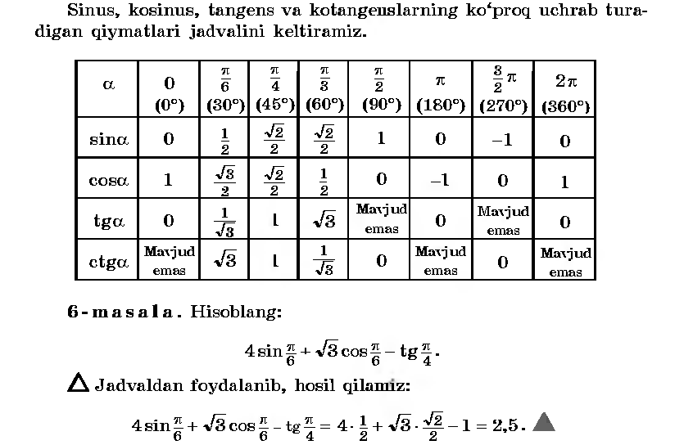
- Yangi mavzuning bayoni
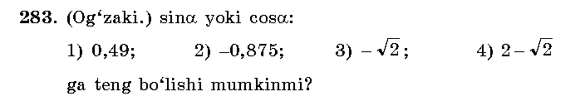
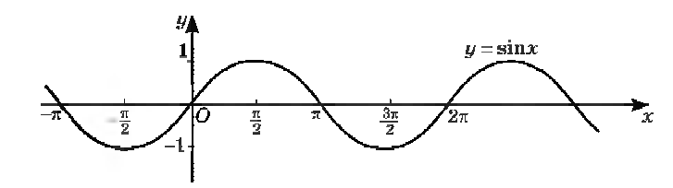
Yechish: 1)sinα=0,49 , cosα=0,49; 2)sinα=-0,875 , cosα=-0,875;
3)sinα≠ - , cosα≠ - ; 4)sinα=2- , cosα=2- .
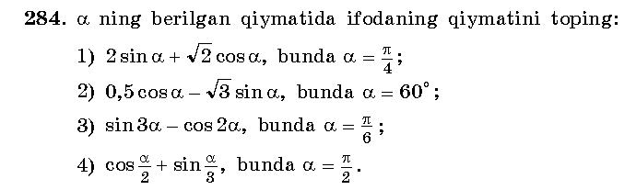
Yechish:1) 2sin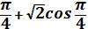=2* + * =
2)0,5cos60⁰- sin60⁰=0,5* - * = 0,25-1,5= -1,25
3)sin3*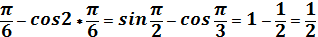 ;
4)cos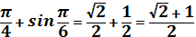;
IV.Mustahkamlash.
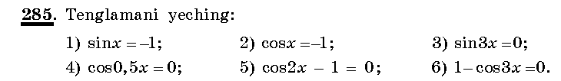
Yechish: 1)x= 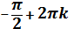; 2)x=𝛑 +2𝛑k; 3)3x=𝛑k; x = ;
4)0,5x= 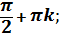 x= ; 5)2x=; x= .
V.Baholash.
VI.Uyga vazifa. 286 –misol .

Sana
Sinf: 9-sinf
Fan: Algebra
Mavzu: Misollar yechish .
Maqsad: a) ta’limiy: O’quvchilarga burchakning radian o’lchovini topish, burchakning sinusi, kosinusi va tangensini hisoblashni o’rgatish orqali bilim, malaka va ko’nikma hosil qilish;
b) tarbiyaviy: O’quvchilarni shu mavzu asosida milliy g’oya ruhida va o’zaro hurmat ruhida tarbiyalash;
c) rivojlantiruvchi: O’quvchilar bilimini rivojlantirish, ko’nikma va malakasini o’stirish, dunyoqarashi va fikrlash qobiliyatini riviojlantirish.
Dars turi: Aralash dars
Dars uslubi : Savol- javob
- Tashkiliy qism.
Salomlashish. Navbatchi o’quvchining o’quvchilar davomati, ob-havo, o’quvchilarning darsga tayyorligi to’g’risidagi axborotini tinglash.
- O’tilgan mavzuni so’rash
Uyga vazifalarni tekshirish.
Mustaqil ish:
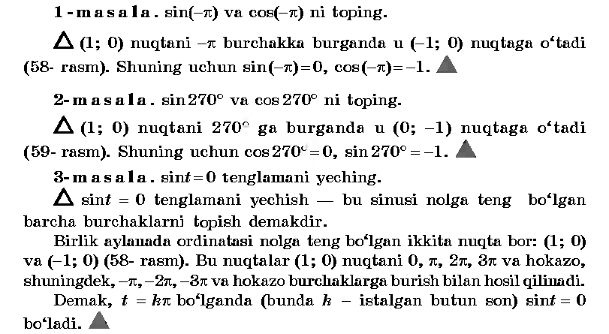
- Yangi mavzuning bayoni
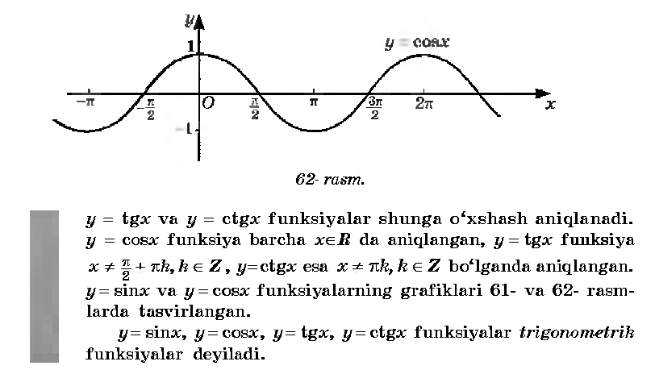
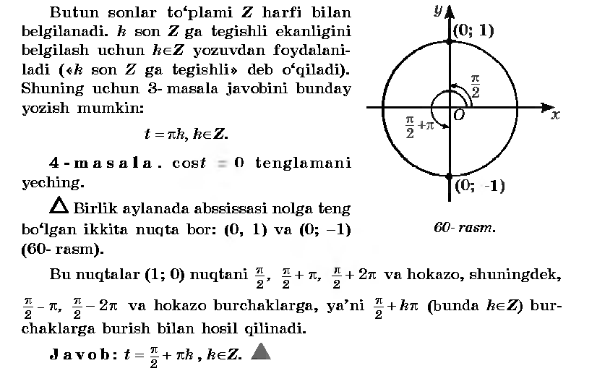
IV.Mustahkamlash.
V.Baholash.
VI.Uyga vazifa. 9-13 –misollar .

Sana
Sinf: 9-sinf
Fan: Algebra
Mavzu: Burchakning sinusi, kosinusi, tangensi va kotangensi ishoralarilari.
Maqsad: a) ta’limiy: O’quvchilarga ixtiyoriy burchakning sinus, kosinus, tangens va kotangensi ishoralarini o’rgatish orqali bilim, malaka va ko’nikma hosil qilish;
b) tarbiyaviy: O’quvchilarni shu mavzu asosida milliy g’oya ruhida va o’zaro hurmat ruhida tarbiyalash;
c) rivojlantiruvchi: O’quvchilar bilimini rivojlantirish, ko’nikma va malakasini o’stirish, dunyoqarashi va fikrlash qobiliyatini riviojlantirish.
Dars turi: Yangi bilim berish
Dars uslubi : Savol- javob
Darsning borishi
- Tashkiliy qism.
Salomlashish. Navbatchi o’quvchining o’quvchilar davomati, ob-havo, o’quvchilarning darsga tayyorligi to’g’risidagi axborotini tinglash.
- O’tilgan mavzuni so’rash
Uyga vazifalarni tekshirish.
Mustaqil ish:
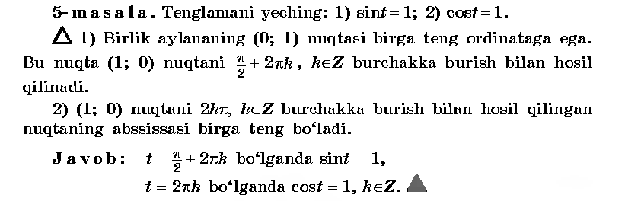
- Yangi mavzuning bayoni
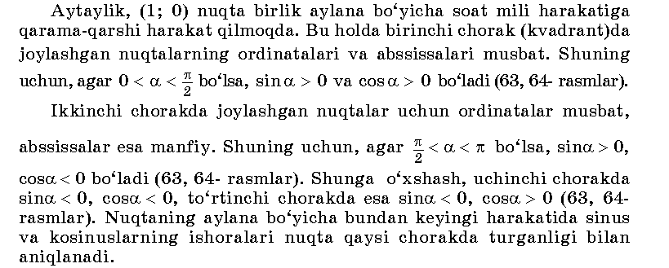
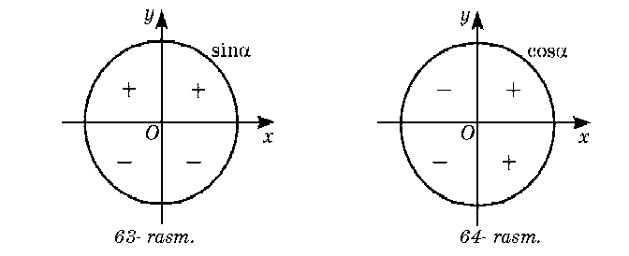
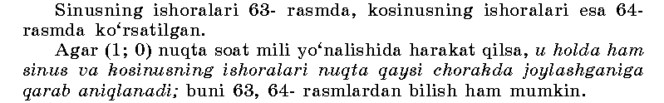
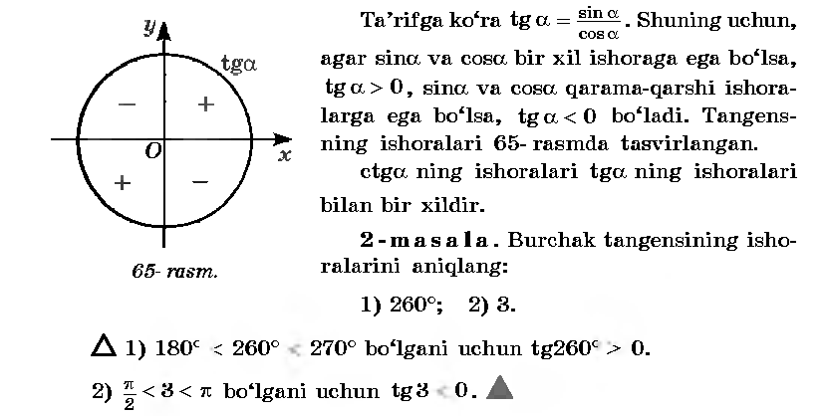
IV.Mustahkamlash.
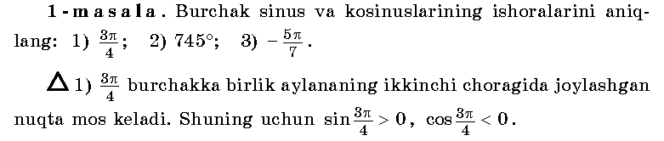
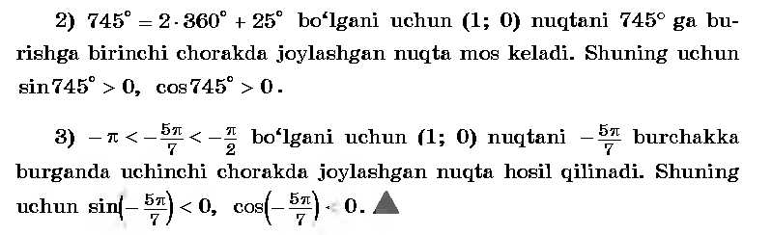
V.Baholash. VI.Uyga vazifa. 290 -291 –misollar .

Sana:
Sinf: 9-sinf
Fan: Algebra
Mavzu: Misollar yechish №292-297.
Maqsad: a) ta’limiy: O’quvchilarga ixtiyoriy burchakning sinus, kosinus, tangens va kotangensi ishoralarini o’rgatish orqali bilim, malaka va ko’nikma hosil qilish;
b) tarbiyaviy: O’quvchilarni shu mavzu asosida milliy g’oya ruhida va o’zaro hurmat ruhida tarbiyalash;
c) rivojlantiruvchi: O’quvchilar bilimini rivojlantirish, ko’nikma va malakasini o’stirish, dunyoqarashi va fikrlash qobiliyatini riviojlantirish.
Dars turi: Aralash dars.
Dars uslubi : Savol- javob
Darsning borishi
- Tashkiliy qism.
Salomlashish. Navbatchi o’quvchining o’quvchilar davomati, ob-havo, o’quvchilarning darsga tayyorligi to’g’risidagi axborotini tinglash.
- O’tilgan mavzuni so’rash
Uyga vazifalarni tekshirish.
Mustaqil ish:
- Yangi mavzuning bayoni
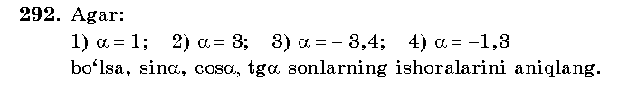
Yechish: 1)α=1rad- I chorak; sinα>0; cosα>0; tgα>0;
2)α=3rad- II chorak; sinα>0; cosα<0; tgα<0;
3) α=-3,4rad- II chorak; sinα>0; cosα<0; tgα<0;
4) α=-1,3rad- IV chorak; sinα<0; cosα>0; tgα<0;
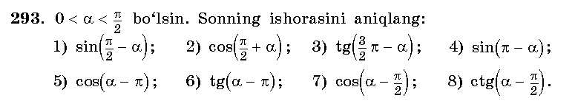
Yechish: 1)I chorak, sinα>0; 2) II chorak, cosα<0; 3) III chorak, tgα>0;
4) II chorak, sinα>0; 5) III chorak, sinα<0; 6) III chorak, tgα>0;
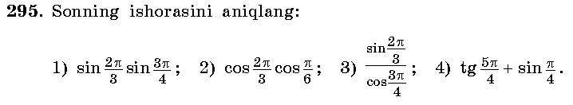
Yechish: 1)(+)(+)=(+); 2)(-)(+)=(-); 3)(+)/(-)=(-); 4)(+)+(+)=(+).
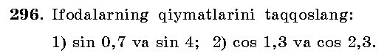
Javobi: 1)sin0,7>sin4; 2)cos1,3>cos2,3
IV.Mustahkamlash.
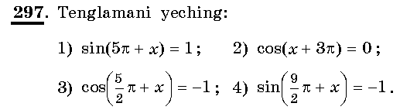
Yechish: 1)5𝛑 +x= 2)3𝛑 +x= 3)
x = -4,5𝛑 +2𝛑n. x = -2,5𝛑 +𝛑n. x = -1,5𝛑 +2𝛑n.
V.Baholash.
VI.Uyga vazifa. 298 -299 –misollar .
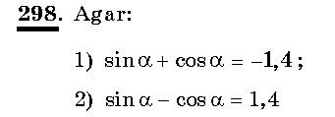
Javob: 1)ikkalasi ham manfiy bo’ladigan chorak – III chorak;
2)sinus musbat, kosinus manfiy bo’ladigan chorak – II chorak.

Sana
Sinf: 9-sinf
Fan: Algebra
Mavzu: Misollar yechish №303-307.
Maqsad: a) ta’limiy: O’quvchilarga ayni bir burchakning sinusi, kosinusi, tangensi va kotangensi orasidagi asosiy munosabatlarni o’rgatish orqali bilim, malaka va ko’nikma hosil qilish;
b) tarbiyaviy: O’quvchilarni shu mavzu asosida milliy g’oya ruhida va o’zaro hurmat ruhida tarbiyalash;
c) rivojlantiruvchi: O’quvchilar bilimini rivojlantirish, ko’nikma va malakasini o’stirish, dunyoqarashi va fikrlash qobiliyatini riviojlantirish.
Dars turi: Aralash dars.
Dars uslubi : Savol- javob
Darsning borishi
- Tashkiliy qism.
Salomlashish. Navbatchi o’quvchining o’quvchilar davomati, ob-havo, o’quvchilarning darsga tayyorligi to’g’risidagi axborotini tinglash.
- O’tilgan mavzuni so’rash
Uyga vazifalarni tekshirish.
Mustaqil ish:
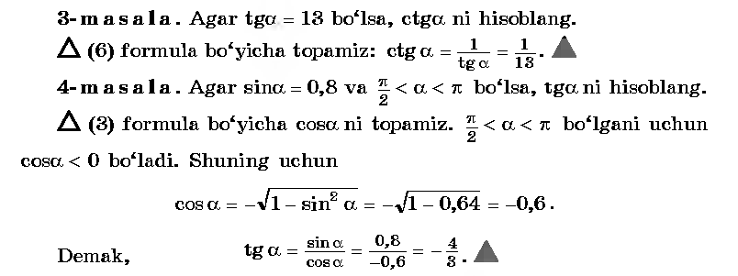
- Yangi mavzuning bayoni
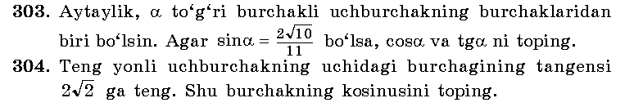
№303.Yechish: cosα = 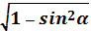 =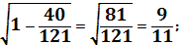
tgα=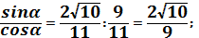
№304.Yechish: 1+tg²α= ; cos²α=
Cosα= Javob: Cosα=
Yechish: (cos²a-sin²a)(cos²a+sin²a)=cos²a-1+cos²a=2cos²a-1=
Cos²a=( ):2= cosa=
IV.Mustahkamlash.
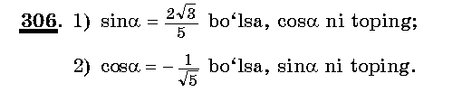
Yechish: 1) sinα = 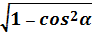 =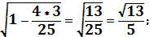
2)cosα = =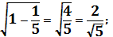
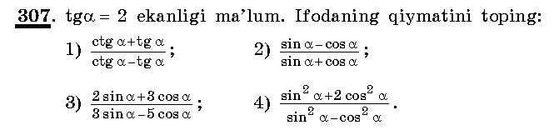
Yechish:1)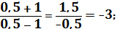 2)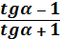 = 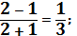
3) = 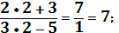
V.Baholash.
VI.Uyga vazifa. 308 -309 –misollar .
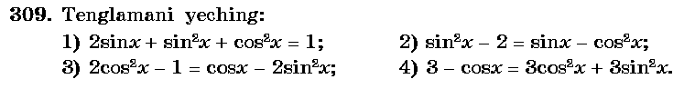
___________________________________________________________________________________________________________________________________________________________________________________________________________________________________________________________________________________________________________________________________________________________

Sana
Sinf: 9-sinf
Fan: Algebra
Mavzu: Trigonometrik ayniyatlar.
Maqsad: a) ta’limiy: O’quvchilarga ayni bir burchakning sinusi, kosinusi, tangensi orasidagi asosiy munosabatlarni va trigonometrik ayniyatlarni o’rgatish orqali bilim, malaka va ko’nikma hosil qilish;
b) tarbiyaviy: O’quvchilarni shu mavzu asosida milliy g’oya ruhida va o’zaro hurmat ruhida tarbiyalash;
c) rivojlantiruvchi: O’quvchilar bilimini rivojlantirish, ko’nikma va malakasini o’stirish, dunyoqarashi va fikrlash qobiliyatini riviojlantirish.
Dars turi: Yangi bilim berish.
Dars uslubi : Savol- javob
Darsning borishi
- Tashkiliy qism.
Salomlashish. Navbatchi o’quvchining o’quvchilar davomati, ob-havo, o’quvchilarning darsga tayyorligi to’g’risidagi axborotini tinglash.
- O’tilgan mavzuni so’rash
Uyga vazifalarni tekshirish.
Mustaqil ish:
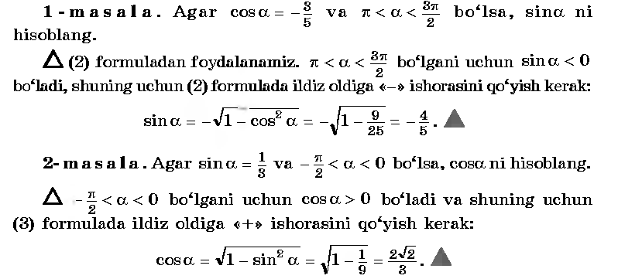
- Yangi mavzuning bayoni
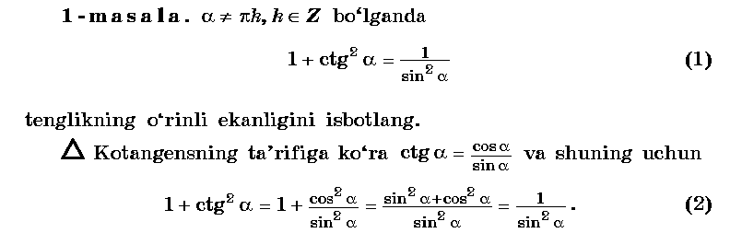
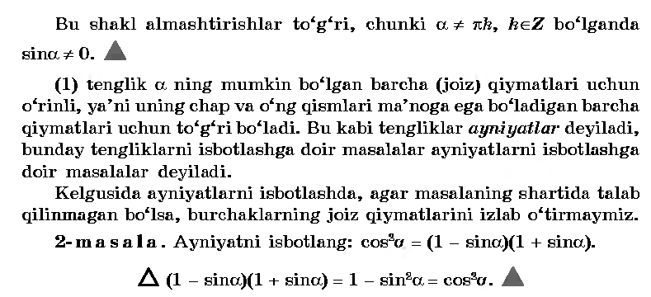
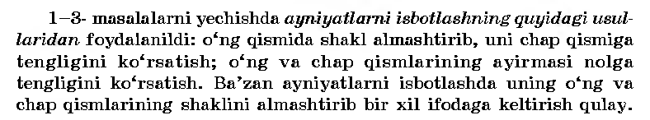
IV.Mustahkamlash.
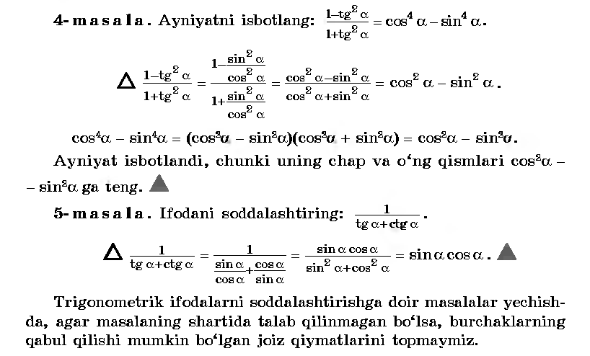
V.Baholash.
VI.Uyga vazifa. 312 –misol .
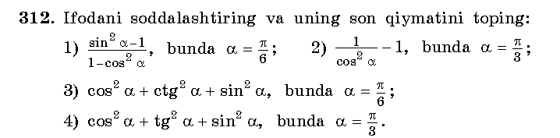
____________________________________________________________________________________________________________________________________________________________________________________________________________
Sana: 4.02. 2014
Sinf: 9-sinf
Fan: Algebra
Mavzu: Misollar yechish.
Maqsad: a) ta’limiy: O’quvchilarga ayni bir burchakning sinusi, kosinusi, tangensi orasidagi asosiy munosabatlarni va trigonometrik ayniyatlarni o’rgatish orqali bilim, malaka va ko’nikma hosil qilish;
b) tarbiyaviy: O’quvchilarni shu mavzu asosida milliy g’oya ruhida va o’zaro hurmat ruhida tarbiyalash;
c) rivojlantiruvchi: O’quvchilar bilimini rivojlantirish, ko’nikma va malakasini o’stirish, dunyoqarashi va fikrlash qobiliyatini riviojlantirish.
Dars turi: Aralash dars.
Dars uslubi : Savol- javob
Darsning borishi
- Tashkiliy qism.
Salomlashish. Navbatchi o’quvchining o’quvchilar davomati, ob-havo, o’quvchilarning darsga tayyorligi to’g’risidagi axborotini tinglash.
- O’tilgan mavzuni so’rash
Uyga vazifalarni tekshirish.
Mustaqil ish:
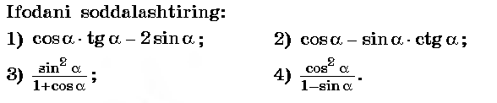
________________________________________________________________________________________________________________________________________________________________________________________________________________________________________________________________________
- Yangi mavzuning bayoni
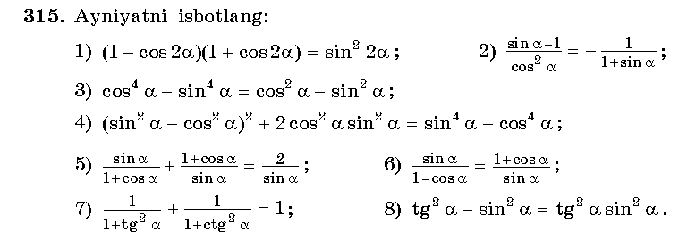________________________________________________________________________________________________________________________________________
____________________________________________________________________________________________________________________________________________________________________________________________________________________________________________________________________________
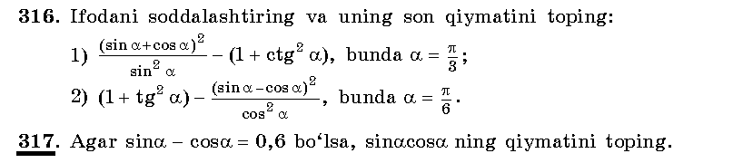________________________________________________________________________________________________________________________________________________________________________________________________________________________________________________________________________________________________________________________________________________________________________________________________________________________________________________________________________________________________________________________________________________________________________________________________________________________________
IV.Mustahkamlash.
_____________________________________________________________________________________________________________________________________________________________________________________________________________________________________________________________________________________________________________________________________________________
V.Baholash.
VI.Uyga vazifa. 318-319 –misollar .
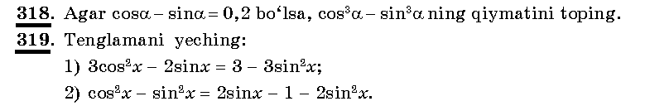
___________________________________________________________________________________________________________________________________________________________________________________________________________________________________________________________________________________________________________________________________________________________________________________________________________________________

Sana
Sinf: 9-sinf
Fan: Algebra
Mavzu: α va (-α) burchakning sinusi, kosinusi, tangensi va kotangensi.
Maqsad: a) ta’limiy: O’quvchilarga α va (-α) burchakning sinusi, kosinusi, tangensi va kotangensini va trigonometrik ayniyatlarni o’rgatish orqali bilim, malaka va ko’nikma hosil qilish;
b) tarbiyaviy: O’quvchilarni shu mavzu asosida milliy g’oya ruhida va o’zaro hurmat ruhida tarbiyalash;
c) rivojlantiruvchi: O’quvchilar bilimini rivojlantirish, ko’nikma va malakasini o’stirish, dunyoqarashi va fikrlash qobiliyatini riviojlantirish.
Dars turi: Aralash dars.
Dars uslubi : Savol- javob
Darsning borishi
- Tashkiliy qism.
Salomlashish. Navbatchi o’quvchining o’quvchilar davomati, ob-havo, o’quvchilarning darsga tayyorligi to’g’risidagi axborotini tinglash.
- O’tilgan mavzuni so’rash
Uyga vazifalarni tekshirish.
Mustaqil ish:
________________________________________________________________________________________________________________________________________________________________________________________________________________________________________________________________________
- Yangi mavzuning bayoni
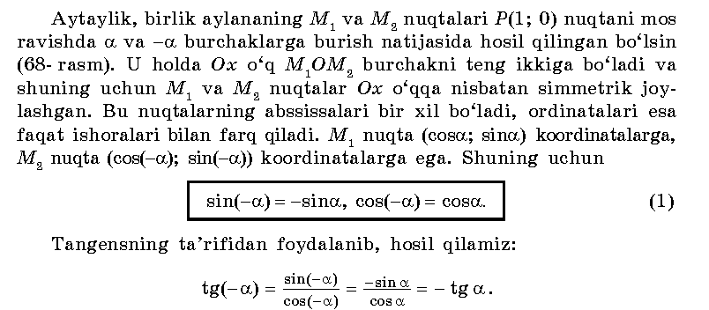
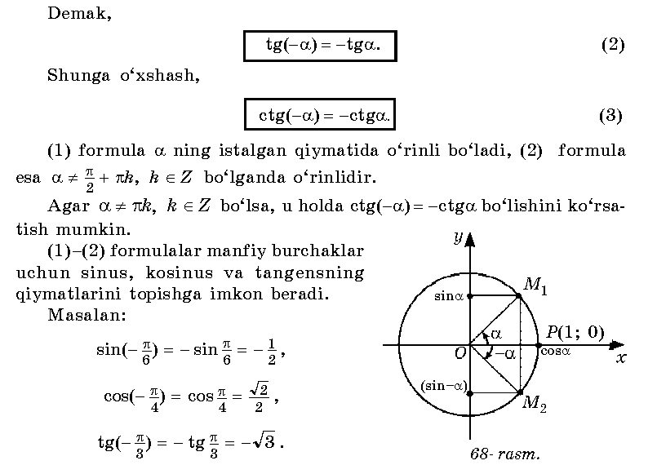
IV.Mustahkamlash.
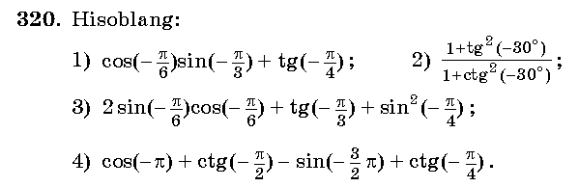_____________________________________________________________________________________________________________________________________________________________________________________________________________________________________________________________________________________________________________________________________________________________________________________________________________________________________________________________________________________________________________________________________________________________________
V.Baholash.
VI.Uyga vazifa. 321 –misol .
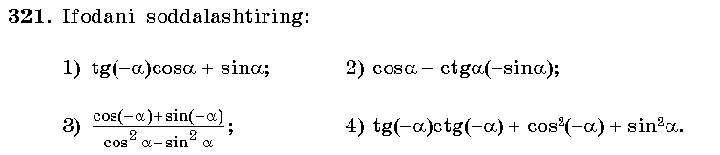
______________________________________________________________________________________________________________________________________________________________________________________________________
Sana:
Sinf: 9-sinf
Fan: Algebra
Mavzu: Misollar yechish №322-323.
Maqsad: a) ta’limiy: O’quvchilarga α va (-α) burchakning sinusi, kosinusi, tangensi va kotangensini va trigonometrik ayniyatlarni o’rgatish orqali bilim, malaka va ko’nikma hosil qilish;
b) tarbiyaviy: O’quvchilarni shu mavzu asosida milliy g’oya ruhida va o’zaro hurmat ruhida tarbiyalash;
c) rivojlantiruvchi: O’quvchilar bilimini rivojlantirish, ko’nikma va malakasini o’stirish, dunyoqarashi va fikrlash qobiliyatini riviojlantirish.
Dars turi: Aralash dars.
Dars uslubi : Savol- javob
Darsning borishi
- Tashkiliy qism.
Salomlashish. Navbatchi o’quvchining o’quvchilar davomati, ob-havo, o’quvchilarning darsga tayyorligi to’g’risidagi axborotini tinglash.
- O’tilgan mavzuni so’rash
Uyga vazifalarni tekshirish.
Mustaqil ish:
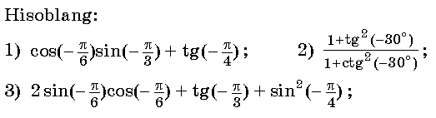
__________________________________________________________________________________________________________________________________________________________________________________________________________________________________________________________________________________________________________________________________________
- Yangi mavzuning bayoni
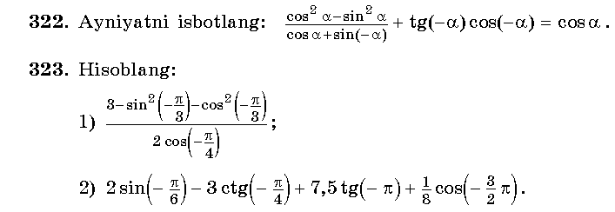
________________________________________________________________________________________________________________________________________________________________________________________________________________________________________________________________________________________________________________________________________________________________________________________________________________________________________________________________________________________________________________________________________________________________________________________________________________________________________________________________________________________________________________________________________________________________________________________________________________________________________________________
IV.Mustahkamlash.
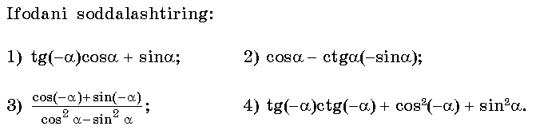_____________________________________________________________________________________________________________________________________________________________________________________________________________________________________________________________________________________________________________________________________________________________________________________________________________________________________________________________________________________________________________________________________________________________________
V.Baholash.
VI.Uyga vazifa. 324 –misol .
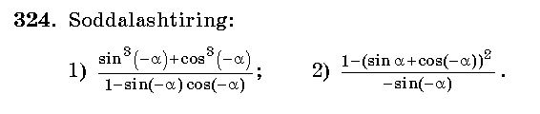
___________________________________________________________________________________________________________________________________________________________________________________________________________________________________________________________________________________________________________________________________________________________________________________________________________________________

Sana
Sinf: 9-sinf
Fan: Algebra
Mavzu: Nazorat ishi
Maqsad: a) ta’limiy: O’quvchilarning trigonometrik ifodalarni soddalashtirish, ifodaning qiymatini topishga doir bilimlarini tekshirish;
b) tarbiyaviy: Oquvchilarni shu mavzu asosida milliy istiqlol ruhida va o’zaro hurmat ruhida tarbiyalash;
c) rivojlantiruvchi: o’quvchilar bilimini rivojlantirish, ko’nikma va malakasini o’stirish, fikrlash qobiliyatini riviojlantirish.
Dars turi: O’quvchilar bilimini tekshirish
Dars uslubi : Yozma ish
Tashkiliy qism.
Salomlashish. Navbatchining o’quvchilar davomati, darsga tayyorligi to’g’risidagi axborotini tinglash.
Darsning borishi:
I variant
1. Ifodani soddalashtiring va α=bo’lganda son qiymatini toping: cos²α+ctg²α+sin²α=
2. Ifodaning ishorasini aniqlang: sin160⁰; cos205⁰; tg97⁰.
3. Hisoblang:sin(-30⁰)+cos(-60⁰)-2tg(-30⁰)ctg(-60⁰).
4. Agar sin𝛼 = cos𝛼, tg 𝛼, ctg𝛼 larni hisoblang.
5. Ayniyatni isbotlang: (1-cos²α)(1+ctg²α)=1.
II variant
1. Ifodani soddalashtiring va α=bo’lganda son qiymatini toping: cos²α+tg²α+sin²α=
2. Ifodaning ishorasini aniqlang: sin88⁰; cos155⁰; tg105⁰.
3. Hisoblang: 5sin(-45⁰)+cos(-45⁰)-3tg(-30⁰)+sin(-30⁰).
4. Agar sin𝛼 = cos𝛼, tg 𝛼, ctg𝛼 larni hisoblang.
5. Ayniyatni isbotlang: cos²α(1+tg²α)-sin²α=cos²α.
Yechimlari:
I variant
____________________________________________________________________________________________________________________________________________________________________________________________________________________________________________________________________________________________________________________________________________________________________________________________________________________________________________________________________________________________________________________________________________________________________________________________________________________________________________________________________________________________________________________________________________________________________________________________________________________________________________________________________________________________________________________________________________________________________________________________________________________________________________________________________________________________________________________________________________________________________________________________________________________________________________________________________________________________________________________________________________________________________________________________________________________________________________________________________________________________________________________________________________________________________________________________________________________________________________________________________________________________________________________________________________________________________________________________________________________________________________________________________________________________________________________________________________________________________________________________________________________________________________________________________________________________________________________________________________________________________________________________________________________________________________________________________________________________________________________________________________________________________________________________________________________________________________________________________________________________________________________________________________________________________________________________________________________________________________________________________________________________________________________________________________________________________

UYGA VAZIFA. Takrorlash

Sana:
Sinf: 9-sinf
Fan: Algebra
Mavzu: Qo’shish formulalari.
Maqsad: a) ta’limiy: O’quvchilarga α va (-α) burchakning sinusi, kosinusi, tangensi va kotangensini va trigonometrik ayniyatlarni o’rgatish orqali bilim, malaka va ko’nikma hosil qilish;
b) tarbiyaviy: O’quvchilarni shu mavzu asosida milliy g’oya ruhida va o’zaro hurmat ruhida tarbiyalash;
c) rivojlantiruvchi: O’quvchilar bilimini rivojlantirish, ko’nikma va malakasini o’stirish, dunyoqarashi va fikrlash qobiliyatini riviojlantirish.
Dars turi: Aralash dars.
Dars uslubi : Savol- javob
Darsning borishi
- Tashkiliy qism.
Salomlashish. Navbatchi o’quvchining o’quvchilar davomati, ob-havo, o’quvchilarning darsga tayyorligi to’g’risidagi axborotini tinglash.
- O’tilgan mavzuni so’rash
Uyga vazifalarni tekshirish.
Mustaqil ish:
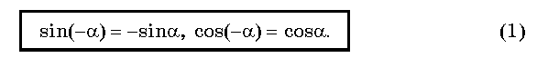
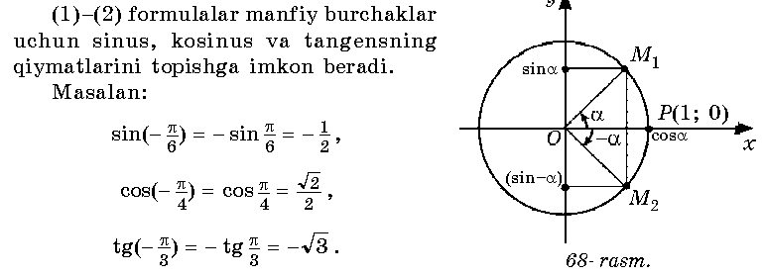
- Yangi mavzuning bayoni
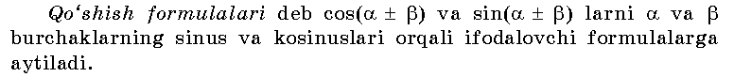
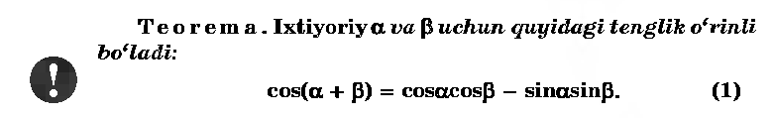
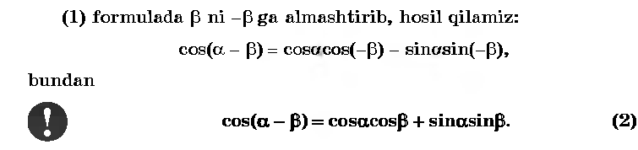
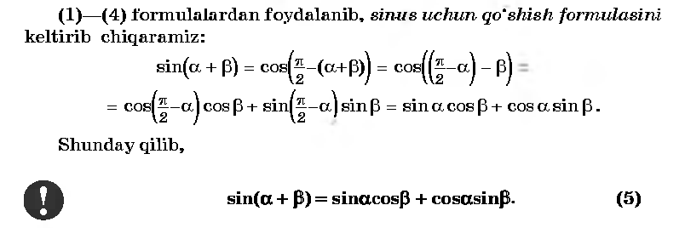
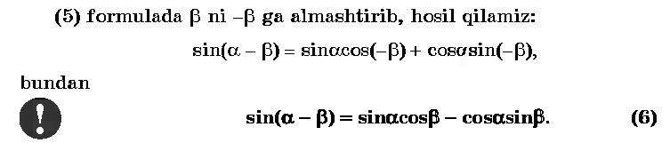
IV.Mustahkamlash.
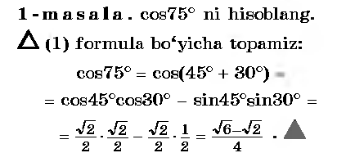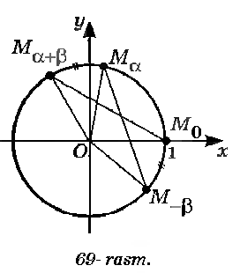
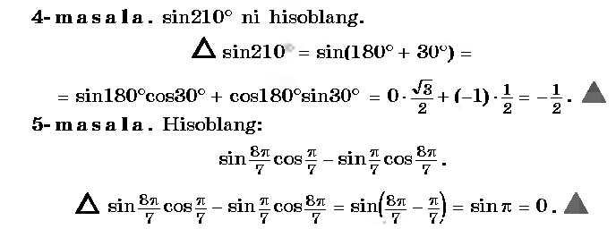
V.Baholash. VI.Uyga vazifa. 329-330 –misollar .

Sana:
Sinf: 9-sinf
Fan: Algebra
Mavzu: Misollar yechish №331-335.
Maqsad: a) ta’limiy: O’quvchilarga sinus, kosinus, tangensni qo’shish formulalarini o’rgatish orqali bilim, malaka va ko’nikma hosil qilish;
b) tarbiyaviy: O’quvchilarni shu mavzu asosida milliy g’oya ruhida va o’zaro hurmat ruhida tarbiyalash;
c) rivojlantiruvchi: O’quvchilar bilimini rivojlantirish, ko’nikma va malakasini o’stirish, dunyoqarashi va fikrlash qobiliyatini riviojlantirish.
Dars turi: Aralash dars.
Dars uslubi : Savol- javob
Darsning borishi
- Tashkiliy qism.
Salomlashish. Navbatchi o’quvchining o’quvchilar davomati, ob-havo, o’quvchilarning darsga tayyorligi to’g’risidagi axborotini tinglash.
- O’tilgan mavzuni so’rash
Uyga vazifalarni tekshirish.
Mustaqil ish:
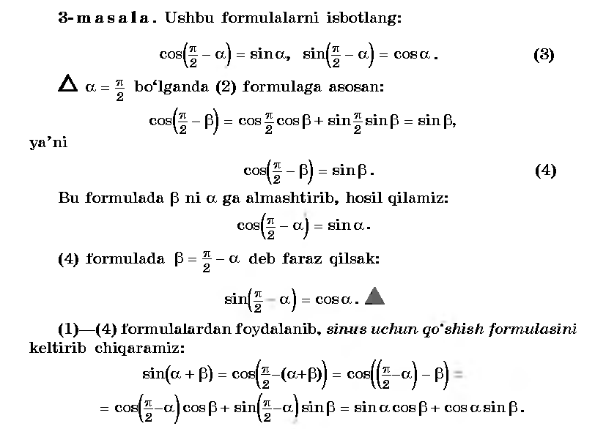
- Yangi mavzuning bayoni
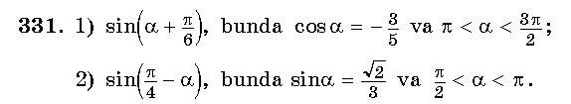
Yechish: 1)sinα= - 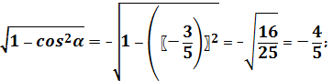
Sin(α+
- cos α= - 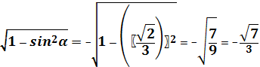
Sin(

IV.Mustahkamlash.
V.Baholash.
VI.Uyga vazifa. _______–misollar .

Sana:
Sinf: 9-sinf
Fan: Algebra
Mavzu: Ikkilangan burchakning sinusi, kosinusi, va tangensi.
Maqsad: a) ta’limiy: O’quvchilarga sinus, kosinus, tangensning ikkilangan burchak formulalarini o’rgatish orqali bilim, malaka va ko’nikma hosil qilish;
b) tarbiyaviy: O’quvchilarni shu mavzu asosida milliy g’oya ruhida va o’zaro hurmat ruhida tarbiyalash;
c) rivojlantiruvchi: O’quvchilar bilimini rivojlantirish, ko’nikma va malakasini o’stirish, dunyoqarashi va fikrlash qobiliyatini riviojlantirish.
Dars turi: Aralash dars.
Dars uslubi : Savol- javob
Darsning borishi:
- Tashkiliy qism.
Salomlashish. Navbatchi o’quvchining o’quvchilar davomati, ob-havo, o’quvchilarning darsga tayyorligi to’g’risidagi axborotini tinglash.
- O’tilgan mavzuni so’rash
Uyga vazifalarni tekshirish.
Mustaqil ish:
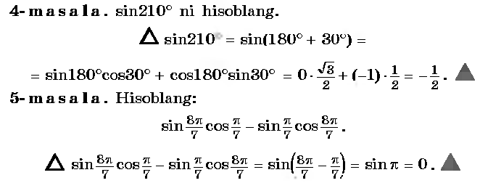
- Yangi mavzuning bayoni
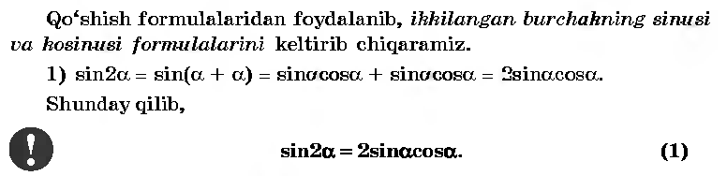
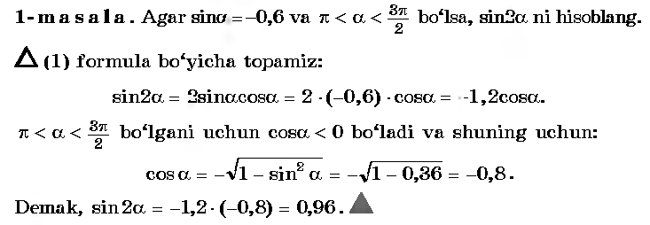
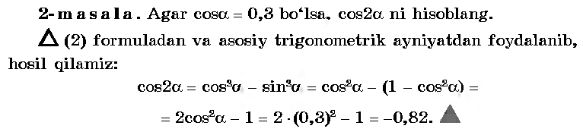
IV.Mustahkamlash.
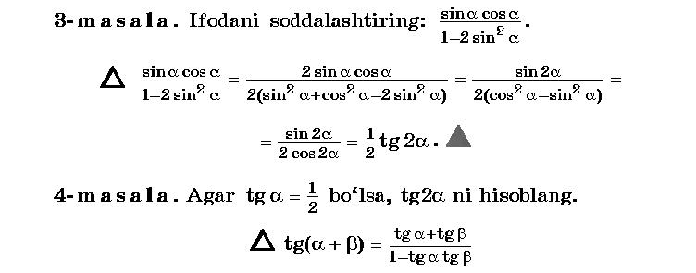
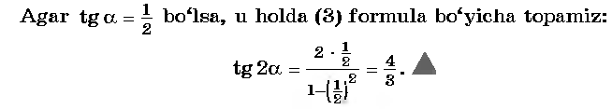
V.Baholash.
VI.Uyga vazifa. 342-343–misollar .
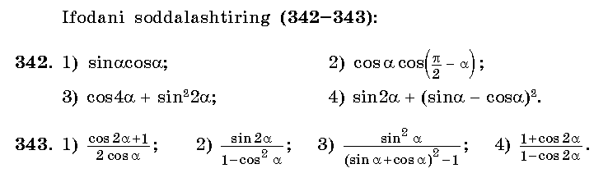

Sana:
Sinf: 9-sinf
Fan: Algebra
Mavzu: Misollar yechish №344-349.
Maqsad: a) ta’limiy: O’quvchilarga sinus, kosinus, tangensning ikkilangan burchak formulalarini o’rgatish orqali bilim, malaka va ko’nikma hosil qilish;
b) tarbiyaviy: O’quvchilarni shu mavzu asosida milliy g’oya ruhida va o’zaro hurmat ruhida tarbiyalash;
c) rivojlantiruvchi: O’quvchilar bilimini rivojlantirish, ko’nikma va malakasini o’stirish, dunyoqarashi va fikrlash qobiliyatini riviojlantirish.
Dars turi: Aralash dars.
Dars uslubi : Savol- javob
Darsning borishi:
- Tashkiliy qism.
Salomlashish. Navbatchi o’quvchining o’quvchilar davomati, ob-havo, o’quvchilarning darsga tayyorligi to’g’risidagi axborotini tinglash.
- O’tilgan mavzuni so’rash
Uyga vazifalarni tekshirish.
Mustaqil ish:
- Yangi mavzuning bayoni
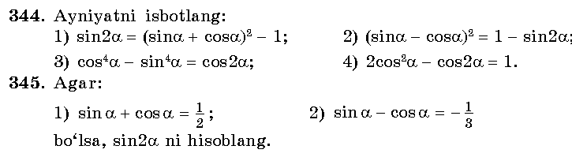___________________________________________________________________________________________________________________________________________________________________________________________________________________________________________________________________________________________________________________________________________________________________________________________________________________________________________________________________________________________________________________________________________________________________________________________________________________________________________________
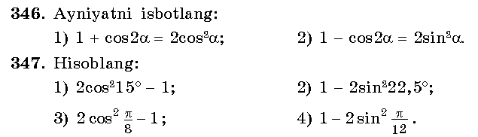_______________________________________________________________________________________________________________________________________________________________________________________________________________________________________________________________________________________________________________________________________________________________________________________________________________________________________________________________________________________________________
IV.Mustahkamlash.
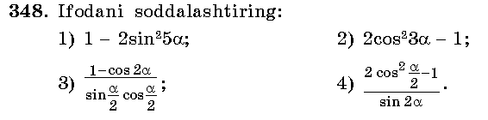_______________________________________________________________________________________________________________________________________________________________________________________________________________________________________________________________________________________________________________________________________________________________________________________________________________________________________________________________________________________________________
V.Baholash.
VI.Uyga vazifa. 342-343–misollar .
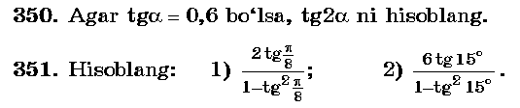______________________________________________________________________________________________________________________________________________________________________________________________________________

Sana:
Sinf: 9-sinf
Fan: Algebra
Mavzu: Keltirish formulalari.
Maqsad: a) ta’limiy: O’quvchilarga keltirish formulalarini va trigonometrik ayniyatlarni o’rgatish orqali bilim, malaka va ko’nikma hosil qilish;
b) tarbiyaviy: O’quvchilarni shu mavzu asosida milliy g’oya ruhida va o’zaro hurmat ruhida tarbiyalash;
c) rivojlantiruvchi: O’quvchilar bilimini rivojlantirish, ko’nikma va malakasini o’stirish, dunyoqarashi va fikrlash qobiliyatini riviojlantirish.
Dars turi: Aralash dars.
Dars uslubi : Savol- javob
Darsning borishi
- Tashkiliy qism.
Salomlashish. Navbatchi o’quvchining o’quvchilar davomati, ob-havo, o’quvchilarning darsga tayyorligi to’g’risidagi axborotini tinglash.
- O’tilgan mavzuni so’rash
Uyga vazifalarni tekshirish.
Mustaqil ish:
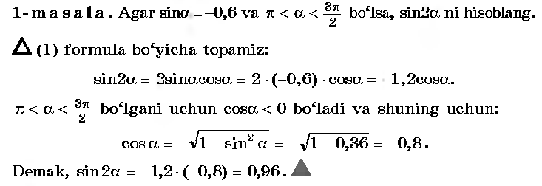
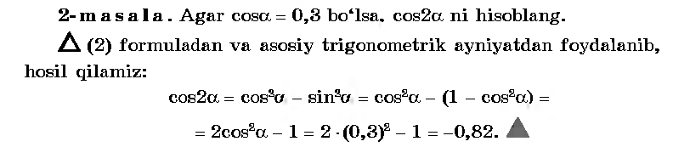
- Yangi mavzuning bayoni
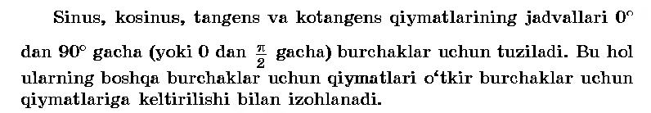
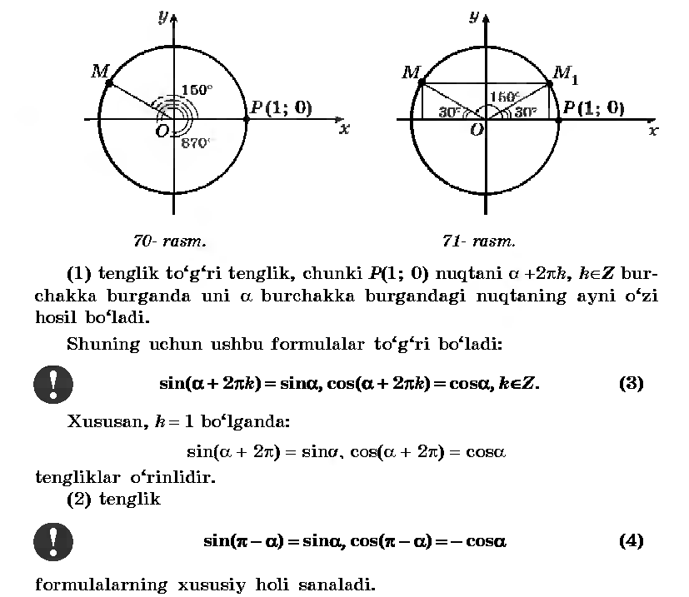
IV.Mustahkamlash.
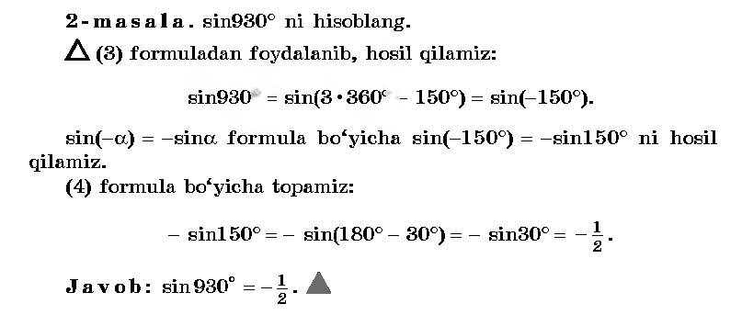
V.Baholash.
VI.Uyga vazifa. 355-356 –misollar .
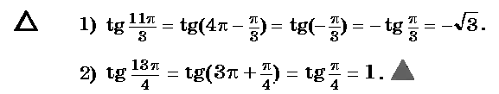

Sana
Sinf: 9-sinf
Fan: Algebra
Mavzu: Misollar yechish №363-367.
Maqsad: a) ta’limiy: O’quvchilarga keltirish formulalarini va trigonometrik ayniyatlarni o’rgatish orqali bilim, malaka va ko’nikma hosil qilish;
b) tarbiyaviy: O’quvchilarni shu mavzu asosida milliy g’oya ruhida va o’zaro hurmat ruhida tarbiyalash;
c) rivojlantiruvchi: O’quvchilar bilimini rivojlantirish, ko’nikma va malakasini o’stirish, dunyoqarashi va fikrlash qobiliyatini riviojlantirish.
Dars turi: Aralash dars.
Dars uslubi : Savol- javob
Darsning borishi
- Tashkiliy qism.
Salomlashish. Navbatchi o’quvchining o’quvchilar davomati, ob-havo, o’quvchilarning darsga tayyorligi to’g’risidagi axborotini tinglash.
- O’tilgan mavzuni so’rash
Uyga vazifalarni tekshirish.
Mustaqil ish:
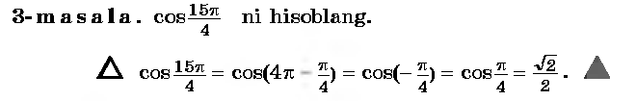
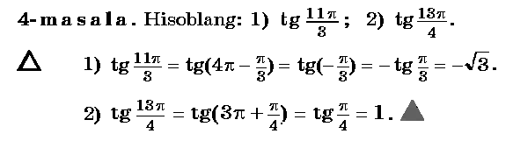
- Yangi mavzuning bayoni
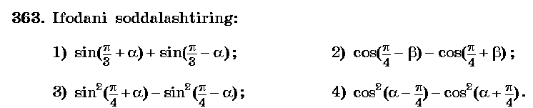
Yechish: 1)2sin=2sin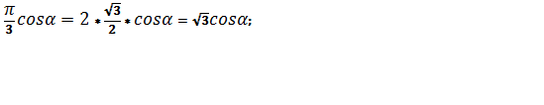
2)-2sin 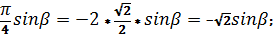
3)(sin((sin(=2sin
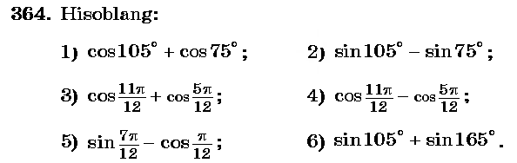
Yechish: 1)cos(90⁰+15⁰)+cos(90⁰-15⁰)=-sin15⁰+sin15⁰=0;
2) sin(90⁰+15⁰)-sin(90⁰-15⁰)=cos15⁰-cos15⁰=0;
3)cos(
IV.Mustahkamlash.
______________________________________________________________________________________________________________________________________________________________________________________________________________________________________________________________________________________________________________________________________________________________________________________________________________________________________________________________________________________________________________________________________________________________________________________________________________________________________________________________________________________________________________________________________________________________________________________________
V.Baholash.
VI.Uyga vazifa. 368-369 –misollar .

Sana:
Sinf: 9-sinf
Fan: Algebra
Mavzu: Misollar yechish №357-360.
Maqsad: a) ta’limiy: O’quvchilarga keltirish formulalarini va trigonometrik ayniyatlarni o’rgatish orqali bilim, malaka va ko’nikma hosil qilish;
b) tarbiyaviy: O’quvchilarni shu mavzu asosida milliy g’oya ruhida va o’zaro hurmat ruhida tarbiyalash;
c) rivojlantiruvchi: O’quvchilar bilimini rivojlantirish, ko’nikma va malakasini o’stirish, dunyoqarashi va fikrlash qobiliyatini riviojlantirish.
Dars turi: Aralash dars.
Dars uslubi : Savol- javob
Darsning borishi
- Tashkiliy qism.
Salomlashish. Navbatchi o’quvchining o’quvchilar davomati, ob-havo, o’quvchilarning darsga tayyorligi to’g’risidagi axborotini tinglash.
- O’tilgan mavzuni so’rash
Uyga vazifalarni tekshirish.
Mustaqil ish:
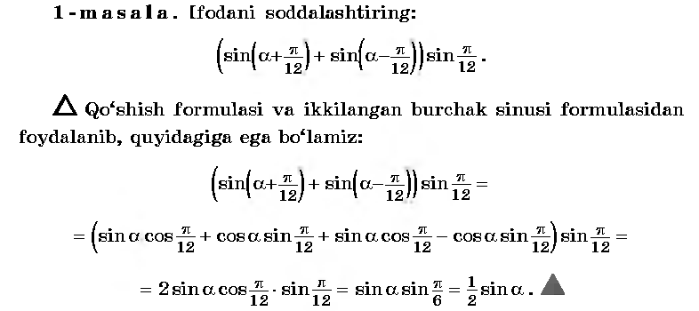
- Yangi mavzuning bayoni
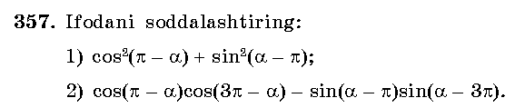
Yechish: 1)cos²𝛼 +sin²𝛼=
2)-cos𝛼*(-cos𝛼)+sin𝛼*(-sin𝛼)=cos²𝛼-sin²𝛼=cos2𝛼
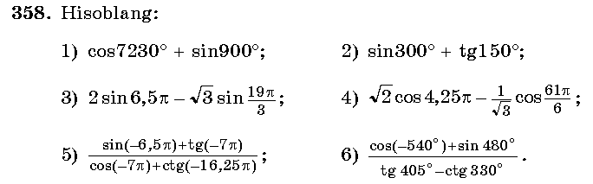
Yechish: 1)cos(7200⁰+30⁰)+sin900⁰=cos30⁰+0=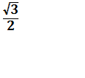;
2) sin(270⁰+30⁰)+tg(180⁰-30⁰)=-cos30⁰-tg30⁰=-;
3)2sin(6
IV.Mustahkamlash.
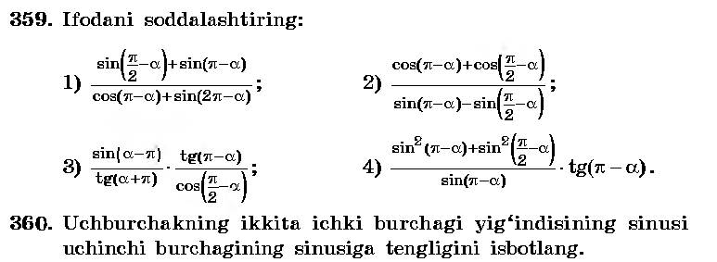
______________________________________________________________________________________________________________________________________________________________________________________________________________________________________________________________________________________________________________________________________________________________________________________________________________________________________________________________________________________________________________________________________________________________________________________________________________________________________________________________________________________________________________________________________________________________________________________________
V.Baholash.
VI.Uyga vazifa. 361-362 –misollar .

Sana:
Sinf: 9-sinf
Fan: Algebra
Mavzu: Nazorat ishi .
Maqsad: a) ta’limiy: O’quvchilarning trigonometrik ifodalarni shakl almashtirish, ayniyatni isbotlashga doir bilimlarini tekshirish;
b) tarbiyaviy: Oquvchilarni shu mavzu asosida milliy istiqlol ruhida va o’zaro hurmat ruhida tarbiyalash;
c) rivojlantiruvchi: o’quvchilar bilimini rivojlantirish, ko’nikma va malakasini o’stirish, fikrlash qobiliyatini riviojlantirish.
Dars turi: O’quvchilar bilimini tekshirish
Dars uslubi : Yozma ish
Tashkiliy qism.
Salomlashish. Navbatchining o’quvchilar davomati, darsga tayyorligi to’g’risidagi axborotini tinglash.
Darsning borishi:
I variant
1. Ifodani soddalashtiring : sin( sin(
2. Ifodani soddalashtiring: 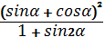.
3. Ifodaning shaklini almashtiring: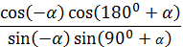.
4. Ayniyatni isbotlang: 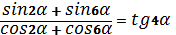.
5. cos va α – III chorakda bo’lsa, sin2α va cos2α ni toping.
II variant
1. Ifodani soddalashtiring : cos( sin(
2. Ifodani soddalashtiring: 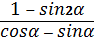.
3. Ifodaning shaklini almashtiring: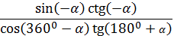.
4. Ayniyatni isbotlang: 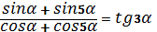.
5. cos va α – III chorakda bo’lsa, sin2α va cos2α ni toping.
Yechimlari:
I variant
____________________________________________________________________________________________________________________________________________________________________________________________________________________________________________________________________________________________________________________________________________________________________________________________________________________________________________________________________________________________________________________________________________________________________________________________________________________________________________________________________________________________________________________________________________________________________________________________________________________________________________________________________________________________________________________________________________________________________________________________________________________________________________________________________________________________________________________________________________________________________________________________________________________________________________________________________________________________________________________________________________________________________________________________________________________________________________________________________________________________________________________________________________________________________________________________________________________________________________________________________________________________________________________________________________________________________________________________________________________________________________________________________________________________________________________________________________________________________________________________________________________________________________________________________________________________________________________________________________________________________________________________________________________________________________________________________________________________________________________________________________________________________________________________________________________________________________________________________________________________________________________________________________________________________________________________________________________________________________________________________________________________________________________________________________________________________

UYGA VAZIFA. Takrorlash

Sana:
Sinf: 9-sinf
Fan: Algebra
Mavzu: Arifmetik progressiya.
Maqsad: a) ta’limiy: O’quvchilarga arifmetik progressiya ta’rifi, uning
hadlarini topish formulalarini o’rgatish orqali bilim, malaka va
ko’nikma hosil qilish;
b) tarbiyaviy: O’quvchilarni shu mavzu asosida milliy g’oya ruhida
va o’zaro hurmat ruhida tarbiyalash;
c) rivojlantiruvchi: O’quvchilar bilimini rivojlantirish, ko’nikma va
malakasini o’stirish, dunyoqarashi va fikrlash qobiliyatini
riviojlantirish.
Dars turi: Yangi bilim berish.
Dars uslubi : Savol- javob
Dars jihozi: ko’rgazma, darslik, tarqatmalar.
Darsning borishi
- Tashkiliy qism.
Salomlashish. Navbatchi o’quvchining o’quvchilar davomati, ob-havo, o’quvchilarning darsga tayyorligi to’g’risidagi axborotini tinglash.
- O’tilgan mavzuni so’rash
Uyga vazifalarni tekshirish.
Mustaqil ish: 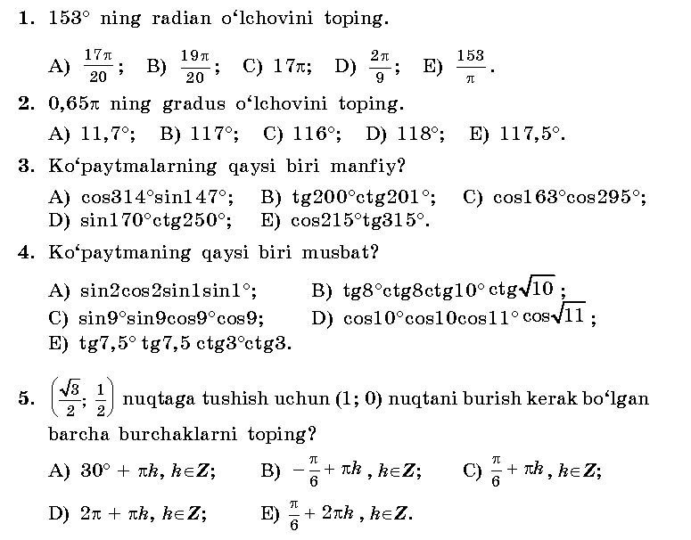

Test kaliti: 1-A; 2-B; 3-C; 4-D; 5-E.
- Yangi mavzuning bayoni
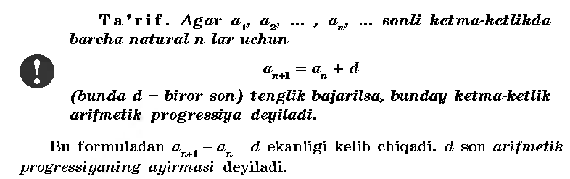
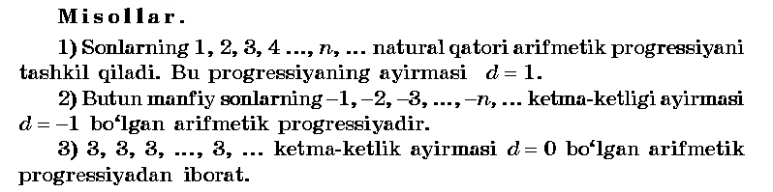
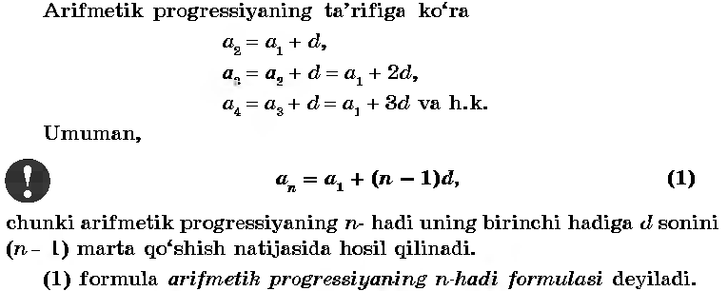
IV.Mustahkamlash.
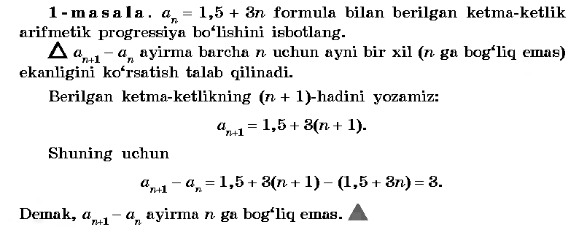
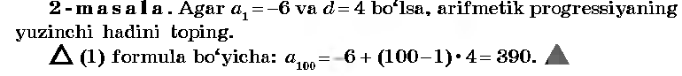
V.Baholash.
VI.Uyga vazifa. 402-403 –misollar .

Sana:
Sinf: 9-sinf
Fan: Algebra
Mavzu: Misollar yechish №404- 409.
Maqsad: a) ta’limiy: O’quvchilarga arifmetik progressiya ta’rifi, uning
hadlarini topish formulalarini o’rgatish orqali bilim, malaka va
ko’nikma hosil qilish;
b) tarbiyaviy: O’quvchilarni shu mavzu asosida milliy g’oya ruhida
va o’zaro hurmat ruhida tarbiyalash;
c) rivojlantiruvchi: O’quvchilar bilimini rivojlantirish, ko’nikma va
malakasini o’stirish, dunyoqarashi va fikrlash qobiliyatini
riviojlantirish.
Dars turi: Aralash dars.
Dars uslubi : Savol- javob
Dars jihozi: ko’rgazma, darslik, tarqatmalar.
Darsning borishi
- Tashkiliy qism.
Salomlashish. Navbatchi o’quvchining o’quvchilar davomati, ob-havo, o’quvchilarning darsga tayyorligi to’g’risidagi axborotini tinglash.
- O’tilgan mavzuni so’rash
Uyga vazifalarni tekshirish.
Mustaqil ish:
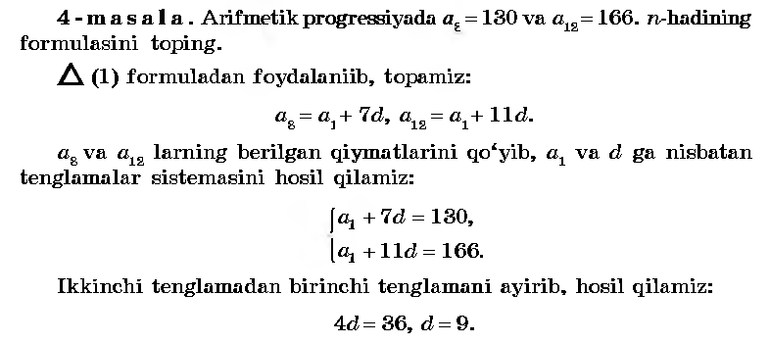
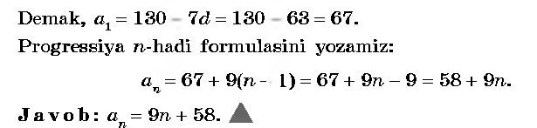
- Yangi mavzuning bayoni

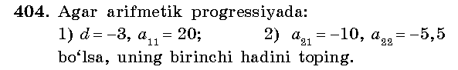
Yechish: 1) a₁₁=a₁+10d; a₁=a₁₁-10d= 20-10*(-3)=50;
2) a₂₂=a₂₁+d; d=a₂₂-a₂₁=-5,5-(-10)=4,5;
a₁=a₂₁-20d=-10-20*4,5=-100;
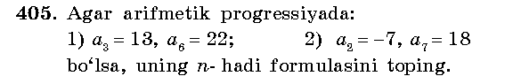
Yechish: 1)22=13+3d; 3d=9; d=3; a₁=13-2d=13-2*3=13-6=7;
a_{n}=a₁+(n-1)d=7+(n-1)*3=3n+4; J: a_{n}=3n+4.
2) 18=-7+5d; 5d=18+7=25; d=5; a₁=-7-d=-7-5=-12;
a_{n}=a₁+(n-1)d=-12+(n-1)*5=5n-17; J: a_{n}=5n-17.
Yechish: a₁=15, a₂=13, a₃=11, . . . a_{n}<0; n-?
d=13-15=-2; a_{n}=a₁+(n-1)d=15+(n-1)*(-2)=17-2n;
17-2n<0; 2n>17; n>8,5 ; n=9. J: 9-hadidan boshlab.
Yechish: -10+(n-1)*0,5<2; 0,5n-10,5<2; 0,5n<12,5
n<12,5:0,5 ; n<25. J: n<25.
IV.Mustahkamlash.
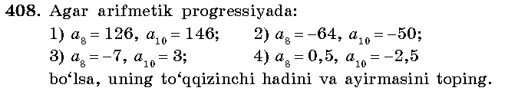
Yechish: 1)a₉=
2)a₉=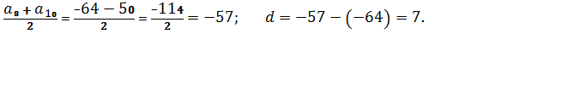
3)a₉=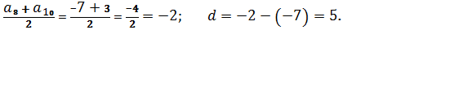
4)a₉=
V.Baholash.
VI.Uyga vazifa. 410-411 –misollar .
Yechish: Shartga ko’ra, a₇+a₈= a₁+6d+a₁+7d=2a₁+13d = 30 ,
Bundan a₁₀+a₅=a₁+9d+a₁+4d=2a₁+13d=30 bo’ladi. J: 30.

Sana:
Sinf: 9-sinf
Fan: Algebra
Mavzu: Arifmetik progressiyaning dastlabki n ta hadining yig’indisi.
Maqsad: a) ta’limiy: O’quvchilarga arifmetik progressiya ta’rifi, uning
hadlarini topish formulalarini o’rgatish orqali bilim, malaka va
ko’nikma hosil qilish;
b) tarbiyaviy: O’quvchilarni shu mavzu asosida milliy g’oya ruhida
va o’zaro hurmat ruhida tarbiyalash;
c) rivojlantiruvchi: O’quvchilar bilimini rivojlantirish, ko’nikma va
malakasini o’stirish, dunyoqarashi va fikrlash qobiliyatini
riviojlantirish.
Dars turi: Yangi bilim berish.
Dars uslubi : Savol- javob
Dars jihozi: ko’rgazma, darslik, tarqatmalar.
Darsning borishi
- Tashkiliy qism.
Salomlashish. Navbatchi o’quvchining o’quvchilar davomati, ob-havo, o’quvchilarning darsga tayyorligi to’g’risidagi axborotini tinglash.
- O’tilgan mavzuni so’rash
Uyga vazifalarni tekshirish.
Mustaqil ish:
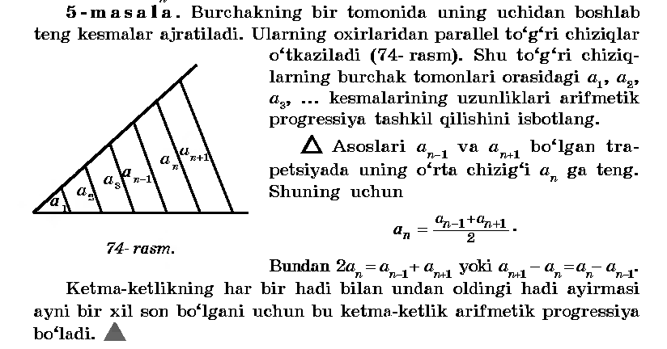
- Yangi mavzuning bayoni
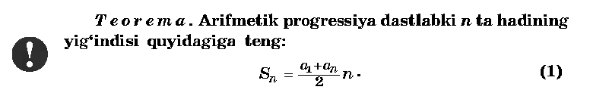
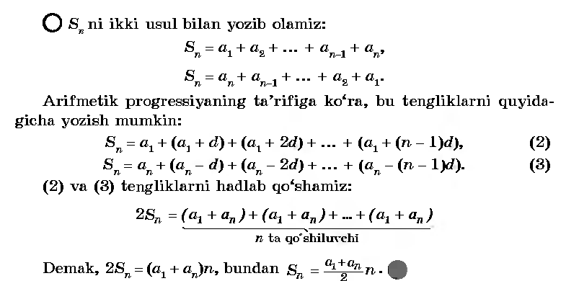
IV.Mustahkamlash.
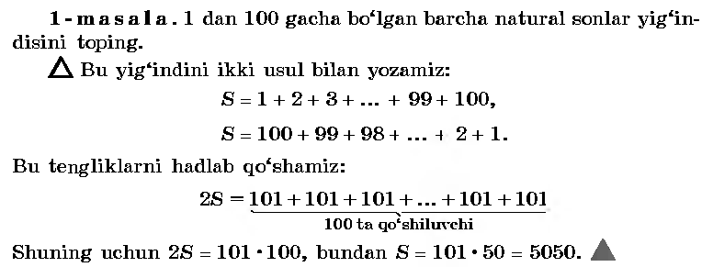
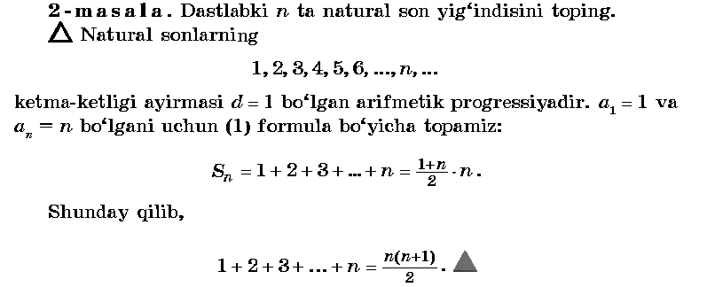
V.Baholash.
VI.Uyga vazifa. 416 –misol .
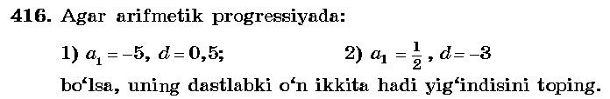
Yechish:1) a₁₂= a₁+11d=-5+11*0,5 = -5+5,5=0,5 ;
S=

Sana:
Sinf: 9-sinf
Fan: Algebra
Mavzu: Misollar yechish №417-420.
Maqsad: a) ta’limiy: O’quvchilarga arifmetik progressiyaning dastlabki n ta
hadi yig’indisini topish formulasini o’rgatish orqali bilim, malaka va
ko’nikma hosil qilish;
b) tarbiyaviy: O’quvchilarni shu mavzu asosida milliy g’oya ruhida
va o’zaro hurmat ruhida tarbiyalash;
c) rivojlantiruvchi: O’quvchilar bilimini rivojlantirish, ko’nikma va
malakasini o’stirish, dunyoqarashi va fikrlash qobiliyatini
riviojlantirish.
Dars turi: Aralash dars.
Dars uslubi : Savol- javob
Dars jihozi: ko’rgazma, darslik, tarqatmalar.
- Tashkiliy qism.
Salomlashish. Navbatchi o’quvchining o’quvchilar davomati, ob-havo, o’quvchilarning darsga tayyorligi to’g’risidagi axborotini tinglash.
- O’tilgan mavzuni so’rash
Uyga vazifalarni tekshirish.
Mustaqil ish:
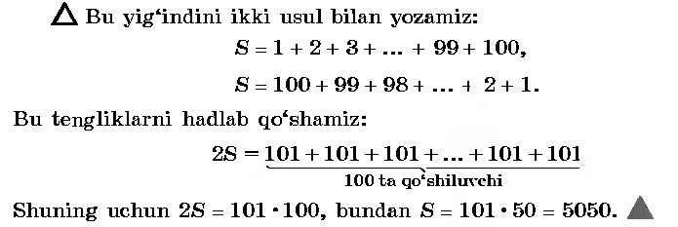
- Yangi mavzuning bayoni
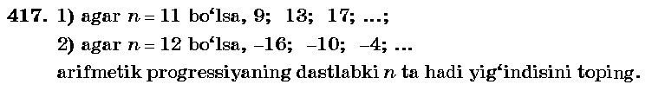__________________________________________________________________________________________________________________________________________________________________________________________________________________________________________________________________________________________________________________________________________________________
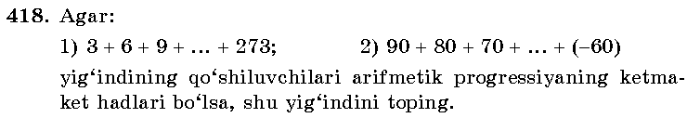_______________________________________________________________________________________________________________________________________________________________________________________________________________________________________________________________________________________________________________________________________________________________________________________________________________________________________________________________________________________________________
___________________________________________________________________________________________________________________________________________________________________________________________________________________________________________________________________________________________________________________________________________________________
IV.Mustahkamlash.
_____________________________________________________________________________________________________________________________________________________________________________________________________________________________________________________________________________________________________________________________________________________________________________________________________________________________________________________________________________________________________________________________________________________________________________
V.Baholash.
VI.Uyga vazifa. 421 –misol .
Yechish:1) a₁=3; d=1; a_{n}= a₁+(n-1)d=3+(n-1)*1=2+n ;
75= ; n²+5n-150=0 ; n=10.
Javob: 10 ta.

Sana
Sinf: 9-sinf
Fan: Algebra
Mavzu: Misollar yechish №422-425.
Maqsad: a) ta’limiy: O’quvchilarga arifmetik progressiyaning dastlabki n ta
hadi yig’indisini topish formulasini o’rgatish orqali bilim, malaka va
ko’nikma hosil qilish;
b) tarbiyaviy: O’quvchilarni shu mavzu asosida milliy g’oya ruhida
va o’zaro hurmat ruhida tarbiyalash;
c) rivojlantiruvchi: O’quvchilar bilimini rivojlantirish, ko’nikma va
malakasini o’stirish, dunyoqarashi va fikrlash qobiliyatini
riviojlantirish.
Dars turi: Aralash dars.
Dars uslubi : Savol- javob
Dars jihozi: ko’rgazma, darslik, tarqatmalar.
- Tashkiliy qism.
Salomlashish. Navbatchi o’quvchining o’quvchilar davomati, ob-havo, o’quvchilarning darsga tayyorligi to’g’risidagi axborotini tinglash.
- O’tilgan mavzuni so’rash
Uyga vazifalarni tekshirish.
Mustaqil ish:
- Yangi mavzuning bayoni
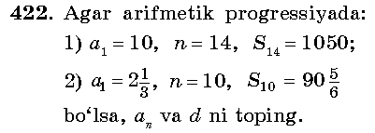__________________________________________________________________________________________________________________________________________________________________________________________________________________________________________________________________________________________________________________________________________________________
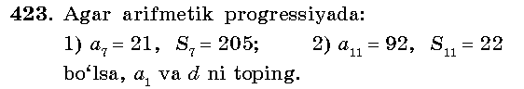_______________________________________________________________________________________________________________________________________________________________________________________________________________________________________________________________________________________________________________________________________________________________________________________________________________________________________________________________________________________________________
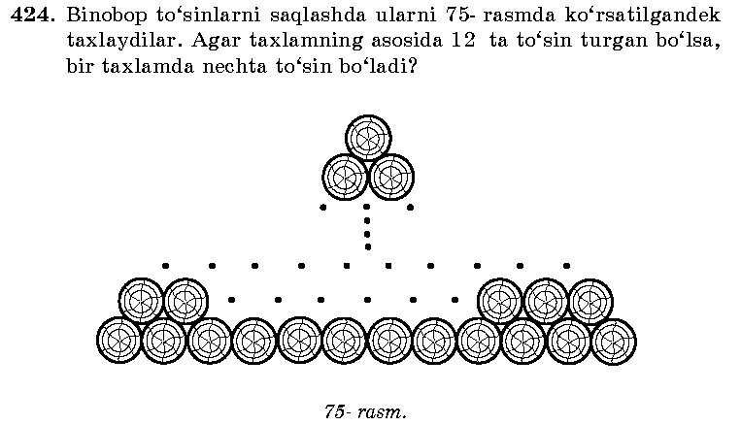___________________________________________________________________________________________________________________________________________________________________________________________________________________________________________________________________________________________________________________________________________________________
IV.Mustahkamlash.
__________________________________________________________________________________________________________________________________________________________________________________________________________________________________________________________________________________________________________________________________________________________
V.Baholash.
VI.Uyga vazifa. 426-427 –misollar .

Sana:
Sinf: 9-sinf
Fan: Algebra
Mavzu: Geometrik progressiya.
Maqsad: a) ta’limiy: O’quvchilarga geometrik progressiya ta’rifi, uning
hadlarini topish formulalarini o’rgatish orqali bilim, malaka va
ko’nikma hosil qilish;
b) tarbiyaviy: O’quvchilarni shu mavzu asosida milliy g’oya ruhida
va o’zaro hurmat ruhida tarbiyalash;
c) rivojlantiruvchi: O’quvchilar bilimini rivojlantirish, ko’nikma va
malakasini o’stirish, dunyoqarashi va fikrlash qobiliyatini
riviojlantirish.
Dars turi: Yangi bilim berish.
Dars uslubi : Savol- javob
Dars jihozi: ko’rgazma, darslik, tarqatmalar.
- Tashkiliy qism.
Salomlashish. Navbatchi o’quvchining o’quvchilar davomati, ob-havo, o’quvchilarning darsga tayyorligi to’g’risidagi axborotini tinglash.
- O’tilgan mavzuni so’rash
Uyga vazifalarni tekshirish.
Mustaqil ish:
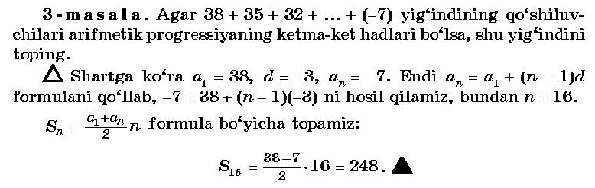
- Yangi mavzuning bayoni
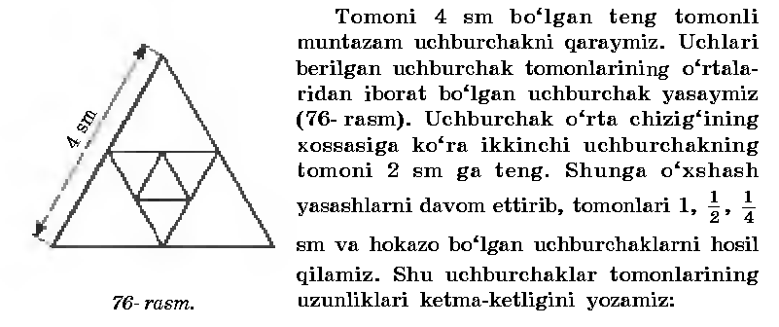
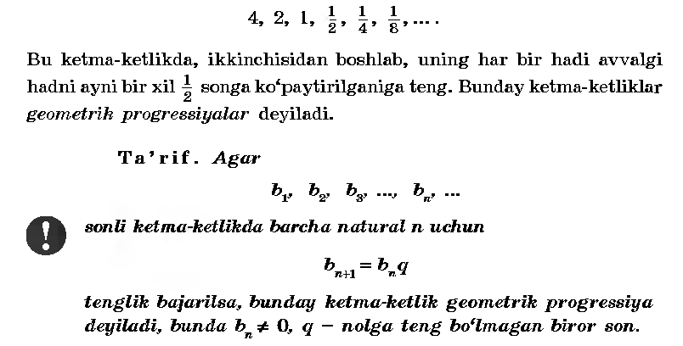
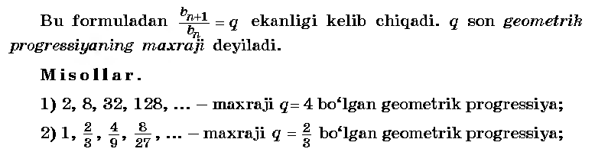
IV.Mustahkamlash.
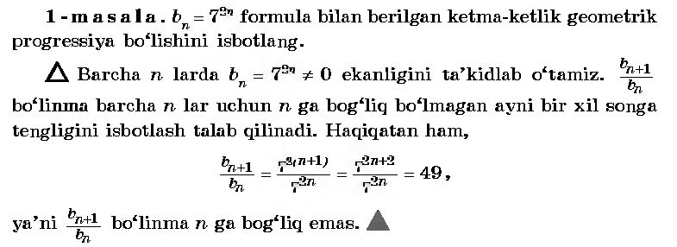
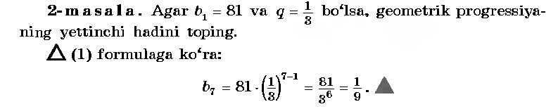
V.Baholash.
VI.Uyga vazifa. 431–misol .
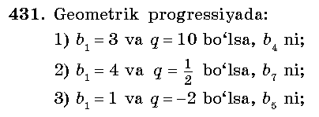 Yechish:1) b₄= b₁*q³=3*10³ = 3000 ;
2) b₇= b₁*q⁶=4*⁶ =
3) b₅= b₁*q⁴=1*(-2)⁴ = 16.

Sana:
Sinf: 9-sinf
Fan: Algebra
Mavzu: Geometrik progressiyaning dastlabki n ta hadi yig’indisini topish.
Maqsad: a) ta’limiy: O’quvchilarga geometrik progressiyaning dastlabki n ta
hadi yig’indisini topish formulasini o’rgatish orqali bilim, malaka va
ko’nikma hosil qilish;
b) tarbiyaviy: O’quvchilarni shu mavzu asosida milliy g’oya ruhida
va o’zaro hurmat ruhida tarbiyalash;
c) rivojlantiruvchi: O’quvchilar bilimini rivojlantirish, ko’nikma va
malakasini o’stirish, dunyoqarashi va fikrlash qobiliyatini
riviojlantirish.
Dars turi: Yangi bilim berish.
Dars uslubi : Savol- javob
Dars jihozi: ko’rgazma, darslik, tarqatmalar.
Darsning borishi
- Tashkiliy qism.
Salomlashish. Navbatchi o’quvchining o’quvchilar davomati, ob-havo, o’quvchilarning darsga tayyorligi to’g’risidagi axborotini tinglash.
- O’tilgan mavzuni so’rash
Uyga vazifalarni tekshirish.
Mustaqil ish:
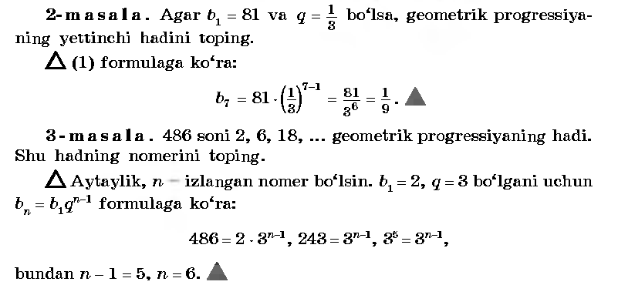
- Yangi mavzuning bayoni
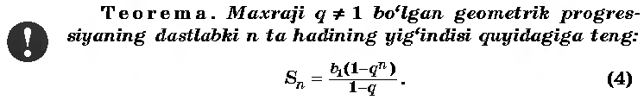
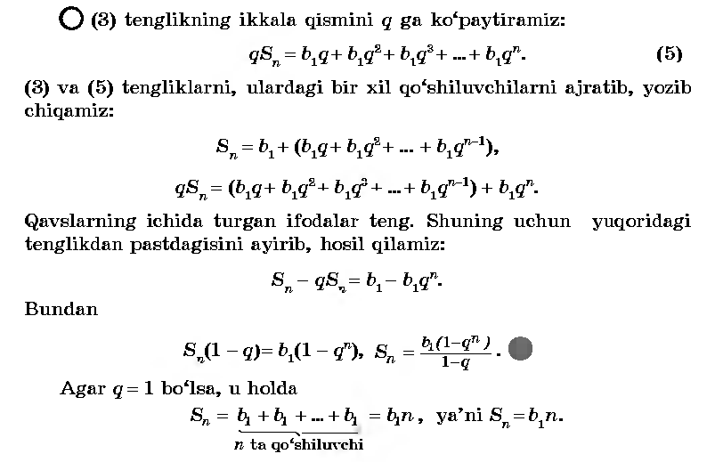
IV.Mustahkamlash.
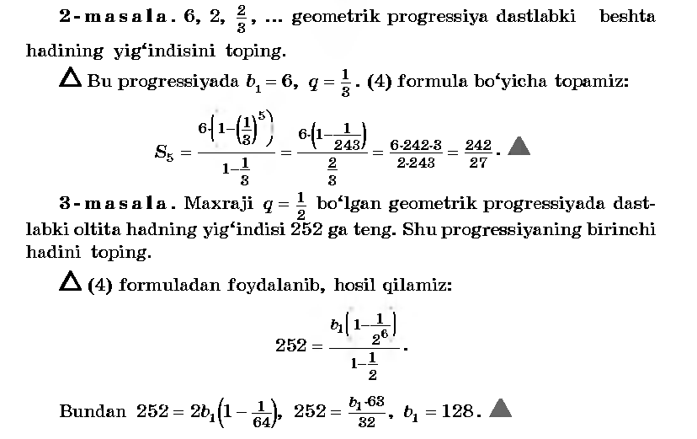
V.Baholash.
VI.Uyga vazifa. 443 –misol .
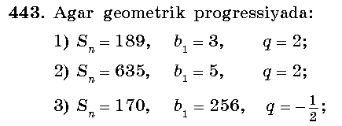
Yechish:1) S=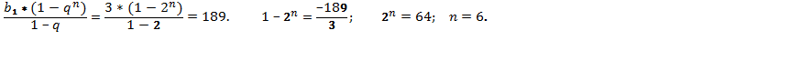

Sana
Sinf: 9-sinf
Fan: Algebra
Mavzu: Misollar yechish №444-445.
Maqsad: a) ta’limiy: O’quvchilarga geometrik progressiyaning dastlabki n ta
hadining yig’indisini topish formulasini puxta o’rgatish orqali bilim,
malaka va ko’nikma hosil qilish;
b) tarbiyaviy: O’quvchilarni shu mavzu asosida milliy g’oya ruhida
va o’zaro hurmat ruhida tarbiyalash;
c) rivojlantiruvchi: O’quvchilar bilimini rivojlantirish, ko’nikma va
malakasini o’stirish, dunyoqarashi va fikrlash qobiliyatini
riviojlantirish.
Dars turi: Aralash dars.
Dars uslubi : Savol- javob
Dars jihozi: ko’rgazma, darslik, tarqatmalar.
Darsning borishi
- Tashkiliy qism.
Salomlashish. Navbatchi o’quvchining o’quvchilar davomati, ob-havo, o’quvchilarning darsga tayyorligi to’g’risidagi axborotini tinglash.
- O’tilgan mavzuni so’rash
Uyga vazifalarni tekshirish.
Mustaqil ish:
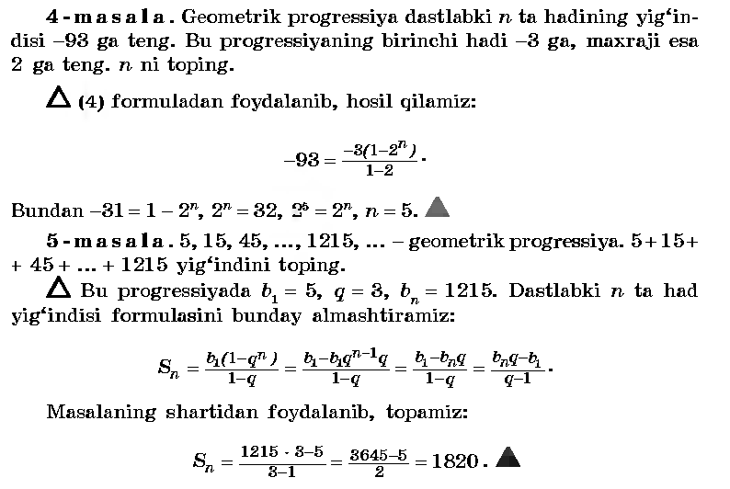
- Yangi mavzuning bayoni
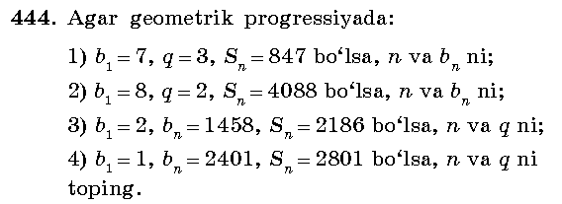___________________________________________________________________________________________________________________________________________________________________________________________________________________________________________________________________________________________________________________________________________________________________________________________________________________________________________________________________________________________________________________________________________________________________________________________________________________________________________________
IV.Mustahkamlash.
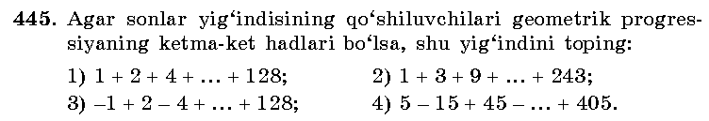_________________________________________________________________________________________________________________________________________________________________________________________________________________________________________________________________________________________________________________________________________________________________________________________________________________________________________________________________________________________________________________________________________________________________________________________________________________________________________________________________________________________________________________________
V.Baholash.
VI.Uyga vazifa. 446 –misol .
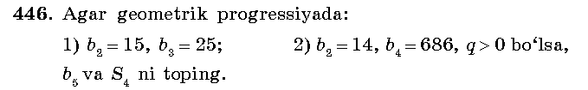_______________________________________________________________________________________________________________________________________________________________________________________________________________

Sana:
Sinf: 9-sinf
Fan: Algebra
Mavzu: Misollar yechish №447-449.
Maqsad: a) ta’limiy: O’quvchilarga geometrik progressiyaning dastlabki n ta
hadining yig’indisini topish formulasini puxta o’rgatish orqali bilim,
malaka va ko’nikma hosil qilish;
b) tarbiyaviy: O’quvchilarni shu mavzu asosida milliy g’oya ruhida
va o’zaro hurmat ruhida tarbiyalash;
c) rivojlantiruvchi: O’quvchilar bilimini rivojlantirish, ko’nikma va
malakasini o’stirish, dunyoqarashi va fikrlash qobiliyatini
riviojlantirish.
Dars turi: Aralash dars.
Dars uslubi : Savol- javob
Dars jihozi: ko’rgazma, darslik, tarqatmalar.
Darsning borishi
- Tashkiliy qism.
Salomlashish. Navbatchi o’quvchining o’quvchilar davomati, ob-havo, o’quvchilarning darsga tayyorligi to’g’risidagi axborotini tinglash.
- O’tilgan mavzuni so’rash
Uyga vazifalarni tekshirish.
Mustaqil ish:
- Yangi mavzuning bayoni
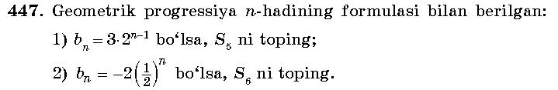
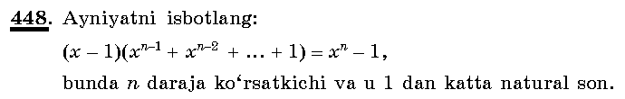________________________________________________________________________________________________________________________________________________________________________________________________________________________________________________________________________________________________________________________________________________________________________________________________________________________________________________________________________________________________________________________________________________________________________________
IV.Mustahkamlash.
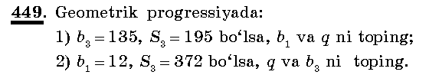
_________________________________________________________________________________________________________________________________________________________________________________________________________________________________________________________________________________________________________________________________________________________________________________________________________________________________________________________________________________________________________________________________________________________________________________________________________________________________________________________________________________________________________________________
V.Baholash.
VI.Uyga vazifa. 450 –misol .
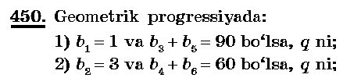 _______________________________________________________________________________________________________________________________________________________________________________________________________________

Sana:
Sinf: 9-sinf
Fan: Algebra
Mavzu: Cheksiz kamayuvchi geometrik progressiya.
Maqsad: a) ta’limiy: O’quvchilarga cheksiz kamayuvchi geometrik
progressiyaning yig’indisini topish formulasini puxta o’rgatish
orqali bilim, malaka va ko’nikma hosil qilish;
b) tarbiyaviy: O’quvchilarni shu mavzu asosida milliy g’oya ruhida
va o’zaro hurmat ruhida tarbiyalash;
c) rivojlantiruvchi: O’quvchilar bilimini rivojlantirish, ko’nikma va
malakasini o’stirish, dunyoqarashi va fikrlash qobiliyatini
riviojlantirish.
Dars turi: Yangi bilim berish.
Dars uslubi : Savol- javob
Dars jihozi: ko’rgazma, darslik, tarqatmalar.
- Tashkiliy qism.
Salomlashish. Navbatchi o’quvchining o’quvchilar davomati, ob-havo, o’quvchilarning darsga tayyorligi to’g’risidagi axborotini tinglash.
- O’tilgan mavzuni so’rash
Uyga vazifalarni tekshirish.
Mustaqil ish:
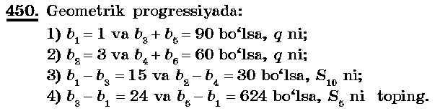
____________________________________________________________________________________________________________________________________________________________________________________________________________________________________________________________________________________________________________________________________________________________________________________________________________________________________
- Yangi mavzuning bayoni
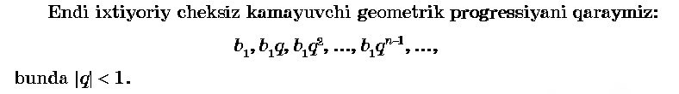
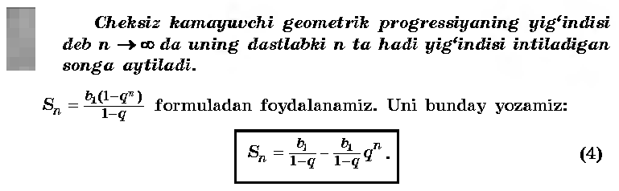
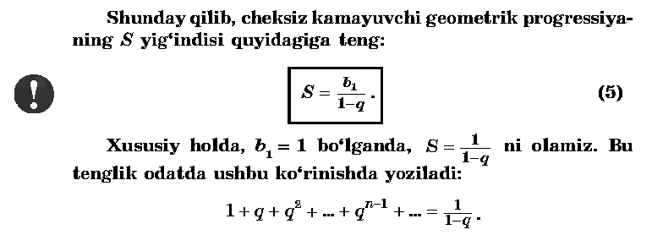
IV.Mustahkamlash.
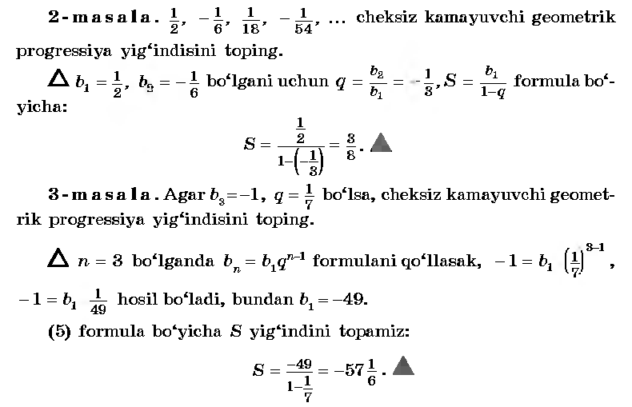
V.Baholash.
VI.Uyga vazifa. 454 –misol .
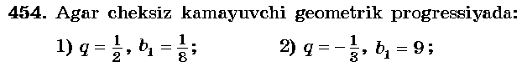
Yechish: 1);

Sana
Sinf: 9-sinf
Fan: Algebra
Mavzu: Misollar yechish №455-459.
Maqsad: a) ta’limiy: O’quvchilarga cheksiz kamayuvchi geometrik
progressiyaning yig’indisini topish formulasini puxta o’rgatish
orqali bilim, malaka va ko’nikma hosil qilish;
b) tarbiyaviy: O’quvchilarni shu mavzu asosida milliy g’oya ruhida
va o’zaro hurmat ruhida tarbiyalash;
c) rivojlantiruvchi: O’quvchilar bilimini rivojlantirish, ko’nikma va
malakasini o’stirish, dunyoqarashi va fikrlash qobiliyatini
riviojlantirish.
Dars turi: Aralash dars.
Dars uslubi : Savol- javob
Dars jihozi: ko’rgazma, darslik, tarqatmalar.
- Tashkiliy qism.
Salomlashish. Navbatchi o’quvchining o’quvchilar davomati, ob-havo, o’quvchilarning darsga tayyorligi to’g’risidagi axborotini tinglash.
- O’tilgan mavzuni so’rash
Uyga vazifalarni tekshirish.
Mustaqil ish:
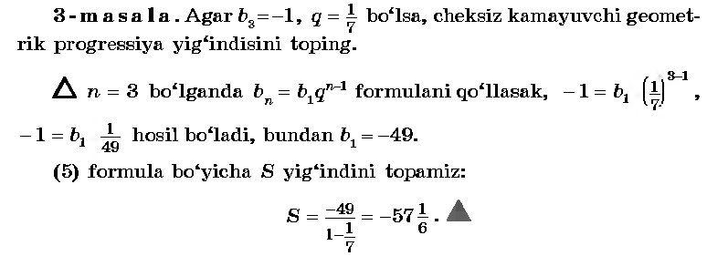
- Yangi mavzuning bayoni
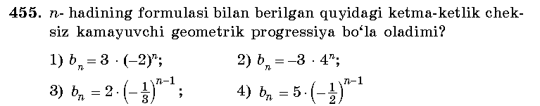___________________________________________________________________________________________________________________________________________________________________________________________________________________________________________________________________________________________________________________________________________________________
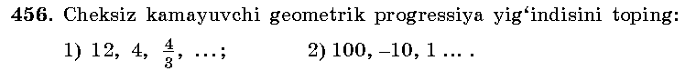_____________________________________________________________________________________________________________________________________________________________________________________________________________________________________________________________________________________
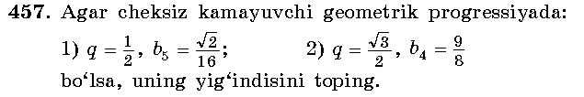___________________________________________________________________________________________________________________________________________________________________________________________________________________________________________________________________________________________________________________________________________________________
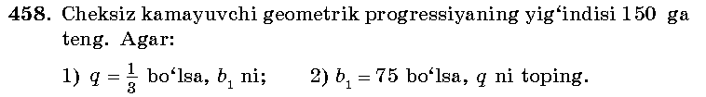__________________________________________________________________________________________________________________________________________________________________________________________________________________________________________________________________________________________________________________________________________________________
IV.Mustahkamlash.
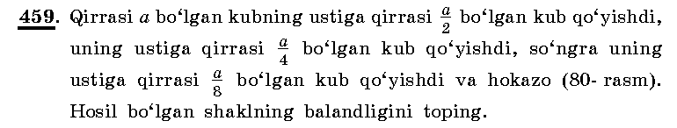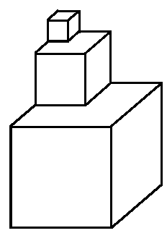
V.Baholash.
VI.Uyga vazifa. 460-461 –misol .
Yechish: 1)0,(5); 4)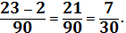

Sana:
Sinf: 9-sinf
Fan: Algebra
Mavzu: Amaliy masalalarni yechish №462-469.
Maqsad: a) ta’limiy: O’quvchilarga arifmetik progressiyaga doir formulalarni,
cheksiz kamayuvchi geometrik progressiyaning yig’indisini topish
formulasini puxta o’rgatish orqali bilim, malaka va ko’nikma hosil
qilish;
b) tarbiyaviy: O’quvchilarni shu mavzu asosida milliy g’oya ruhida
va o’zaro hurmat ruhida tarbiyalash;
c) rivojlantiruvchi: O’quvchilar bilimini rivojlantirish, ko’nikma va
malakasini o’stirish, dunyoqarashi va fikrlash qobiliyatini
riviojlantirish.
Dars turi: Aralash dars.
Dars uslubi : Savol- javob
Dars jihozi: ko’rgazma, darslik, tarqatmalar.
- Tashkiliy qism.
Salomlashish. Navbatchi o’quvchining o’quvchilar davomati, ob-havo, o’quvchilarning darsga tayyorligi to’g’risidagi axborotini tinglash.
- O’tilgan mavzuni so’rash
Uyga vazifalarni tekshirish.
Mustaqil ish:
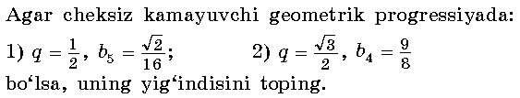________________________________________________________________________________________________________________________________________________________________________________________________________________________________________________________________________________________
- Yangi mavzuning bayoni
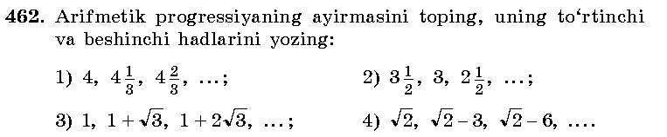
Yechish: 1)d=4
2)d=3-3
3)d=1+
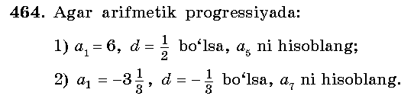_____________________________________________________________________________________________________________________________________________________________________________________________________________________________________________________________________________________
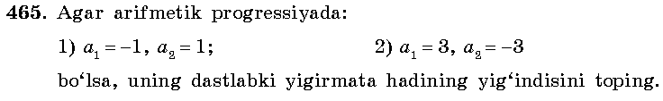___________________________________________________________________________________________________________________________________________________________________________________________________________________________________________________________________________________________________________________________________________________________
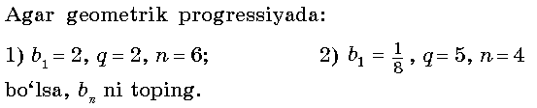__________________________________________________________________________________________________________________________________________________________________________________________________________________
IV.Mustahkamlash.
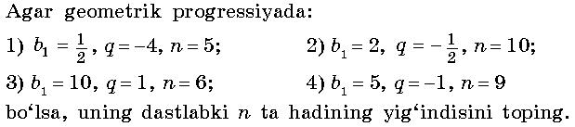
V.Baholash.
VI.Uyga vazifa. 474-475 –misollar .
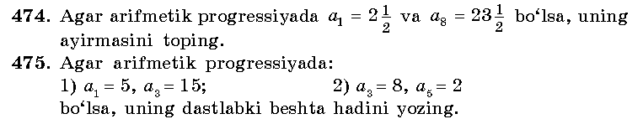
Yechish: ______________________________________________________________________________________________________________________________________________________________________________________________________________

Sana:
Sinf: 9-sinf
Fan: Algebra
Mavzu: Nazorat ishi .
Maqsad: a) ta’limiy: O’quvchilarning trigonometrik ayniyatlar, arifmetik progressiya, cheksiz kamayuvchi geometrik progressiya hadlari va yig’indisini topishga doir bilimlarini tekshirish;
b) tarbiyaviy: Oquvchilarni shu mavzu asosida milliy istiqlol ruhida va o’zaro hurmat ruhida tarbiyalash;
c) rivojlantiruvchi: o’quvchilar bilimini rivojlantirish, ko’nikma va malakasini o’stirish, fikrlash qobiliyatini riviojlantirish.
Dars turi: O’quvchilar bilimini tekshirish
Dars uslubi : Yozma ish
Tashkiliy qism.
Salomlashish. Navbatchining o’quvchilar davomati, darsga tayyorligi to’g’risidagi axborotini tinglash.
Darsning borishi:
I variant
1. Ifodani soddalashtiring : 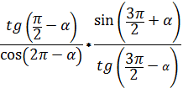
2. Hisoblang: 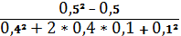.
3. Agar arifmetik progressiyada d=-3, a₁₁=20 bo’lsa, uning birinchi hadini toping.
4. Cheksiz kamayuvchi geometrik prograssiyada 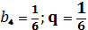 bo’lsa, bu progressiya yig’indisini toping.
5. Agar (b_{n} ) geometrik progressiyada b₁=8, 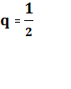 bo’lsa, dastlabki beshta hadlarining yig’indisini toping.
II variant
1. Ifodani soddalashtiring : ctgα+sin²α+ctg²a*sin²a
2. Hisoblang: 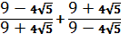.
3. Agar arifmetik progressiyada a₂₁=-10, a₂₂=-5,5 bo’lsa, uning birinchi hadini toping.
4. Cheksiz kamayuvchi geometrik prograssiyada 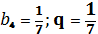 bo’lsa, bu progressiya yig’indisini toping.
5. Agar (b_{n} ) geometrik progressiyada b₁=3, bo’lsa, dastlabki oltita hadlarining yig’indisini toping.
Yechimlari:
I variant
__________________________________________________________________________________________________________________________________________________________________________________________________________________________________________________________________________________________________________________________________________________________________________________________________________________________________________________________________________________________________________________________________________________________________________________________________________________________________________________________________________________________________________________________________________________________________________________________________________________________________________________________________________________________________________________________________________________________________________________________________________________________________________________________________________________________________________________________________________________________________________________________________________________________________________________________________________________________________________________________________________________________________________________________________________________________________________________________________________________________________________________________________________________________________________________________________________________________________________________________________________________________________________________________________________________________________________________________________________________________________________________________________________________________________________________________________________________________________________________________________________________________________________________________________________________________________________________________________________________________________________________________________________________________________________________________________________________________________________________________________________________________________________________________________________________________________________________________________________________________________________________________________________________
UYGA VAZIFA. Takrorlash

Sana:
Sinf: 9-sinf
Fan: Algebra
Mavzu: Nazorat ishi .
Maqsad: a) ta’limiy: O’quvchilarning arifmetik progressiya, geometrik progressiya hadlari va yig’indisini topishga doir bilimlarini tekshirish;
b) tarbiyaviy: Oquvchilarni shu mavzu asosida milliy istiqlol ruhida va o’zaro hurmat ruhida tarbiyalash;
c) rivojlantiruvchi: o’quvchilar bilimini rivojlantirish, ko’nikma va malakasini o’stirish, fikrlash qobiliyatini riviojlantirish.
Dars turi: O’quvchilar bilimini tekshirish
Dars uslubi : Yozma ish
Tashkiliy qism.
Salomlashish. Navbatchining o’quvchilar davomati, darsga tayyorligi to’g’risidagi axborotini tinglash.
Darsning borishi:
I variant
- Arifmetik progressiyada a1=-1, d=3 bo’lsa, uning 10- hadini toping.
4. b1=-5, q=2 bo’lsa, uning beshinchi hadini toping.
5.
II variant
- Arifmetik progressiyada a1=-1, d=3 bo’lsa, uning 10- hadini toping.
4. b1=-5, q=2 bo’lsa, uning beshinchi hadini toping.
5.
Yechimlari:
I variant
__________________________________________________________________________________________________________________________________________________________________________________________________________________________________________________________________________________________________________________________________________________________________________________________________________________________________________________________________________________________________________________________________________________________________________________________________________________________________________________________________________________________________________________________________________________________________________________________________________________________________________________________________________________________________________________________________________________________________________________________________________________________________________________________________________________________________________________________________________________________________________________________________________________________________________________________________________________________________________________________________________________________________________________________________________________________________________________________________________________________________________________________________________________________________________________________________________________________________________________________________________________________________________________________________________________________________________________________________________________________________________________________________________________________________________________________________________________________________________________________________________________________________________________________________________________________________________________________________________________________________________________________________________________________________________________________
UYGA VAZIFA. Takrorlash

Sana:
Sinf: 9-sinf
Fan: Algebra
Mavzu: Takrorlash: Kvadrat funksiya №491-493.
Maqsad: a) ta’limiy: O’quvchilarga kvadrat funksiya ta’rifi, uning grafigini
yasashni puxta o’rgatish orqali bilim, malaka va ko’nikma hosil
qilish;
b) tarbiyaviy: O’quvchilarni shu mavzu asosida milliy g’oya ruhida
va o’zaro hurmat ruhida tarbiyalash;
c) rivojlantiruvchi: O’quvchilar bilimini rivojlantirish, ko’nikma va
malakasini o’stirish, dunyoqarashi va fikrlash qobiliyatini
riviojlantirish.
Dars turi: Takrorlash.
Dars uslubi : Savol- javob
Dars jihozi: ko’rgazma, darslik, tarqatmalar.
- Tashkiliy qism.
Salomlashish. Navbatchi o’quvchining o’quvchilar davomati, ob-havo, o’quvchilarning darsga tayyorligi to’g’risidagi axborotini tinglash.
- O’tilgan mavzuni so’rash
Uyga vazifalarni tekshirish.
Mustaqil ish:
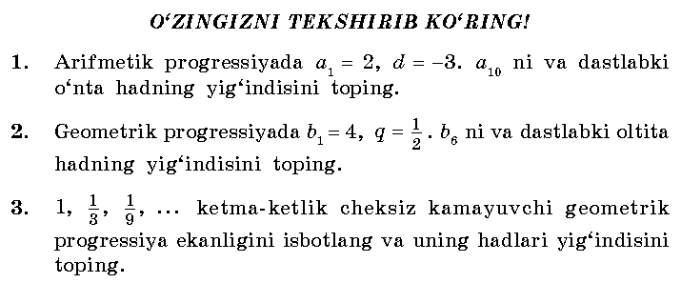______________________________________________________________________________________________________________________________________________________________________________________________________________________________________________________________________________________________________________________________________________________________________________________________________________________________________________________________________________________________________________________________________________________________________________________________________________________________________________________
- Yangi mavzuning bayoni
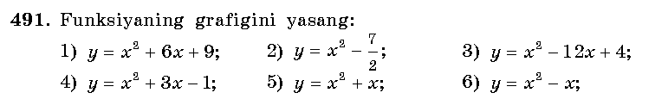_____________________________________________________________________________________________________________________________________________________________________________________________________________________________________________________________________________________
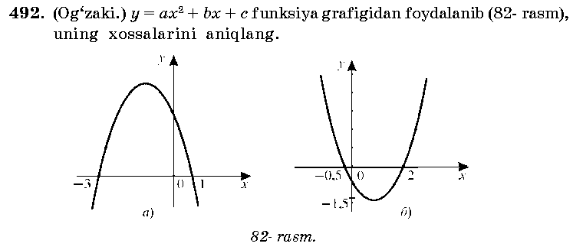________________________________________________________________________________________________________________________________________________________________________________________________________________________________________________________________________________________
IV.Mustahkamlash.
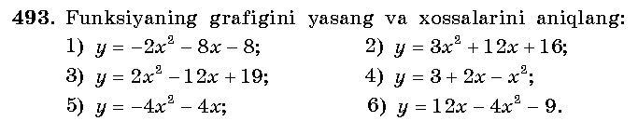____________________________________________________________________________________________________________________________________________________________________________________________________________
V.Baholash.
VI.Uyga vazifa. 494 –misol .
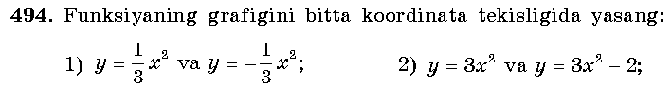
Yechish: ______________________________________________________________________________________________________________________________________________________________________________________________________________

Sana
Sinf: 9-sinf
Fan: Algebra
Mavzu: Takrorlash: Ratsional ko’rsatkichli daraja №491-493.
Maqsad: a) ta’limiy: O’quvchilarga ratsional ko’rsatkichli daraja ta’rifi, uning
xossalarini puxta o’rgatish orqali bilim, malaka va ko’nikma hosil
qilish;
b) tarbiyaviy: O’quvchilarni shu mavzu asosida milliy g’oya ruhida
va o’zaro hurmat ruhida tarbiyalash;
c) rivojlantiruvchi: O’quvchilar bilimini rivojlantirish, ko’nikma va
malakasini o’stirish, dunyoqarashi va fikrlash qobiliyatini
riviojlantirish.
Dars turi: Takrorlash.
Dars uslubi : Savol- javob
Dars jihozi: ko’rgazma, darslik, tarqatmalar.
- Tashkiliy qism.
Salomlashish. Navbatchi o’quvchining o’quvchilar davomati, ob-havo, o’quvchilarning darsga tayyorligi to’g’risidagi axborotini tinglash.
- O’tilgan mavzuni so’rash
Uyga vazifalarni tekshirish.
Mustaqil ish:
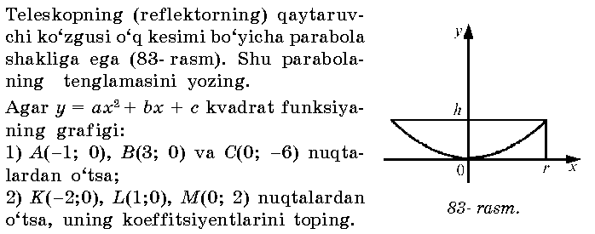______________________________________________________________________________________________________________________________________________________________________________________________________________________________________________________________________________________________________________________________________________________________________________________________________________________________________________________________________________________________________________________________________________________________________________________________________________________________________________________
- Yangi mavzuning bayoni
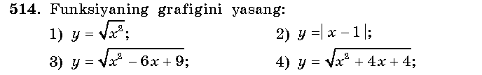_____________________________________________________________________________________________________________________________________________________________________________________________________________________________________________________________________________________
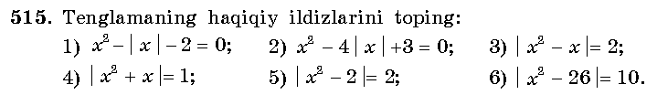________________________________________________________________________________________________________________________________________________________________________________________________________________________________________________________________________________________
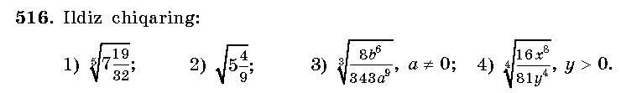________________________________________________________________________________________________________________________________________
IV.Mustahkamlash.
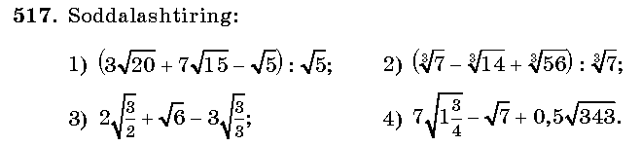____________________________________________________________________________________________________________________________________________________________________________________________________________
V.Baholash.
VI.Uyga vazifa. 519-520 –misollar .
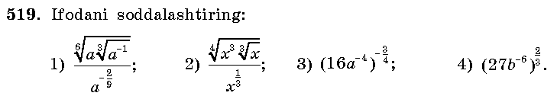
Yechish: ______________________________________________________________________________________________________________________________________________________________________________________________________

Sana:
Sinf: 9-sinf
Fan: Algebra
Mavzu: Takrorlash: Trigonometriya elementlari №530-534.
Maqsad: a) ta’limiy: O’quvchilarga trigonometriya elementlari, uning
xossalarini puxta o’rgatish orqali bilim, malaka va ko’nikma hosil
qilish;
b) tarbiyaviy: O’quvchilarni shu mavzu asosida milliy g’oya ruhida
va o’zaro hurmat ruhida tarbiyalash;
c) rivojlantiruvchi: O’quvchilar bilimini rivojlantirish, ko’nikma va
malakasini o’stirish, dunyoqarashi va fikrlash qobiliyatini
riviojlantirish.
Dars turi: Takrorlash.
Dars uslubi : Savol- javob
Dars jihozi: ko’rgazma, darslik, tarqatmalar.
- Tashkiliy qism.
Salomlashish. Navbatchi o’quvchining o’quvchilar davomati, ob-havo, o’quvchilarning darsga tayyorligi to’g’risidagi axborotini tinglash.
- O’tilgan mavzuni so’rash
Uyga vazifalarni tekshirish.
Mustaqil ish:
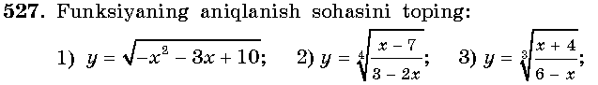______________________________________________________________________________________________________________________________________________________________________________________________________________________________________________________________________________________________________________________________________________________________________________________________________________________________________________________________________________________________________________________________________________________________________________________________________________________________________________________
- Yangi mavzuning bayoni
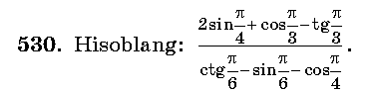_____________________________________________________________________________________________________________________________________________________________________________________________________________________________________________________________________________________
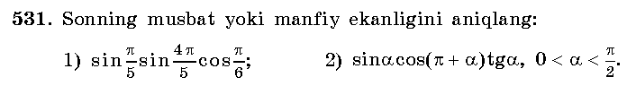____________________________________________________________________________________________________________________________________________
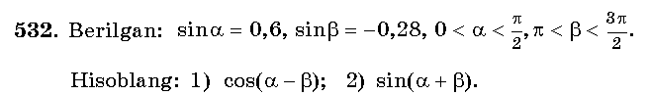_____________________________________________________________________________________________________________________________________________________________________________________________________________________________________________________________________________________
IV.Mustahkamlash.
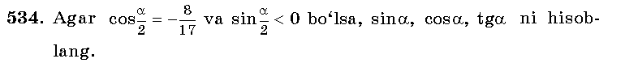____________________________________________________________________________________________________________________________________________________________________________________________________________
V.Baholash.
VI.Uyga vazifa. 533 –misol .
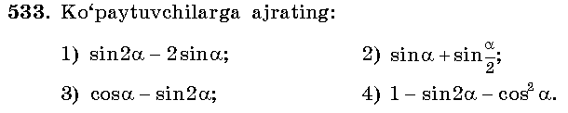
Yechish: ______________________________________________________________________________________________________________________________________________________________________________________________________

Sana:
Sinf: 9-sinf
Fan: Algebra
Mavzu: Takrorlash: Progressiya №535-541.
Maqsad: a) ta’limiy: O’quvchilarga progressiyalar, ularning dastlabki n ta
hadi yig’indisini topish formulasini puxta o’rgatish orqali bilim,
malaka va ko’nikma hosil qilish;
b) tarbiyaviy: O’quvchilarni shu mavzu asosida milliy g’oya ruhida
va o’zaro hurmat ruhida tarbiyalash;
c) rivojlantiruvchi: O’quvchilar bilimini rivojlantirish, ko’nikma va
malakasini o’stirish, dunyoqarashi va fikrlash qobiliyatini
riviojlantirish.
Dars turi: Takrorlash.
Dars uslubi : Savol- javob
Dars jihozi: ko’rgazma, darslik, tarqatmalar.
- Tashkiliy qism.
Salomlashish. Navbatchi o’quvchining o’quvchilar davomati, ob-havo, o’quvchilarning darsga tayyorligi to’g’risidagi axborotini tinglash.
- O’tilgan mavzuni so’rash
Uyga vazifalarni tekshirish.
Mustaqil ish:
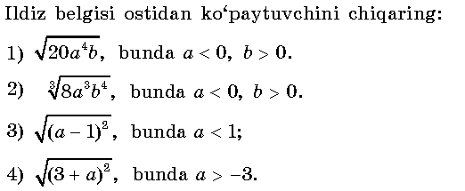__________________________________________________________________________________________________________________________________________________________________________________________________________________________________________________________________________________________________________________________________________________________________________________________________________________________________________________________________________________________________________
- Yangi mavzuning bayoni
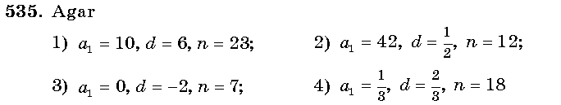
_________________________________________________________________________________________________________________________________________________________________________________________________________________________________________________________________________________________________________________________________________________________________________________________________________________________________
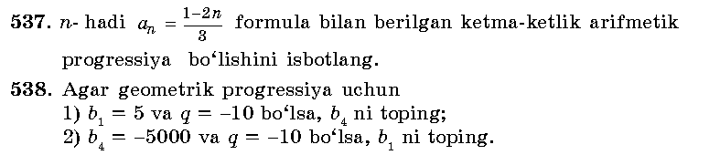_________________________________________________________________________________________________________________________________________________________________________________________________________________________________________________________________________________________________________________________________________________________________________________________________________________________________
IV.Mustahkamlash.
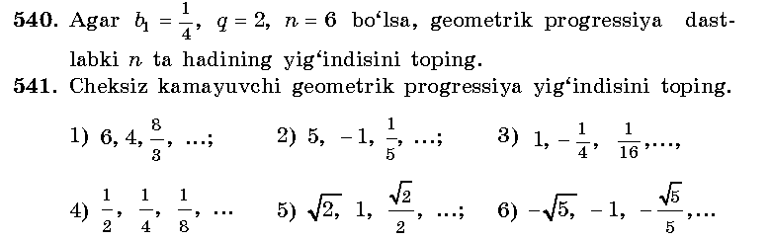
Yechish: ____________________________________________________________________________________________________________________________________________________________________________________________________________________________________________________________________________________________________________________________________________________________________________________________________________________________________
V.Baholash.
VI.Uyga vazifa. 542-543 –misollar .

Sana:
Sinf: 9-sinf
Fan: Algebra
Mavzu: Takrorlash: Yakunlovchi dars №593-616.
Maqsad: a) ta’limiy: O’quvchilarga algebraic kasrlar va ularni qisqartirish,
tenglamalar va tenglamalar sistemasini yechishni puxta o’rgatish
orqali bilim, malaka va ko’nikma hosil qilish;
b) tarbiyaviy: O’quvchilarni shu mavzu asosida milliy g’oya ruhida
va o’zaro hurmat ruhida tarbiyalash;
c) rivojlantiruvchi: O’quvchilar bilimini rivojlantirish, ko’nikma va
malakasini o’stirish, dunyoqarashi va fikrlash qobiliyatini
riviojlantirish.
Dars turi: Takrorlash.
Dars uslubi : Savol- javob
Dars jihozi: ko’rgazma, darslik, tarqatmalar.
- Tashkiliy qism.
Salomlashish. Navbatchi o’quvchining o’quvchilar davomati, ob-havo, o’quvchilarning darsga tayyorligi to’g’risidagi axborotini tinglash.
- O’tilgan mavzuni so’rash
Uyga vazifalarni tekshirish.
Mustaqil ish:
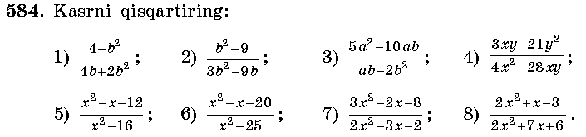__________________________________________________________________________________________________________________________________________________________________________________________________________________________________________________________________________________________________________________________________________________________________________________________________________________________________________________________________________________________________________
- Yangi mavzuning bayoni
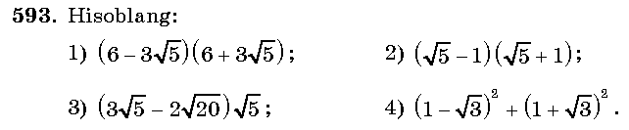
_________________________________________________________________________________________________________________________________________________________________________________________________________________________________________________________________________________________________________________________________________________________________________________________________________________________________
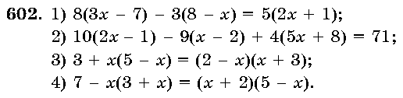_________________________________________________________________________________________________________________________________________________________________________________________________________________________________________________________________________________________________________________________________________________________________________________________________________________________________
IV.Mustahkamlash.
Yechish: ____________________________________________________________________________________________________________________________________________________________________________________________________________________________________________________________________________________________________________________________________________________________________________________________________________________________________
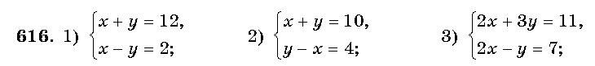____________________________________________________________________________________________________________________________________________________________________________________________________________________________________________________________________________________________________________________________________________________________________________________________________________________________________
V.Baholash.
VI.Uyga vazifa. Takrorlash.

